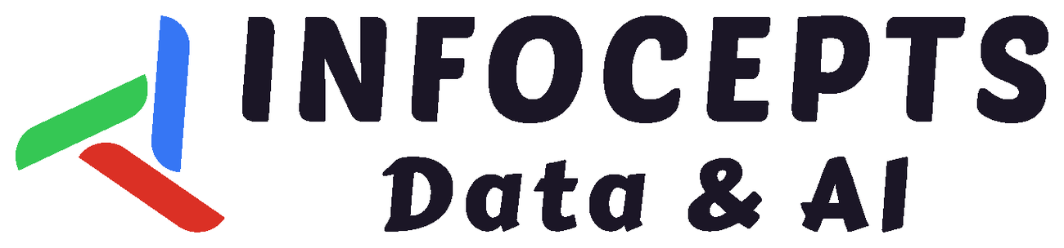
QUALITY VISION AGENT  Detect defects in milliseconds, automate quality actions, and continuously improve inspection models across plants-without moving sensitive production images off-site. | EDGE AI + CLOSED-LOOP QUALITY  From inspection to action
TARGET  UP TO 62%  fewer defect escapes | TARGET  UP TO 38%  less inspection labour | EDGE SPEED  <10 MS  ONNX/TensorRT inference | PROTOTYPE AI  0.964 / 0.971  mAP / precision
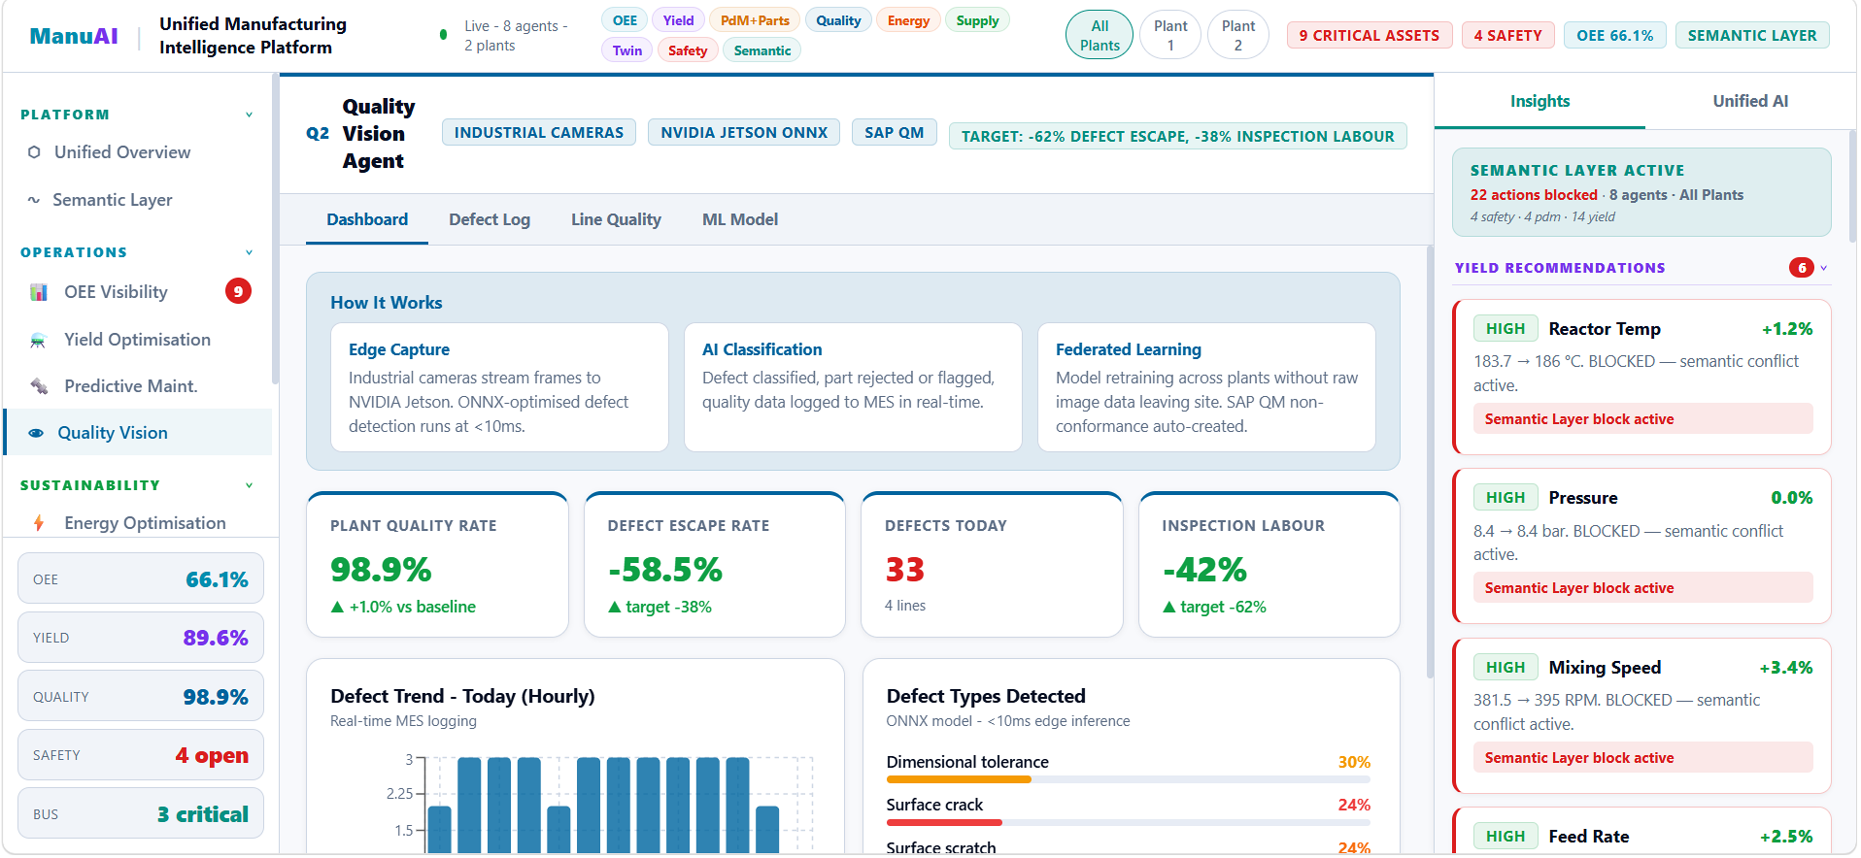
Illustrative product experience: real-time quality KPIs, defect intelligence, semantic governance and multi-plant visibility
SOLUTION OVERVIEW Quality Vision Agent combines industrial cameras, NVIDIA Jetson edge inference, ONNX/TensorRT models, MES logging and SAP QM workflows-turning each visual inspection into a traceable quality action while supporting federated retraining across plants.
THE BUSINESS PROBLEMS  • Manual visual inspection requires significant labour and is difficult to scale consistently.  • Defect escapes, re-inspection and rejected parts increase quality cost and response effort.  • Quality performance varies by production line and needs real-time plant-wide visibility. | HOW IT WORKS  1 Capture: Industrial cameras stream frames to NVIDIA Jetson.  2 Detect: ONNX-optimised models classify defect type and severity.  3 Act: Accept, reject or re-inspect decisions are logged instantly.  4 Integrate: MES/SAP QM workflows create traceable quality events.  5 Learn: Federated retraining improves models across plants. | PLATFORM CAPABILITIES  • ONNX/TensorRT edge inference supports decisions in under 10 milliseconds.  • Defect classification triggers accept, reject or re-inspect actions and MES/SAP QM records.  • The semantic layer can block recommendations when a conflict is detected.  • Federated retraining keeps raw images at the plant and aggregates gradients only.  • Model version, mAP, precision, feature importance and training history remain visible.
BUSINESS OUTCOMES
01  Improve plant and line quality  Track quality rate, defects and escapes in real time | 02  Reduce defect escapes and labour  Work toward the targets shown in the agent | 03  Accelerate quality action  Faster accept, reject, re-inspect and non-conformance handling | 04  Learn across plants  Federated retraining without moving raw images off-site
WHO BENEFITS? COO / VP Manufacturing • Head of Quality • Plant Managers • Quality Engineers • IT/OT & AI Teams
INTEGRATIONS & DEPLOYMENT Industrial cameras • NVIDIA Jetson • ONNX/TensorRT • MES • SAP QM
PRIVACY & MODEL GOVERNANCE Raw images remain at the plant • Gradient aggregation only • Deployed and archived model history • Semantic conflict blocking
TECHNOLOGY ECOSYSTEM Industrial cameras, NVIDIA Jetson, ONNX/TensorRT, MES and SAP QM-exactly as shown in the agent screens
RESOURCES Request Product Walkthrough | Request Architecture & Integration Overview | Request Detailed Solution Brief (available on request)
READY TO MODERNISE VISUAL QUALITY INSPECTION?  Explore a guided walkthrough tailored to your production lines, quality workflows and deployment environment. | REQUEST A GUIDED DEMO →  Discuss a Pilot Opportunity • Speak with an Expert
Targets and prototype model metrics are illustrative and should be validated for each client environment, product mix and deployment scope.

