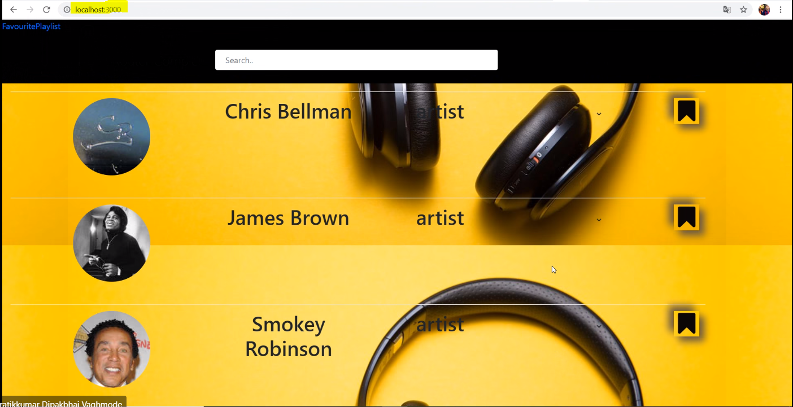
1) When you run our application , you’ll get the below home page.

2) In the below screenshot , we are searching a particular artist/song name ( here the search is dynamic where you get suggestions based the letters you type on the search bar. (Ex: Here we have searched ‘mj’ and it results the below).

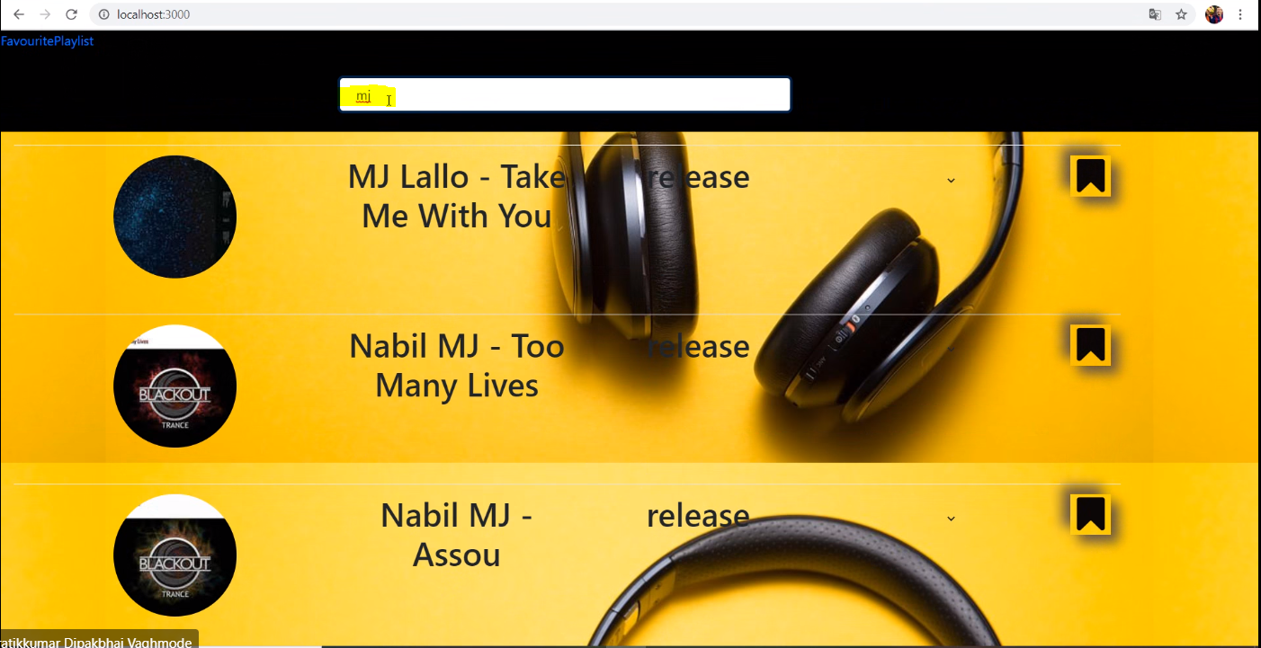

3) Once you get your desired list , you can save your favorite using the drop-down in order to segregate your wish list.

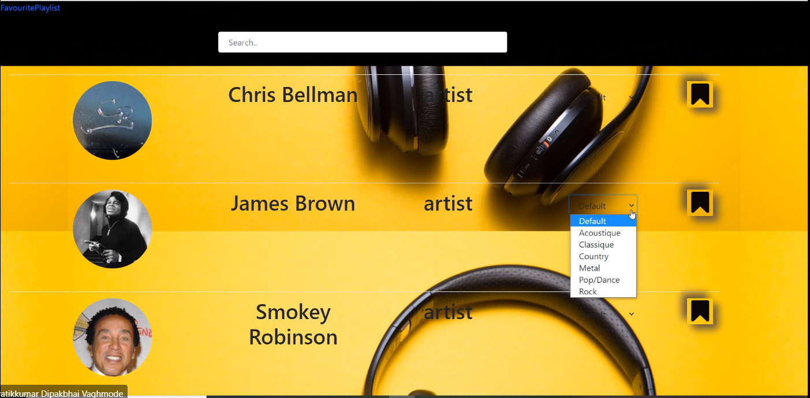

4) Once you have selected your category , you hit the save icon , in order to save it. And it gets saved.

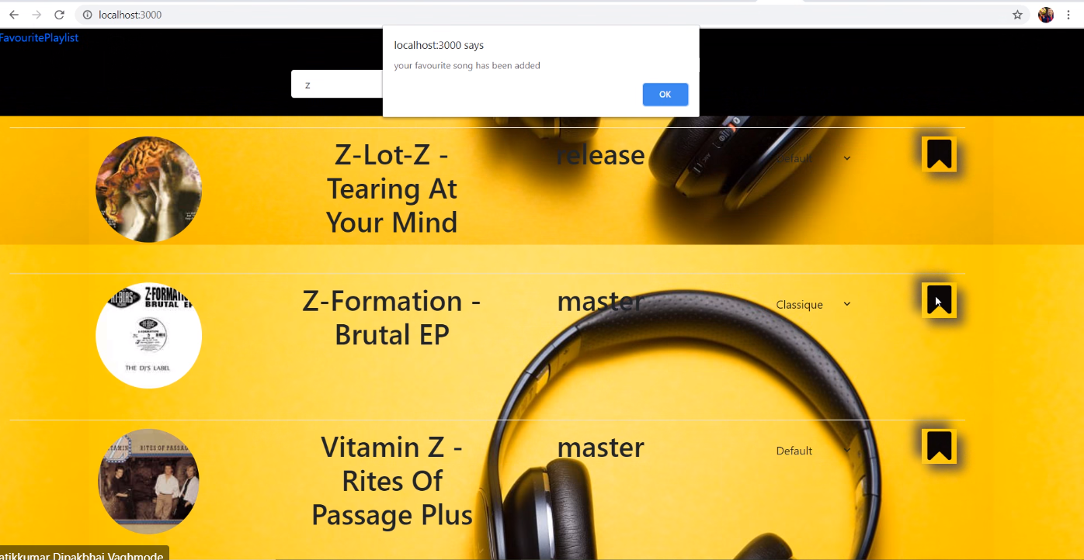

5) To view the favorite list , please click on the favorite list link which is present on the left top corner.
Once you click on it , you will be catered with the list of saved items, .
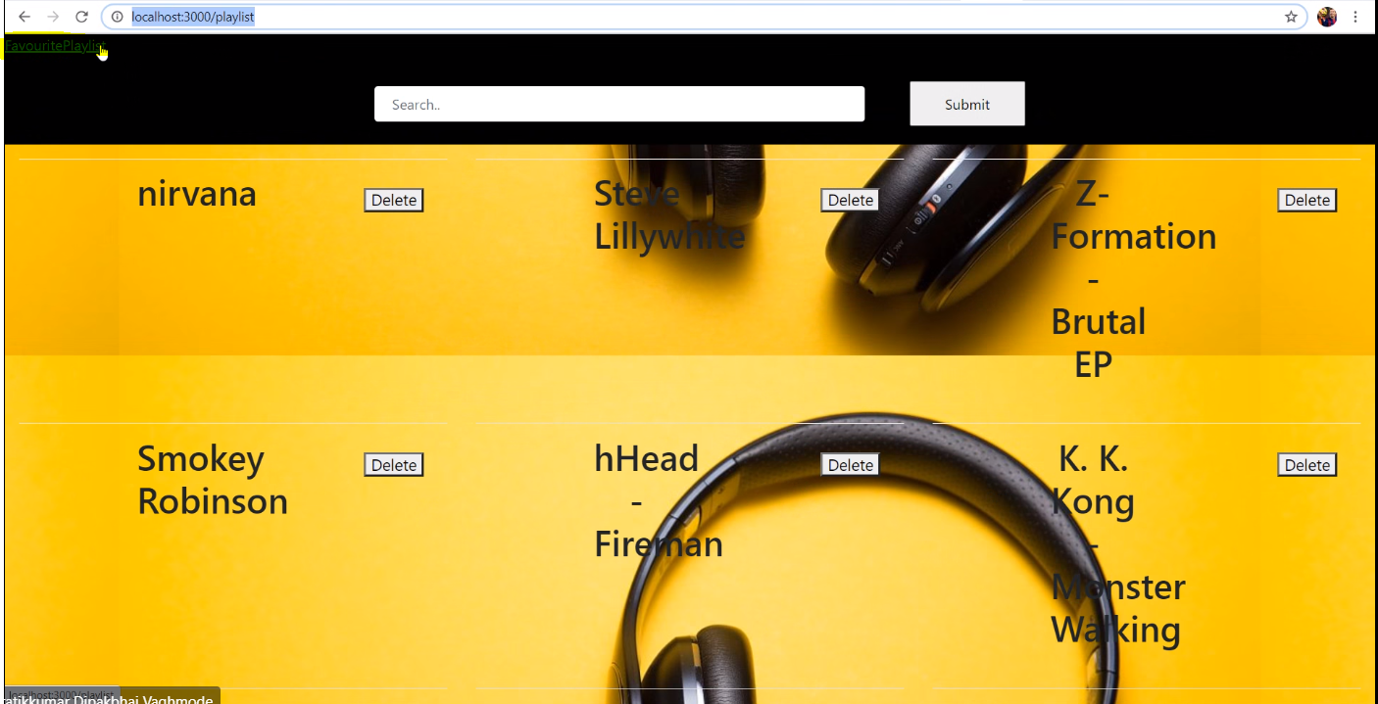

6) And if you wish to delete the saved track , you can do it by hitting the Delete button .

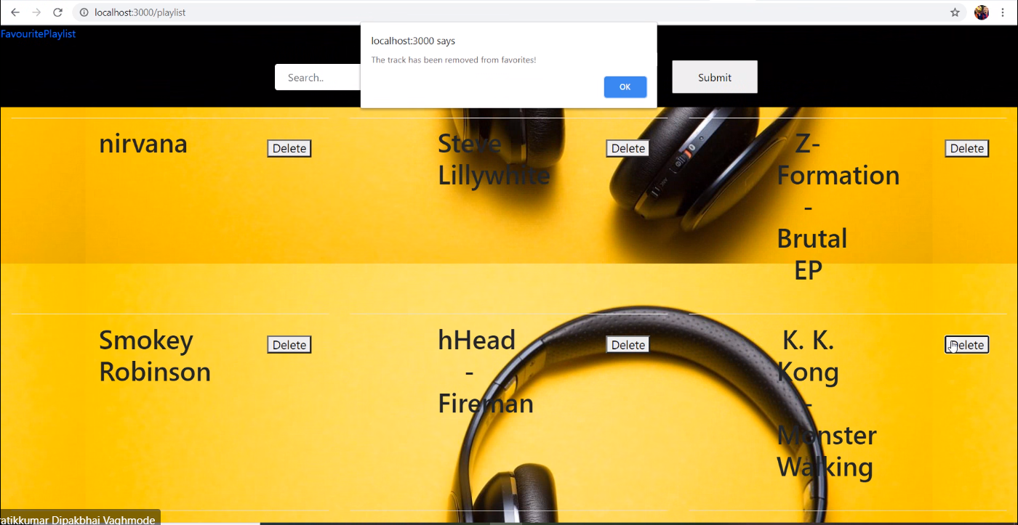

Database: Here we have used “MySql” .
→Firstly, please install the “MySql” driver using ‘npm install mysql’ command.
→ For the database connection , we have used the following:

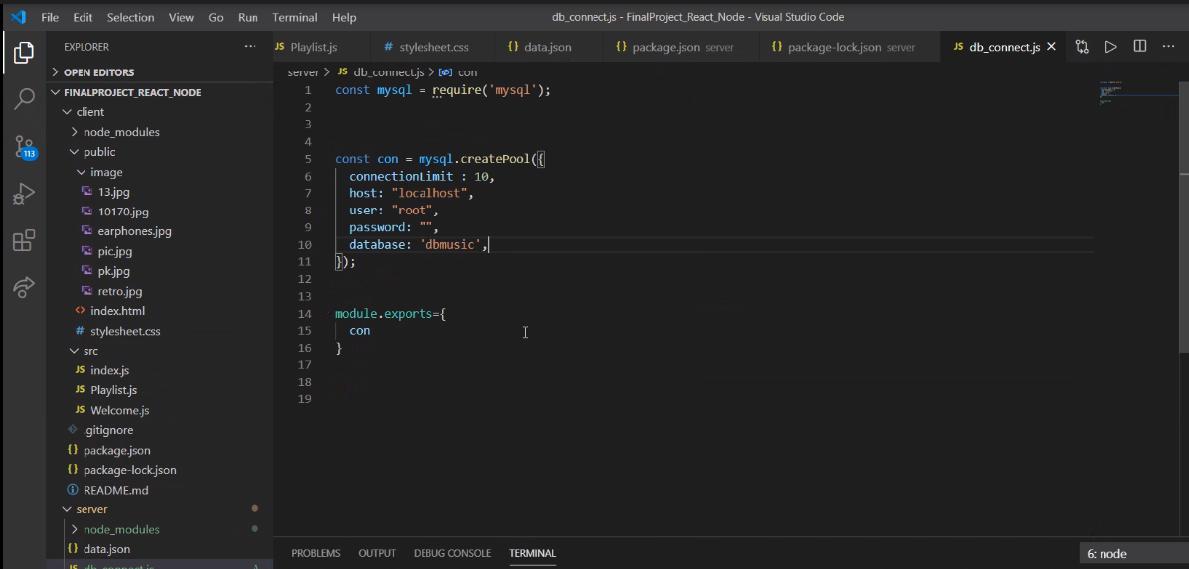
→ Please set your workbench details as per your system.
→Note: Here we changed the column name ‘title’ of the playlist table to ‘type’

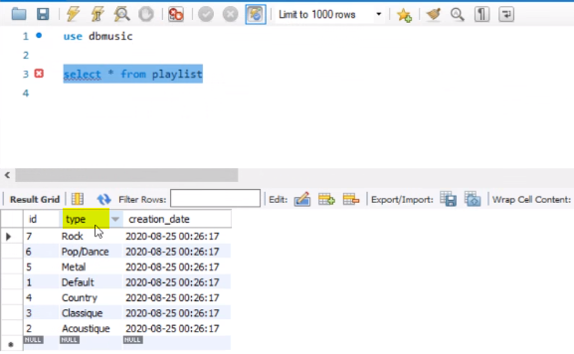

→ And the ‘track’ table is as follows:
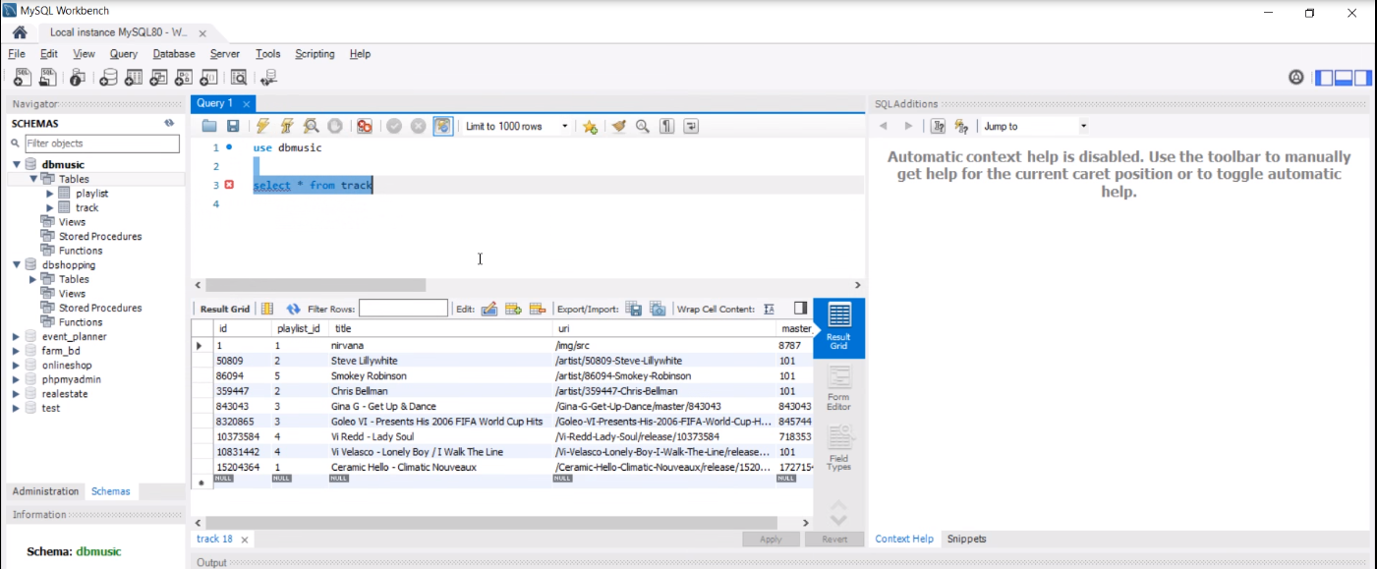

Distribution Of Work :

Client: Anu Charley, Mahidhar.
Server: Pratik Vaghmode, Vinay Dhanush.
Database:Pratik Vaghmode, Vinay Dhanush.
Design:Anu Charley, Mahidhar.
Documentation: Pratik, Vinay.

