TEAM PHOENIX
PROJECT DOCUMENTATION
Multi-Mode Smart Robotic Car
Line Following • Obstacle / Wall Avoidance • Manual Control
Built on ESP32
Team Members
Aayush Dhakal
Anukul Dhakal
Deepa Sharma
Kapil Paudel
Barsha Bhandari
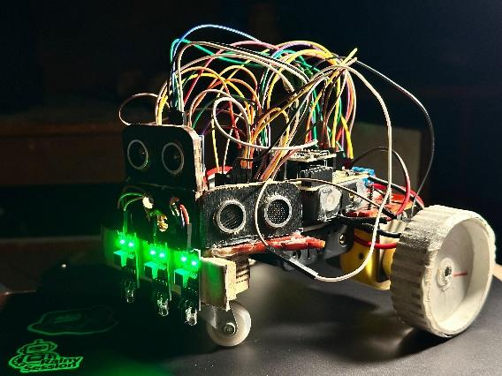
Date: 2082-03-19
DECLARATION
This is to certify that the project documentation entitled ‘Multi-Mode Smart Robotic Car,’ presented by Team Phoenix, is our own original work, carried out under the mentorship of Swarnim Ranabhat, Robotics Club. We further declare that this report has not been submitted elsewhere, in part or in full, for any academic qualification, degree, or competition prior to this.
Submitted by:
Signature: _______________________ Aayush Dhakal
Signature: _______________________ Anukul Dhakal
Signature: _______________________ Deepa Sharma
Signature: _______________________ Kapil Paudel
Signature: _______________________ Barsha Bhandari

ACKNOWLEDGEMENT
We would like to express our sincere gratitude to our mentor, Swarnim Ranabhat, for his continuous guidance, valuable feedback, and unwavering support throughout the development of this project. His technical insight and encouragement were instrumental in helping us bring this robotic car from concept to completion.
We are also thankful to the Robotics Club for providing us with the platform, resources, and opportunity to design, build, and test this project. The exposure gained through this experience has been invaluable in strengthening our practical understanding of embedded systems and robotics.
Finally, we extend our heartfelt appreciation to our families and friends for their constant encouragement and patience throughout the duration of this project.

ABSTRACT
This project presents the design and implementation of a multi-mode smart robotic car developed by Team Phoenix. The robot integrates three operating modes within a single hardware platform: autonomous line following, autonomous obstacle/wall avoidance, and manual (remote) control. The system is built around an ESP32 microcontroller, which reads input from three IR sensors and three ultrasonic sensors, and drives the wheels through a motor driver module. Power management is handled by a buck converter, which regulates the battery voltage down to a stable supply for the control electronics. The result is a compact, low-cost, multi-functional robotic platform suitable for demonstration, learning, and further development in robotics and embedded systems.

TABLE OF CONTENTS

Table of Contents
Here is the clean and correctly formatted Table of Contents matching the project documentation structure provided:
Preliminary Pages
- i. Declaration ............................................................................................................ i
- ii. Acknowledgement ............................................................................................. ii
- iii. Abstract ................................................................................................................. iii
Main Chapters
- Abstract ................................................................................................................. 1
- Introduction ............................................................................................................ 2
- Objectives ................................................................................................................ 3
- System Overview ..................................................................................................... 4
- Components Used ................................................................................................... 5
  - 5.1 ESP32 Development Board ......................................................................... 5
  - 5.2 Motor Driver Module (e.g., L298N) ........................................................... 5
  - 5.3 IR Sensors ($×3$) — Line Following ......................................................... 5
  - 5.4 Ultrasonic Sensors ($×3$) — Obstacle/Wall Avoidance ........................... 5
  - 5.5 Buck Converter ........................................................................................... 5
  - 5.6 Supporting Components ............................................................................. 5
- Circuit Diagram ....................................................................................................... 6
  - 6.1 Pin Connection Summary ........................................................................... 6
- Working Principle .................................................................................................. 7
  - 7.1 Mode Selection ............................................................................................ 7
  - 7.2 Manual Control Mode ................................................................................. 7
  - 7.3 Line Following (Auto Mode) ........................................................................ 7
  - 7.4 Wall / Obstacle Avoidance ......................................................................... 7
- Software / Program Code ..................................................................................... 8
- Applications ............................................................................................................ 9
- Advantages and Limitations ................................................................................... 10
- Future Enhancements ............................................................................................. 11
- Conclusion ............................................................................................................. 12
- References .............................................................................................................. 13

2. Introduction
Robotic cars that combine multiple modes of operation are widely used to demonstrate core concepts in embedded systems, sensor fusion, and control logic. This project was undertaken by Team Phoenix to design a single robotic platform capable of switching between three distinct behaviors:
- Line Following Mode — the robot autonomously follows a marked path (typically a black line on a white surface, or vice versa) using IR sensors.
- Wall/Obstacle Avoidance Mode — the robot autonomously detects obstacles in its path using ultrasonic sensors and manoeuvres around them.
- Manual Control Mode — the robot can be driven manually by a user through the ESP32's onboard WiFi connectivity.
The ESP32 was chosen as the central controller because of its processing power, multiple GPIO pins, and built-in WiFi/Bluetooth capability, which makes it well suited to handle multiple sensor inputs while also supporting a remote-control interface.

3. Objectives
- To design a single robotic car capable of operating in three distinct, selectable modes.
- To implement autonomous line-following logic using an array of three IR sensors.
- To implement autonomous obstacle detection and avoidance using three ultrasonic sensors placed to cover front and side directions.
- To enable manual driving of the robot through wireless control via the ESP32.
- To design a stable and safe power supply system using a buck converter.
- To document the hardware design, working principle, and software logic for future reference and improvement.

4.System Overview
The diagram below shows how the major subsystems connect: three 18650 Li-ion cells power the L298N motor driver directly and, through the buck converter, provide a regulated supply to the ESP32 and all sensors. The ESP32 reads the IR and ultrasonic sensors and, based on the active mode (Manual or Auto), sends control signals to the motor driver, which drives the two DC motors. The full wiring layout is shown in Section 6 (Circuit Diagram).

5. Components Used
The table below summarizes all hardware components used in this project. Detailed explanations of each component follow in the subsections below.
Component | Qty | Purpose in this Project
ESP32 Development Board | 1 | Main microcontroller — processes sensor data and controls motors
L298N / Motor Driver Module | 1 | Drives the DC gear motors using signals from the ESP32
IR (Infrared) Sensor Module | 3 | Detects the black/white line for line-following mode
Ultrasonic Sensor (HC-SR04) | 3 | Measures distance to obstacles for wall/obstacle avoidance
Buck Converter (Step-down) | 1 | Steps down battery voltage to a safe, regulated supply for ESP32/sensors
DC Gear Motors | 2 or 4 | Provide motion to the chassis wheels
Robot Chassis + Wheels | 1 set | Mechanical frame that houses all components
Rechargeable Battery Pack (Li-ion / Li-Po) | 1 | Main power source for motors and electronics
Jumper Wires / Connectors | As required | Electrical connections between modules

5.1 ESP32 Development Board
The ESP32 is a low-cost, low-power system-on-chip microcontroller with integrated WiFi and Bluetooth. It serves as the "brain" of the robot in this project. It reads digital/analog signals from the IR and ultrasonic sensors, runs the decision-making logic for all three modes, and sends PWM/digital control signals to the motor driver. Its built-in WiFi is used to host or connect to a control interface for the manual driving mode, removing the need for a separate wireless module.
- Dual-core processors suitable for handling multiple sensors in real time

Multiple GPIO pins for interfacing sensors and the motor driver
- Built-in WiFi for manual/remote control
- Operates at 3.3V logic level
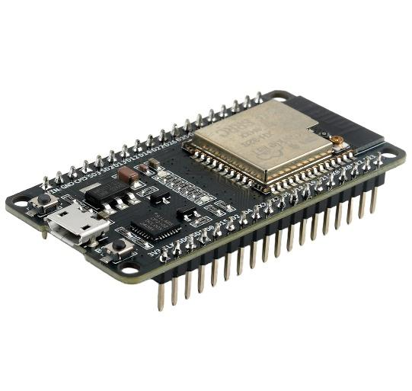

5.2 Motor Driver Module (e.g. L298N)
A motor driver module acts as an interface between the low-power ESP32 outputs and the high-current DC motors. The ESP32 cannot drive motors directly since its GPIO pins can only supply a small current. The motor driver takes low-power control signals from the ESP32 and switches the higher-voltage/current supply needed to run the motors, and also allows the direction of each motor to be reversed (forward/reverse/turning).
- Controls speed via PWM signals from the ESP32
- Controls direction (forward, reverse, left turn, right turn)
- Protects the microcontroller from motor back-EMF and high current draw
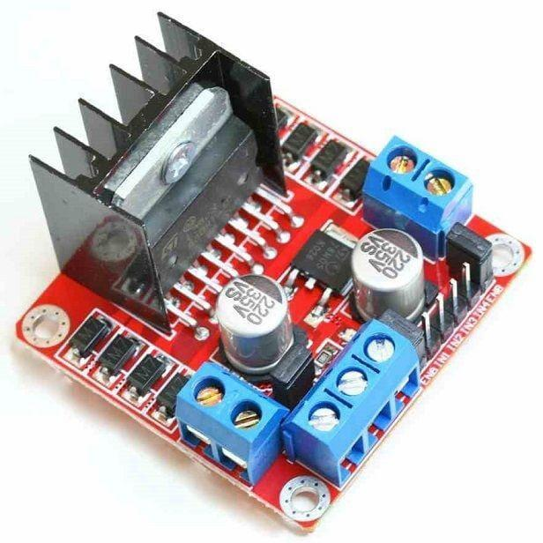

5.3 IR Sensors (×3) — Line Following
Three infrared (IR) sensors are mounted on the underside of the chassis, typically arranged as left, center, and right. Each IR sensor emits infrared light and measures the reflection: a light surface reflects more IR light back, while a dark surface (the line) absorbs it. By comparing the output of the three sensors, the ESP32 determines whether the robot is centered on the line, or drifting left/right, and adjusts motor speed/direction accordingly to stay on track.
- Left sensor: detects drift to the left of the line
- Center sensor: confirms the robot is aligned on the line
- Right sensor: detects drift to the right of the line

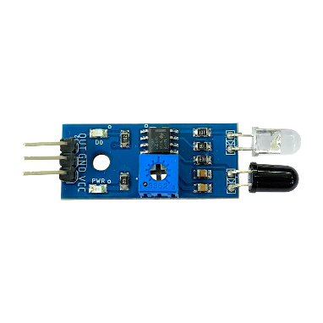

5.4 Ultrasonic Sensors (×3) — Obstacle/Wall Avoidance
Three ultrasonic sensors (such as the HC-SR04) are mounted around the robot — commonly front, left, and right — to give it awareness of obstacles in multiple directions. Each sensor works by emitting a high-frequency sound pulse and measuring the time taken for the echo to return after bouncing off an object. This time is converted into a distance value. The ESP32 uses these distance readings from all three sensors to decide whether to continue straight, or steer away from a wall/obstacle detected on either side or ahead.
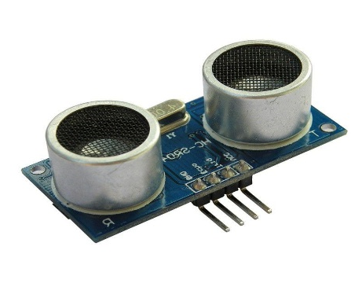

- Front sensor: detects obstacles directly ahead
- Left sensor: detects walls/obstacles on the left side
- Right sensor: detects walls/obstacles on the right side

5.5 Buck Converter
The buck converter is a step-down DC-DC voltage regulator. The battery pack used in the robot typically supplies a higher voltage than the ESP32 and sensors can safely handle. The buck converter steps this voltage down to a stable, regulated output (commonly 5V), protecting the electronics from over-voltage while still allowing the motors to be powered from the higher raw battery voltage. This ensures reliable operation of the microcontroller and sensors even as battery voltage fluctuates under motor load.
- Protects sensitive electronics (ESP32, sensors) from battery voltage variation
- Improves overall power efficiency compared to a linear regulator
- Allows a single battery pack to power both motors and control electronics safely
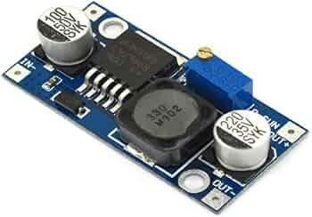

5.6 Supporting Components
- DC Gear Motors — convert electrical energy into rotational motion to drive the wheels
- Chassis and Wheels — the mechanical structure that houses and mounts all components
- Battery Pack (3 × 18650 Li-ion cells) — primary power source for the entire system
- Jumper Wires / Connectors — used for all electrical interconnections between modules

6. Circuit Diagram
The circuit diagram below shows the complete wiring between the ESP32, L298N motor driver, three IR sensors, three ultrasonic sensors, buck converter, the 18650 battery pack, and the two DC motors.
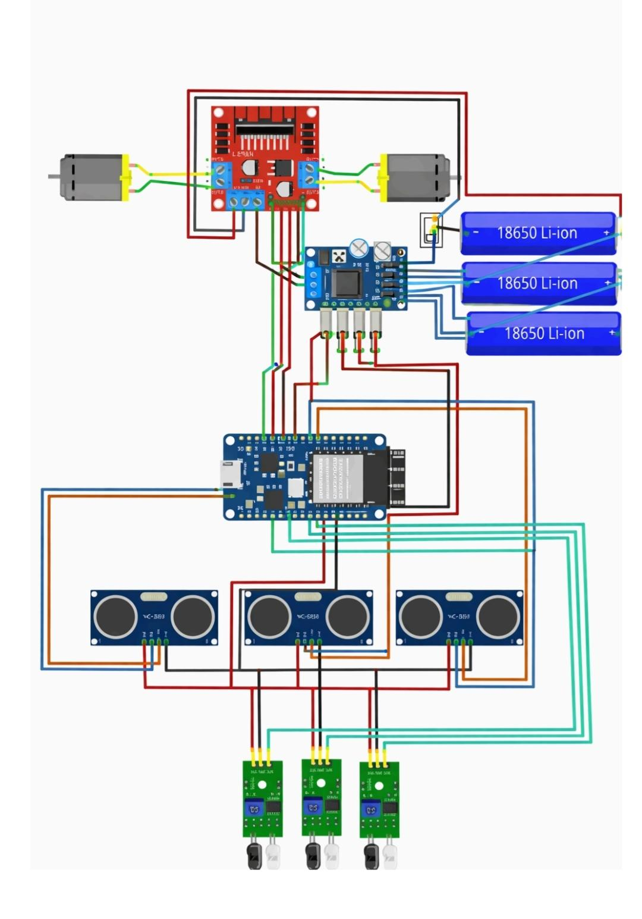

6.1

6.1.Pin Connection Summary
The table below lists the exact ESP32 GPIO connections used in the firmware.
Connection | ESP32 Pin
Motor Driver — ENA (Left PWM) | GPIO 14
Motor Driver — IN1 (Left Fwd) | GPIO 27
Motor Driver — IN2 (Left Back) | GPIO 26
Motor Driver — ENB (Right PWM) | GPIO 25
Motor Driver — IN3 (Right Fwd) | GPIO 33
Motor Driver — IN4 (Right Back) | GPIO 32
IR Sensor — Left | GPIO 36
IR Sensor — Middle | GPIO 35
IR Sensor — Right | GPIO 34
Ultrasonic — Left (TRIG / ECHO) | GPIO 18 / GPIO 2
Ultrasonic — Center (TRIG / ECHO) | GPIO 16 / GPIO 17
Ultrasonic — Right (TRIG / ECHO) | GPIO 5 / GPIO 15
L298N GND | ESP32 GND (shared with battery GND)
L298N 12V / VCC | Battery +

7. Working Principle

7.1 Mode Selection
The ESP32 starts up in MANUAL mode and hosts its own WiFi access point (SSID: "A1"). A phone or laptop connects to this network and opens the car's built-in web page, which contains a Mode button, a D-pad (forward / back / left / right), a STOP button, and a speed slider. Tapping the Mode button sends a request to the ESP32 (/mode?state=1 or 0) which flips an internal autoMode flag between MANUAL and AUTO — the motors are stopped immediately on every mode change as a safety measure.

7.2 Manual Control Mode
While autoMode is false, every button press/release on the web page sends the full set of currently-held direction keys to the ESP32 (/cmd?keys=...). The firmware converts this into a command bitmask and drives each wheel independently through the motor driver: pressing only Forward/Back drives both wheels together, while Left/Right applies a turn bias (or a gentle pivot if no forward/back key is held). Releasing all keys stops the motors immediately, and the page also auto-releases all keys if the browser tab loses focus, as a safety fallback. The speed slider adjusts the base motor speed in real time.

7.3 Line Following (Auto Mode)
While autoMode is true, the ESP32 continuously reads the three IR sensors and converts each reading to a 0/1 value against a threshold. The combination of the three readings decides the movement:
- Only the middle sensor sees the line → move forward
- Right sensor (or right+middle) sees the line → sharp right turn
- Left sensor (or left+middle) sees the line → sharp left turn
- All three sensors see the line → treated as an obstacle/junction cue and hands off to the ultrasonic routine (ultra())
- All three sensors are off the line → the car checks the left and right ultrasonic distances (see 7.4) before deciding to reverse

7.4 Wall / Obstacle Avoidance
When all three IR sensors read "off the line", the firmware checks whether both the left and right ultrasonic sensors read less than 30 cm. If so, it concludes the car has entered a walled corridor and locks into a dedicated wallFollowLoop(): from this point on it ignores the IR sensors completely and steers purely from the front/left/right ultrasonic distances — steering sharply away from a close obstacle ahead, or gently toward the side with more open space, using the ultra() routine. This lock-in loop keeps servicing the WiFi server on every cycle, so a mode-switch command from the phone is still received instantly and safely stops the motors. If the left/right distances are not both under the threshold in the all-black condition, the car simply reverses (Back()) instead of entering wall-follow mode.

8. Software / Program Code
The complete ESP32 firmware (file: ESP32_Car_Manual_Auto_WallFollow.ino) implements both control modes described above. Its structure is summarized below; the full source file is provided as a separate attachment alongside this document.
- Libraries used: WiFi.h, WebServer.h, NewPing.h (for ultrasonic ranging)
- setup(): configures motor pins and PWM channels, sets IR pins as input, starts the WiFi access point, and registers the web server routes (/, /cmd, /speed, /mode)
- loop(): services incoming WiFi requests every cycle, and calls runAutoMode() only when AUTO mode is active
- applyMotors(): translates the manual D-pad key bitmask into left/right motor speed and direction
- runAutoMode(): reads the three IR sensors and drives the line-following / wall-entry logic described in 7.3–7.4
- ultra(): reads all three ultrasonic sensors and drives sharp/slight turn or forward motion based on relative distances
- wallFollowLoop(): the locked-in ultrasonic-only navigation loop, exits the instant the phone switches back to MANUAL
- htmlPage: the self-contained web interface (HTML/CSS/JS) served directly from the ESP32 to the controlling phone/browser

9. Applications
- Educational demonstration of embedded systems and robotics concepts
- Prototype platform for autonomous navigation research
- Base platform for warehouse or indoor delivery robot concepts
- Foundation for further development into fully autonomous vehicles

10. Advantages and Limitations

Advantages
- Combines three functionalities in a single low-cost platform
- Modular design allows individual subsystems to be improved independently
- ESP32's built-in WiFi removes the need for an extra wireless module

Limitations
- IR sensors are sensitive to ambient lighting conditions
- Ultrasonic sensors have blind spots and limited angular coverage with only three units
- Manual control depends on WiFi range and network stability

11. Future Enhancements
- Add more ultrasonic sensors or a servo-mounted sensor for 180°/360° obstacle scanning
- Implement PID control for smoother line following
- Add a mobile app with live camera feed for manual control
- Integrate SLAM or mapping for more advanced autonomous navigation

12. Conclusion
Team Phoenix successfully designed a multi-mode robotic car integrating line-following, obstacle-avoidance, and manual-control capabilities on a single ESP32-based platform. The project demonstrates practical application of embedded systems, sensor interfacing, and motor control, and provides a solid foundation for further robotics development.

13. References
- ESP32 official documentation
- Motor driver module datasheet
- HC-SR04 ultrasonic sensor datasheet
- IR sensor module datasheet

