Step1 : Certificate Creation:
- Go/pki or PKI Operations - OpenSSL CSR generation (novartis.net)
- Create CSR with bash
openssl req -out "hostname.csr" -newkey rsa:2048 -nodes -sha256 -keyout "hostname.key"
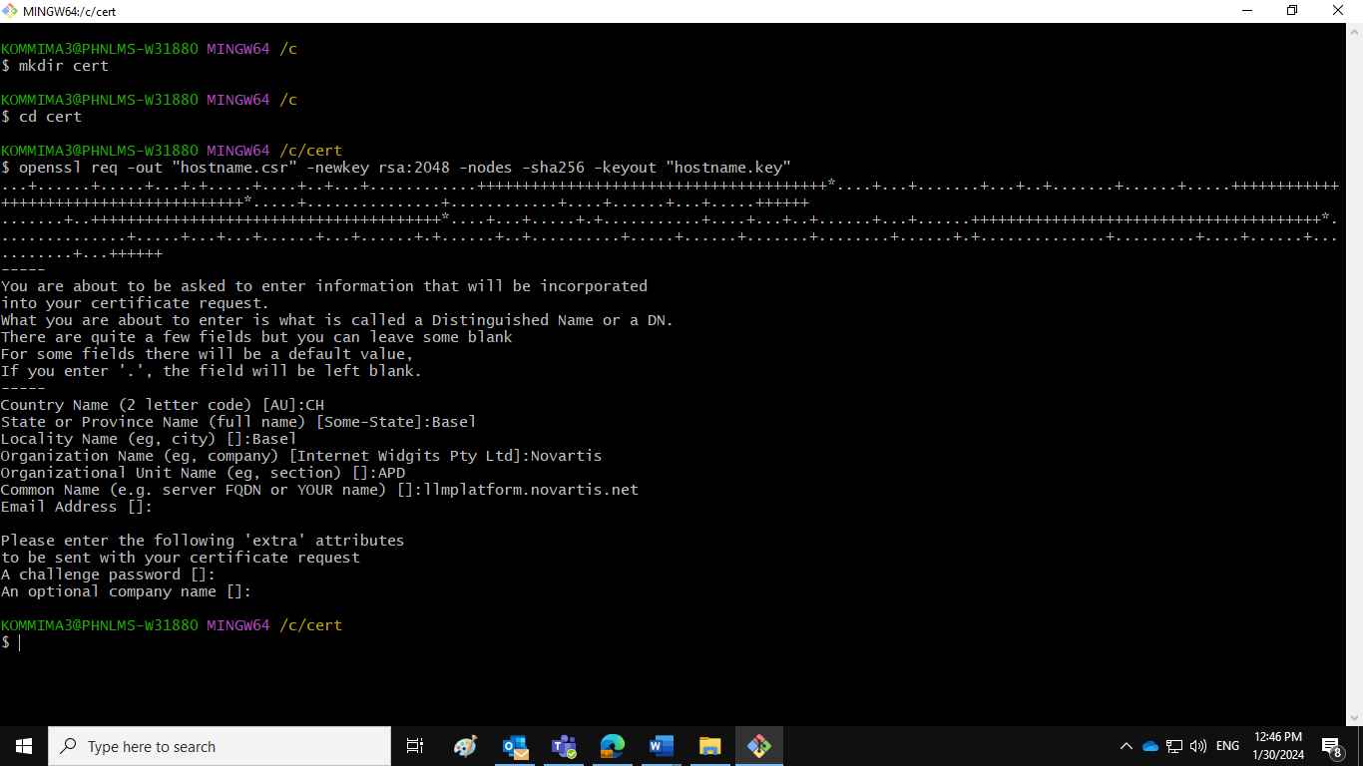

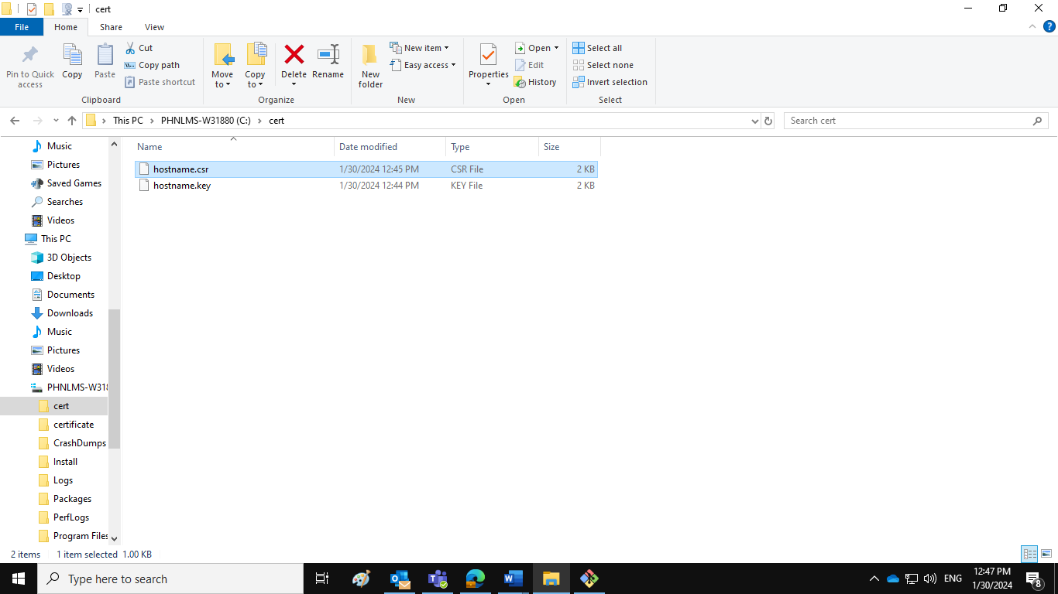

Step3: Request for the Registration Authority Certificate

- PKI Operations - Web Server Certificates (novartis.net)
- Create Certificate request and download here - Registration Authority - Request Certificate (novartis.net)

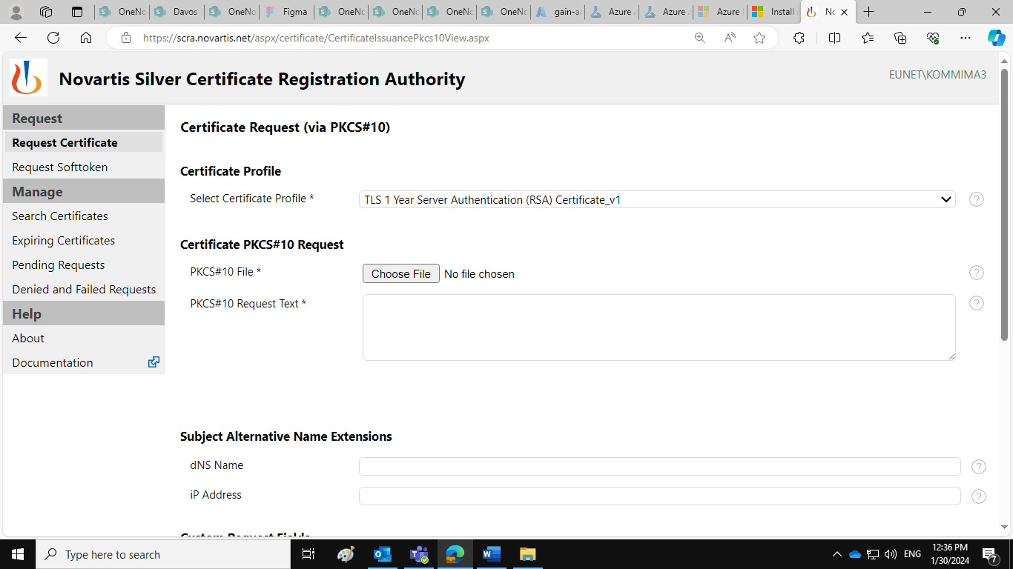
Choose the .csr file which we created:
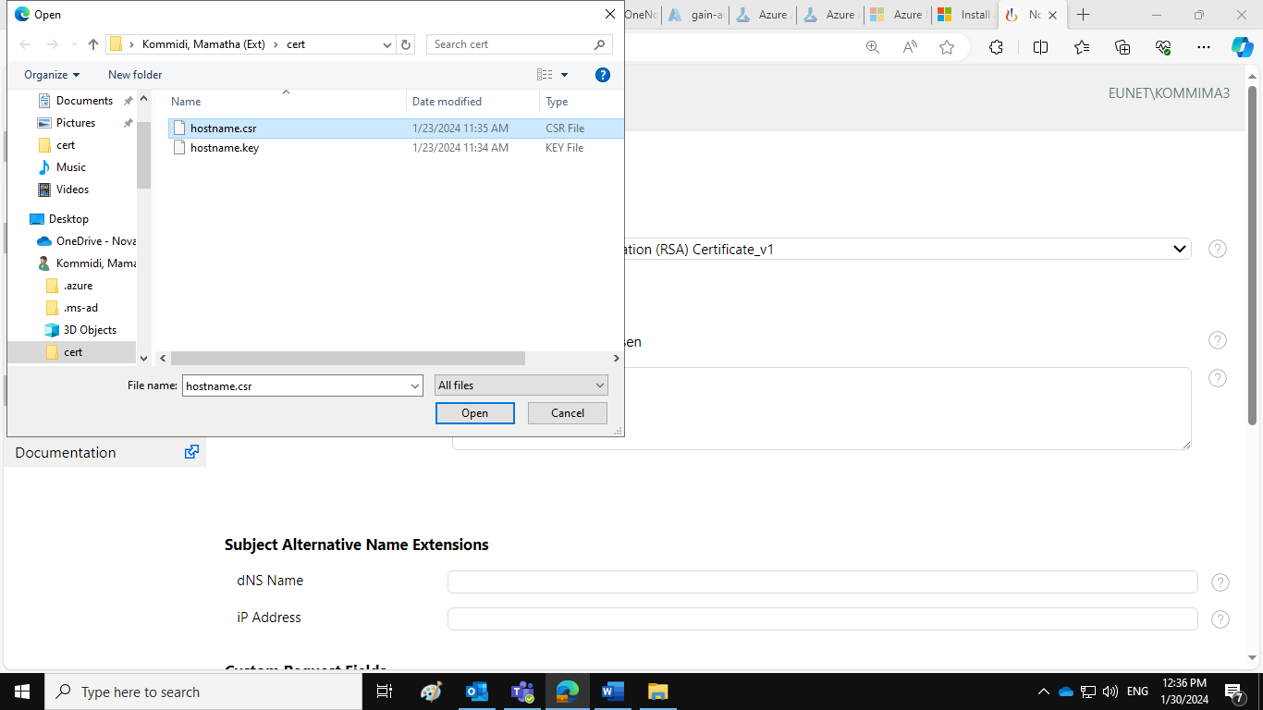
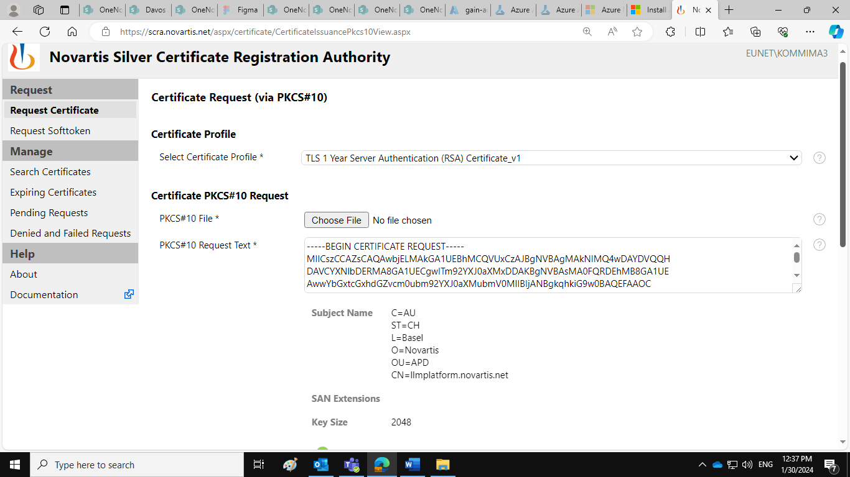
Provide required fileds as DL and Application ID and Request for the certificate.
s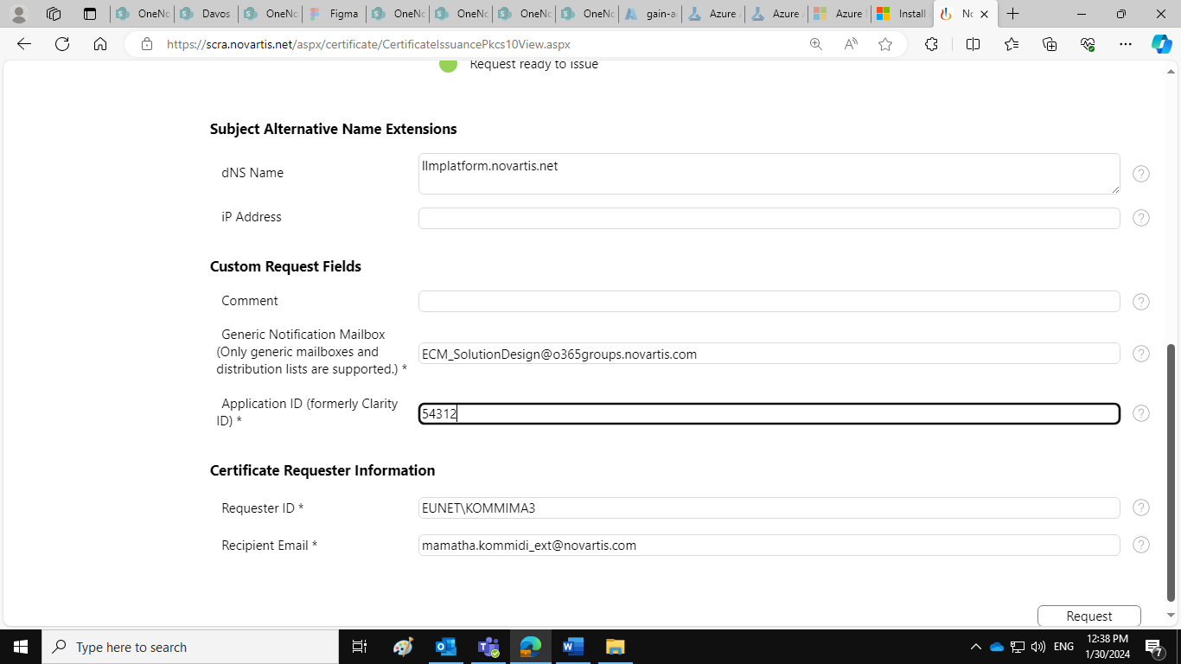
Download the certificate in required format like .cert, .pem
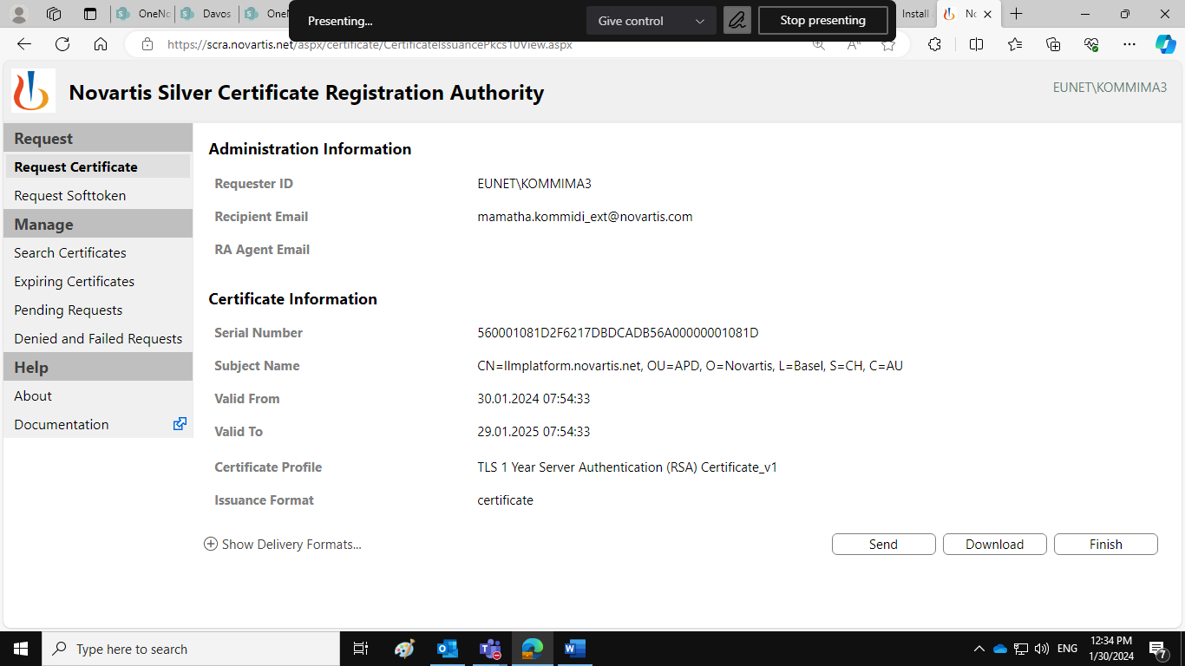
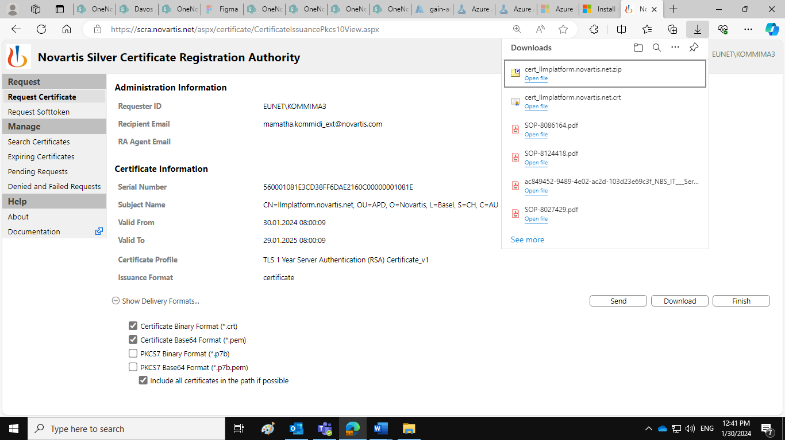
Step4: Once you download the certificate, unzip the certificate, zip only .pem file from the unzipped folder, zip the file and send request to Azure AD for the certificate.

Step5: Create .pem file for Azure DevOps Service Connection:
Add .pem and .key file in single file and save as .pem file.
Add cert and key file in a single file and save as .pem file (if AD team uploaded crt file to AD)
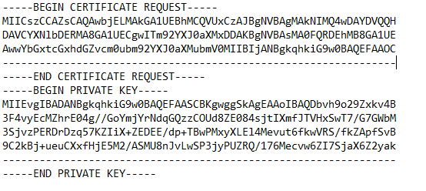
Create Azure DevOps Service Connection:
Once we receive the Client ID, Tenant ID details from Azure AD team,
Step6 :Go to Azure DevOps Project, Project settings
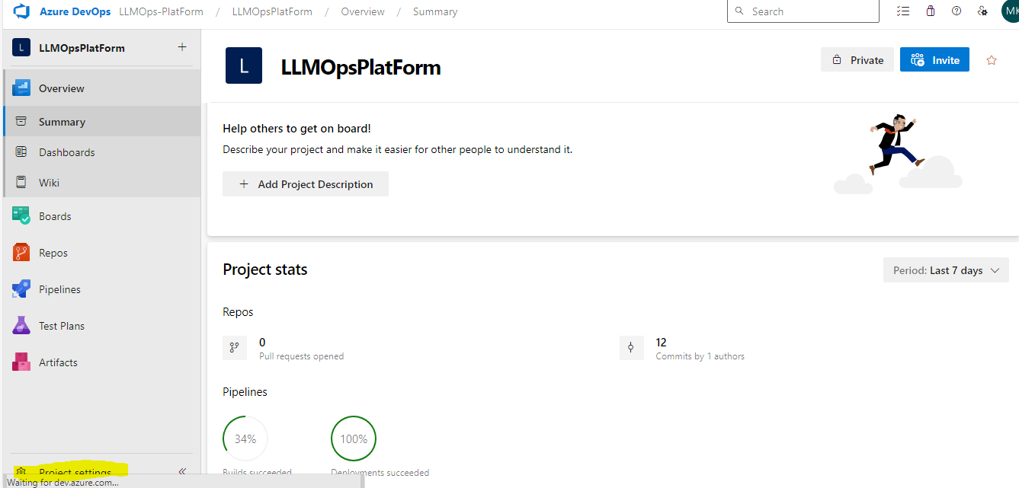

Step7: Go to Pipelines --> Service Connection --> New Service Connection
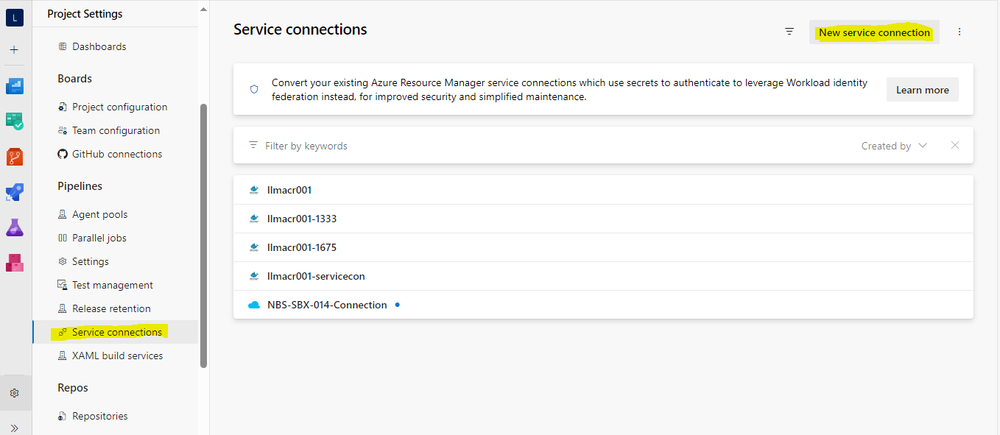
Step8: Select Azure Resource Manager:
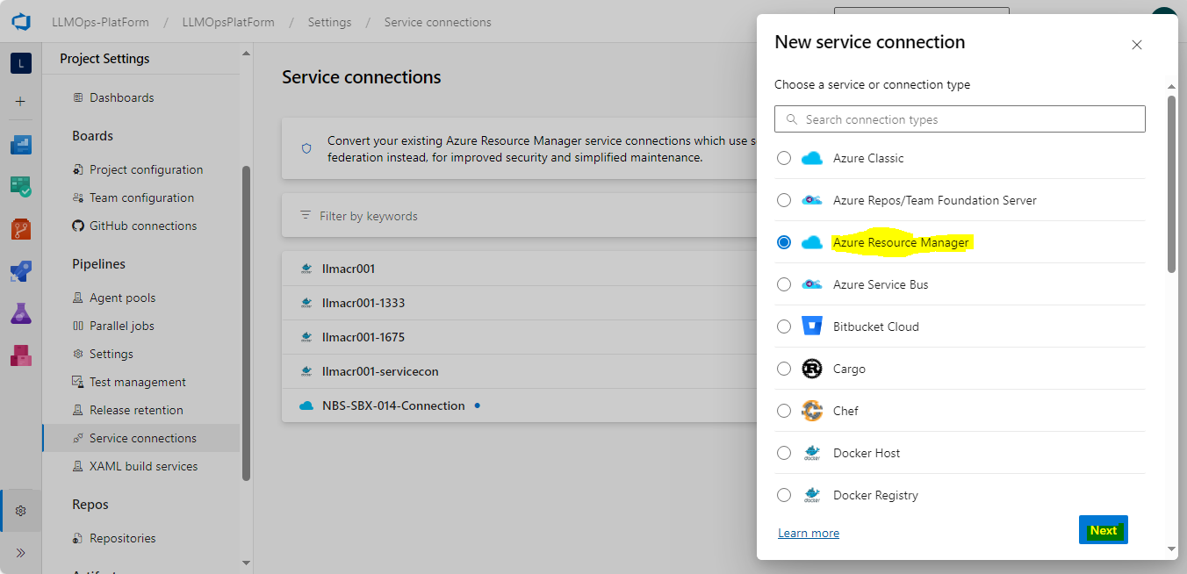
Step9: Select Service Principal Manual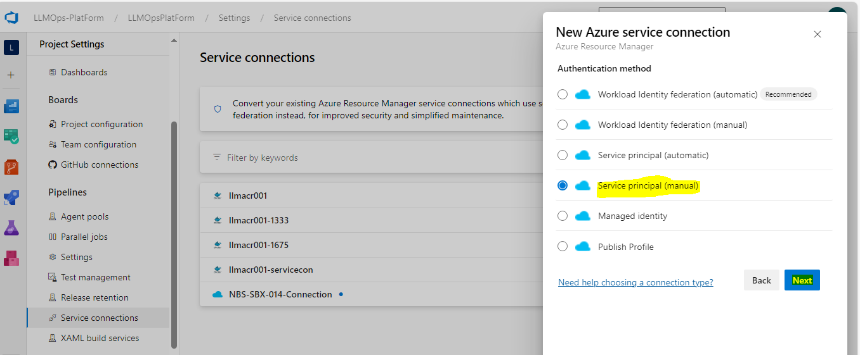
Step10: File all the required fields as Subscription ID, Name, Service Principal ID(Client ID)
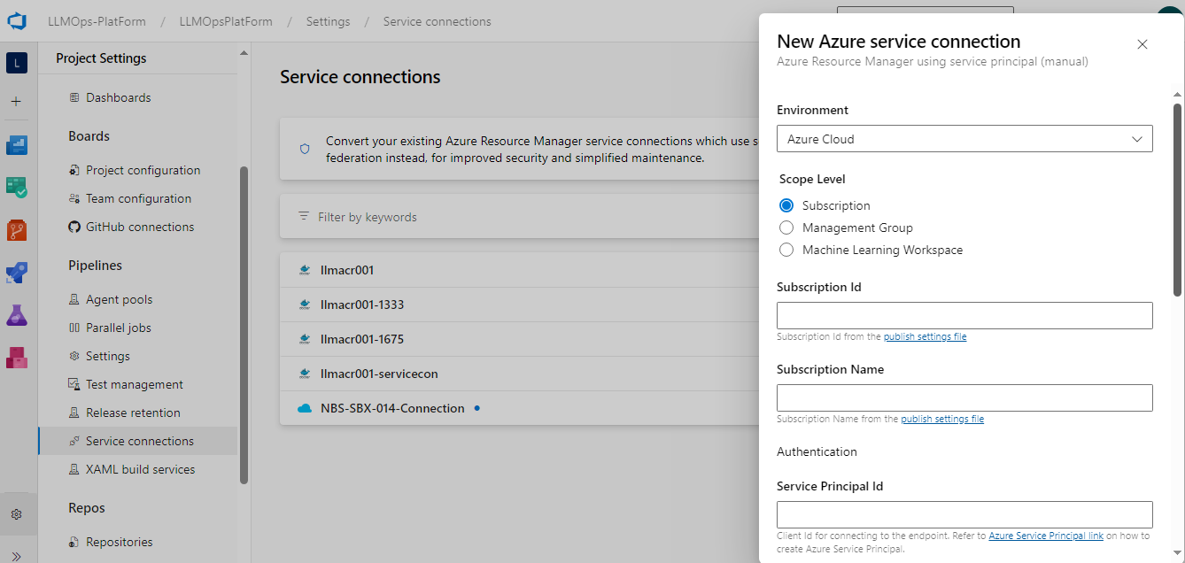
Step11: Credentials select Certificate and copy the .pem file content which we created in Step 5.