Wearable Solution for elderly Fall detection

**Purpose of the document:**

1. To let you understand how to use the product.

2. To let you use all the options supported in the product.

**Must needed components / software (Spent INR 3,000 for the components):**

1. We made the APP for Android at this point.

• Apk Name: fall_detection.apk to be installed in your phone.

• Size of the APK – 4.768 MB.

• Clear cache option provided to enable faster working.

2. The hardware components to be embedded in the glove.

• A pair of bands in which the hardware kit can be embedded (Stitched or pasted based on expert inputs)

• Kit for Right Hand Glove – ATTINY85 Microcontroller, Bluetooth module(HC-05), Gyro, Heart rate sensor, 9v Battery, Power Control Circuitry.

• Kit for Left Hand Glove - ATTINY85 Microcontroller, Bluetooth modules, Accelerometer, GPS Module, 9v Battery, Power Control Circuitry.

• Kit for Restroom Setup – Arduino Nano, IR sensors, Force Sensitive Resistors.

• The complete kit view is presented below in fig. 1.

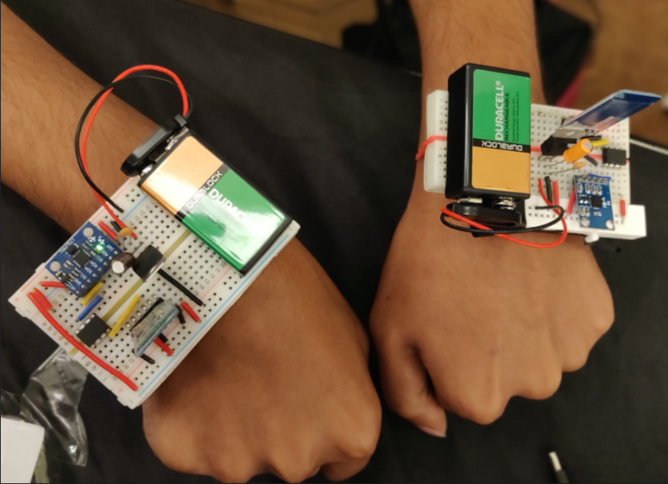

**Figure 1** Kit view as a wearable

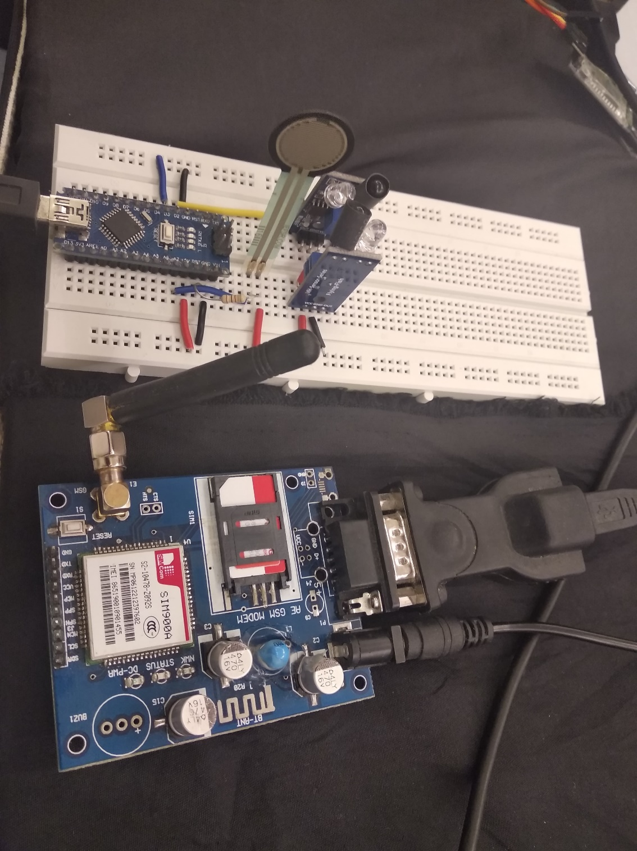

**Figure 2** System for detecting Inside Restroom fall

**Procedure to get Started:**

1. Install Arduino IDE and all dependent libraries in the computer.
2. Connect the circuitry as Indicated in Connections.txt and burn the Gyro_code in Right Glove and Accelerometer_Code in the Left glove Attiny85.
3. Also connect the restroom Setup as shown in Fig. 2 and burn the restroom code into that Arduino Nano.
4. Now Open Device Manager and make a note of all the COM ports of connected devices.
5. Change the COM port numbers accordingly in the Integrated_code.py and Run It.
6. Now you can see the data analytics and if a fall occurs a call is generated Immediately.
7. Install the Fall detection app in an Android Device and Open the App.
8. Enter your Account credentials as shown in Fig. 3
9. After successful Login, you can see the devices that are connected to your account as shown in Fig. 4
10. Enter into any of the device of your choice where you can see the previous fall data, heart rate analysis, nearby hospitals, route to the fall as shown in Fig. 5

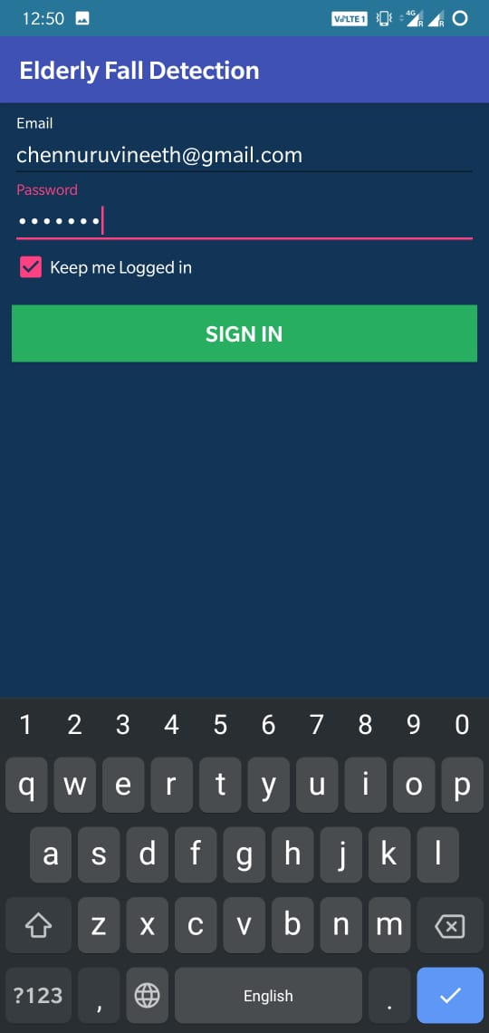

**Figure 3** Login Page for the user

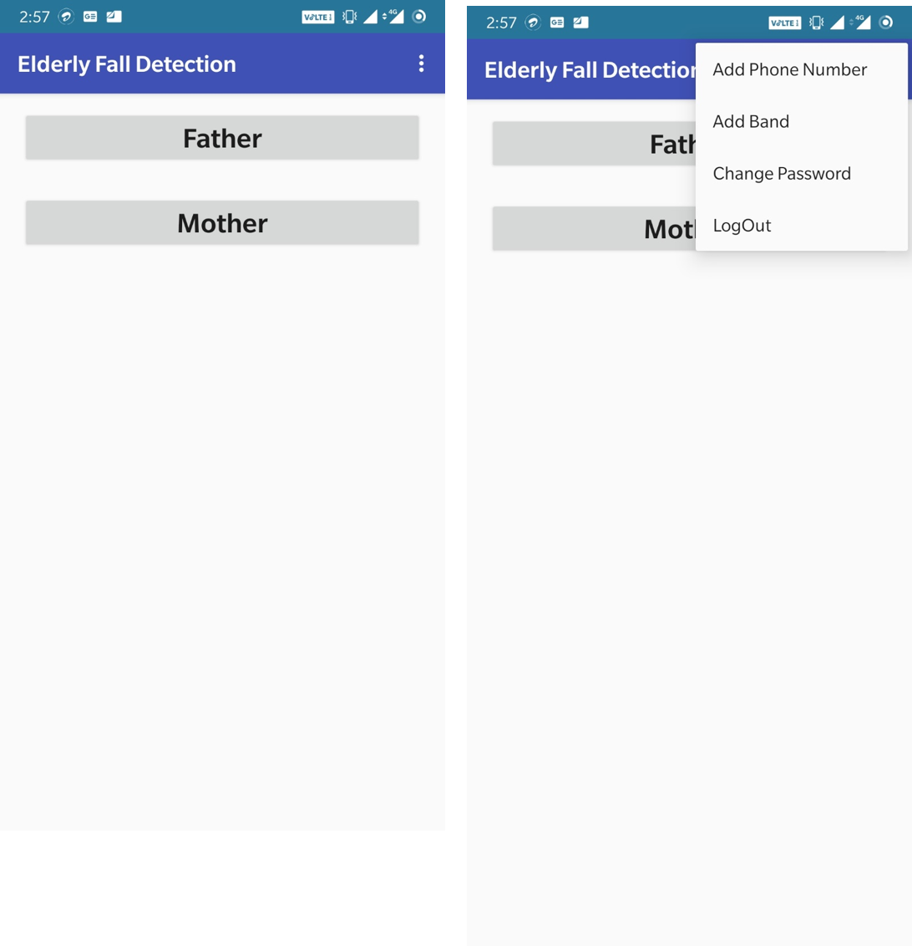

**Figure 4** Devices connected by the user login

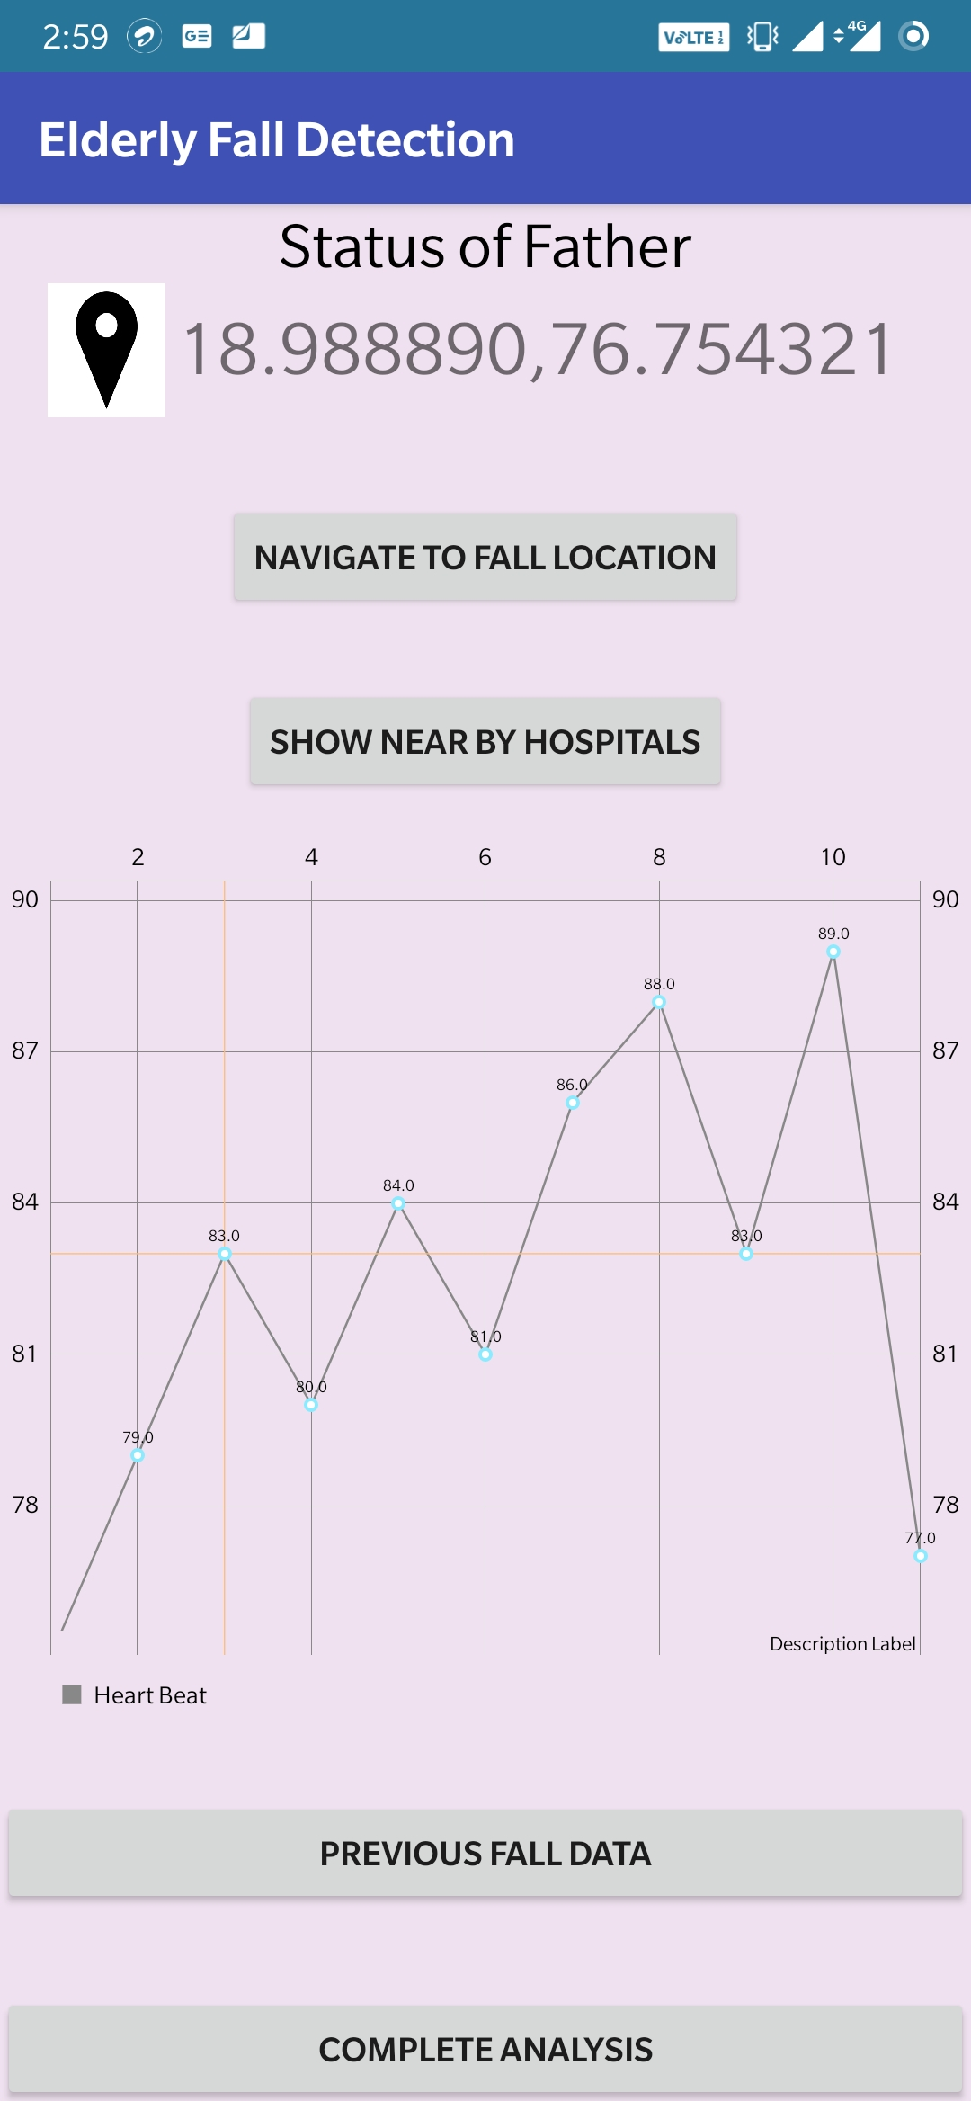

**Figure 5** Selection of different features in the App (Including HeartRate)

**Data Analytics:**

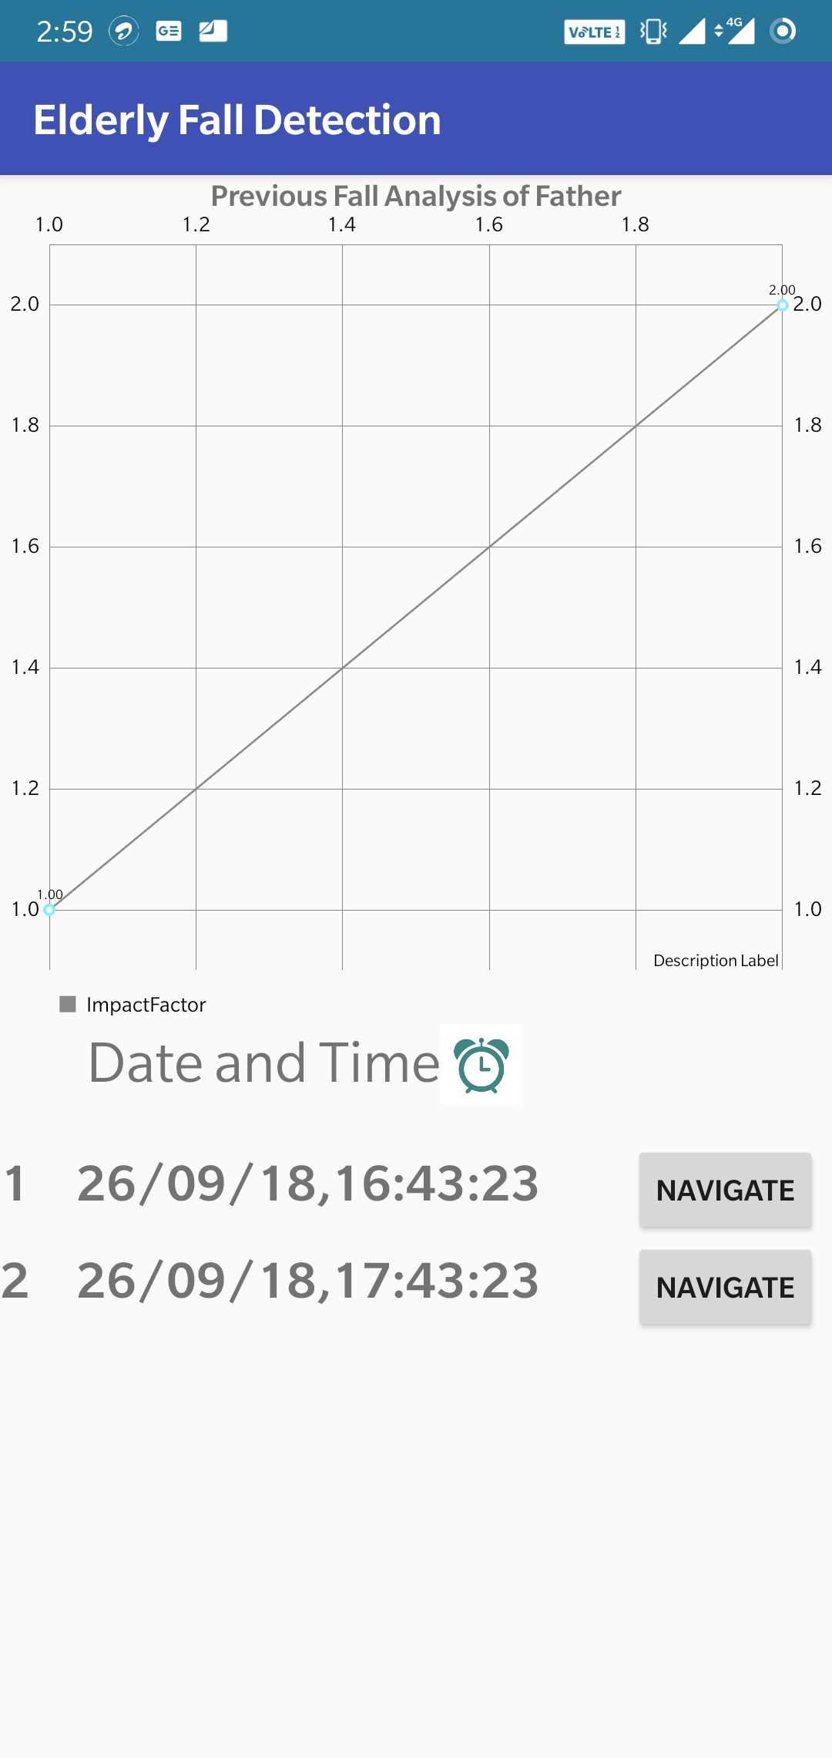

**Figure 6** Fall analysis of the Father

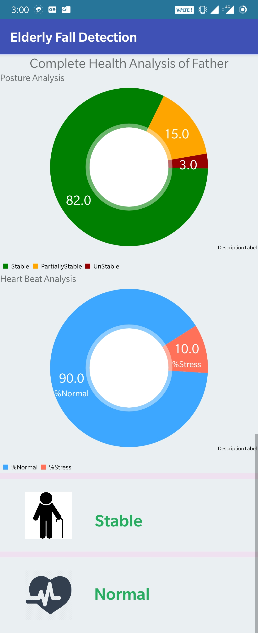

**Figure 7** Complete Analysis of the Father