|  |  |  |  |  |  |  |  |
| --- | --- | --- | --- | --- | --- | --- | --- |
| |  | | --- | |  | | C++ project  gAME sTORE Class 12 C++ final project Final project of C++ for class 12. It uses all the concepts taught throughout the year. | |  | |  | |  | | --- | |  | | Ashwin Vaidya 12 A  6 | |

Acknowledgement

I would like to express my gratitude to my teacher Mr. Pankaj Kumar who gave me the golden opportunity to do this C++ project on the “Game Store”.

Secondly I would also like to thank my parents and my brother.

I would also like to thank Anudeep for helping me in this project.

Certificate

This is to certify that Ashwin Vaidya of class 12 A has successfully completed the C++ project of Game Store.

It is further certified that this project is the original work of the candidate.

Signature

(Mr. Pankaj Kumar)

INDEX

1. Introduction
2. Layout
3. Screens
4. Code
5. Printout
6. Bibliography

Introduction

It is not a big surprise that a lot of digital stores (app stores) are coming up now-a-days. It has opened an entire world of opportunities for independent developers to come up. One unique feature of these stores is that they have unlimited stock. It then becomes important to keep a track of purchases of customers and sales of publishers. Any error in the system means a great loss to the publishers and customers.

In this project I have simulated a digital game store (e.g. Steam). It currently has support only for single user.

LAYOUT

Login Screen

Publisher Dashboard Client Dashboard

View Games Marketplace

Add Games Add Funds

Remove Games View Orders

View Sales Back

Back

SCREENS

Login

Display

1. DeveloperDashboard
2. CustomerDashboard
3. Exit

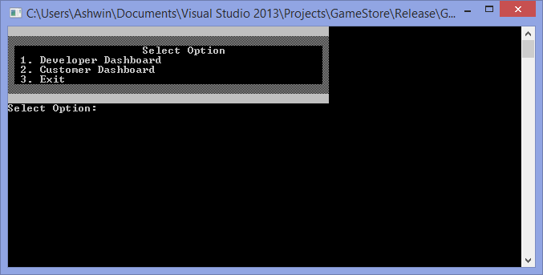

PublisherDash

//Current support single user only

Open gamelist.gsf

Display

1. View Games
2. Add Game
3. Remove Game
4. View Sales
5. Back

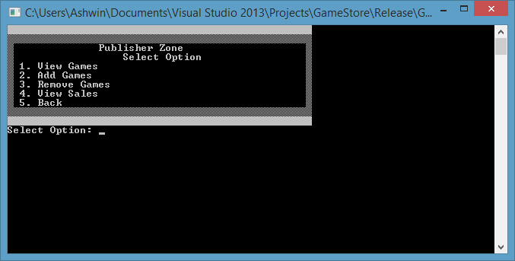

ClientDash

//Current support single user only

Open client.gsf

Display

Welcome To GameStore Marketplace

Total Spent:

Balance:

1. Marketplace
2. Add Funds
3. View Orders
4. Back

Screenshot

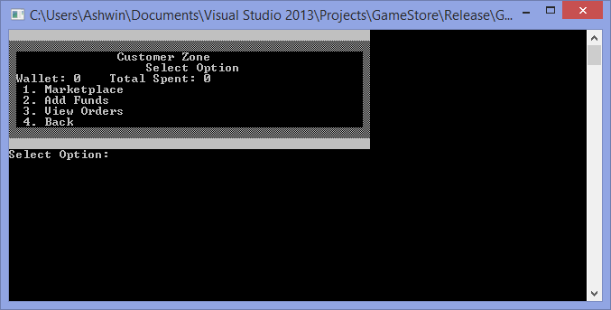

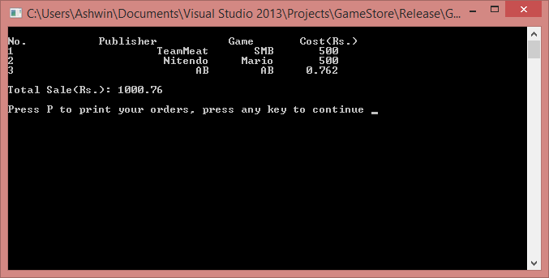

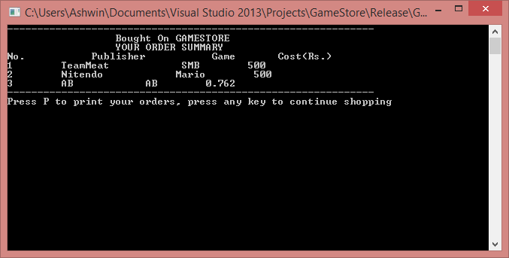

Files

gamelist.gsf – contains list of publisher and game

client.gsf – contains list of client and details

sale.gsf- contains sales list and cost

bill.txt- open this file to print

print.txt-open this file to print publisher sales

CODE

Header files

* Customer.h
* Draw.h
* Publisher.h

Source Files

* Customer.cpp
* Draw.cpp
* Publisher.cpp
* Main.cpp

Customer.h

#ifndef CUSTOMER_H

#define CUSTOMER_H

class Customer

{

public:

void addFunds();

void removeFunds(float);

void printOrders();

void buy();

float funds;

float spent;

};

#endif

Draw.h

#ifndef DRAW_H

#define DRAW_H

#include <windows.h>

#include <string>

#include "Customer.h"

#include "Publisher.h"

class Draw

{

public:

void gotoxy(int,int);

void clear();

void loginScreen();

void pubDash();

void clientDash();

private:

void listGames();

void dispPubSales();

void dispCustSales();

};

#endif

Publisher.h

#ifndef PUBLISHER_H

#define PUBLISHER_H

class Publisher

{

public:

char pubName[15];

char gameName[15];

float cost ;

void printSales();

void addGame();

void removeGame();

};

#endif

Customer.cpp

#include"Customer.h"

#include"Publisher.h"

#include<iostream>

#include<conio.h>

#include<fstream>

#include<iomanip>

using namespace std;

void Customer::addFunds()

{

float n;

cout << "Enter the funds you want to add: ";cin >> n;

funds += n;

ofstream f("Client.gsf", ios::out);

f.seekp(0);

f.write((char *) this, sizeof(Customer));

f.close();

}

void Customer::removeFunds(float n)

{

funds -= n;

spent += n;

ofstream f("Client.gsf", ios::out);

f.seekp(0);

f.write((char *) this, sizeof(Customer));

f.close();

}

void Customer::buy()

{

int flag = 1;

Publisher pub;

char gName[15];

cout << "Enter the name of the game you want to buy: "; cin >> gName;

//Check for purchase

fstream sales("sales.gsf", ios::in|ios::out);

sales.seekg(0);

while (sales.read((char*)&pub, sizeof(Publisher)))

{

if (strcmp(pub.gameName, gName) == 0){

cout << "You already have the game";

_getch();

sales.close();

return;

}

}

//Continue if game is not purchased earlier

fstream sale("sales.gsf", ios::app);

fstream gList("gamelist.gsf", ios::in);

while (gList.read((char*)&pub, sizeof(Publisher)))

{

if (strcmp(pub.gameName, gName) == 0)

{

float temp = funds - pub.cost;

if (temp >= 0)

{

removeFunds(pub.cost);

sale.write((char*)&pub, sizeof(Publisher));

cout << "You Have successfully brought the game!"; _getch();

flag = 0;

}

else{

cout << "You do not have enough funds!\n"; _getch();

}

}

}

if (flag)

{

cout << "Did not find the game please check the spelling ";

_getch();

}

gList.close();

sale.close();

}

void Customer::printOrders()

{

ofstream FILE("bill.txt", ios::out);

fstream f;

f.open("sales.gsf", ios::in);

Publisher pub;

int i = 1;

float TotalSale = 0;

cout << endl;

FILE << "-------------------------------------------------------------\n";

FILE << " Bought On GAMESTORE \n";

FILE << " YOUR ORDER SUMMARY\n";

FILE << "No. Publisher Game Cost(Rs.)\n";

while (f.read((char *)&pub, sizeof(Publisher)))

{

FILE << i << setw(30) << pub.pubName << setw(10) << pub.gameName << setw(10) << pub.cost << endl;

i++;

TotalSale += pub.cost;

}

f.close();

FILE << "\nTotal Sale(Rs.): " << TotalSale << endl << endl;

FILE << "-------------------------------------------------------------\n";

FILE.close();

cout << "Sales saved in bill.txt. Open file to print";

_getch();

}

Draw.cpp

#include "Draw.h"

#include<conio.h>

#include <iostream>

#include<iomanip>

#include<fstream>

using namespace std;

void Draw::gotoxy(int y, int x)

{

COORD coord;

coord.X = x;

coord.Y = y;

SetConsoleCursorPosition(

GetStdHandle(STD_OUTPUT_HANDLE),coord);

}

void Draw::loginScreen()

{

system("cls");

for (int i = 0; i < 50; i++)

cout << (char)219;

cout << "\n";

for (int i = 0; i < 50; i++)

cout << (char)177;

cout << "\n";

cout << (char)177 << " Select Option\n";

cout << (char)177 << " 1. Developer Dashboard\n";

cout << (char)177 << " 2. Customer Dashboard\n";

cout << (char)177 << " 3. Exit\n";

for (int i = 0; i < 50; i++)

cout << (char)177;

cout << "\n";

for (int i = 0; i < 50; i++)

cout << (char)219;

cout << "\n";

for (int i = 2; i < 6; i++){

gotoxy(i, 49); cout << (char)177;

}

gotoxy(8, 0);

int inp = 0; cout << "Select Option: ";

cin >> inp;

switch (inp)

{

case 1:

pubDash();

break;

case 2:

clientDash();

break;

case 3:

exit(0);

break;

default:

loginScreen();

break;

}

}

void Draw::clientDash()

{

while (true){

system("cls");

Customer cust;

fstream f("Client.gsf", ios::in|ios::out);

f.seekg(0);

if (f.read((char *)&cust, sizeof(Customer)))

f.close();

else{

cust.funds = 0;

cust.spent = 0;

f.seekp(0);

f.write((char *)&cust, sizeof(cust));

f.close();

}

for (int i = 0; i < 50; i++)

cout << (char)219;

cout << "\n";

for (int i = 0; i < 50; i++)

cout << (char)177;

cout << "\n";

cout << (char)177 << " Customer Zone\n";

cout << (char)177 << " Select Option\n";

cout << (char)177 << "Wallet: " << cust.funds << " Total Spent: " << cust.spent << "\n";

cout << (char)177 << " 1. Marketplace\n";

cout << (char)177 << " 2. Add Funds\n";

cout << (char)177 << " 3. View Orders\n";

cout << (char)177 << " 4. Back\n";

for (int i = 0; i < 50; i++)

cout << (char)177;

cout << "\n";

for (int i = 0; i < 50; i++)

cout << (char)219;

cout << "\n";

for (int i = 2; i < 9; i++){

gotoxy(i, 49); cout << (char)177;

}

gotoxy(11, 0);

int inp = 0; cout << "Select Option: ";

cin >> inp;

switch (inp)

{

case 1:

system("cls");

listGames();

cust.buy();

break;

case 2:

cust.addFunds();

break;

case 3:

dispCustSales();

break;

case 4:

loginScreen();

break;

default:

clientDash();

break;

}

}

}

void Draw::pubDash()

{

Publisher pub;

while (true){

system("cls");

for (int i = 0; i < 50; i++)

cout << (char)219;

cout << "\n";

for (int i = 0; i < 50; i++)

cout << (char)177;

cout << "\n";

cout << (char)177 << " Publisher Zone\n";

cout << (char)177 << " Select Option\n";

cout << (char)177 << " 1. View Games\n";

cout << (char)177 << " 2. Add Games\n";

cout << (char)177 << " 3. Remove Games\n";

cout << (char)177 << " 4. View Sales\n";

cout << (char)177 << " 5. Back\n";

for (int i = 0; i < 50; i++)

cout << (char)177;

cout << "\n";

for (int i = 0; i < 50; i++)

cout << (char)219;

cout << "\n";

for (int i = 2; i < 9; i++){

gotoxy(i, 49); cout << (char)177;

}

gotoxy(11, 0);

int inp = 0; cout << "Select Option: ";

cin >> inp;

switch (inp)

{

case 1:

listGames();

break;

case 2:

pub.addGame();

break;

case 3:

pub.removeGame();

break;

case 4:

dispPubSales();

break;

case 5:

loginScreen();

default:

pubDash();

break;

}

}

}

void Draw::listGames()

{

fstream f;

f.open("gamelist.gsf", ios::in);

Publisher pub;

if (f){

int i = 1;

cout << "No. Publisher Game Cost(Rs.)\n";

while (f.read((char *)&pub, sizeof(Publisher)))

{

cout << i<< setw(20)<< pub.pubName<< setw(20) << pub.gameName<<setw(10)<< pub.cost << endl;

i++;

}

f.close();

}

else

cout << "Sorry! No games available now :(\n";

_getch();

}

void Draw::dispPubSales()

{

system("cls");

fstream f;

f.open("sales.gsf", ios::in);

Publisher pub;

if (f){

int i = 1;

float TotalSale = 0;

cout << endl;

cout << "No. Publisher Game Cost(Rs.)\n";

while (f.read((char *)&pub, sizeof(Publisher)))

{

cout << i <<setw(60) << pub.pubName << setw(100)<< pub.gameName <<setw(30) << pub.cost << endl;

i++;

TotalSale += pub.cost;

}

f.close();

cout << "\nTotal Sale: " << TotalSale << endl<<endl;

cout << "Press P to print your orders, press any key to continue ";

char n;

cin >> n;

switch (n){

case 'P':

pub.printSales();

break;

case 'p':

pub.printSales();

break;

default:

pubDash();

}

}

else{

cout << "You have not sold anything\n";

_getch();

}

}

void Draw::dispCustSales()

{

system("cls");

fstream f;

f.open("sales.gsf", ios::in);

Publisher pub;

if (f){

int i = 1;

cout << "-------------------------------------------------------------\n";

cout << " Bought On GAMESTORE \n";

cout << " YOUR ORDER SUMMARY\n";

cout << "No. Publisher Game Cost(Rs.)\n";

while (f.read((char *)&pub, sizeof(Publisher)))

{

cout << i << " " << pub.pubName << " " << pub.gameName << " " << pub.cost << endl;

i++;

}

f.close();

cout << "-------------------------------------------------------------\n";

cout << "Press P to print your orders, press any key to continue shopping ";

char n;

cin >> n;

if (n == 'p' || n == 'P'){

Customer cust; cust.printOrders();

}

}

else{

cout << "You have not made any purchases\n"; _getch();

}

}

Publisher.cpp

#include "Publisher.h"

#include <fstream>

#include<conio.h>

#include<iostream>

using namespace std;

void Publisher::addGame()

{

char gName[15];

cout << "\nEnter game name: "; cin >> gName;

fstream sales("gamelist.gsf", ios::in | ios::out);

sales.seekg(0);

while (sales.read((char*)this, sizeof(Publisher)))

{

if (strcmp(gameName, gName) == 0){

cout << "There is already a game with this name in store!";

_getch();

sales.close();

return;

}

}

ofstream f("gamelist.gsf", ios::app);

strcpy_s(gameName, gName);

cout << "\nEnter publisher name: "; cin>>pubName;

cout << "\nEnter cost: "; cin >> cost;

f.write((char *)this, sizeof(Publisher));

f.close();

}

void Publisher::removeGame()

{

char gName[15];

int flag = 1;

cout << "Enter the name of the game you want to remove: ";

cin >> gName;

ifstream f("gamelist.gsf");

ofstream o("temp.gsf");

while (f.read((char*)this, sizeof(Publisher)))

{

if (strcmp(gameName, gName)!=0)

{

o.write((char*)this, sizeof(Publisher));

flag = 0;

}

}

f.close();

o.close();

remove("gamelist.gsf");

rename("temp.gsf", "gamelist.gsf");

if (flag){

cout << "\nDidn't Find The Game Please Check The Spelling.";

_getch();

}

}

void Publisher::printSales()

{

}

Main.cpp

//-----------------------------------------------------------------------------------

//-----------------------------Copyright Game Store (c)------------------------------

//----------------------------------Ashwin Vaidya------------------------------------

//-----------------------------------------------------------------------------------

#include <iostream>

#include <conio.h>

#include "Draw.h"

using namespace std;

int main()

{

Draw D;

D.loginScreen();

_getch();

return 0;

}

Bibliography

1. MSDN Documentation
2. Computer Science with C++ by Sumita Arora
3. stackoverflow.com