**Assignment-2**

**Advance software Engineering**

A Weather application has developed using android studio and using an API of openweathersource.org which will display the temperature of the city you have entered in the input. The application give you the temperature all over the globe.

In frontend I have used .xml and where as in the backend has created using the Java. The output (JSON) is kept in an object and displayed the needed information.

The output is in kelvin temperature.

Figure of the main_activity.java

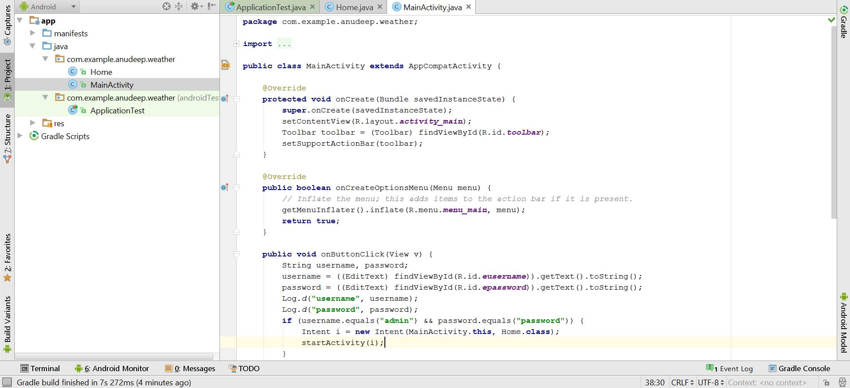

Figure from the content_main.xml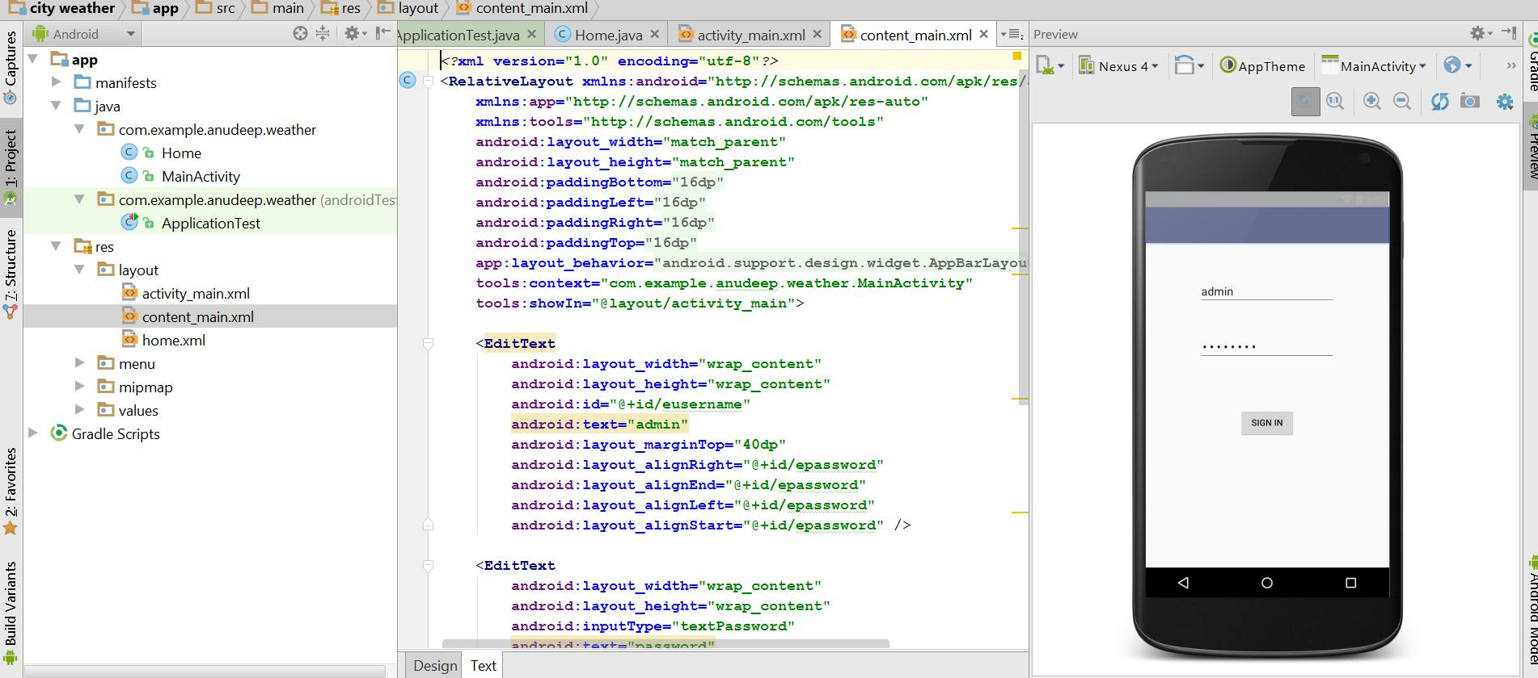

The output extracted is

Minimum and Maximum temperatures in kelvin.

