**Provision a Virtual network with two subnets.**

* Open the VS code and create 3 files with extensions **.tf** and name as **providers.tf**, **variables.tf**, **main.tf**
* Save all these scripts in a folder and open the terminal in vs code
* Change the directory to the folder where you save the files
* In the terminal initialize the terraform with the command
  + **terraform init –upgrade**
* **terraform plan** command to visualize the execution plan
* 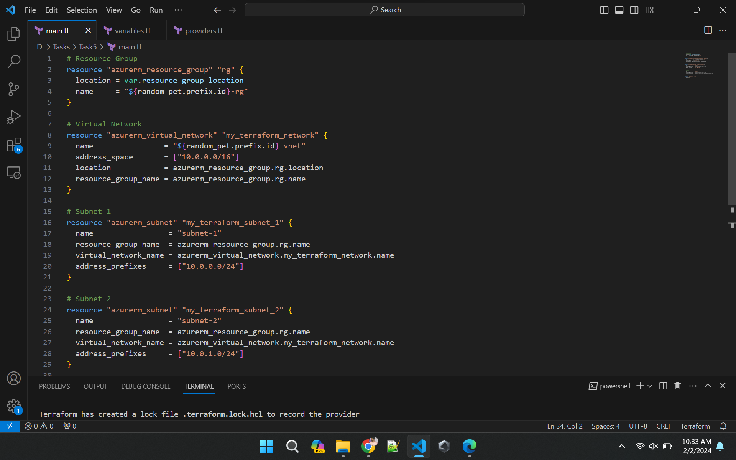**terraform apply** command to accept and execute to the azure cloud infrastructure

