**REFERECNE:** [Quickstart: Use Terraform to create a Windows VM - Azure Virtual Machines | Microsoft Learn](https://learn.microsoft.com/en-us/azure/virtual-machines/windows/quick-create-terraform)

* I have created 3 files with **.tf** extension, namely **main.tf**, **variable.tf**, **output.tf** all these 3 files are place in the folder name **infra**
* In the root directory I have created another 3 files name **main.tf, variables.tf and providers.tf** where it contains the script to access the modules of infra folder
* Use the terraform command ***terraform init*** to initialize the terraform
* 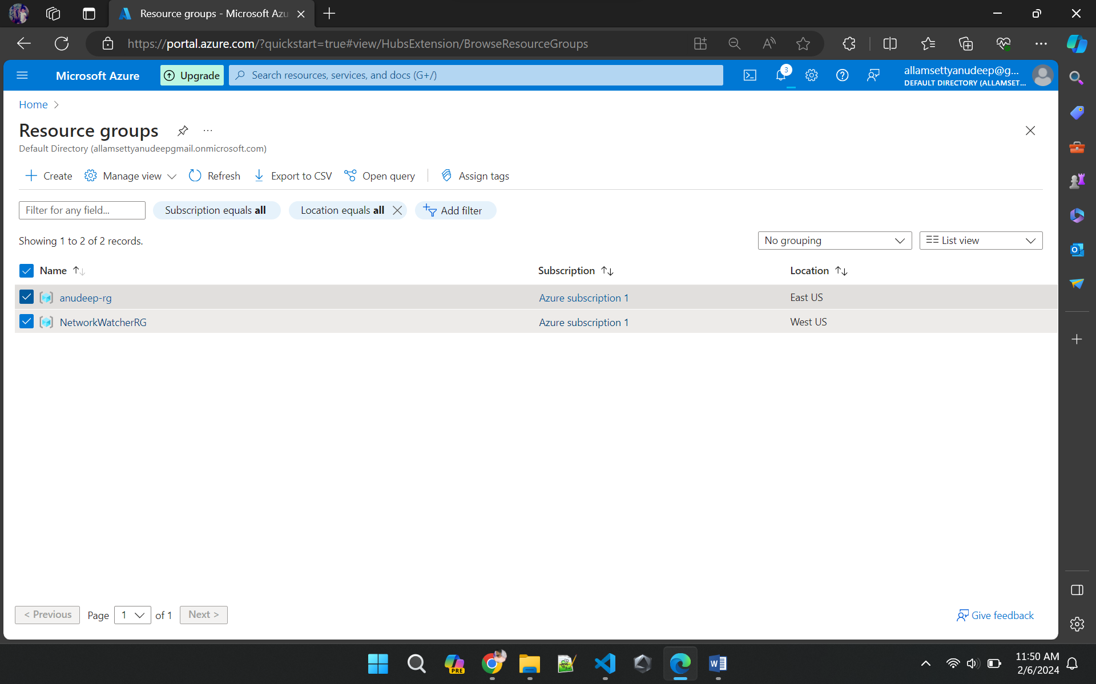Use the terraform command ***terraform plan*** and ***terraform apply*** to visualize the execution plan and apply the changes

