**DATABASE TABLES**

Table 1: Admin Credentials Table

| AID(PK, int, not null) | UserID(nvarchar(150), null) | Password(nvarchar(150), null) |
| --- | --- | --- |

Table 2: Course Table

| CID(PK, int, not null) | Cname(nvarchar(150), null) | Duration(nvarchar(150), null | Cfees(int, null) |
| --- | --- | --- | --- |

Table 3: Registration Table

| Stid(PK, int, not null) | Stfname(nvarchar(150), null) | Stlname(nvarchar(150), null) | StFathername(nvarchar(150), null) | StFatherPhone( int, null) | StEmail( int, null) | Stphone(int, null) |
| --- | --- | --- | --- | --- | --- | --- |
| Coursejoin(nvarchar(150), null) | CourseFees(int, null) | Firstinstallment(int, null) | FeesDue(int, null) | Joindate(date, null) |  |  |

Table 4: Tutors Table

| Tid(PK, int, not null) | Tname(nvarchar(150), null) | Temail(nvarchar(150), null) | Tphone(int, null) | Tcourse(nvarchar(150), null) | Tqualification(nvarchar(150), null) | Joindate(date, null) |
| --- | --- | --- | --- | --- | --- | --- |

**FLOW CHART**

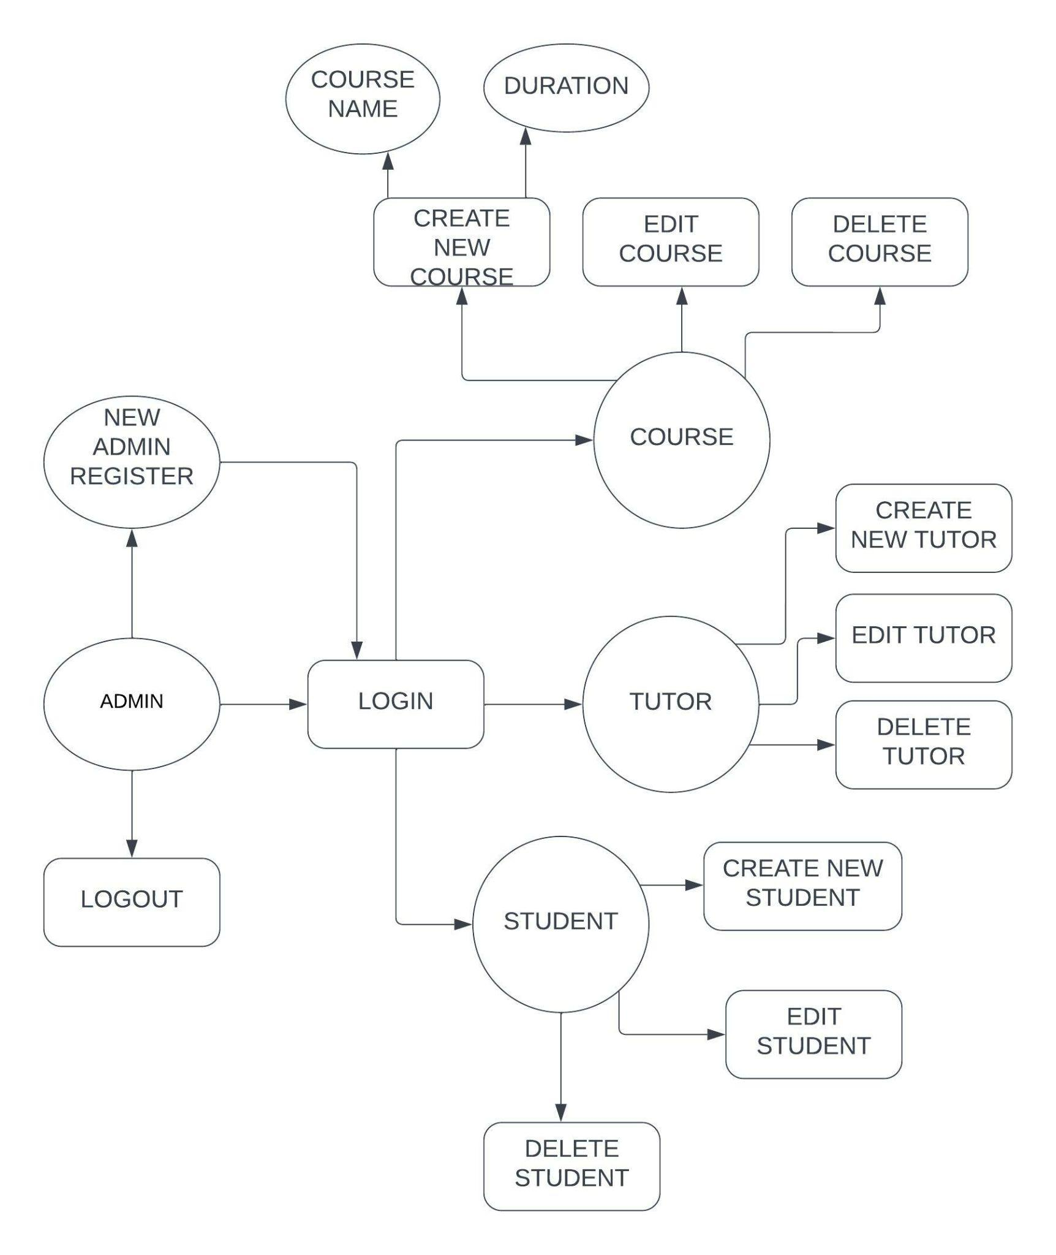

**USER STORIES**

I am owner of a tuition centre, and I want to manage the course’s that are been taught in my centre and also the teacher’s who are teaching in my tuition centre. I also want to maintain the record of students, which includes their name’s, and mobile number, fee’s they paid, remaining due, etc. And also, their should be a option for adding new admin.