import matplotlib.pyplot as pyplot

x=[1,2,3]

y=[2,4,7]

pyplot.plot(x,y)

pyplot.xlabel("X Axis")

pyplot.ylabel("Y Axis")

pyplot.title("my firstgraph")

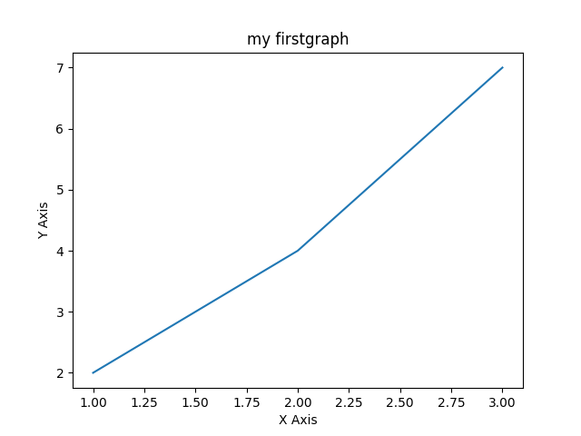pyplot.show()