Foresyth : Sales & Demand Forecasting System
Anudeep.G
Department of Computer Science and Engineering
KLH (Deemed to be University)
Bowrampet Campus, Hyderabad, India
2420030148@klh.edu.in

Pushpak.G
Department of Computer Science and Engineering
KLH (Deemed to be University)
Bowrampet Campus, Hyderabad, India
2420030107@klh.edu.in

Jawwad.Md
Department of Computer Science and Engineering
KLH (Deemed to be University)
Bowrampet Campus, Hyderabad, India
2420030075@klh.edu.in

Abstract—Accurate short-term sales forecasting is essential for effective inventory planning, staffing, and promotional decision-making in retail. However, raw sales data is frequently incomplete, duplicated, or noisy, and simple forecasting methods fail to capture seasonality, holiday effects, and sudden demand anomalies. This paper presents an end-to-end Sales & Demand Forecasting System that combines automated data cleaning and quality scoring, fuzzy duplicate detection (RapidFuzz), and anomaly detection with two complementary time-series forecasting models — ARIMA and Prophet — evaluated on the real-world Walmart Sales Dataset. Model performance is compared using Mean Absolute Error (MAE), Root Mean Squared Error (RMSE), and Mean Absolute Percentage Error (MAPE), and the better-performing model is automatically selected per series. Results are surfaced through an interactive Streamlit dashboard that presents sales trends, data quality scores, detected anomalies, and forecast outputs in a form accessible to non-technical business stakeholders. The proposed system demonstrates that combining rigorous data preparation with dual-model forecasting and an interpretable dashboard can produce more reliable, actionable demand forecasts than single-model, notebook-only approaches.
Keywords—sales forecasting, demand forecasting, ARIMA, Prophet, time-series analysis, data quality, anomaly detection, Streamlit dashboard

I. INTRODUCTION
Retail and e-commerce businesses depend on accurate short-term sales forecasts to plan inventory, staffing, and promotional campaigns. Overestimating demand ties up capital in unsold stock, while underestimating it leads to stockouts and lost sales. In practice, most organizations rely on manual spreadsheets or a single forecasting model applied uniformly across all products and stores, without first verifying whether the underlying sales data is complete, duplicate-free, and free of anomalies.
This gap motivates the present work: a system that treats data quality as a first-class concern, detects unusual sales spikes or drops before they distort model training, and compares two complementary forecasting techniques — the classical statistical ARIMA model and the additive, seasonality-aware Prophet model — rather than committing to a single approach in advance.
The main contributions of this work are: (1) an integrated pipeline that scores data quality and flags duplicates and anomalies before any model is trained; (2) a side-by-side comparison of ARIMA and Prophet with automatic per-series model selection; (3) retention of the evaluation metrics behind each selection, so that the choice remains auditable; and (4) an interactive dashboard that exposes every intermediate output of the pipeline to non-technical users.
The remainder of this paper is organized as follows. Section II states the problem and objectives. Section III reviews existing forecasting approaches and identifies the gap this work addresses. Section IV describes the proposed methodology, including data cleaning, anomaly detection, and the forecasting pipeline. Section V outlines the system architecture. Section VI discusses expected results and the evaluation plan, Section VII presents limitations and future work, and Section VIII concludes the paper.

II. PROBLEM STATEMENT AND OBJECTIVES
Retail forecasting in practice suffers from three linked problems. First, source data is rarely analysis-ready: exports contain missing weeks, negative or impossible values, and duplicate rows whose text fields differ only in spelling, spacing, or case. Second, a single model is often applied to every product and store, even though series differ in length, volatility, and seasonal strength. Third, model outputs are typically delivered as static notebooks or spreadsheets that decision makers cannot interrogate. Errors introduced at any of these steps propagate silently into inventory and staffing decisions.
The objectives of this work are: (1) to detect and quantify missing, invalid, and duplicate records and summarize them in a single data quality score; (2) to identify anomalous sales observations without discarding genuine demand events; (3) to train ARIMA and Prophet models on every cleaned series; (4) to evaluate both models on a held-out time window using MAE, RMSE, and MAPE and select the better model per series automatically; (5) to present the full pipeline through an interactive dashboard for non-technical stakeholders; and (6) to define a reproducible evaluation protocol that avoids temporal leakage.

III. LITERATURE SURVEY
A range of prior work addresses time-series forecasting individually, but few studies combine data quality assurance with multi-model comparison in a single deployable system.
Taylor and Letham [1] introduced Prophet, an additive regression model combining trend, weekly and yearly seasonality, and holiday effects, designed for automatic fitting with minimal manual tuning. It performs well on business time series with strong seasonality, but is less precise on series with complex short-term autocorrelation.
Box and Jenkins [2] established the ARIMA methodology, using differencing and autocorrelation analysis to model stationary time series. ARIMA remains strong on well-behaved, short-horizon series but requires manual parameter tuning and struggles with multiple overlapping seasonalities.
Comparative studies [3] benchmarking ARIMA against Prophet on retail sales data generally find that neither model dominates universally: Prophet tends to outperform on series with strong seasonality and holiday effects, while ARIMA can outperform on short, stable series.
Hyndman and Athanasopoulos [4] recommend benchmarking against simple methods such as seasonal naive forecasts and validating with time-ordered splits rather than random ones, practices adopted in this work. Because no single model is expected to dominate, this work compares two rather than committing to one in advance.
Across this literature, model comparison is typically the end point of the study. Data-quality verification, duplicate detection, and anomaly detection are rarely treated as part of the forecasting pipeline itself, and results are usually reported in a static notebook rather than an interactive decision-support tool that a non-technical stakeholder could use directly. The system proposed in this paper is designed to close that gap.

IV. PROPOSED METHODOLOGY

A. Data Collection
The system is developed and validated using the Walmart Sales Dataset (Kaggle) [5], which provides weekly, store-level retail sales data along with a holiday indicator flag. The data cover 45 stores over roughly 143 weeks between February 2010 and late 2012, and mark weeks containing four major holidays: the Super Bowl, Labor Day, Thanksgiving, and Christmas. Regional covariates such as temperature, fuel price, consumer price index, and unemployment rate are also distributed with the data, although the current pipeline uses only the holiday flag as an exogenous input.
The system accepts sales data in CSV or Excel format, allowing it to generalize beyond this dataset to other retail sources. At minimum, an input file must contain a date column, a numeric sales column, and optionally an identifier such as store or department so that separate series can be modelled independently. Each series is reindexed to a regular weekly frequency so that missing weeks are made explicit.

B. Data Cleaning and Quality Scoring
Raw sales data is first passed through a cleaning pipeline built on Pandas [6] and NumPy that detects missing values, invalid entries (e.g., negative sales or impossible dates), and duplicate records. Duplicate detection uses RapidFuzz [7] to catch near-duplicate text fields (such as inconsistently formatted store or product names) that exact-match comparison would miss; record pairs whose similarity score exceeds a configurable threshold are treated as candidate duplicates. The pipeline produces a composite data quality score — combining completeness, validity, and duplicate rate — so that data issues are visible before they affect forecasting. The score can be expressed as
Q = w₁C + w₂V + w₃ (1 − D) (1)
where C is the fraction of non-missing required fields, V the fraction of records passing validity rules, D the fraction of records identified as duplicates, and the non-negative weights w sum to one. Reporting Q alongside its three components shows whether a low score reflects missing data, invalid entries, or duplication, and helps users decide whether a series is fit for forecasting.

C. Anomaly Detection
Before model training, the cleaned series is scanned for anomalous sales spikes or drops that could otherwise distort the fitted models. Detected anomalies are flagged and surfaced to the user rather than silently removed, so that genuine demand events (e.g., a promotion) are not confused with data errors.
Anomalies in time series may be point, contextual, or collective [8]: a single extreme week, a value that is unusual only for its time of year, or a run of abnormal weeks. Because retail sales are strongly seasonal, detection is applied to deviations from the expected seasonal level rather than to raw values, so that predictable holiday peaks are not flagged as errors. A robust z-score or interquartile-range rule on seasonal residuals is a natural baseline.

D. Forecasting Models
Two forecasting models are trained on each cleaned, anomaly-flagged series: ARIMA, implemented via Statsmodels [9], and Prophet. ARIMA is fitted using standard Box-Jenkins order selection on the differenced series, while Prophet is configured with weekly and yearly seasonality and the dataset's holiday flag as a regressor.
An ARIMA(p, d, q) model combines autoregressive terms of order p, differencing of order d to achieve stationarity, and moving-average terms of order q [2]. Candidate orders are inspected using autocorrelation and partial-autocorrelation plots and compared using information criteria such as AIC. Prophet instead decomposes a series as
y(t) = g(t) + s(t) + h(t) + ε_{t} (2)
where g(t) is a piecewise trend, s(t) periodic seasonality, h(t) the effect of holidays, and ε is an error term [1].

E. Model Evaluation and Selection
Both models are evaluated on a held-out time window using Mean Absolute Error (MAE), Root Mean Squared Error (RMSE), and Mean Absolute Percentage Error (MAPE), computed with Scikit-learn [10]. For actual values y, forecasts ŷ, and n forecast points, the metrics are
MAE = (1/n) Σ |y_{t} − ŷ_{t}| (3)
RMSE = √[(1/n) Σ (y_{t} − ŷ_{t})²] (4)
MAPE = (100/n) Σ |(y_{t} − ŷ_{t}) / y_{t}| (5)
MAE and RMSE are expressed in the units of sales and are therefore comparable only within a series, with RMSE penalizing large misses more heavily. MAPE is scale-free and allows comparison across stores, but becomes unstable or undefined when actual values are zero or near zero [11]. Reporting all three gives complementary views of forecast quality. The better-performing model per series is selected automatically, and the evaluation metrics behind that choice are retained for transparency.

F. Interactive Dashboard
All outputs — sales trends, the data quality score, detected anomalies, and forecast results from both models — are presented through an interactive Streamlit dashboard [12], using Plotly and Matplotlib for visualization, so that business stakeholders without a technical background can explore the results directly. Separate views cover trends (with holiday weeks marked), data quality, flagged anomalies, and the ARIMA and Prophet forecasts with the metrics behind the selected model; users can choose a store or department and adjust the forecast horizon.

V. SYSTEM ARCHITECTURE
Fig. 1 shows the proposed pipeline. The system follows a linear pipeline: raw CSV/Excel data is ingested, passed through the cleaning and quality-scoring stage, then through anomaly detection, then through the dual-model forecasting and evaluation stage, and finally rendered on the Streamlit dashboard. Each stage exposes its intermediate output (cleaned data, quality score, anomaly flags, forecasts, and evaluation metrics) so that the dashboard can present the full pipeline, not just the final forecast, to the end user. Table I lists the software components used at each stage.
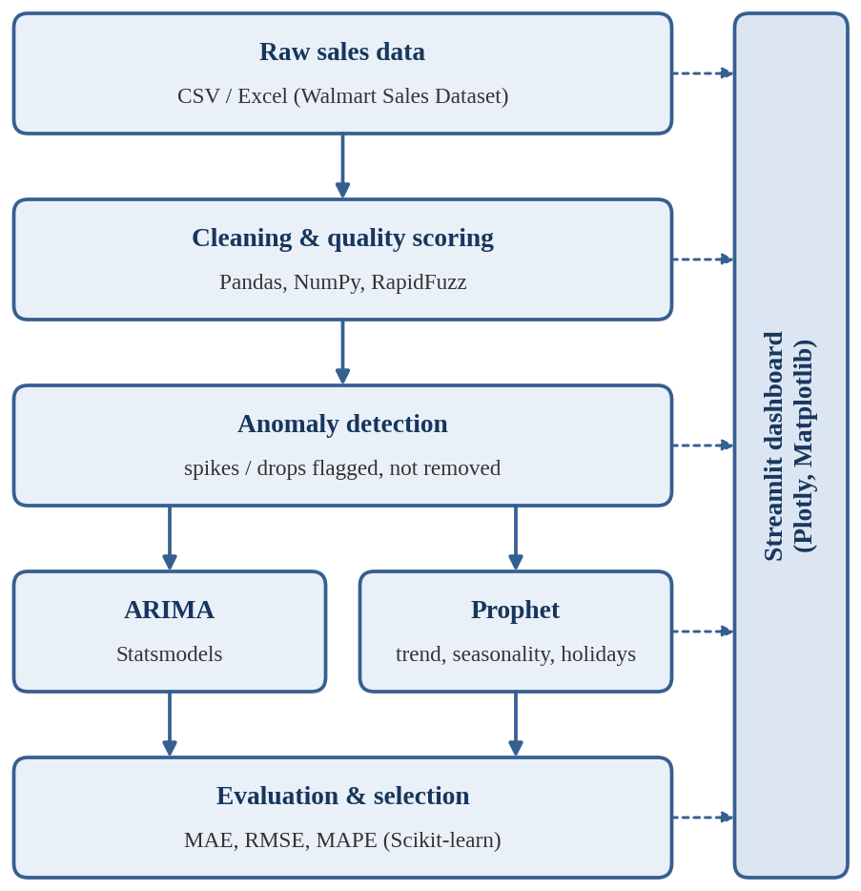
Fig. 1. Proposed pipeline of the Sales & Demand Forecasting System.
Stage | Tools | Purpose
Data cleaning | Pandas, NumPy | Missing, invalid, and duplicate records
Duplicate detection | RapidFuzz | Fuzzy matching of near-duplicate text fields
ARIMA | Statsmodels | Box-Jenkins forecasting
Prophet | Prophet | Trend, seasonality, and holiday effects
Evaluation | Scikit-learn | MAE, RMSE, and MAPE
Dashboard | Streamlit, Plotly, Matplotlib | Interactive visualization
TABLE I. SOFTWARE COMPONENTS AT EACH PIPELINE STAGE

VI. EXPECTED RESULTS AND EVALUATION PLAN
As this system is under active development, this section outlines the evaluation plan rather than final results. The cleaning pipeline will be evaluated by the proportion of missing, duplicate, and invalid records it correctly identifies on a held-out labeled sample. Forecasting performance will be reported per store/department series using MAE, RMSE, and MAPE for both ARIMA and Prophet, with the automatically selected model's error rate compared against a naive baseline (e.g., a seasonal moving average). The target is a MAPE low enough to support practical inventory-planning decisions, consistent with typical retail forecasting benchmarks reported in the literature reviewed in Section III.
Evaluation will use a chronological rolling-origin scheme, illustrated in Fig. 2. Each series is divided into an expanding training window followed by a validation window; the window then advances and the models are refitted [4]. A final segment at the end of each series is locked as a test set and used only once, after all design decisions are complete. No shuffling is performed, and every data-dependent step, including anomaly thresholds and model fitting, uses the training window alone, so no future information leaks into the forecasts.
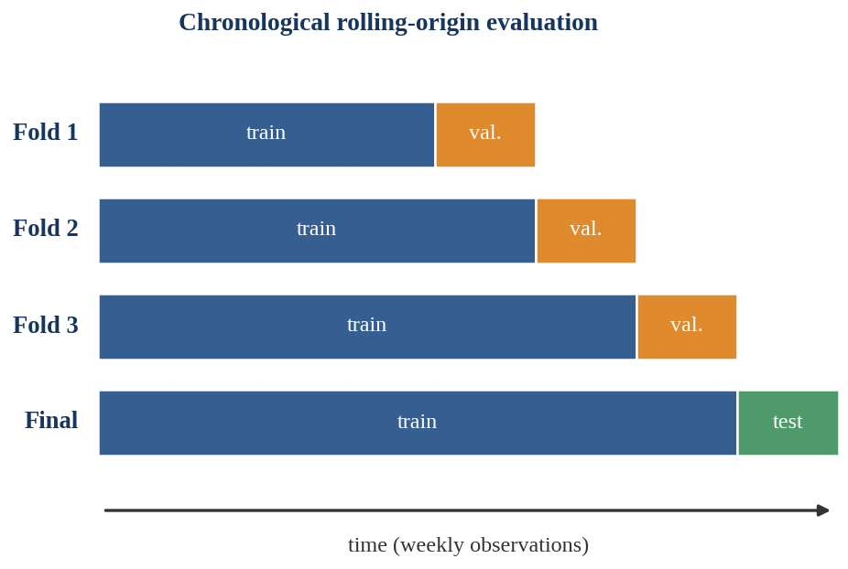
Fig. 2. Chronological rolling-origin evaluation with a locked final test segment.
Table II lists the planned experiments. E2 and E3 test the central premise of this paper — that data cleaning and careful anomaly handling improve forecasts — while E4 tests whether per-series model selection beats using a single model everywhere.
ID | Comparison | Question addressed
E1 | ARIMA, Prophet, naive baseline | Does either model beat the baseline?
E2 | Raw vs. cleaned input | Does cleaning reduce forecast error?
E3 | Anomalies kept, flagged, removed | How does anomaly handling affect error?
E4 | Selected vs. fixed model | Does per-series selection help?
E5 | Detected vs. labeled defects | How accurately are defects found?
TABLE II. PLANNED EXPERIMENTS
Based on the comparative literature [3], the working hypothesis is that Prophet will be favored on series with strong seasonality and holiday effects and ARIMA on shorter, stable series, so that neither model will be selected universally. Results will be summarized across stores using the median and interquartile range of each metric.

VII. LIMITATIONS AND FUTURE WORK
This work has several limitations. First, ARIMA and Prophet are univariate in their standard form; the holiday flag is the only exogenous signal, so promotions, prices, and macroeconomic conditions are not modelled explicitly. Second, the development dataset covers a single retailer over roughly three years, so conclusions about relative model performance may not transfer to other contexts or to intermittent-demand series. Third, telling a genuine promotional spike from a data error requires business context, which is why anomalies are flagged for review rather than removed automatically. Finally, the dashboard has not yet been evaluated with real users.
Future work includes extending the anomaly detection module with more advanced statistical methods, testing the system on additional retail datasets, and adding model explainability features to the dashboard so that stakeholders can understand why a particular forecast was produced. Further directions include exogenous regressors such as markdowns, temperature, fuel price, and unemployment; machine-learning candidates such as gradient boosting; prediction intervals; and a usability study with retail planners.

VIII. CONCLUSION
This paper presented the design of an end-to-end Sales & Demand Forecasting System that integrates data cleaning, quality scoring, anomaly detection, and dual-model (ARIMA and Prophet) forecasting behind an interactive dashboard. Unlike prior work that evaluates forecasting models in isolation, the proposed system treats data quality and model comparison as parts of a single pipeline, aimed at producing forecasts that are both accurate and trustworthy for business use.

ACKNOWLEDGMENT
The authors thank Madhu Guda, Assistant Professor, Department of Computer Science and Engineering, KLH (Deemed to be University), Bowrampet Campus, for guidance and feedback throughout this project.

REFERENCES
[1] S. J. Taylor and B. Letham, “Forecasting at scale,” The American Statistician, vol. 72, no. 1, pp. 37–45, 2018.
[2] G. E. P. Box and G. M. Jenkins, Time Series Analysis: Forecasting and Control. San Francisco: Holden-Day, 1970.
[3] Comparative benchmarking studies of ARIMA and Prophet for retail and demand forecasting, various authors, 2020–2024.
[4] R. J. Hyndman and G. Athanasopoulos, Forecasting: Principles and Practice, 3rd ed. Melbourne, Australia: OTexts, 2021.
[5] “Walmart Recruiting - Store Sales Forecasting,” Kaggle. [Online]. Available: https://www.kaggle.com/c/walmart-recruiting-store-sales-forecasting
[6] W. McKinney, “Data structures for statistical computing in Python,” in Proc. 9th Python in Science Conf. (SciPy), 2010, pp. 56–61.
[7] RapidFuzz Documentation. [Online]. Available: https://rapidfuzz.github.io/RapidFuzz/
[8] V. Chandola, A. Banerjee, and V. Kumar, “Anomaly detection: A survey,” ACM Computing Surveys, vol. 41, no. 3, pp. 1–58, 2009.
[9] S. Seabold and J. Perktold, “Statsmodels: Econometric and statistical modeling with Python,” in Proc. 9th Python in Science Conf. (SciPy), 2010, pp. 92–96.
[10] F. Pedregosa et al., “Scikit-learn: Machine learning in Python,” Journal of Machine Learning Research, vol. 12, pp. 2825–2830, 2011.
[11] R. J. Hyndman and A. B. Koehler, “Another look at measures of forecast accuracy,” International Journal of Forecasting, vol. 22, no. 4, pp. 679–688, 2006.
[12] Streamlit Documentation. [Online]. Available: https://docs.streamlit.io

