DEMANDIQ: INTELLIGENT SALES & DEMAND FORECASTING SYSTEM

A Project Report Submitted in the partial fulfillment of the requirements for the award of the degree of

BACHELOR OF TECHNOLOGY
In

DEPARTMENT OF COMPUTER SCIENCE AND ENGINEERING
By
JAWWAD | : 2420030075
PUSHPAK | : 2420030107
ANUDEEP | : 2420030148

Under the Esteemed Guidance of

Dr. N. Sunanda

Associate Professor

Department of Computer Science and Engineering

AY: 2026-2027

Semester: Odd




K L (Deemed to be) University
DEPARTMENT OF COMPUTER SCIENCE AND ENGINEERING

Declaration

The Project Report entitled “DEMANDIQ: INTELLIGENT SALES & DEMAND FORECASTING SYSTEM” is a record of Bonafide work of Jawwad – 2420030075, Pushpak – 2420030107, Anudeep – 2420030148 submitted in partial fulfillment for the award of B. Tech in Computer Science and Engineering to the K L University. The results embodied in this report have not been copied from any other departments/University/Institute.

Jawwad – 2420030075
Pushpak – 2420030107
Anudeep – 2420030148

K L (Deemed to be) University
DEPARTMENT OF COMPUTER SCIENCE AND ENGINEERING

CERTIFICATE

This is to certify that the project report entitled “DEMANDIQ: INTELLIGENT SALES & DEMAND FORECASTING SYSTEM” is a bonafide work done and submitted by Jawwad – 2420030075, Pushpak – 2420030107, Anudeep – 2420030148 in partial fulfillment of the requirements for the award of the degree of BACHELOR OF TECHNOLOGY in Department of Computer Science and Engineering, K L (Deemed to be University), during the academic year 2026-2027.

_____________________  Signature of the Guide  Dr. N. Sunanda  Associate Professor, CSE | _____________________  Course Coordinator  Dr. N. Sunanda  Department of CSE | _____________________  Head of the Department  Dr.P. Venkateswara Rao  Department of CSE

ACKNOWLEDGEMENT
The success in this project would not have been possible but for the timely help and guidance rendered by many people. We wish to express our sincere thanks to all those who have assisted us in one way or the other for the completion of our project.

Our greatest appreciation to our Course Coordinator and guide Dr. N. Sunanda, Associate Professor, Department of Computer Science and Engineering, which cannot be expressed in words for her tremendous support, encouragement and guidance for this project.

We express our gratitude to Dr.P. Venkateswara Rao ,Head of the Department of Computer Science and Engineering, for providing us with adequate facilities, ways and means by which we were able to complete this project.

We thank all the members of teaching and non-teaching staff, and also those who have assisted us directly or indirectly for successful completion of this project. Finally, we sincerely thank our parents, friends and classmates for their kind help and cooperation during our work.

Jawwad – 2420030075
Pushpak – 2420030107
Anudeep – 2420030148

Abstract
Retailers plan inventory, staffing and promotions from sales forecasts, but real sales data is noisy, seasonal and holiday-driven, and errors in the raw data silently degrade forecasting models. DemandIQ is an intelligent sales and demand forecasting system that makes data quality and model choice part of the forecasting pipeline.

The system accepts CSV or Excel sales files, cleans missing values, invalid records and fuzzy duplicates (RapidFuzz) and reports a data quality score. It flags anomalous sales spikes and drops with IQR and Z-score rules, then forecasts daily sales with ARIMA and Prophet on the same chronological hold-out window (the last 20% of the data). Both models are evaluated with MAE, RMSE and MAPE, the better model is selected automatically, and all results are presented in an interactive Streamlit dashboard.

The system was evaluated on the Maggi sales dataset of 500 daily invoice records (1 January 2024 to 14 May 2025). ARIMA outperformed Prophet on every metric (MAE 323.36 vs 349.98, RMSE 406.81 vs 424.22, MAPE 44.77% vs 51.97%) and trained about 16 times faster (0.27 s vs 4.37 s), so it was auto-selected. All four functional test cases and the pytest suite passed.
Keywords: demand forecasting, ARIMA, Prophet, data quality, anomaly detection, Streamlit.
Index
S. No. | Chapters | Topics | Page.no
 |  | Acknowledgement | ii
 |  | Abstract | iii
1 | Introduction | 1.1 Background of the project  1.2 Problem statement  1.3 Scope of the project  1.4 Objective(s)  1.5 Importance of the application  1.6 Target users/audience  1.7 Literature survey and research gap | 1-3
2 | System Requirements | 2.1 Hardware requirements  2.2 Software requirements  2.3 Development tools and frameworks | 4-5
3 | Technology Stack | 3.1 Front-end  3.2 Back-end  3.3 Data storage  3.4 Version control  3.5 APIs or external services | 6-7
4 | System Architecture | 4.1 High-level architecture diagram  4.2 Description of each layer  4.3 Deployment architecture | 8-9
5 | Design | 5.1 Wireframes or mockups  5.2 Dataset and database schema | 10-13
6 | Implementation | 6.1 Module-wise implementation  6.2 Front-end logic  6.3 Backend logic  6.4 Database connectivity  6.5 API integration  6.6 Authentication & authorization | 14-16
7 | Features | 7.1 List of main features  7.2 How each feature works | 17-18
8 | Testing and Results | 8.1 Functional testing  8.2 Integration testing  8.3 Tools used for testing  8.4 Test cases and results  8.5 Validation method and model performance  8.6 Analysis of results | 19-22
9 | Deployment | 9.1 Steps to deploy  9.2 Environment configuration  9.3 Hosting of frontend and backend | 23
10 | Challenges & Limitations | 10.1 Issues faced during development  10.2 Solutions applied  10.3 Current limitations or known bugs | 24
11 | Future Enhancements | 11.1 Planned features  11.2 Possible integrations or optimizations | 25
12 | Conclusion | 12.1 Summary of the project  12.2 What was achieved  12.3 Skills learned during development | 26
13 | References |  | 27
14 | Appendices | Appendix A: Screenshots of the application  Appendix B: Sample code snippet  Appendix C: Installation / setup instructions  Appendix D: User manual  Appendix E: Certifications | 28-34

CHAPTER 1
Introduction

1.1 Background of the project
Retailers and consumer-goods distributors plan inventory, staffing, procurement and promotions around one question: how much will we sell tomorrow, next week and next month? A good answer keeps shelves stocked without tying up cash in unsold goods; a poor answer leads either to stockouts and lost revenue or to overstock and wastage.
In practice, the sales data from which these forecasts are made is rarely clean. Daily sales are noisy, follow weekly cycles, react to holidays and promotions, and are often exported from billing systems as spreadsheets that contain missing values, invalid entries and near-duplicate records. When such data is fed straight into a forecasting model, the model silently learns from the errors and the manager has no way of knowing how much to trust the result.
DemandIQ is an intelligent sales and demand forecasting system built to address this gap. It treats data quality and model choice as part of the forecasting pipeline instead of leaving them to the user. The system cleans and quality-scores the raw sales data, flags unusual spikes and drops, forecasts daily demand with two well-known time-series models (ARIMA and Prophet), compares them on the same hold-out window and presents everything through an interactive Streamlit dashboard. The system is demonstrated on a real-style sales dataset for Maggi instant noodles containing 500 daily invoice records.

1.2 Problem statement
To build a system that cleans and quality-checks raw sales data, detects anomalies and forecasts demand with ARIMA and Prophet, so that managers receive forecasts they can trust. Without trustworthy forecasts, stockouts, overstock and lost revenue follow, and bad data silently hurts the models.

1.3 Scope of the project
The work carried out in this project covers the following:
- Loading a sales file in CSV or Excel format and building a single daily net-sales series from it.
- Detecting and handling missing values, invalid records and fuzzy duplicates, and reporting a data quality score.
- Flagging anomalous sales spikes and drops using IQR and Z-score rules before model training.
- Forecasting daily sales with ARIMA and Prophet, evaluating them with MAE, RMSE and MAPE on a chronological hold-out set, and selecting the better model automatically.
- Presenting trends, quality scores, anomalies, forecasts and business insights in an interactive Streamlit dashboard.
The following are outside the scope of this version: forecasts at region or product-variant level (only daily totals are forecast), deep-learning models, user login and access control, and cloud hosting. These are listed as future enhancements in Chapter 11.

1.4 Objective(s)
1. Design a cleaning pipeline for missing values, invalid records and fuzzy duplicates (RapidFuzz) that reports a data quality score.
2. Detect anomalous sales spikes and drops (IQR / Z-score) before model training.
3. Forecast daily sales with ARIMA and Prophet, evaluate with MAE, RMSE and MAPE, and auto-select the better model.
4. Develop an interactive Streamlit dashboard for trends, quality scores, anomalies, forecasts and business insights.

1.5 Importance of the application
Demand forecasts drive decisions that directly affect revenue and cost. DemandIQ is important because it:
- Makes data quality visible. A numeric quality score shows how reliable the input data is before any forecast is trusted.
- Separates real events from errors. Anomalies are flagged rather than deleted, so a genuine festival spike is not lost while a data-entry error can still be spotted.
- Removes guesswork in model choice. Both models are run on the same hold-out window and the one with the lower error is selected automatically.
- Is usable by non-programmers. The dashboard turns statistical output into charts and plain business insights.

1.6 Target users/audience
The application is intended for store managers, sales and business analysts, small retailers and distributors, and supply-chain or warehouse planners who need short-term demand forecasts but may not have a data-science team. Typical uses are retail and e-commerce inventory planning, staffing and promotion planning, and supply-chain and warehouse demand planning.

1.7 Literature survey and research gap
Four representative studies were reviewed. They are summarised in Table 1.1.
Table 1.1: Summary of literature survey
S.No | Author(s) & Year | Method / Technique | Key Findings | Limitation / Gap
1 | Taylor & Letham, 2018 | Prophet: additive trend, seasonality and holiday model | Robust on business series with strong seasonality and holidays | Less suited to short-term autocorrelation; one model only
2 | Box et al., 2015 | ARIMA(p, d, q) with differencing and ACF/PACF | Strong baseline for short-horizon, stable series | Manual tuning; weak with multiple seasonalities
3 | Hasan et al., 2022 | ARIMA vs Prophet vs LightGBM on Walmart M5 data | ARIMA gave the lowest RMSE; Prophet the highest | Accuracy only; no data-quality or anomaly stage
4 | Aras et al., 2017 | Single vs combination methods for retail sales | Compared single and ensemble forecasts on retail data | No data-quality checks or user-facing dashboard

Research gap. Existing work compares models in isolation. DemandIQ combines data-quality scoring, anomaly handling, ARIMA-versus-Prophet auto-selection and a business dashboard in one pipeline, which addresses Objectives 1 to 4 above.

CHAPTER 2
System Requirements

2.1 Hardware requirements
DemandIQ uses classical statistical models, so no GPU is needed. The minimum and recommended configuration is given in Table 2.1.
Table 2.1: Hardware requirements
Component | Requirement
Processor | Intel i5 / AMD Ryzen 5 or higher
Memory (RAM) | 8 GB (16 GB recommended)
Storage | 5 GB free disk space
GPU | Not required
Network | Internet connection needed only to download Python packages

2.2 Software requirements
Table 2.2: Software requirements
Software | Requirement / Purpose
Operating system | Windows 10/11 or Ubuntu
Language | Python 3.10 or later
Editors | VS Code and Jupyter Notebook
Version control | Git and GitHub
Browser | Any modern web browser to open the Streamlit dashboard

2.3 Development tools and frameworks
The project is written entirely in Python and relies on the open-source libraries listed in Table 2.3.
Table 2.3: Libraries and frameworks used
Library / Framework | Role in DemandIQ
Pandas, NumPy | Loading CSV/Excel files, cleaning, building the daily series and numerical operations
RapidFuzz | Fuzzy string matching to find near-duplicate records
Statsmodels | ARIMA model (differencing, ACF/PACF analysis, AIC-based order selection)
Prophet | Trend, weekly seasonality and India holiday effects forecasting model
Scikit-learn | Error metrics: MAE, RMSE and MAPE
Streamlit | Interactive web dashboard
Plotly, Matplotlib | Interactive and static charts
pytest | Automated functional and end-to-end tests

CHAPTER 3
Technology Stack
The technology stack is deliberately compact: a single language (Python) is used for data processing, modelling and the user interface, which keeps the system easy to install, run and extend.

3.1 Front-end
The user interface is built with Streamlit, which converts Python scripts into interactive web applications without separate HTML, CSS or JavaScript code. Charts are drawn with Plotly (interactive: hover, zoom, pan) and Matplotlib (static plots). The dashboard has a left sidebar with a Navigate menu of eight pages (Dashboard, Upload Data, Data Cleaning, Data Quality, Duplicate Detection, Anomaly Detection, Sales Analytics and Forecast) and a Load sample dataset button.

3.2 Back-end
The back-end is a set of Python modules that perform the actual work: Pandas and NumPy for data handling, RapidFuzz for fuzzy duplicate detection, Statsmodels for ARIMA, Prophet for the Prophet model and Scikit-learn for evaluation metrics. There is no separate web server; the Streamlit process calls these modules directly.

3.3 Data storage
DemandIQ does not use a database. Input is read from CSV or Excel files supplied by the user and all intermediate results (clean data, quality scores, anomaly flags and forecasts) are held in memory as Pandas data frames while the dashboard session is active. This keeps the system lightweight; persistent storage is a possible future enhancement.

3.4 Version control
Source code is managed with Git and hosted on GitHub, which supports collaboration among the three team members. Repository link: [GitHub URL].

3.5 APIs or external services
No paid or online API is used. The only external data is the India public-holiday calendar, which Prophet loads through its built-in country-holiday support. All other processing runs locally.

CHAPTER 4
System Architecture

4.1 High-level architecture diagram
DemandIQ follows a linear pipeline in which each stage consumes the output of the previous one (Figure 4.1).
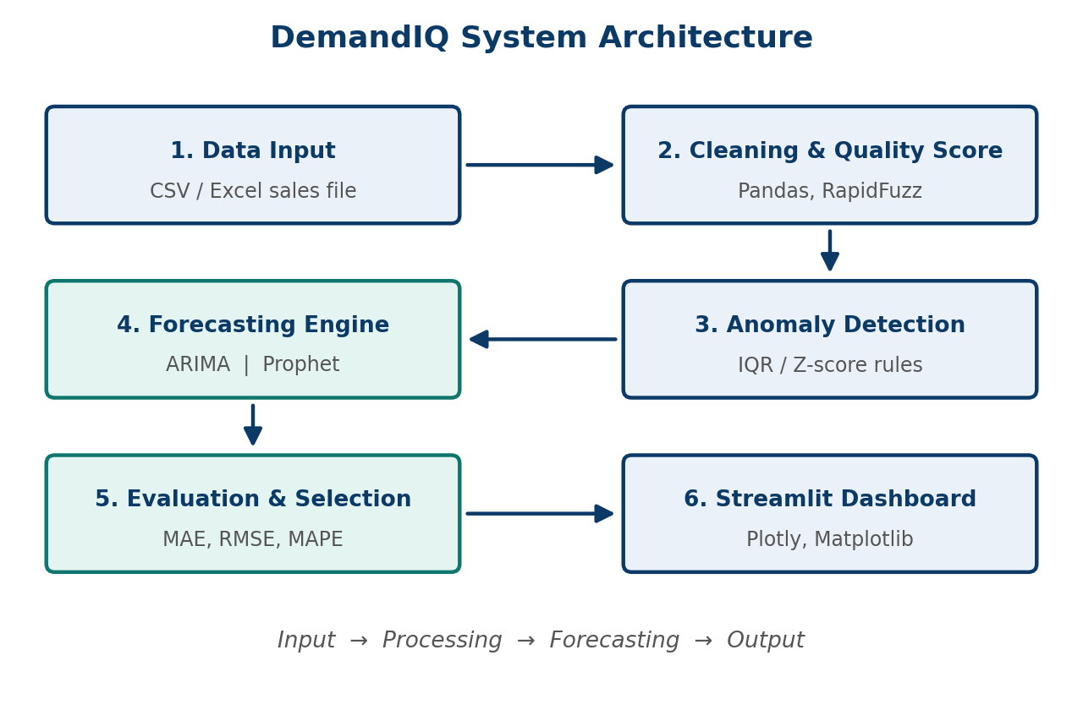
Figure 4.1: High-level architecture of DemandIQ

4.2 Description of each layer

Input layer: data ingestion
Loads the CSV or Excel sales file and converts it into a Pandas data frame. The date column is parsed and the sales columns are validated.

Processing layer: cleaning, quality scoring and anomaly detection
Missing values, invalid rows and fuzzy duplicates are detected and handled, and a data quality score is calculated. The cleaned data is then scanned for unusual sales spikes and drops using IQR and Z-score rules. Anomalies are flagged but not deleted.

Forecasting layer: ARIMA, Prophet and model selection
The daily net-sales series is split chronologically (first 80% for training, last 20% for hold-out testing). ARIMA and Prophet are trained on the training part and predict the hold-out window. MAE, RMSE and MAPE are computed for both and the model with the lowest error is selected.

Presentation layer: Streamlit dashboard
Displays the upload preview, cleaning audit trail, quality scores, duplicate and anomaly results, sales analytics, forecasts and automatic business insights through a sidebar-navigated Streamlit application for non-technical users.

4.3 Deployment architecture
The current deployment is a single-machine, local Streamlit web application: the user starts the Streamlit server on a laptop or desktop and opens the dashboard in a browser. There is no separate database or application server and no CI/CD pipeline. Because the application is pure Python with pip-installable dependencies, it is cloud-ready and can later be hosted on a cloud platform or exposed as an API (see Chapter 11).

CHAPTER 5
Design

5.1 Wireframes or mockups
The interface follows a simple layout: a left sidebar for navigation and a main area that shows one page at a time under the title “Sales & Demand Forecasting System”. The pages follow the order of the processing pipeline, so a user can move from top to bottom through the sidebar (Table 5.1). Figure 5.1 shows the final interface on the Data Quality page.
Table 5.1: Navigation pages of the DemandIQ dashboard
Sidebar page | Purpose
Dashboard | Landing page of the application
Upload Data | Upload a CSV, XLSX or XLS file (up to 200 MB) and preview its rows, row count and column count
Data Cleaning | Run automated cleaning and view the cleaning summary, audit log and imputation summary
Data Quality | Weighted data-quality scorecard
Duplicate Detection | Exact duplicate check and fuzzy near-duplicate search
Anomaly Detection | Outlier detection with a chosen algorithm and treatment action
Sales Analytics | Exploratory charts: trend, monthly sales, distribution, moving average, categorical breakdown
Forecast | Forecast period, model choice, forecast summary, business insight, graph, metrics and export

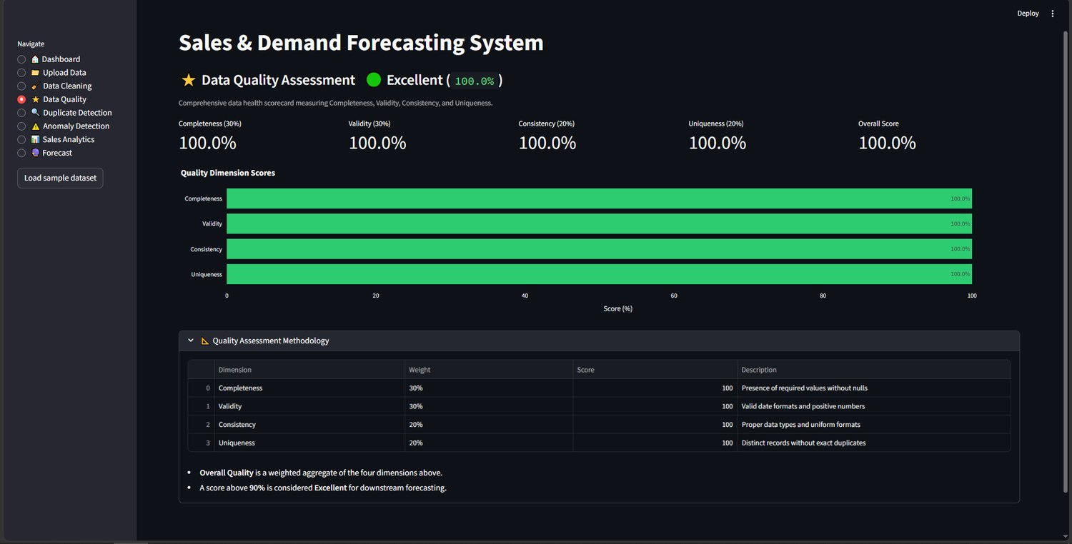
Figure 5.1: Final DemandIQ interface (Data Quality page) with sidebar navigation
Screenshots of all pages are included in Appendix A.

5.2 Dataset and database schema
As there is no database, the design centres on the structure of the input file. The project uses the Maggi sales dataset: 500 daily invoice records from 1 January 2024 to 14 May 2025, stored as CSV. It has 10 columns, no missing values, no duplicate rows and no gaps in the dates. Table 5.2 lists the columns and Figure 5.2 shows the first records.
Table 5.2: Schema of the Maggi sales dataset
Column | Type | Description
Invoice_Date | text (date) | Date of the daily invoice record; 500 unique values
Region | text | 4 regions (e.g. East, South, North, West)
Distribution_Channel | text | 4 channels (e.g. Kirana Store, Supermarket, Quick Commerce)
Product_Variant | text | 5 Maggi variants (e.g. 2-Minute Masala, Oats Noodles, Special Masala)
Pack_Size | text | 3 pack sizes (e.g. 70g, 76g)
MRP_per_Unit_INR | integer | Maximum retail price per unit; 5 distinct values
Quantity_Sold_Units | integer | Units sold in the record
Gross_Sales_INR | integer | Sales value before discount
Discount_Applied_INR | float | Discount given
Net_Sales_INR | float | Gross sales minus discount; forecasting target

In the dashboard the loaded file is shown with the columns Date, Region, Distribution_Channel, Product, Pack_Size, MRP_per_Unit_INR, Quantity, Gross Sales, Discount_Applied_INR and Sales, where Sales is the net sales value used as the forecasting target.
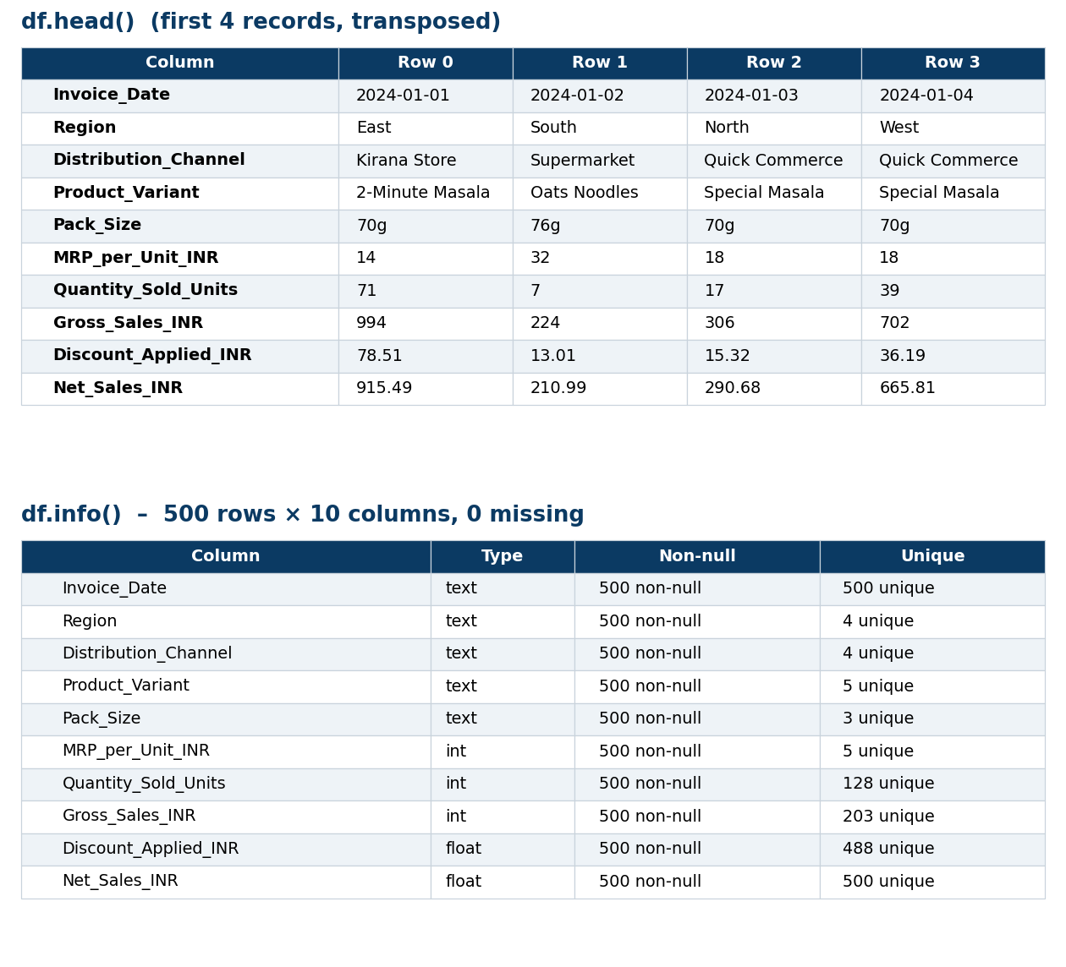
Figure 5.2: First records (transposed) and column summary of the dataset
During preprocessing, Invoice_Date is renamed to Date and Net_Sales_INR to Sales, and one daily series is built. The internal model-ready structure is therefore a two-column table (Date, Sales) with 500 rows.

Exploratory analysis
Daily net sales range from roughly ₹200 to ₹2,100, with a mean of about ₹946 and a median of about ₹884; the distribution is slightly right-skewed (Figure 5.3).
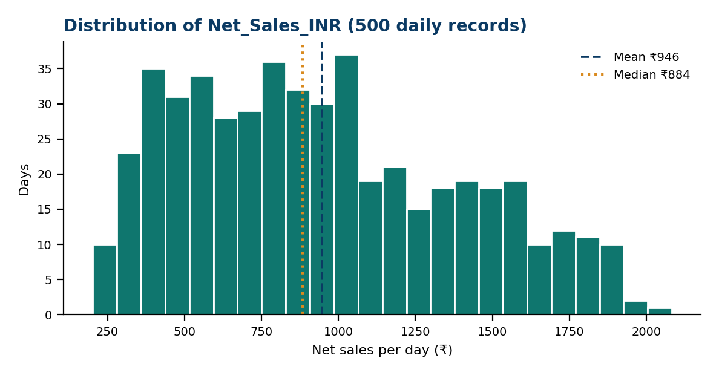
Figure 5.3: Distribution of daily Net_Sales_INR (500 records)
The correlation matrix (Figure 5.4) shows that net sales are strongly linked to quantity sold (0.81), as expected, and that gross and net sales are almost perfectly correlated (1.00). MRP is negatively correlated with quantity (-0.53) and almost uncorrelated with net sales (-0.02), which suggests that sales volume rather than price level drives daily revenue in this dataset.
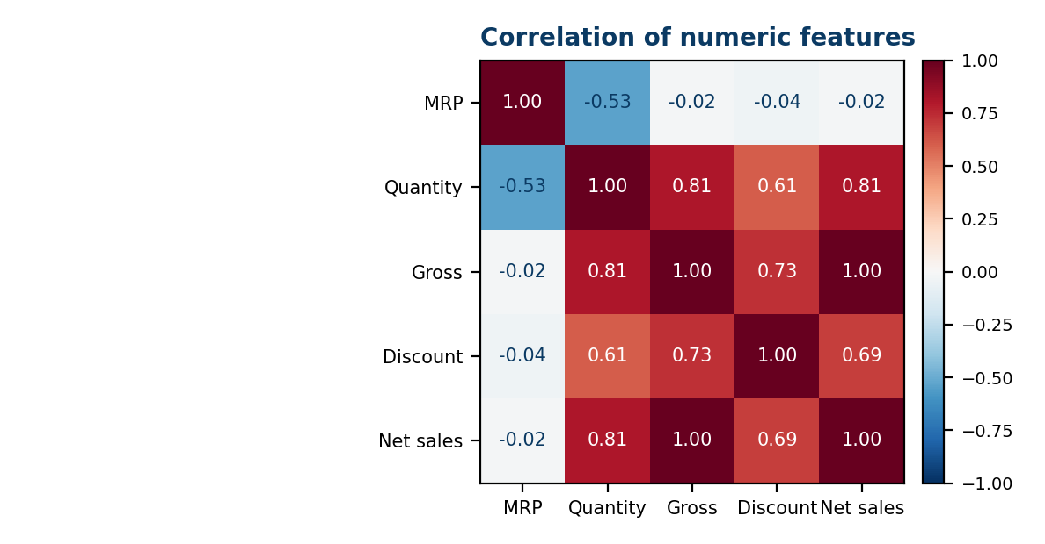
Figure 5.4: Correlation of numeric features

CHAPTER 6
Implementation

6.1 Module-wise implementation
The system is divided into four modules. Each team member was responsible for specific modules, as shown in Table 6.1.
Table 6.1: Modules and team contribution
Module | Purpose | Input → Output | Developed by
1. Data Cleaning & Quality Scoring | Clean data and score its quality | Raw CSV/Excel → clean data + quality score | Anudeep (2420030148)
2. Anomaly Detection | Flag unusual sales spikes and drops | Clean series → anomaly flags | Anudeep (2420030148)
3. Forecasting & Evaluation | Train ARIMA and Prophet and pick the best | Series → forecasts + MAE/RMSE/MAPE | Jawwad (2420030075)
4. Streamlit Dashboard | Show results to business users; testing and documentation | All outputs → interactive charts | Pushpak (2420030107)

6.2 Front-end logic
The Streamlit script reads the page chosen in the sidebar and draws that page. The Upload Data page accepts CSV, XLSX and XLS files (limit 200 MB per file), shows a preview table and the number of rows and columns (500 and 10 for the Maggi file). Each later page calls the matching back-end module and shows its result: cleaning counts and the audit log, the quality scorecard, duplicate findings, anomaly bounds and chart, exploratory charts, and the forecast summary. Charts are interactive (hover, zoom, pan, download as image). The Load sample dataset button loads the demonstration data without a file upload.

6.3 Backend logic

Data cleaning and quality scoring (Module 1)
- The Run Automated Cleaning action standardises null values, strips trailing whitespace, validates dates, removes rows with negative sales, price or quantity (an optional checkbox), drops exact duplicate rows and imputes missing values.
- Every run produces an audit trail: a cleaning summary (clean records retained, rows removed, missing values fixed, duplicates removed), an audit log of removed records and an imputation summary. A technical JSON report lists Original Rows, Final Rows, Rows Removed, Missing Values Before/Fixed/After, Invalid Dates, Invalid Numeric Values, Negative Values Removed, Exact Duplicates Removed and a reasons breakdown.
- On the Duplicate Detection page, exact duplicate rows are counted and a near-duplicate search compares the distinct values of a chosen text column using RapidFuzz (Levenshtein-based) matching. The user picks the column, the fuzzy matching method (token_sort was used) and a similarity threshold (default 80%); up to 1,000 distinct values are compared, and the threshold can be tuned to limit false positives.
- The Data Quality page shows a weighted scorecard of four dimensions: Completeness (30%), Validity (30%), Consistency (20%) and Uniqueness (20%). The overall score is their weighted aggregate, and a score above 90% is rated Excellent for downstream forecasting. The Maggi dataset scored 100% on every dimension.

Anomaly detection (Module 2)
Two simple, explainable statistical rules are applied to the daily series:
- IQR rule: a value is flagged if it lies below Q1 − 1.5 × IQR or above Q3 + 1.5 × IQR.
- Z-score rule: a value is flagged if its absolute Z-score is greater than 3.
On the Anomaly Detection page the user chooses the detection algorithm and a treatment action. With the IQR algorithm and the Flag Only action the page displayed the bounds [-451.02, 2294.06] and 0 detected anomalies on the clean Maggi data. Flagged days are highlighted on the trend chart but are not removed automatically, because a holiday spike is a real event and should not be deleted from the history.

Forecasting and evaluation (Module 3)
The data are split chronologically: the first 80% of days train the models and the last 20% (100 days) are held out. There is no shuffling, so the models never see future data during training.
- ARIMA(p, d, q) from Statsmodels. Differencing makes the series stationary, ACF/PACF plots guide the choice of p and q, and the final order is chosen by AIC. ARIMA is univariate.
- Prophet with weekly seasonality and India public holidays added. Yearly seasonality is not used because 500 days is too short a history to learn it reliably.
Three error metrics are computed on the hold-out window, where y is the actual value, ŷ the forecast and n the number of test days:
- MAE = (1/n) Σ |y − ŷ|
- RMSE = √[ (1/n) Σ (y − ŷ)² ]
- MAPE = (100/n) Σ |(y − ŷ) / y|
The model with the lowest MAPE (and RMSE) on the same hold-out window is selected as the best model. On the Forecast page the user sets the forecast period (30 days in the demonstration), the model (Auto Select) and how missing dates are filled (Zero), then presses Run Forecast. The page shows the selected model, total predicted demand, average daily demand and forecast trend, an automatic business insight, a historical-versus-forecast graph, a model metrics table and the forecast data for export.

6.4 Database connectivity
There is no database connection. Data enters the system through file upload (CSV or Excel) and is read directly into Pandas. The design keeps the loading step in one function, so a database or API source can be added later without changing the other modules.

6.5 API integration
DemandIQ does not call any web API. The "integration" is between Python libraries: Pandas output feeds RapidFuzz and the anomaly rules, the cleaned series feeds Statsmodels and Prophet, Scikit-learn computes the metrics, and Streamlit and Plotly display everything.

6.6 Authentication & authorization
The present version is a single-user, locally run application and has no login or role system. Authentication and data-privacy controls are planned for a future cloud version (Chapter 11).

CHAPTER 7
Features

7.1 List of main features
- CSV / XLSX / XLS sales file upload with data preview
- Automated data cleaning with an audit trail and JSON report
- Exact and fuzzy near-duplicate detection (RapidFuzz)
- Weighted data quality score (completeness, validity, consistency, uniqueness)
- Anomaly detection with IQR and Z-score rules and a selectable treatment action
- Exploratory sales analytics (trend, monthly sales, distribution, moving average, categorical breakdown)
- Dual-model forecasting with ARIMA and Prophet and automatic model selection
- Automatic business insight and forecast data export

7.2 How each feature works
Table 7.1: Features and how they work
Feature | User perspective | Technical description
File upload | Drag and drop or browse for a CSV, XLSX or XLS file, or load the sample dataset. | Pandas reads the file (limit 200 MB); a preview, row count and column count are shown (500 rows, 10 columns).
Automated cleaning | One click cleans the file and shows exactly what was changed. | Null standardisation, whitespace stripping, date validation, negative-value removal, exact-duplicate removal and imputation, with an audit log and JSON report.
Fuzzy duplicates | Near-identical text values are found even when not exact copies. | RapidFuzz token_sort matching on a chosen column with an adjustable similarity threshold (default 80%).
Quality score | A weighted percentage and rating show how trustworthy the data is. | Completeness 30%, validity 30%, consistency 20%, uniqueness 20%; above 90% is Excellent. Tests: 100% on clean data and 95.6% after fault injection.
Anomaly detection | Unusual sales days are detected and shown on the trend chart. | IQR (bounds [-451.02, 2294.06] on the Maggi data) or Z-score rule, with a treatment action such as Flag Only.
Sales analytics | Charts show how sales behave over time and across categories. | Daily trend, monthly sales bars, box plot and histogram, 7-day moving average and a breakdown by a chosen category (e.g. Region).
Forecasting & auto selection | The user chooses a period and model and gets forecasts and the best model. | ARIMA and Prophet trained on the first 80% and compared on the last 20%; Auto Select picks the lowest error.
Business insight & export | A plain-language recommendation and downloadable forecast data. | The forecast summary (total, average, trend %) generates a text insight; the forecast table is exported as CSV.

CHAPTER 8
Testing and Results

8.1 Functional testing
Functional testing was automated with pytest. Test suites were written for the cleaning module, the quality-scoring module, the forecasting module and the complete end-to-end flow. All of these tests passed (100%). As DemandIQ has no REST back-end, Postman testing was not applicable and is replaced by these pytest suites.

8.2 Integration testing
Integration was verified with end-to-end tests that push a complete sales file through the full pipeline (upload → cleaning → anomaly detection → forecasting → evaluation → dashboard output). Test cases TC-01 to TC-04 in Table 8.1 exercise each hand-over between modules.

8.3 Tools used for testing
- pytest for automated unit and end-to-end tests.
- Fault injection on the Maggi dataset (duplicate rows, missing values and an artificial spike) to check that the pipeline reacts correctly.
- Chronological hold-out evaluation with MAE, RMSE and MAPE to validate the forecasting models.

8.4 Test cases and results
Table 8.1: Test cases and results
Test ID | Test description | Expected result | Actual result | Status
TC-01 | Upload a CSV / Excel sales file | File loads without errors | 500 rows loaded; Date and Sales validated, 0 missing. | Passed
TC-02 | Inject duplicate and missing rows | Issues detected; quality score drops | Quality score fell from 100% to 95.6%; 5 duplicates and 15 missing values found. | Passed
TC-03 | Insert an artificial sales spike | Spike flagged as anomaly | Spike of 10,413.9 exceeded the IQR upper bound (2,294.1) and was flagged. | Passed
TC-04 | Run both models on the hold-out | MAE, RMSE, MAPE computed; best model chosen | ARIMA (RMSE 406.8, MAPE 44.8%) vs Prophet (424.2, 52.0%); ARIMA selected. | Passed

8.5 Validation method and model performance
Validation method. A chronological hold-out was used: the last 20% of the series (100 days) was kept aside, with no shuffling and no future-data leakage, and both models were evaluated on exactly the same window. The results are in Table 8.2 and Figure 8.1.
Table 8.2: ARIMA vs Prophet on the hold-out period
Metric | ARIMA | Prophet | Better
MAE | 323.36 | 349.98 | ARIMA
RMSE | 406.81 | 424.22 | ARIMA
MAPE (%) | 44.77% | 51.97% | ARIMA
Training time (s) | 0.27 s | 4.37 s | ARIMA
Selected model | — | — | ARIMA

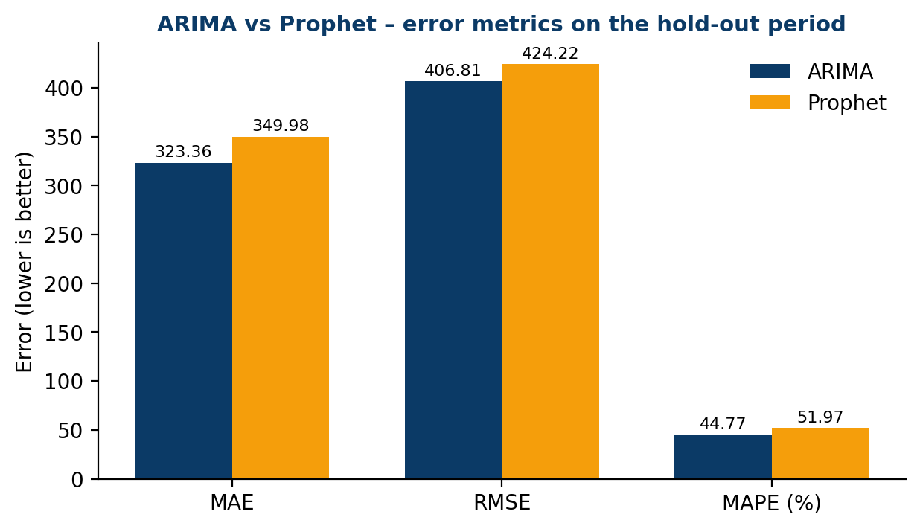
Figure 8.1: Error metrics of ARIMA and Prophet (lower is better)
Performance testing. ARIMA trained in 0.27 s and Prophet in 4.37 s, so ARIMA is about 16 times faster. The dashboard renders in under one second.
Forecast output. In the final dashboard run, a 30-day forecast starting on 15 May 2025 was produced with Auto Select, which chose ARIMA. The forecast summary showed a total predicted demand of 20,251 units, an average daily demand of 675 and a decreasing trend of 12.4%, together with the business insight “Avoid overstocking as demand softens.” (Figure 8.2a).
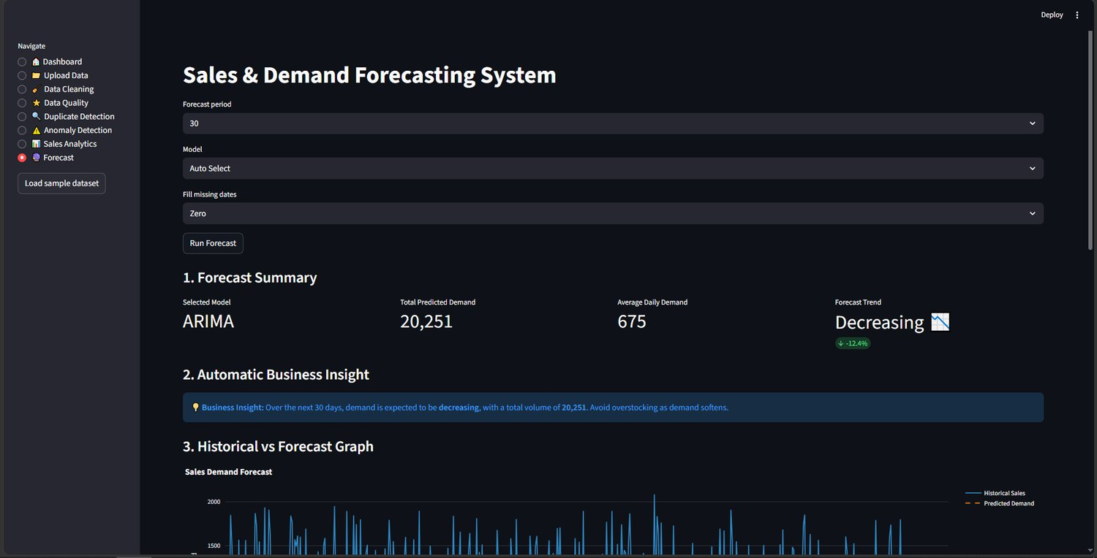
Figure 8.2a: Forecast summary and automatic business insight (30-day forecast)

8.6 Analysis of results
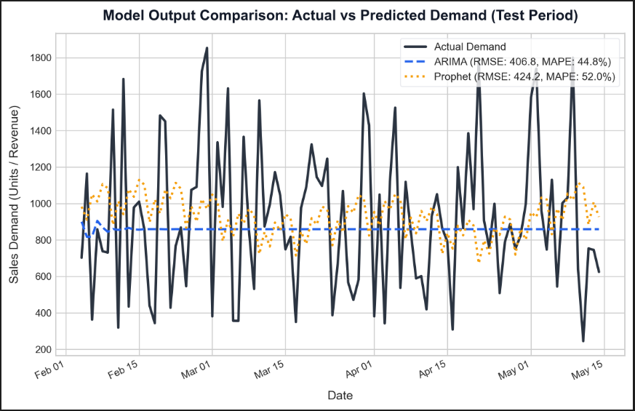
Figure 8.2: Actual vs predicted demand on the hold-out period
- Interpretation. ARIMA beat Prophet on every metric (MAPE 44.8% vs 52.0%, RMSE 406.8 vs 424.2). Prophet’s strength is yearly seasonality, which needs a multi-year history; with only 500 days it could use only the weekly pattern and holidays.
- Error analysis. Demand spikes and weekend peaks cause the largest errors, while steady weekdays are forecast best. In Figure 8.2 the ARIMA forecast flattens to an almost constant level, which is typical of multi-step ARIMA forecasts on a noisy series, whereas Prophet follows the weekly cycle more closely but with a larger average error.
- Key drivers. The weekly cycle (weekend versus weekday), channel mix and pack-size popularity.
- Honest reading of the numbers. A MAPE of about 45% shows that day-by-day sales in this dataset are very volatile and that these are baseline results. They are best viewed as a comparison between the two models rather than as production-grade accuracy; longer history and more features should improve them.

CHAPTER 9
Deployment

9.1 Steps to deploy
1. Install Python 3.10 or later and Git on the target machine.
2. Clone the project repository: [GitHub URL].
3. Create and activate a virtual environment.
4. Install the dependencies: pandas, numpy, rapidfuzz, statsmodels, prophet, scikit-learn, streamlit, plotly, matplotlib (and pytest for testing).
5. Start the dashboard with: streamlit run [app.py – replace with the actual entry file]
6. Open the address shown in the terminal (by default http://localhost:8501) in a web browser and upload a sales file.

9.2 Environment configuration
The application needs only a Python 3.10+ environment with the libraries above; no environment variables, API keys or database credentials are required. Using a virtual environment keeps the library versions isolated, and a requirements file is recommended so the same versions can be installed on another machine.

9.3 Hosting of frontend and backend
Front end and back end run together in a single Streamlit process, currently hosted locally on the user’s machine. The same package can be moved to a cloud platform without code changes, because it has no machine-specific dependencies; this is listed as a future enhancement.

CHAPTER 10
Challenges & Limitations

10.1 Issues faced during development
- Short history. Only 500 days of data are available, so only a weekly pattern can be learned and no yearly seasonality.
- Holiday spikes versus real anomalies. A spike caused by a holiday looks like an outlier to a statistical rule.
- Fuzzy-duplicate false positives. Similar-looking but genuinely different records can be wrongly flagged as duplicates.

10.2 Solutions applied
- Weekly seasonality is modelled explicitly and yearly seasonality is switched off for Prophet.
- Anomalies are flagged rather than deleted, and the India holiday calendar is added to Prophet so that holiday effects are modelled instead of being treated as errors.
- The RapidFuzz similarity threshold is tuned to reduce false positives.

10.3 Current limitations or known bugs
- Forecasts are made for daily totals only; there are no region-wise or variant-wise forecasts.
- Only statistical models (ARIMA and Prophet) are used; there are no machine-learning or deep-learning models.
- The system has been validated on one dataset (Maggi, 500 days).
- There is no login, no persistent storage and no cloud deployment yet.

CHAPTER 11
Future Enhancements

11.1 Planned features
- Improve performance: hyperparameter tuning and additional models such as LightGBM or LSTM.
- Expand data and features: more datasets and product-level as well as daily data, including region and variant forecasts.
- Build an interface for retailers: a cloud web app or API.
- Scale and secure: cloud scaling, user login and data privacy.

11.2 Possible integrations or optimizations
- Integration with billing or point-of-sale systems to fetch invoices automatically instead of uploading files.
- Use of an ensemble of ARIMA, Prophet and machine-learning models, since the literature shows that combination methods can help.
- Persistent storage (database) so that past forecasts and quality reports can be tracked over time.
- Applications in retail and e-commerce inventory planning, staffing and promotion planning, and supply-chain and warehouse demand planning.

CHAPTER 12
Conclusion

12.1 Summary of the project
DemandIQ cleans, quality-scores and forecasts Maggi daily sales using Python, ARIMA, Prophet and Streamlit. It makes data quality and model choice part of the forecasting pipeline: it scores the data, flags anomalies, compares ARIMA and Prophet on the same hold-out and shows everything in a single dashboard.

12.2 What was achieved
All four objectives set in Chapter 1 were met (4 of 4):
Table 12.1: Objectives versus outcomes
Objective | Outcome
1. Cleaning pipeline with a quality score | Achieved: missing, invalid and fuzzy-duplicate records are handled and a quality score is reported (100% on the clean data, 95.6% after fault injection).
2. Anomaly detection before training | Achieved: IQR / Z-score rules flagged the injected spike of 10,413.9 above the bound of 2,294.1.
3. ARIMA and Prophet with auto-selection | Achieved: both models were compared on one hold-out; ARIMA won with RMSE 406.8 and MAPE 44.8% against Prophet’s 424.2 and 52.0%.
4. Interactive dashboard | Achieved: Streamlit dashboard showing trends, quality scores, anomalies, forecasts and insights.

The headline result is a lowest MAPE of 44.8% achieved by ARIMA, which was auto-selected as the better model.

12.3 Skills learned during development
- Time-series modelling with ARIMA (stationarity, differencing, ACF/PACF, AIC) and Prophet (trend, seasonality, holidays).
- Data-quality engineering: missing-value handling, fuzzy matching and anomaly detection.
- Model evaluation with MAE, RMSE and MAPE and leakage-free chronological validation.
- Building interactive dashboards with Streamlit and Plotly.
- Automated testing with pytest, and team collaboration with Git and GitHub.

CHAPTER 13
References
[1] S. J. Taylor and B. Letham, “Forecasting at scale,” The American Statistician, vol. 72, no. 1, pp. 37–45, 2018.
[2] G. E. P. Box, G. M. Jenkins, G. C. Reinsel and G. M. Ljung, Time Series Analysis: Forecasting and Control. Wiley, 2015.
[3] M. R. Hasan, M. A. Kabir, R. A. Shuvro and P. Das, “A Comparative Study on Forecasting of Retail Sales,” arXiv:2203.06848, 2022.
[4] Maggi sales dataset (CSV), 500 daily invoice records, 1 Jan 2024 – 14 May 2025.
[5] S. Aras, İ. D. Kocakoç and C. Polat, “Comparative study on retail sales forecasting between single and combination methods,” J. Bus. Econ. Manag., vol. 18, no. 5, 2017.
[6] RapidFuzz and Streamlit documentation (rapidfuzz.github.io, docs.streamlit.io).
Project links: GitHub: [GitHub URL] | Demo video: [Demo video URL]

CHAPTER 14
Appendices

Appendix A: Screenshots of the application
Figures A.1 to A.11 show the implemented DemandIQ dashboard running on the Maggi sales dataset.
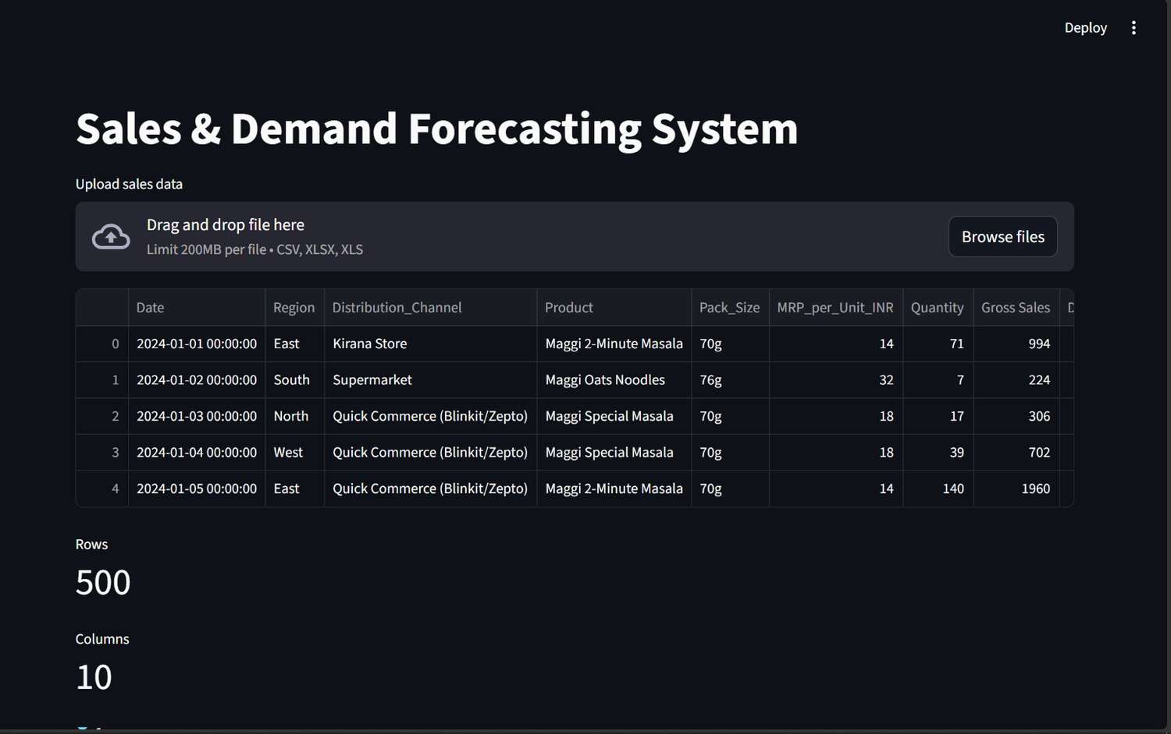
Figure A.1: Upload Data page with file preview (500 rows, 10 columns)
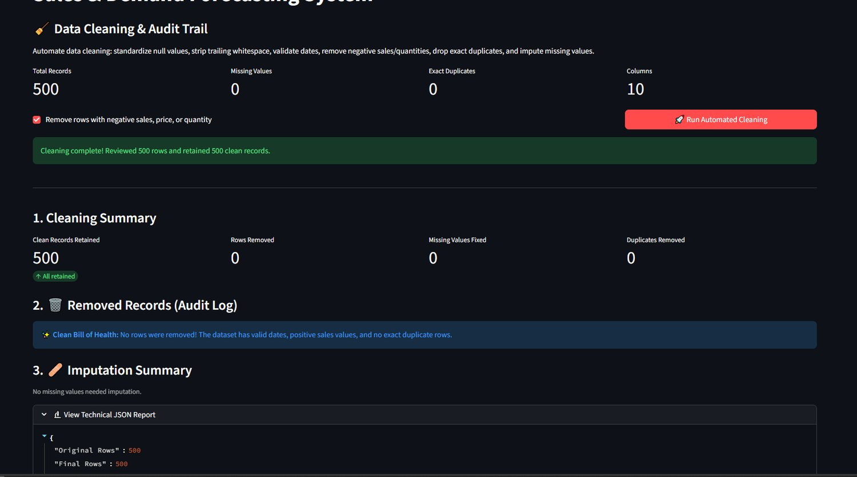
Figure A.2: Data Cleaning & Audit Trail page (500 rows reviewed, 500 retained)
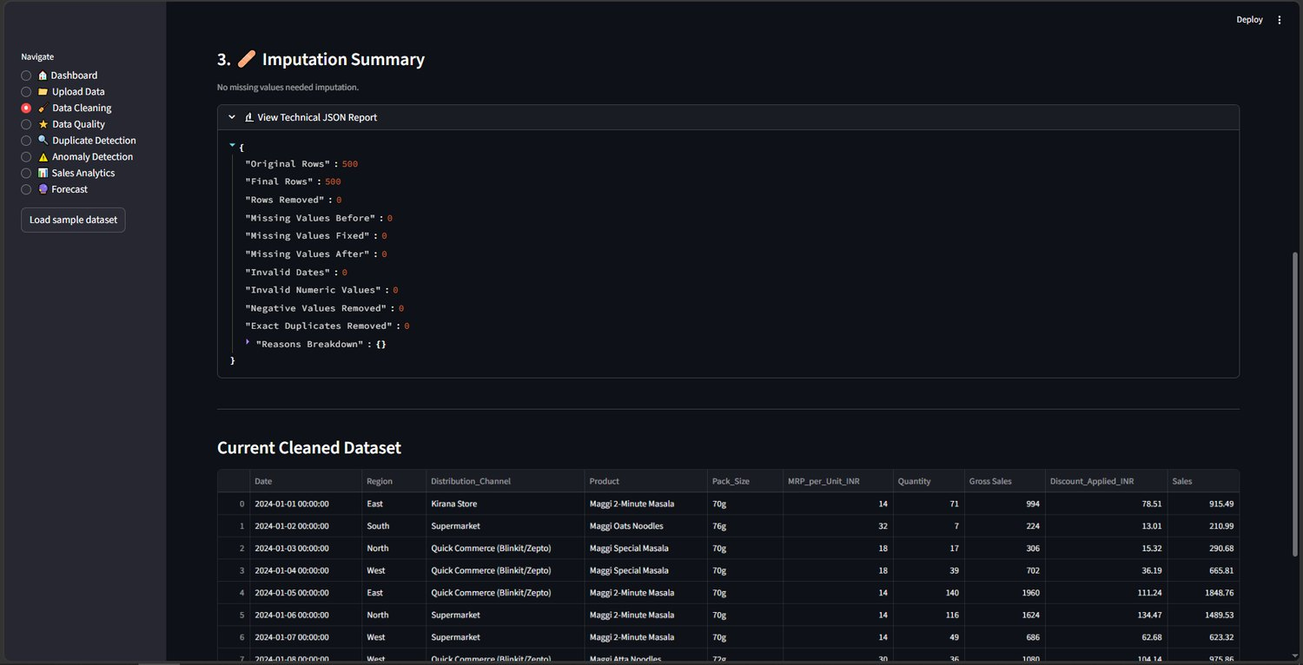
Figure A.3: Imputation summary, technical JSON report and cleaned dataset
Figure A.4: Data Quality Assessment with weighted dimension scores
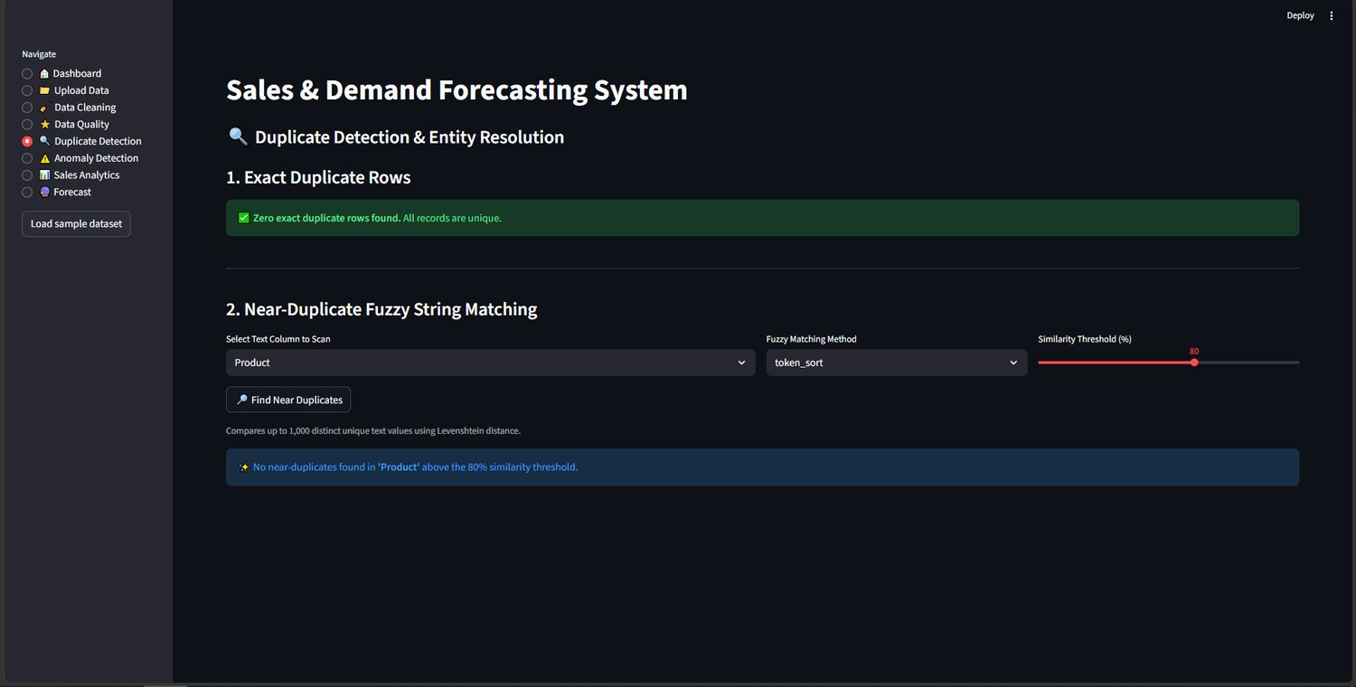
Figure A.5: Duplicate Detection and Entity Resolution (exact and fuzzy matching)
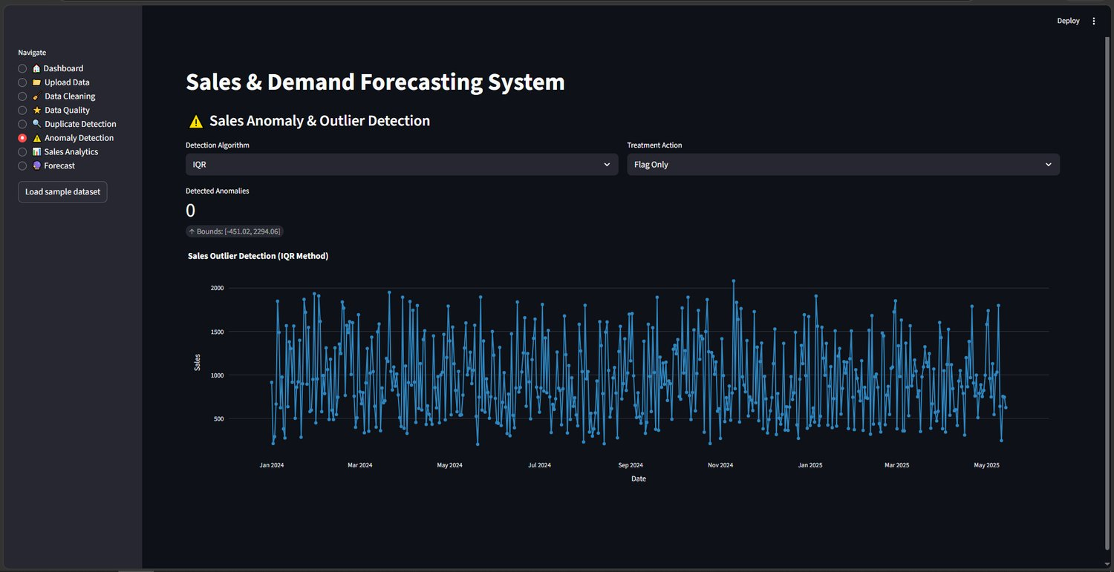
Figure A.6: Sales Anomaly & Outlier Detection (IQR, bounds [-451.02, 2294.06])
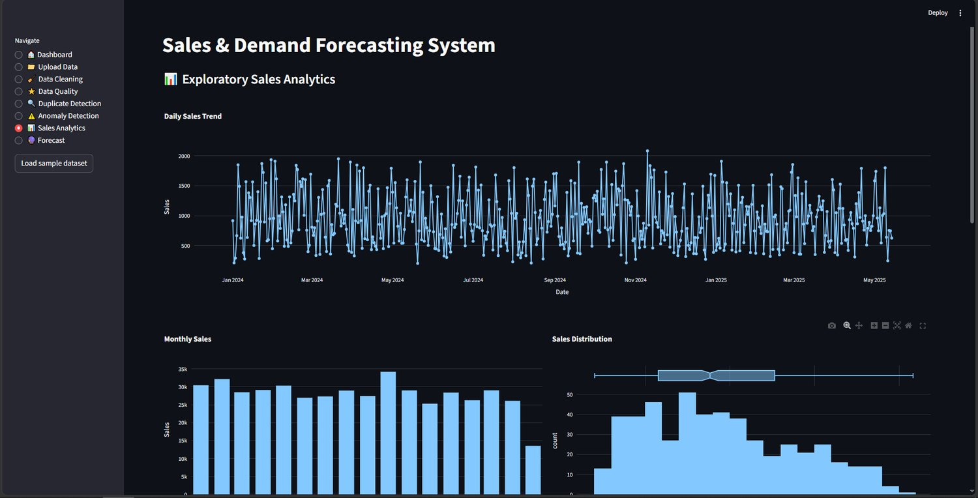
Figure A.7: Exploratory Sales Analytics – daily trend, monthly sales and distribution
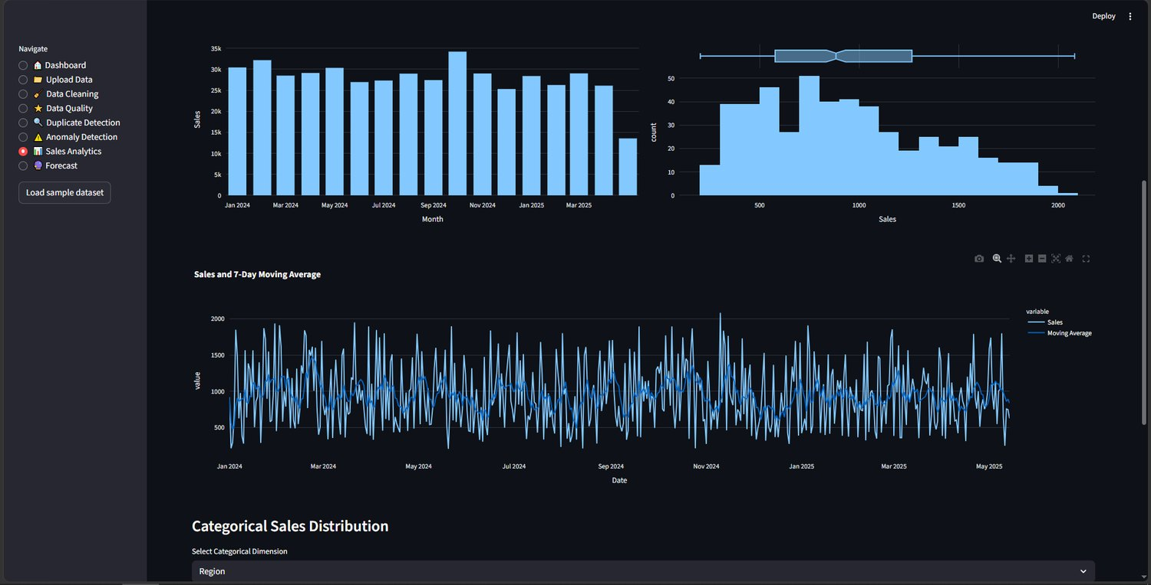
Figure A.8: Sales and 7-day moving average
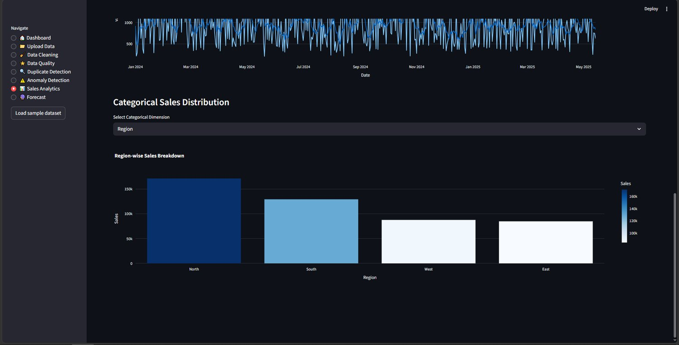
Figure A.9: Region-wise sales breakdown (North highest, East lowest)
Figure A.10: Forecast page – summary and automatic business insight
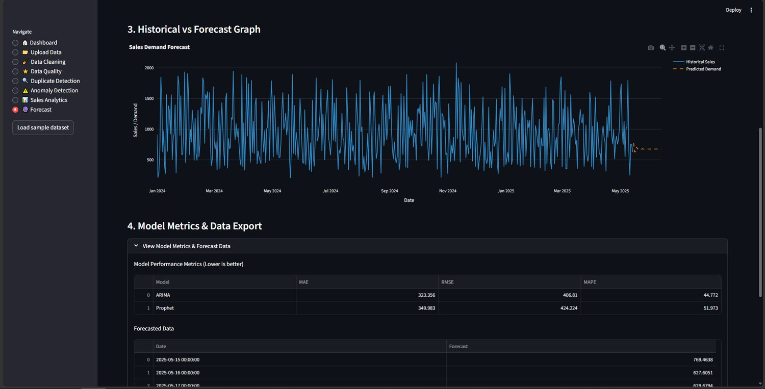
Figure A.11: Historical vs forecast graph and model performance metrics

Appendix B: Sample code snippet
Core of the model-building step (chronological split, ARIMA, Prophet and model selection):
split = int(len(series) * 0.8) # 80/20, no shuffle
train, test = series[:split], series[split:]

arima = ARIMA(train, order=(p, d, q)).fit()
a_pred = arima.forecast(steps=len(test))

m = Prophet(weekly_seasonality=True)
m.add_country_holidays("IN")
m.fit(train_df)
p_pred = m.predict(future)["yhat"]

best = min(scores, key=lambda k: scores[k]["mape"])

Appendix C: Installation / setup instructions
python -m venv venv
venv\Scripts\activate # Windows (Ubuntu: source venv/bin/activate)
pip install pandas numpy rapidfuzz statsmodels prophet scikit-learn
pip install streamlit plotly matplotlib pytest
streamlit run app.py # replace app.py with the actual entry file

Appendix D: User manual
1. Start the dashboard and open it in the browser (http://localhost:8501).
2. Open Upload Data and upload a CSV, XLSX or XLS sales file, or press Load sample dataset.
3. Open Data Cleaning, tick the negative-value option if required and press Run Automated Cleaning; read the cleaning summary and audit log.
4. Open Data Quality to read the weighted quality score and rating.
5. Open Duplicate Detection, choose a text column, method and similarity threshold, and press Find Near Duplicates.
6. Open Anomaly Detection, choose the algorithm and treatment action, and read the bounds and flagged days.
7. Open Sales Analytics to explore trends, monthly sales, distribution, moving average and category breakdowns.
8. Open Forecast, set the forecast period, model (Auto Select) and missing-date handling, press Run Forecast, and read the summary, insight, graph and metrics; export the forecast data if needed.

Appendix E: Certifications

This is to certify that the project report entitled " DemandIQ: Intelligent Sales & Demand Forecasting System" is a bonafide work carried out and submitted by G.Anudeep (Reg. No: 2420030148), Md. Jawwad (Reg. No: 2420030075), and G.Pushpak (Reg. No: 2420030107) in partial fulfillment of the requirements for the award of the degree of BACHELOR OF TECHNOLOGY in Department of Computer Science and Engineering, K L (Deemed to be) University, during the academic year 2026–2027.

_____________________  Signature of the Guide  Dr. N. Sunanda  Associate Professor, CSE | _____________________  Course Coordinator  Dr. N. Sunanda  Department of CSE | _____________________  Head of the Department  Dr.P. Venkateswara Rao  Department of CSE

