DemandIQ : Sales & Demand Forecasting System
Dr. N. Sunanda  Associate Professor, Department of CSE  KLH (Deemed to be University)  Bowrampet Campus, Hyderabad, India | Anudeep.G  Department of Computer Science and Engineering  KLH (Deemed to be University)  Bowrampet Campus, Hyderabad, India  2420030148@klh.edu.in
Pushpak.G  Department of Computer Science and Engineering  KLH (Deemed to be University)  Bowrampet Campus, Hyderabad, India  2420030107@klh.edu.in | Jawwad.Md  Department of Computer Science and Engineering  KLH (Deemed to be University)  Bowrampet Campus, Hyderabad, India  2420030075@klh.edu.in

Abstract—Accurate short-term sales forecasting is essential for effective inventory planning, staffing, and promotional decision-making in retail. However, raw sales data is frequently incomplete, duplicated, or noisy, and forecasting models trained on it inherit those errors. This paper presents DemandIQ, an end-to-end sales and demand forecasting system that combines automated data cleaning with an audit trail, a weighted data quality score, exact and fuzzy duplicate detection (RapidFuzz), IQR and Z-score anomaly detection, and two complementary time-series models — ARIMA and Prophet. The system is evaluated on a Maggi sales dataset of 500 daily invoice records (January 2024 to May 2025) using a chronological 80/20 hold-out. On the 100-day test window ARIMA outperformed Prophet on all three metrics (MAE 323.36 vs 349.98, RMSE 406.81 vs 424.22, MAPE 44.77% vs 51.97%) and trained about 16 times faster, so it was selected automatically. Tests with injected faults confirmed that duplicates, missing values, and an artificial sales spike were detected. All outputs are presented through an interactive Streamlit dashboard accessible to non-technical business stakeholders. Absolute errors remain high because daily sales are volatile, so the results are presented as a transparent, auditable baseline rather than production-grade accuracy.
Keywords—sales forecasting, demand forecasting, ARIMA, Prophet, time-series analysis, data quality, anomaly detection, Streamlit dashboard

I. INTRODUCTION
Retail and e-commerce businesses depend on accurate short-term sales forecasts to plan inventory, staffing, and promotional campaigns. Overestimating demand ties up capital in unsold stock, while underestimating it leads to stockouts and lost sales. In practice, most organizations rely on manual spreadsheets or a single forecasting model applied uniformly across all products and stores, without first verifying whether the underlying sales data is complete, duplicate-free, and free of anomalies.
Time-series forecasting methods fall broadly into three families. Classical statistical models such as ARIMA [2] describe a series through its own past values and past errors. Decomposable additive models such as Prophet [1] describe a series as the sum of a trend, periodic seasonality, and holiday effects. Machine-learning models, including gradient-boosted trees [15] and recurrent neural networks, learn non-linear relationships from engineered features and usually need larger volumes of data. Large benchmarks show that the winner depends on the data: in the M5 retail competition the best-performing submissions relied largely on gradient-boosted trees trained across thousands of related series [14], whereas for a single short series, as studied here and in [3], simpler statistical models remain competitive. Choosing a model in advance is therefore risky, and a practical system should compare candidates on the data at hand.
A second and less visible risk lies in the data itself. Raw sales exports contain missing weeks, impossible values, and duplicate records whose text fields differ only in spelling, spacing, or case. Data cleaning has long been recognized as a prerequisite for reliable analysis [16], yet in most forecasting studies it is performed once, by hand, and is not reported to the end user. A forecasting model trained on such data inherits its errors silently, and the business user has no way of knowing how far the forecast can be trusted.
This gap motivates the present work: a system that treats data quality as a first-class concern, detects unusual sales spikes or drops before they distort model training, and compares two complementary forecasting techniques, the classical statistical ARIMA model and the additive, seasonality-aware Prophet model, rather than committing to a single approach in advance.
The main contributions of this work are: (1) an integrated pipeline that scores data quality and flags duplicates and anomalies before any model is trained; (2) a side-by-side comparison of ARIMA and Prophet with automatic per-series model selection; (3) retention of the evaluation metrics behind each selection, so that the choice remains auditable; (4) an interactive dashboard that exposes every intermediate output of the pipeline to non-technical users; and (5) a leakage-free evaluation protocol with a documented set of fault-injection tests.
The remainder of this paper is organized as follows. Section II states the problem and objectives. Section III explains the system architecture. Section IV reviews existing forecasting approaches and identifies the gap this work addresses. Section V describes the proposed methodology, including the dataset, data cleaning, anomaly detection, the two forecasting models, and the evaluation protocol. Section VI walks through the dashboard implementation page by page. Section VII presents the experimental results and discussion, Section VIII covers limitations, threats to validity, and future work, and Section IX concludes the paper.

II. PROBLEM STATEMENT AND OBJECTIVES
Retail forecasting in practice suffers from three linked problems. First, source data is rarely analysis-ready: exports contain missing weeks, negative or impossible values, and duplicate rows whose text fields differ only in spelling, spacing, or case. Second, a single model is often applied to every product and store, even though series differ in length, volatility, and seasonal strength. Third, model outputs are typically delivered as static notebooks or spreadsheets that decision makers cannot interrogate. Errors introduced at any of these steps propagate silently into inventory and staffing decisions.
Formally, let R be a raw sales table with at least a date column and a numeric sales column. The system must produce (i) a cleaned daily series y₁, …, y_{T} together with an audit trail of every change made to R; (ii) a data quality score Q and a set of flagged anomalous days; (iii) forecasts ŷ_{T+1}, …, ŷ_{T+h} from two candidate models; and (iv) the identity of the model with the lower error on a held-out window, together with the metrics that justify the choice.
The objectives of this work are: (1) to detect and quantify missing, invalid, and duplicate records and summarize them in a single data quality score; (2) to identify anomalous sales observations without discarding genuine demand events; (3) to train ARIMA and Prophet models on the cleaned daily series; (4) to evaluate both models on a held-out time window using MAE, RMSE, and MAPE and select the better model automatically; (5) to present the full pipeline through an interactive dashboard for non-technical stakeholders; and (6) to define a reproducible evaluation protocol that avoids temporal leakage.
The intended users are store managers, sales and business analysts, small retailers and distributors, and supply-chain or warehouse planners who need short-term demand forecasts but may not have a data-science team. Typical uses are inventory planning, staffing and promotion planning, and warehouse demand planning. These users shape the requirements below.
Functional requirements. The system shall (FR1) accept CSV, XLSX, and XLS sales files; (FR2) clean the data and report every change; (FR3) compute and explain a data quality score; (FR4) find exact and near-duplicate records; (FR5) flag anomalous days; (FR6) forecast daily sales with two models and select one; (FR7) present all results in an interactive interface; and (FR8) let the user export the forecast. Non-functional requirements. The system shall be transparent, so that every automated decision can be inspected; reproducible, so that the same file gives the same results; light enough to run on an ordinary laptop with no GPU; and responsive, so that the dashboard renders in under one second once results are computed.
Assumptions. The work assumes that the business question is a short-term forecast of daily net sales, that the input is a billing-style export with one record per day or per invoice, that sales history is the only predictor available, and that the public-holiday calendar of India is relevant to the demonstration data. If these assumptions fail, for example for intermittent demand with many zero days, the conclusions on model ranking and on MAPE would need to be re-examined.
The scope of this version is deliberately bounded. The system forecasts a single daily net-sales series; it does not forecast at region or product-variant level, does not use deep-learning models, and has no user authentication or cloud hosting. These items are discussed as future work in Section VIII.

III. SYSTEM ARCHITECTURE

A. Pipeline View
Fig. 1 shows the proposed pipeline as a data-flow diagram. The five boxes on the left, connected by solid arrows, are the processing stages; the tall box on the right is the Streamlit dashboard; and the dashed arrows show that every stage also sends its output to the dashboard. The diagram should be read from top to bottom. Raw CSV or Excel sales data enters at the top. The cleaning and quality-scoring stage, built on Pandas, NumPy, and RapidFuzz, produces the cleaned series, the audit trail, and the quality score. The anomaly-detection stage then flags spikes and drops without removing them, as the box label states. The flow then splits into two parallel branches, ARIMA (Statsmodels) and Prophet (trend, seasonality, holidays), which both consume the same cleaned series and are therefore directly comparable. The two branches rejoin in the evaluation and selection stage, which computes MAE, RMSE, and MAPE with Scikit-learn and chooses the better model.
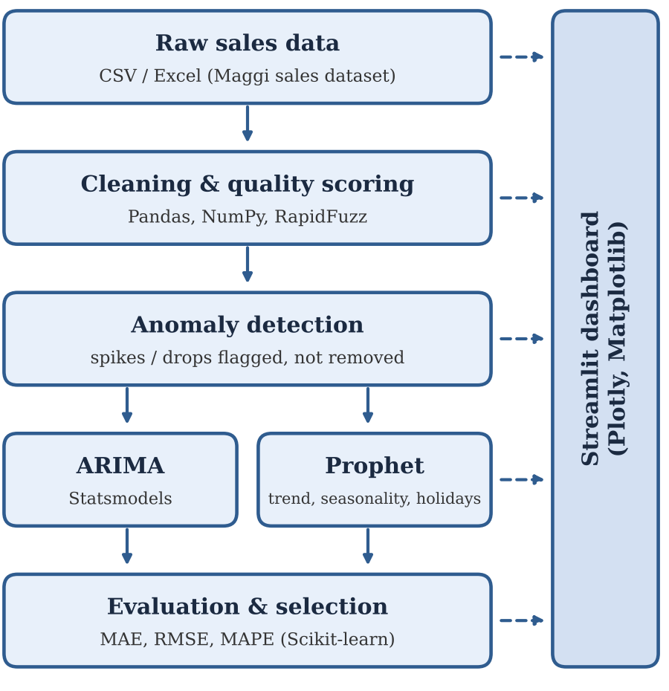
Fig. 1. Proposed pipeline of the Sales & Demand Forecasting System. Solid arrows show data flow between stages; dashed arrows show that each stage exposes its output to the dashboard.
The dashed arrows are the architectural feature that distinguishes the system from a notebook workflow. Each stage exposes its intermediate output (cleaned data, quality score, anomaly flags, forecasts, and evaluation metrics) so that the dashboard can present the full pipeline, not just the final forecast, to the end user. A manager can therefore see why a forecast should or should not be trusted: a low quality score or a flagged anomaly is visible before the forecast is read. The parallel ARIMA and Prophet branches also mean that adding a third model, such as a gradient-boosted learner, requires only a new branch before the evaluation stage.
Table I lists what each stage exposes and where the user sees it. The mapping is one-to-one: every analytical output has a dedicated page, which makes the dashboard a faithful view of the pipeline.
Stage | Output exposed | Dashboard page
Ingestion | File preview, row and column counts | Upload Data
Cleaning | Summary, audit log, imputation summary | Data Cleaning
Quality scoring | Four dimension scores, overall rating | Data Quality
Duplicate search | Exact and fuzzy matches | Duplicate Detection
Anomaly detection | Bounds, flagged days | Anomaly Detection
Exploration | Trend, monthly, distribution, region | Sales Analytics
Forecast and evaluation | Summary, insight, graph, metrics, export | Forecast
TABLE I. STAGE OUTPUTS EXPOSED TO THE DASHBOARD

B. Layered View
Fig. 2 presents the same system as four layers, numbered from 1 to 6 in the order of execution. The layout is a snake: the top row runs left to right (1 Data Input, 2 Cleaning & Quality Score), the arrow then drops to 3 Anomaly Detection, runs right to left to 4 Forecasting Engine, drops to 5 Evaluation & Selection, and finally runs left to right to 6 Streamlit Dashboard. The footer of the figure labels the four layers: Input → Processing → Forecasting → Output. Blue boxes (1, 2, 3, and 6) are the input, processing, and presentation components, while the two green boxes (4 and 5) form the forecasting layer, where the models are trained and compared.
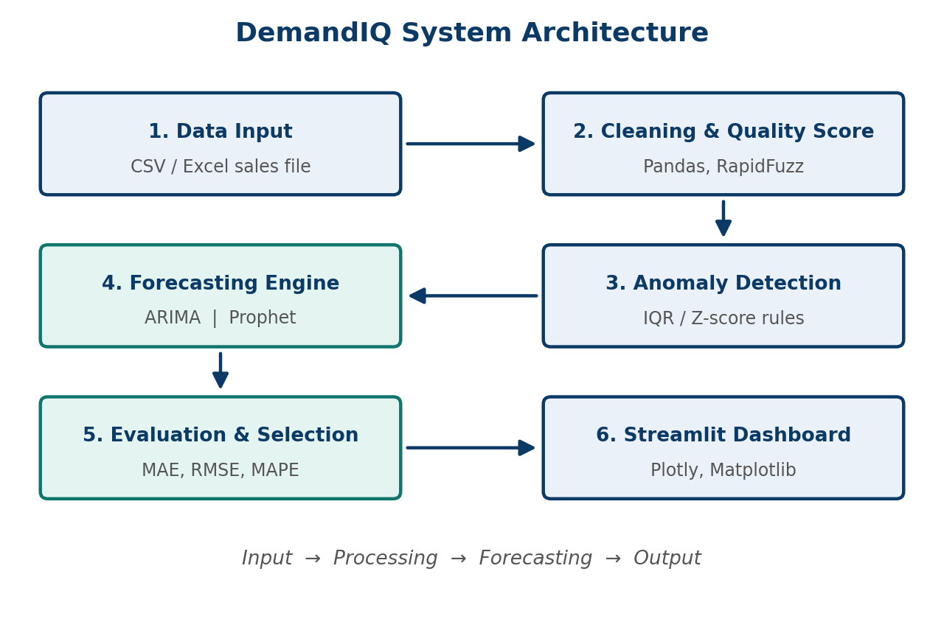
Fig. 2. Layered architecture of DemandIQ: input, processing, forecasting, and output layers.
1) Input layer. Loads the CSV or Excel sales file into a Pandas data frame, parses the date column, and validates the sales columns. 2) Processing layer. Handles cleaning, quality scoring, duplicate detection, and anomaly flagging; anomalies are flagged but not deleted. 3) Forecasting layer. Splits the daily series chronologically, trains ARIMA and Prophet on the first 80%, predicts the held-out 20%, computes MAE, RMSE, and MAPE, and selects the model with the lowest error. 4) Presentation layer. Displays the upload preview, cleaning audit trail, quality scores, duplicate and anomaly results, sales analytics, forecasts, and automatic business insights through a sidebar-navigated Streamlit application for non-technical users.

C. Data Flow and Deployment
DemandIQ does not use a database. Input is read from the file supplied by the user, and all intermediate results (clean data, quality scores, anomaly flags, and forecasts) are held in memory as Pandas data frames while the dashboard session is active. This keeps the system lightweight and removes any need for credentials or connection management. The loading step is kept in one function, so a database or billing-system source can later be added without changing the other modules. No paid or online API is used; the only external data is the India public-holiday calendar, which Prophet loads through its built-in country-holiday support.
The current deployment is a single-machine, local Streamlit web application: the user starts the Streamlit server on a laptop or desktop and opens the dashboard in a browser (by default on port 8501). Front end and back end run together in one Streamlit process, which calls the Python modules directly, so there is no separate web server, application server, or CI/CD pipeline. The minimum configuration is an Intel i5 or AMD Ryzen 5 class processor with 8 GB of RAM and Python 3.10 or later; no GPU is needed because only classical statistical models are used. Because the application is pure Python with pip-installable dependencies, it is cloud-ready and can later be hosted on a cloud platform or exposed as an API.
Scalability. The cost of each stage is modest for daily series. Cleaning is linear in the number of rows, fuzzy matching is quadratic in the number of distinct values (hence its cap), and ARIMA and Prophet each fit a single univariate series, which took 0.27 s and 4.37 s for 400 training days. A system that forecasts every product and region separately would multiply these costs by the number of series, which is manageable for hundreds of series on one machine but would call for batch processing or a cloud deployment at larger scale.

D. Software Components
Table II lists the software components used at each stage. Source code is managed with Git and GitHub, and the automated tests are written with pytest.
Stage | Tools | Purpose
Data cleaning | Pandas, NumPy | Missing, invalid, and duplicate records
Duplicate detection | RapidFuzz | Fuzzy matching of near-duplicate text fields
ARIMA | Statsmodels | Box-Jenkins forecasting
Prophet | Prophet | Trend, seasonality, and holiday effects
Evaluation | Scikit-learn | MAE, RMSE, and MAPE
Dashboard | Streamlit, Plotly, Matplotlib | Interactive visualization
Testing | pytest | Automated unit and end-to-end tests
TABLE II. SOFTWARE COMPONENTS AT EACH PIPELINE STAGE

E. Design Rationale
Four design decisions shape the architecture. A linear pipeline. Cleaning precedes anomaly detection, which precedes forecasting, because each step depends on the quality of the previous one: duplicates left in the data would distort the quartiles used by the IQR rule, and an uncorrected spike would distort the fitted models. Flag rather than delete. A statistical rule cannot tell a data-entry error from a festival peak, so the default is to show the suspicious days and let the user decide. Two models on one window. Evaluating both on the identical hold-out window makes the comparison fair and removes the need to guess in advance which model suits the series. In-memory state with no database. This keeps installation to a single pip command and keeps sensitive sales files on the user’s own machine, at the price of losing history between sessions, which is listed as a limitation in Section VIII.

F. Extensibility
The modular structure makes two kinds of extension straightforward. A new forecasting model needs only to be fitted on the training part of the cleaned series and to return forecasts for the test window; the evaluation stage then scores it with the same metrics, and the selection rule picks the best of three or more candidates without further change. A new data-quality dimension, such as timeliness or plausibility of ranges, can be added to the weighted score as long as the weights are rebalanced to sum to one, and it will appear as an additional bar on the Data Quality page. Both extensions follow from the choice to keep every stage’s output as a plain data frame or a small set of numbers rather than as state hidden inside a model object.

IV. LITERATURE SURVEY
A range of prior work addresses time-series forecasting individually, but few studies combine data quality assurance with multi-model comparison in a single deployable system. This section reviews the literature in five groups and summarizes it in Table III.

A. Statistical Time-Series Models
Box and Jenkins [2] established the ARIMA methodology, using differencing and autocorrelation analysis to model stationary time series. ARIMA remains strong on well-behaved, short-horizon series but requires manual parameter tuning and struggles with multiple overlapping seasonalities. Its central assumption is that the series becomes stationary after differencing, so that its mean and autocovariance do not depend on time; when this holds, a compact model with only a few parameters can describe the short-term dependence of today’s value on recent values and recent errors. Hyndman and Athanasopoulos [4] recommend benchmarking against simple methods such as seasonal naive forecasts and validating with time-ordered splits rather than random ones, practices adopted in this work.

B. Decomposable Additive Models
Taylor and Letham [1] introduced Prophet, an additive regression model combining trend, weekly and yearly seasonality, and holiday effects, designed for automatic fitting with minimal manual tuning and for analysts who are not forecasting specialists. It performs well on business time series with strong seasonality and several seasons of history, but is less precise on series with complex short-term autocorrelation. The design philosophy in [1] is an analyst-in-the-loop approach: the model has interpretable parameters, such as the flexibility of the trend and the list of holidays, that a non-specialist can adjust using domain knowledge, which is why it suits a dashboard aimed at business users.

C. Machine-Learning and Combination Methods
Chen and Guestrin [15] proposed XGBoost, a scalable gradient-boosted tree system that has become a standard learner for tabular and lagged-feature forecasting problems. The M5 accuracy competition [14] evaluated a large set of methods on hierarchical retail unit sales and found that the best submissions were dominated by tree-based machine learning rather than classical models. Aras et al. [13] compared single and combination forecasting methods on weekly retail sales of ten products and reported that no single model outperformed all others across all series, while most combined forecasts gave statistically significant accuracy gains. These findings support comparing several models per series, and motivate the ensemble extension discussed in Section VIII.

D. Comparative Studies
A comparative study [3] benchmarking ARIMA, Prophet, and LightGBM on Walmart M5 retail data reported the lowest RMSE for ARIMA and the highest for Prophet, which shows that no model can be assumed best in advance and that the answer depends on the series. Because no single model is expected to dominate, this work compares two rather than committing to one in advance.

E. Data Quality and Anomaly Detection
Rahm and Do [16] classify data quality problems into single-source and multi-source, schema-level and instance-level problems, and survey cleaning approaches including duplicate elimination. Chandola et al. [8] survey anomaly detection and distinguish point, contextual, and collective anomalies, a distinction that matters for sales data because a festival peak is an anomaly statistically but a genuine event commercially.

F. Research Gap and Positioning
Taken together, these studies leave a clear opening. Reference [3] shows that a classical model can beat a decomposable model on retail data, [13] shows that no single model wins on every series, and [14] and [15] show that machine-learning models need large, related collections of series to pay off. The data-layer work in [16] and [8] supplies mature techniques for cleaning, duplicate elimination, and outlier detection, but these techniques are not connected to the forecasting step in the forecasting studies above. The present work does not propose a new forecasting algorithm; its contribution is the composition of these established building blocks into one transparent pipeline whose every stage can be inspected, and whose model choice is made by the data rather than by the analyst.
Across this literature, model comparison is typically the end point of the study. Data-quality verification, duplicate detection, and anomaly detection are rarely treated as part of the forecasting pipeline itself, and results are usually reported in a static notebook rather than an interactive decision-support tool that a non-technical stakeholder could use directly. The system proposed in this paper is designed to close that gap.
Ref. | Method | Key finding and gap
[1] | Prophet: additive trend, seasonality, holidays | Automatic, analyst-friendly; needs long history for yearly seasonality
[2] | ARIMA (Box–Jenkins) | Strong short-horizon baseline; manual tuning; one model only
[3] | ARIMA vs Prophet vs LightGBM on M5 data | ARIMA lowest RMSE, Prophet highest; accuracy only, no data-quality stage
[13] | Single vs combination methods, weekly retail sales | No single model best on all series; combinations often better
[14] | M5 competition, hierarchical retail sales | Tree-based ML led; needs many related series
[15] | XGBoost gradient-boosted trees | Scalable learner; needs feature engineering and more data
[16] | Data cleaning survey | Taxonomy of data errors; not linked to forecasting
[8] | Anomaly detection survey | Point, contextual, collective anomalies; no sales dashboard
TABLE III. SUMMARY OF RELATED WORK

V. PROPOSED METHODOLOGY
The methodology follows the order in which a sales file travels through the system: the data is collected and profiled (Section V-A), cleaned and scored (V-B), screened for anomalies (V-C), forecast by two models (V-D), and the models are evaluated and one is selected (V-E). Each step is designed so that its result is visible to the user rather than hidden inside a notebook.

A. Data Collection and Profiling
The system is developed and validated using a Maggi (instant noodles) sales dataset [5] of 500 daily invoice records from 1 January 2024 to 14 May 2025. Each record has 10 attributes: invoice date, region (4 values), distribution channel (4), product variant (5), pack size (3), MRP per unit, quantity sold, gross sales, discount applied, and net sales in INR (Table IV). The dataset has no missing values and no duplicate rows. The forecasting target is net sales (gross sales minus discount).
Column | Type | Description
Invoice_Date | date | Daily record; 500 unique values
Region | text | 4 regions (East, South, North, West)
Distribution_Channel | text | 4 channels, e.g., Kirana Store, Supermarket, Quick Commerce
Product_Variant | text | 5 Maggi variants
Pack_Size | text | 3 pack sizes, e.g., 70 g, 76 g
MRP_per_Unit_INR | integer | Retail price per unit; 5 distinct values
Quantity_Sold_Units | integer | Units sold in the record
Gross_Sales_INR | integer | Sales value before discount
Discount_Applied_INR | float | Discount given
Net_Sales_INR | float | Gross minus discount; forecasting target
TABLE IV. SCHEMA OF THE MAGGI SALES DATASET
Daily net sales range from about ₹200 to ₹2,100, with a mean of about ₹946 and a median of about ₹884. Fig. 3 shows the distribution. The histogram is unimodal and right-skewed: most days fall between roughly ₹250 and ₹1,250, with a long tail of high-sales days up to about ₹2,100, and the mean (dashed line) lies to the right of the median (dotted line), which is the signature of a right tail. No day has zero or negative sales. This shape matters for anomaly detection, because a rule that assumes symmetry would misjudge the tail, and it explains why MAPE is harsher than MAE on this series (Section VII-F).
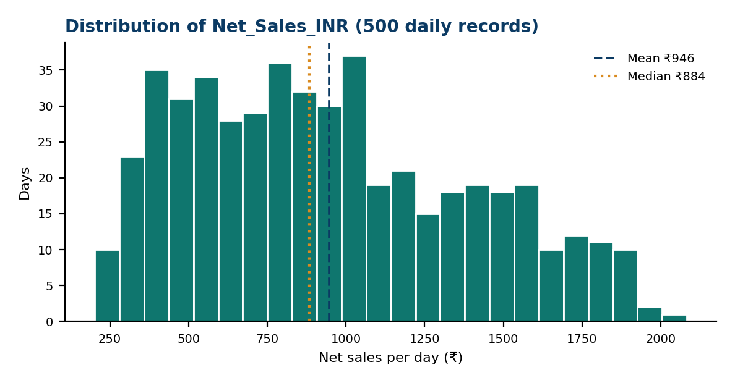
Fig. 3. Distribution of daily net sales (500 records). The dashed line marks the mean (₹946) and the dotted line the median (₹884).
Fig. 4 shows the correlation matrix of the five numeric attributes. Net sales correlate strongly with quantity sold (r = 0.81) and almost perfectly with gross sales (r = 1.00), while MRP is almost uncorrelated with net sales (r = −0.02) and negatively correlated with quantity (r = −0.53). Discount is positively correlated with quantity (0.61) and gross sales (0.73). Three conclusions follow. First, sales volume rather than price level drives daily revenue in this dataset. Second, because gross and net sales are almost identical, gross sales must never be used as a predictor of net sales, since it would leak the target; the forecasting models are therefore univariate and use only the date and net-sales columns. Third, the positive link between discount and volume suggests that promotions coincide with high-volume days, which is one reason spikes should be flagged rather than deleted.
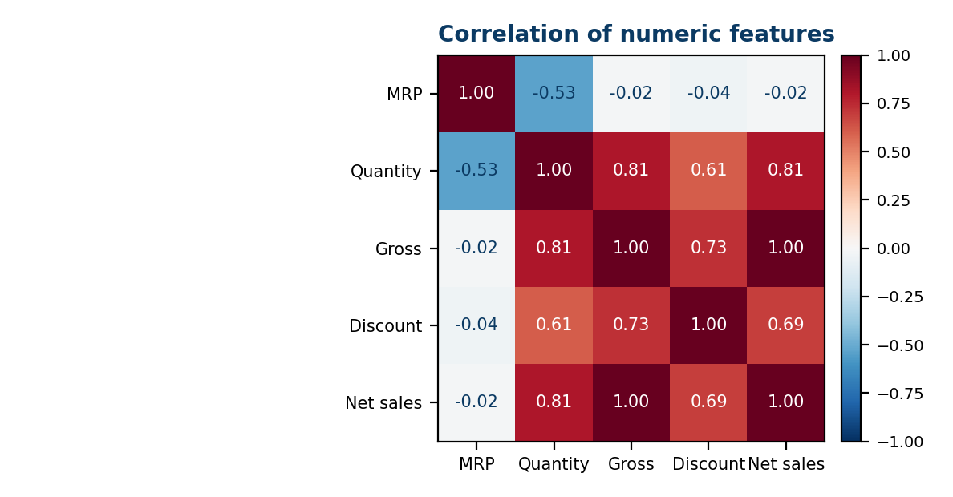
Fig. 4. Correlation matrix of the numeric features. Dark red denotes strong positive and blue negative correlation.
The system accepts sales data in CSV, XLSX, or XLS format (up to 200 MB per file), allowing it to generalize beyond this dataset to other retail sources. At minimum, an input file must contain a date column and a numeric sales column; region, channel, and product attributes support the exploratory analysis. During preprocessing, the date column is renamed Date and net sales Sales, and the cleaned records are arranged as a two-column daily series. Missing calendar dates can be filled explicitly (with zero in the demonstration).
Three properties of the series shape the modelling choices. The dataset has one record per day on 500 consecutive calendar days with no gaps, so the series has a regular daily frequency and a natural seven-day period, which is why weekly seasonality is enabled for Prophet. The history is just over one year and four months long, so it contains no full second annual cycle and yearly seasonality cannot be estimated reliably. Finally, with 400 training observations, a model with many parameters would overfit easily, which favours the parsimonious ARIMA and Prophet specifications used here.

B. Data Cleaning and Quality Scoring
Raw sales data is first passed through an automated cleaning pipeline built on Pandas [6] and NumPy. The procedure, summarized below, is applied in a fixed order so that the audit trail is reproducible.
Algorithm 1: Automated cleaning.
1) Standardize null markers and strip trailing whitespace from text fields.
2) Parse and validate dates; count invalid dates and invalid numeric values.
3) Optionally remove rows with negative sales, price, or quantity.
4) Drop exact duplicate rows and record them in the audit log.
5) Impute remaining missing values and record each imputation.
6) Emit the cleaning summary, the audit log, the imputation summary, and a technical report.
Every run therefore produces an audit trail with the number of rows removed, missing values fixed, and duplicates removed, together with a log of removed records. The technical report lists original and final row counts, rows removed, missing values before, fixed, and after, invalid dates, invalid numeric values, negative values removed, exact duplicates removed, and a breakdown of reasons. On the Maggi file all of these counts are zero: 500 rows are reviewed and 500 retained.
Near-duplicate text values are found with RapidFuzz [7] (token-sort matching based on edit distance) on a user-selected column. In token-sort matching the words of each string are first sorted alphabetically, so that “Masala 2-Minute Maggi” and “Maggi 2-Minute Masala” compare as identical, and a normalized edit-distance similarity between 0 and 100 is then computed. Value pairs whose similarity exceeds a configurable threshold (80% by default) are reported as candidate duplicates, and up to 1,000 distinct values are compared per run. The threshold can be raised to limit false positives, because similar-looking but genuinely different values, such as two different pack sizes, can otherwise be wrongly flagged.
A composite data quality score combines four dimensions so that data issues are visible before they affect forecasting:
Q = w₁C + w₂V + w₃K + w₄U (1)
where C (completeness) is the fraction of required fields that are present, V (validity) the fraction of records with valid dates and positive numbers, K (consistency) the share of values with proper data types and uniform formats, and U (uniqueness) the share of distinct records without exact duplicates. The weights are w₁ = w₂ = 0.30 and w₃ = w₄ = 0.20, which sum to one (Table V), and a score above 90% is rated Excellent for downstream forecasting. Completeness and validity carry the larger weights because missing and impossible values damage a forecast more directly than formatting inconsistencies. Reporting the four components alongside Q shows whether a low score reflects missing data, invalid entries, inconsistent formats, or duplication. The Maggi dataset scored 100% on every dimension.
Dimension | Weight | What is measured
Completeness (C) | 30% | Presence of required values without nulls
Validity (V) | 30% | Valid date formats and positive numbers
Consistency (K) | 20% | Proper data types and uniform formats
Uniqueness (U) | 20% | Distinct records without exact duplicates
TABLE V. DATA QUALITY DIMENSIONS AND WEIGHTS
Worked example. Suppose a file has completeness 0.95, validity 1.00, consistency 1.00, and uniqueness 0.97. Then Q = 0.30(0.95) + 0.30(1.00) + 0.20(1.00) + 0.20(0.97) = 0.979, or 97.9%, which is rated Excellent, and the dashboard would show that the only shortfalls are in completeness and uniqueness. This example is illustrative and is not one of the experimental results.
Cost of fuzzy matching. Comparing every pair of m distinct values requires m(m − 1)/2 similarity computations, which is 499,500 for m = 1,000. The quadratic growth is the reason the number of distinct values compared per run is capped at 1,000; all other cleaning steps are single passes over the rows and grow linearly with the file size.

C. Anomaly Detection
Before model training, the cleaned series is scanned for anomalous sales spikes or drops. Two simple, explainable rules are available. The interquartile-range (IQR) rule flags values outside the interval
[Q₁ − 1.5·IQR, Q₃ + 1.5·IQR] (2)
where IQR = Q₃ − Q₁, and the Z-score rule flags values with
|z_{t}| = |y_{t} − μ| / σ > 3 (3)
where μ and σ are the mean and standard deviation of the series. The IQR rule is robust to extreme values because quartiles are barely affected by a few outliers, whereas the Z-score rule is itself distorted by large outliers through μ and σ; offering both lets the user compare them. The user chooses the algorithm and a treatment action; in the default Flag Only mode, anomalies are highlighted and surfaced rather than removed, so that genuine demand events (e.g., a promotion) are not confused with data errors.
Anomalies in time series may be point, contextual, or collective [8]. The rules above target point anomalies in the daily series. On the Maggi data the IQR bounds were [−451.02, 2294.06] and no anomalies were detected. Because the two bounds differ by 4·IQR, they imply an IQR of about 686, a first quartile near ₹578, and a third quartile near ₹1,265. The lower bound is negative and can never be crossed by non-negative sales, and the upper bound lies above the largest observed day (about ₹2,100), so none of the 500 days is flagged. For strongly seasonal data, applying the same rules to seasonal residuals rather than raw values, so that predictable holiday peaks are not flagged, is a natural extension.

D. Forecasting Models
Two forecasting models are trained on the cleaned daily series: ARIMA, implemented via Statsmodels [9], and Prophet. ARIMA is fitted using standard Box–Jenkins order selection on the differenced series, while Prophet is configured with weekly seasonality and the India public-holiday calendar; yearly seasonality is switched off because 500 days is too short a history to learn it reliably.
1) ARIMA. An ARIMA(p, d, q) model combines autoregressive terms of order p, differencing of order d to achieve stationarity, and moving-average terms of order q [2]. With the backshift operator B (where B y_{t} = y_{t−1}) it is written
φ(B)(1 − B)^{d} y_{t} = c + θ(B) ε_{t} (4)
where φ(B) = 1 − φ₁B − … − φ_{p}B^{p} and θ(B) = 1 + θ₁B + … + θ_{q}B^{q}. Candidate orders are inspected using autocorrelation (ACF) and partial-autocorrelation (PACF) plots: a sharp cut-off of the PACF suggests the autoregressive order, and a cut-off of the ACF suggests the moving-average order. Candidates are then compared using the Akaike information criterion,
AIC = 2k − 2 ln L̂ (5)
where k is the number of estimated parameters and L̂ the maximized likelihood, so that the criterion rewards fit but penalizes complexity. A property of ARIMA relevant to the results is that multi-step forecasts of a stationary model revert toward the series mean as the horizon grows, so a 100-day forecast tends to flatten.
The Box–Jenkins procedure [2] follows an identification, estimation, and checking cycle, which is applied here as follows.
Algorithm 3: ARIMA order selection.
1) Inspect the training series and difference it until it is approximately stationary; the number of differences is d.
2) Plot the ACF and PACF of the differenced series to propose small values of p and q.
3) Fit the candidate models and record the AIC of each.
4) Keep the order with the lowest AIC and use it for the hold-out forecast.
2) Prophet. Prophet instead decomposes a series as
y(t) = g(t) + s(t) + h(t) + ε_{t} (6)
where g(t) is a piecewise trend with automatically selected change points, s(t) periodic seasonality, h(t) the effect of holidays, and ε is an error term [1]. Seasonality is modelled by a Fourier series,
s(t) = Σ_{n=1}^{N} [a_{n} cos(2πnt/P) + b_{n} sin(2πnt/P)] (7)
with period P = 7 days for the weekly cycle used here and Fourier order N. Holidays enter as indicator variables, here for the India public-holiday calendar, each with its own fitted effect. The practical difference between the two models is summarized in Table VI. ARIMA models the dependence of today’s sales on recent sales, while Prophet models the calendar structure, so each is expected to win on a different kind of series.
Aspect | ARIMA | Prophet
Core idea | Past values and past errors | Trend + seasonality + holidays
Seasonality | Not explicit in basic form | Weekly (yearly off)
Holidays | Not supported | India calendar
Tuning | Order (p, d, q) via ACF, PACF, AIC | Mostly automatic
Library | Statsmodels [9] | Prophet [1]
Training time (s) | 0.27 | 4.37
TABLE VI. CHARACTERISTICS OF THE TWO CANDIDATE MODELS

E. Model Evaluation and Selection
Both models are trained on the first 80% of the series (400 days) and evaluated on the final 20% (100 days) using Mean Absolute Error (MAE), Root Mean Squared Error (RMSE), and Mean Absolute Percentage Error (MAPE), computed with Scikit-learn [10]. The split is chronological with no shuffling, so no future information leaks into training. For actual values y, forecasts ŷ, and n forecast points, the metrics are
MAE = (1/n) Σ |y_{t} − ŷ_{t}| (8)
RMSE = √[(1/n) Σ (y_{t} − ŷ_{t})²] (9)
MAPE = (100/n) Σ |(y_{t} − ŷ_{t}) / y_{t}| (10)
MAE and RMSE are expressed in the units of sales and are therefore comparable only within a series, with RMSE penalizing large misses more heavily because errors are squared. MAPE is scale-free and allows comparison across stores, but becomes unstable or undefined when actual values are zero or near zero [11]. Reporting all three gives complementary views of forecast quality. The model with the lowest error on the same hold-out window is selected automatically (Auto Select; MAPE is the selection key in the reference implementation, with RMSE as a cross-check), and the metrics behind that choice are retained for transparency:
m* = argmin_{m ∈ {ARIMA, Prophet}} MAPE(m) (11)
Hyndman and Koehler [11] also proposed the mean absolute scaled error (MASE), which divides the forecast error by the in-sample error of a naive forecast and is therefore defined even when actual values are zero. It was not used in this version, but it is a natural addition once a naive baseline is evaluated.
Algorithm 2: Model evaluation and selection.
1) Split the cleaned daily series chronologically: first 80% for training, last 20% for testing.
2) Fit ARIMA and Prophet on the training part only.
3) Forecast the full test window with each model.
4) Compute MAE, RMSE, and MAPE for each model on the identical window, and record training time.
5) Select the model with the lowest error and keep all metrics for the dashboard.
6) Produce the forecast for the horizon requested by the user with the selected model.

F. Implementation Modules and Configuration
The implementation is divided into four modules whose inputs and outputs are listed in Table VII. Each module consumes only the output of the previous one, so a module can be tested, replaced, or extended without changing the others. The behaviour of the pipeline is controlled by a small set of parameters, collected in Table VIII, most of which the user can change from the dashboard.
Module | Purpose | Input → Output
1. Data cleaning and quality scoring | Clean the data and score its quality | Raw CSV/Excel → clean data + quality score
2. Anomaly detection | Flag unusual sales spikes and drops | Clean series → anomaly flags
3. Forecasting and evaluation | Train ARIMA and Prophet; pick the better | Series → forecasts + MAE, RMSE, MAPE
4. Streamlit dashboard | Show results to business users | All outputs → interactive charts
TABLE VII. IMPLEMENTATION MODULES
Parameter | Value
Accepted input formats / size limit | CSV, XLSX, XLS / 200 MB
Quality weights (C, V, K, U) | 0.30, 0.30, 0.20, 0.20
“Excellent” quality threshold | Above 90%
Fuzzy matching method / default threshold | token_sort / 80%
Distinct values compared per run | Up to 1,000
IQR multiplier / Z-score threshold | 1.5 / 3
Default anomaly treatment | Flag Only
Train / test split | First 80% / last 20% (400 / 100 days)
Prophet seasonality / holidays | Weekly on, yearly off / India calendar
Forecast period in the demonstration | 30 days
Missing calendar dates | Filled with zero (demonstration)
TABLE VIII. KEY CONFIGURATION PARAMETERS
Reproducibility is supported in three ways. The chronological split is deterministic, so repeated runs on the same file give the same hold-out window. The audit trail records every change made to the input. Finally, the automated pytest suites for cleaning, quality scoring, forecasting, and the end-to-end flow can be re-run after any code change to confirm that the pipeline still behaves as reported in Section VII.
Worked example. For three test days with actual sales 800, 1,000, and 400 and forecasts 900, 900, and 600, the absolute errors are 100, 100, and 200, so MAE = 133.3. The squared errors are 10,000, 10,000, and 40,000, so RMSE = √20,000 = 141.4, which exceeds the MAE because the largest miss is weighted more heavily. The percentage errors are 12.5%, 10%, and 50%, so MAPE = 24.2%, and the single low-sales day dominates it. This illustrative example shows why the three metrics are reported together.
The core of the model-building step of the implementation is shown in Listing 1: the chronological split, the two fits, and the selection of the best model by MAPE.
split = int(len(series) * 0.8) # 80/20, no shuffle
train, test = series[:split], series[split:]
arima = ARIMA(train, order=(p, d, q)).fit()
a_pred = arima.forecast(steps=len(test))
m = Prophet(weekly_seasonality=True)
m.add_country_holidays("IN")
m.fit(train_df)
p_pred = m.predict(future)["yhat"]
best = min(scores, key=lambda k: scores[k]["mape"])

Listing 1. Core model-building step (chronological split, ARIMA, Prophet, selection).

VI. DASHBOARD IMPLEMENTATION
All outputs are presented through an interactive Streamlit dashboard [12], using Plotly and Matplotlib for visualization, so that business stakeholders without a technical background can explore the results directly. A sidebar menu leads through eight pages that follow the order of the pipeline (Table IX), so a user can move from top to bottom through the menu. A Load sample dataset button loads the demonstration data without a file upload. Charts are interactive: they support hover, zoom, pan, and download as an image. The pages are described below together with the screenshots that illustrate them.
Streamlit re-runs the Python script whenever the user changes a control, and the application reads the page chosen in the sidebar and draws only that page. Each page calls the matching back-end module and shows its result, while the cleaned data and the other intermediate results are kept in memory for the session so that later pages do not need the file to be uploaded again. This execution model is what allows a pure-Python code base to behave like a multi-page web application without any separate front-end code.
Sidebar page | Purpose
Dashboard | Landing page of the application
Upload Data | Upload a CSV, XLSX, or XLS file (up to 200 MB); preview rows, row count, and column count
Data Cleaning | Run automated cleaning; view summary, audit log, and imputation summary
Data Quality | Weighted data-quality scorecard
Duplicate Detection | Exact duplicate check and fuzzy near-duplicate search
Anomaly Detection | Outlier detection with a chosen algorithm and treatment action
Sales Analytics | Trend, monthly sales, distribution, moving average, categorical breakdown
Forecast | Forecast period, model, summary, insight, graph, metrics, and export
TABLE IX. NAVIGATION PAGES OF THE DASHBOARD

A. Upload and Cleaning Pages
The Upload Data page accepts CSV, XLSX, and XLS files and shows a preview table together with the number of rows and columns; for the Maggi file these are 500 and 10. The Data Cleaning page shows the total records, missing values, exact duplicates, and columns before cleaning, offers a checkbox to remove rows with negative sales, price, or quantity, and runs the cleaning on a button press. Afterwards it presents the cleaning summary (clean records retained, rows removed, missing values fixed, duplicates removed), the audit log of removed records, the imputation summary, an expandable technical JSON report, and the cleaned dataset. On the Maggi file the page reports that 500 rows were reviewed and 500 retained, with an audit-log message that no records were removed.
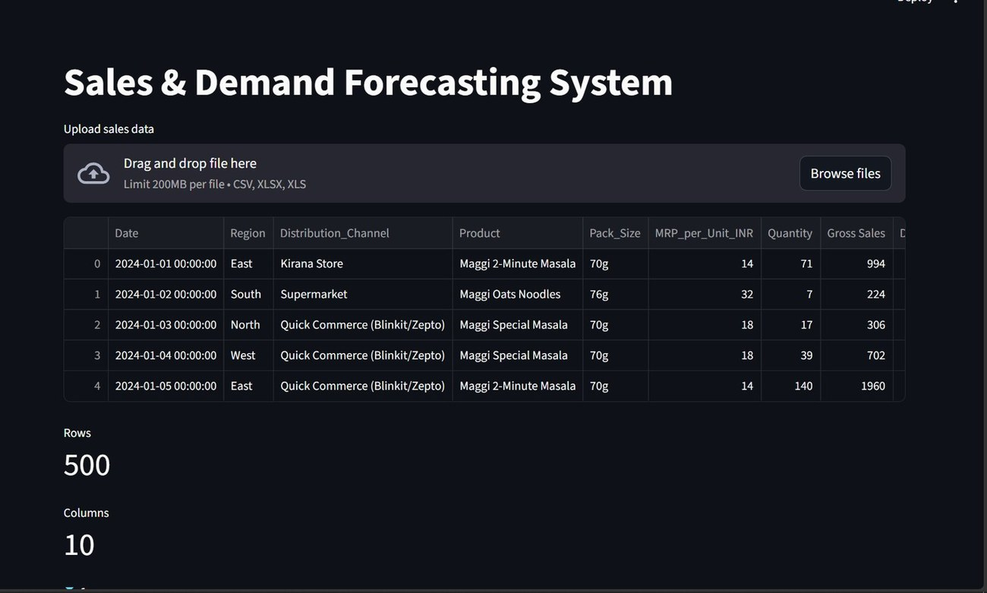
Fig. 5. Upload Data page: drag-and-drop area, preview of the first five records, and row and column counts.
Fig. 5 shows the Upload Data page. The drag-and-drop area states the accepted formats (CSV, XLSX, XLS) and the 200 MB limit per file. Below it, the preview table shows the first five records of the Maggi file: consecutive daily dates beginning on 1 January 2024, each with a region, distribution channel, product variant, pack size, MRP per unit, quantity, and gross sales, followed by the discount and sales columns. The counters under the table confirm that 500 rows and 10 columns were loaded, which is the first check a user makes that the right file was read.
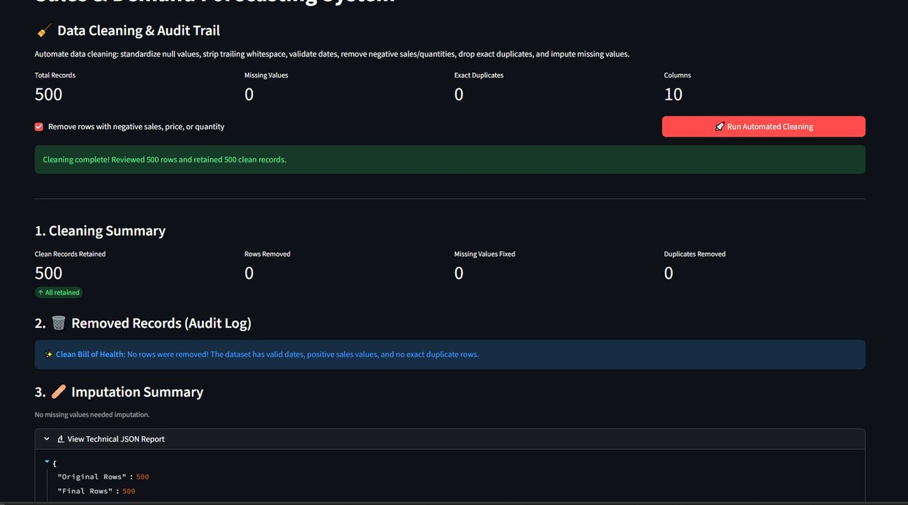
Fig. 6. Data Cleaning page: pre-cleaning counters, cleaning action, cleaning summary, and audit log.
Fig. 6 shows the Data Cleaning page after cleaning has run. The four counters at the top (500 total records, 0 missing values, 0 exact duplicates, 10 columns) describe the file before cleaning, and the checkbox beneath them controls whether rows with negative sales, price, or quantity are removed. After the red Run Automated Cleaning button is pressed, a green banner reports that 500 rows were reviewed and 500 clean records retained. Section 1, the Cleaning Summary, repeats this as four figures (clean records retained, rows removed, missing values fixed, duplicates removed). Section 2, the Audit Log of removed records, shows a short message that nothing was removed because the dates are valid, the sales values are positive, and there are no exact duplicates. Section 3 is the imputation summary, and the expandable technical JSON report holds the detailed counts listed in Section V-B.
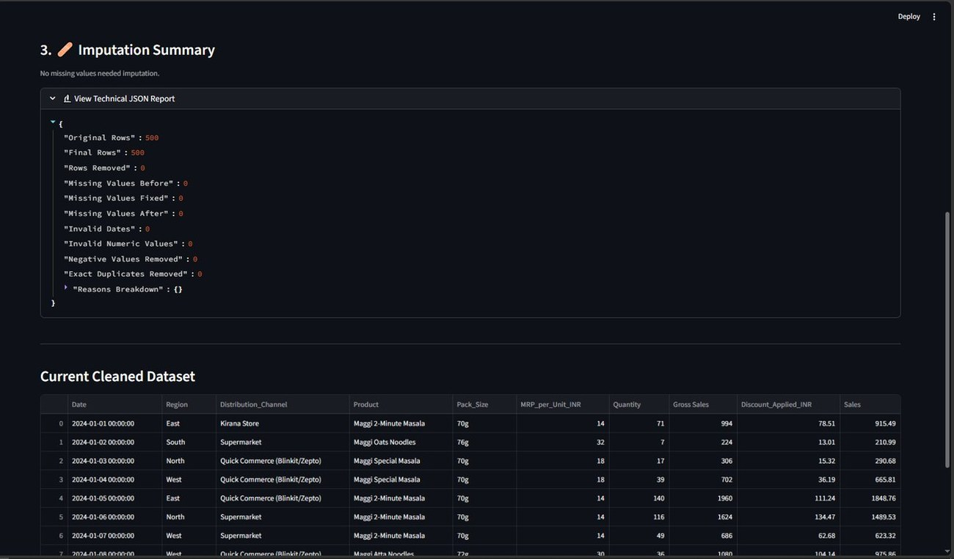
Fig. 7. Imputation summary, technical JSON report, and cleaned dataset on the Data Cleaning page.
Fig. 7 shows the lower part of the Data Cleaning page. The imputation summary states that no missing values needed imputation. The expanded technical JSON report lists the counters named in Section V-B: original rows 500, final rows 500, rows removed 0, missing values before, fixed, and after all 0, invalid dates 0, invalid numeric values 0, negative values removed 0, exact duplicates removed 0, and an empty reasons breakdown. Below the report the Current Cleaned Dataset table shows the rows that will be passed to the later stages, with the columns renamed to Date and Sales as described in Section V-A. The JSON form is intended for users who want to log or compare cleaning runs outside the dashboard.

B. Data Quality Page
Fig. 8 shows the Data Quality page. At the top, the heading reports the overall rating, “Excellent”, with a score of 100.0%. Below it, five tiles show the four dimension scores with their weights (Completeness 30%, Validity 30%, Consistency 20%, Uniqueness 20%) and the overall score. The horizontal green bars chart the four dimensions on a 0–100 scale, so any dimension that falls short is immediately visible as a shorter bar. The expandable Quality Assessment Methodology table at the bottom repeats the weight and a plain-language description for each dimension, and states that the overall quality is a weighted aggregate and that a score above 90% is considered Excellent.
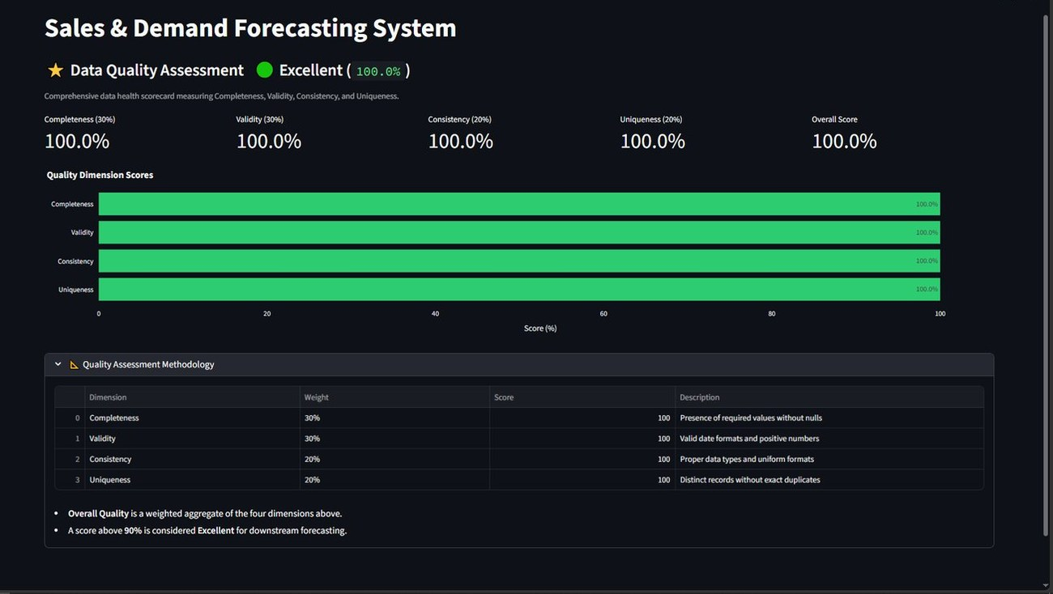
Fig. 8. Data Quality page: overall rating, four weighted dimension scores, bar chart, and methodology table.

C. Duplicate Detection Page
Fig. 9 shows the Duplicate Detection and Entity Resolution page, which has two parts. Part 1, Exact Duplicate Rows, shows a green banner stating that zero exact duplicate rows were found and all records are unique. Part 2, Near-Duplicate Fuzzy String Matching, gives the user three controls: the text column to scan (here Product), the fuzzy matching method (token_sort), and a similarity-threshold slider (set to 80%). A note under the Find Near Duplicates button states that up to 1,000 distinct values are compared using edit distance. The blue result banner reports that no near-duplicates were found in the Product column above the 80% threshold, which is the expected outcome for the five distinct, correctly spelled Maggi variants.
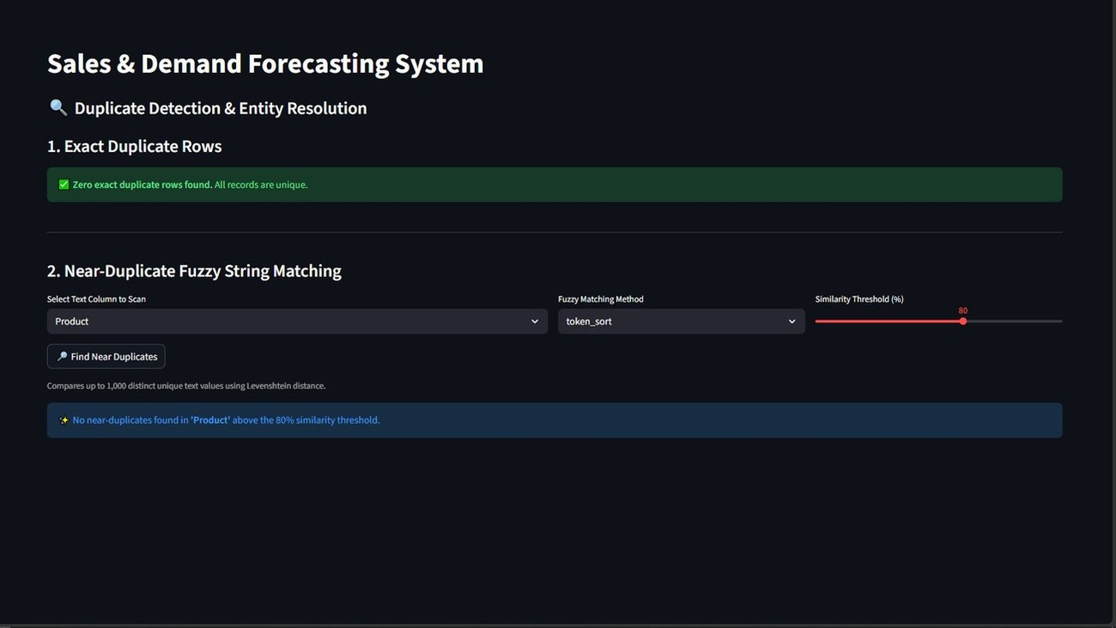
Fig. 9. Duplicate Detection page: exact-duplicate check and fuzzy near-duplicate search with column, method, and threshold controls.

D. Anomaly Detection Page
Fig. 10 shows the Sales Anomaly and Outlier Detection page. Two drop-down lists let the user choose the detection algorithm (IQR in the figure) and the treatment action (Flag Only). The Detected Anomalies counter shows 0, with the computed bounds [−451.02, 2294.06] displayed beneath it. The chart plots the daily sales from January 2024 to May 2025 as a line with markers; all points lie between roughly ₹200 and ₹2,100, inside the bounds, so none is highlighted. When anomalies exist, they are marked on this chart rather than removed from the data.
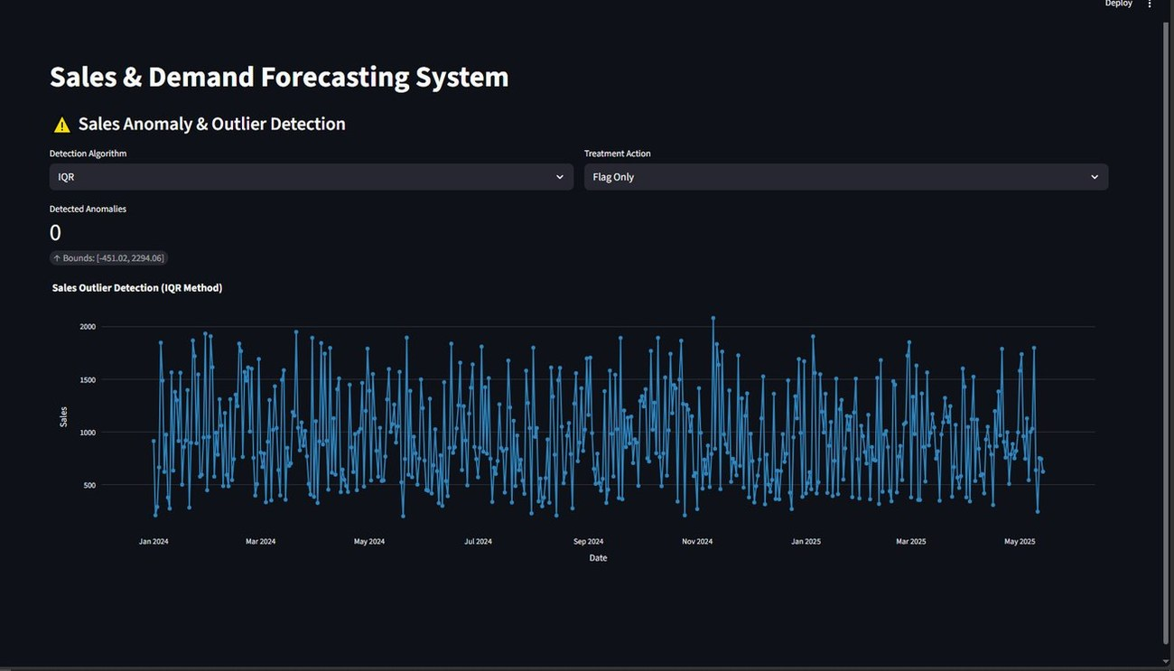
Fig. 10. Anomaly Detection page: algorithm and treatment selectors, anomaly count, IQR bounds, and the daily sales chart.

E. Sales Analytics Page
The Sales Analytics page provides exploratory charts so that the user understands the series before forecasting. Fig. 11 shows the daily sales trend over the 500 days. The series oscillates between about ₹200 and ₹2,100 with no visible long-term upward or downward drift, and with dense day-to-day variation, which already suggests that daily forecasts will have a high percentage error. Fig. 12 combines three panels. The Monthly Sales bar chart shows broadly similar totals across months, with a peak around September 2024 and a much shorter last bar for May 2025, which is low because the dataset ends on 14 May and the month is therefore incomplete. The Sales Distribution panel pairs a box plot with a histogram, repeating the right-skewed shape of Fig. 3. The Sales and 7-Day Moving Average panel overlays a smoothed line on the raw series; the moving average removes the weekly oscillation and shows that the underlying level is stable.
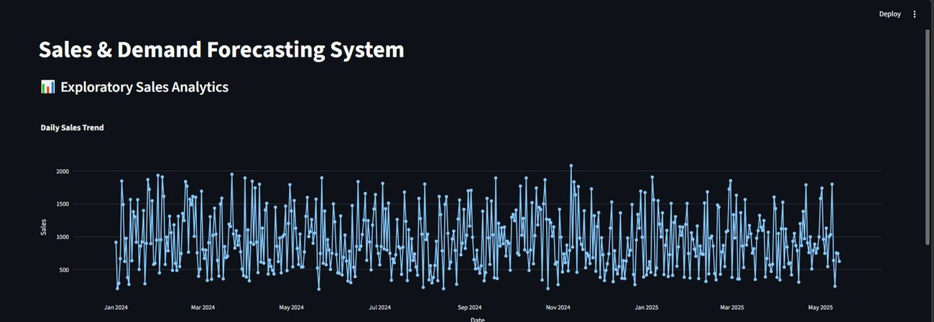
Fig. 11. Sales Analytics: daily sales trend, January 2024 to May 2025.
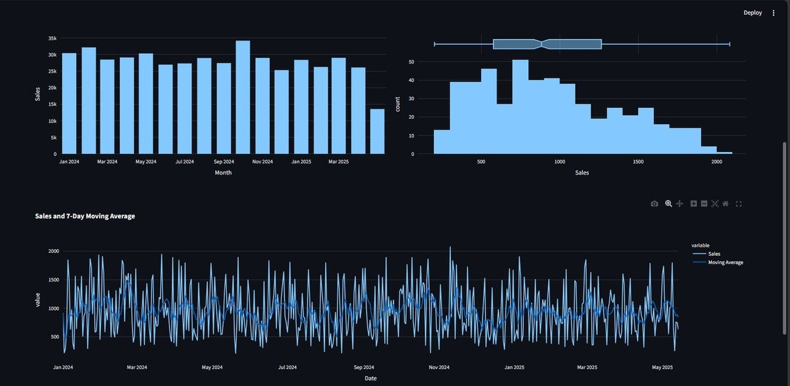
Fig. 12. Sales Analytics: monthly sales, sales distribution with box plot, and sales with 7-day moving average.
The last panel, Fig. 13, is a categorical breakdown that lets the user choose a dimension such as Region. The Region-wise Sales Breakdown shows North with the highest total sales, followed by South, then West and East at similar and lower levels, with East the lowest. This breakdown is not used by the univariate models, but it shows what a region-level forecast could target in future work.
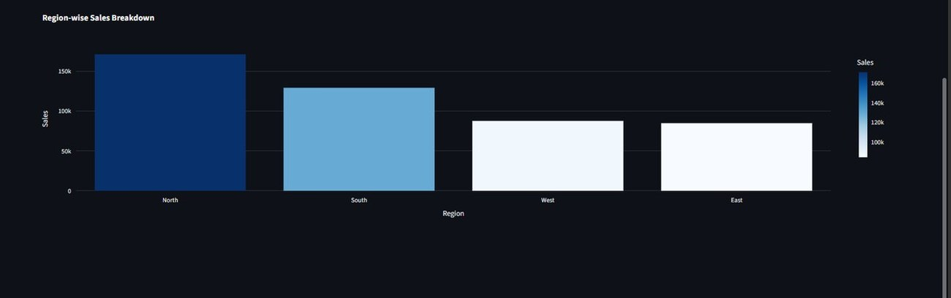
Fig. 13. Sales Analytics: region-wise sales breakdown (North highest, East lowest).

F. Forecast Page
On the Forecast page the user sets the forecast period (30 days in the demonstration), the model (Auto Select), and the handling of missing dates (Zero), and then presses Run Forecast. Fig. 14 shows the result. Section 1, Forecast Summary, reports the selected model (ARIMA), the total predicted demand (20,251), the average daily demand (675), and the forecast trend (Decreasing, −12.4%). Section 2, Automatic Business Insight, turns these numbers into a sentence for managers: over the next 30 days demand is expected to decrease with a total volume of 20,251, so overstocking should be avoided as demand softens. Section 3 draws the historical-versus-forecast graph, and Section 4 shows the model metrics table and the forecast data, which can be exported. The metrics table and graph are discussed with the results in Section VII-E.
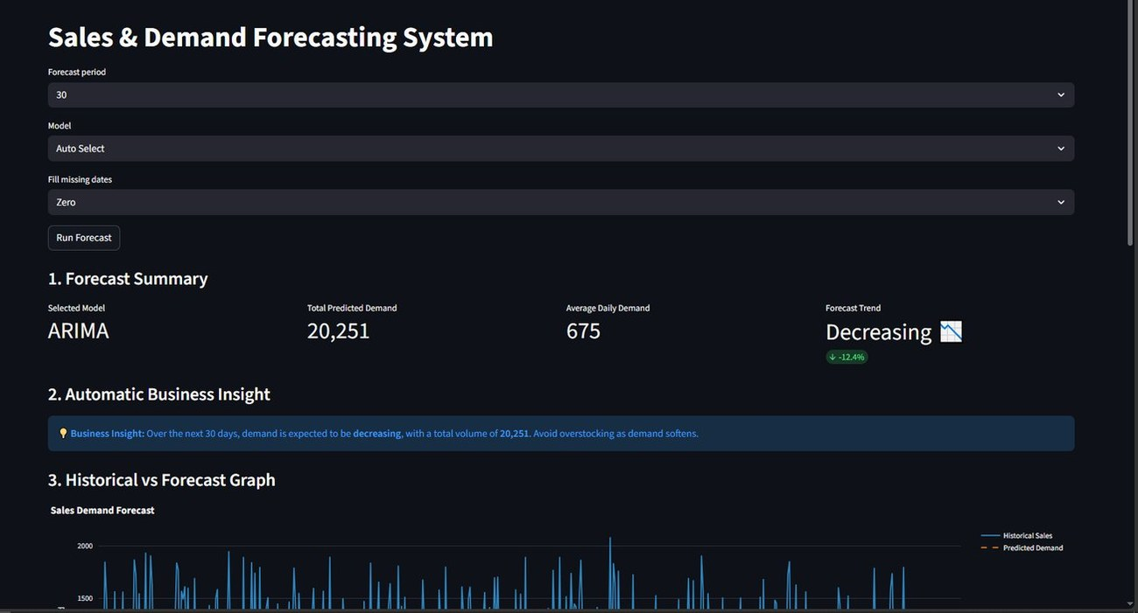
Fig. 14. Forecast page: selected model, total and average predicted demand, trend, and automatic business insight for a 30-day forecast.

G. End-to-End Usage Scenario
A typical session follows the sidebar from top to bottom. The user starts the dashboard, opens it in a browser, and uploads a sales file or presses Load sample dataset. On the Data Cleaning page the user runs the automated cleaning and reads the audit log; on the Data Quality page the user reads the weighted score and its rating. If the score is lower than expected, the Duplicate Detection page helps locate the cause, where the user chooses a text column, a matching method, and a similarity threshold and presses Find Near Duplicates. The Anomaly Detection page then shows the bounds and any flagged days, and the Sales Analytics page gives a visual feel for the series. Finally, on the Forecast page the user chooses the forecast period, the model (normally Auto Select), and how missing dates are filled, presses Run Forecast, reads the summary and business insight, and exports the forecast table if needed. The order matters: every page after Data Cleaning works on the cleaned series, so any correction made early is reflected in all later results.

H. Usability Considerations
The interface is designed for people who are not programmers. Defaults are chosen so that a first-time user can press the main button on each page and obtain a sensible result: the quality weights, the 80% fuzzy threshold, the IQR rule, the Flag Only treatment, and Auto Select are all preset. Results are given in plain language as well as in numbers, for example the rating Excellent beside the score and the automatic business insight beside the forecast summary. Status banners use colour consistently (green for success, blue for information), and every chart supports hover, zoom, and download. A formal usability study has not yet been carried out and is part of future work.

VII. RESULTS AND DISCUSSION

A. Experimental Setup
Experiments were run on the Maggi dataset described in Section V-A. The daily net-sales series (500 days) was split chronologically into 400 training days (1 January 2024 to 3 February 2025) and a 100-day hold-out test window (4 February to 14 May 2025). Both models were trained on the training days only and evaluated on the identical test window, so the comparison is free of temporal leakage. A single chronological split was used; a rolling-origin scheme is left for future work. The experiments need no GPU and use the Python libraries listed in Table II.
The main findings of this section can be summarized in five points. (1) ARIMA beat Prophet on MAE, RMSE, and MAPE on the same 100-day window. (2) ARIMA trained about 16 times faster. (3) The injected faults, namely duplicates, missing values, and a sales spike, were all detected. (4) Absolute errors are high because daily sales are very volatile. (5) The dashboard exposes every intermediate result, so each finding can be checked by the user.

B. Forecast Accuracy
Table X reports the hold-out errors. ARIMA outperformed Prophet on every metric, with an MAE of 323.36 against 349.98, an RMSE of 406.81 against 424.22, and a MAPE of 44.77% against 51.97%, so ARIMA was selected automatically. ARIMA also trained in 0.27 s compared with 4.37 s for Prophet, about 16 times faster.
Metric | ARIMA | Prophet
MAE | 323.36 | 349.98
RMSE | 406.81 | 424.22
MAPE (%) | 44.77 | 51.97
Training time (s) | 0.27 | 4.37
Selected | Yes | No
TABLE X. HOLD-OUT PERFORMANCE OF ARIMA AND PROPHET
Fig. 15 compares both forecasts with the actual demand over the test window. The solid black line is the actual daily demand, which is highly volatile: it swings between troughs below ₹400 and peaks above ₹1,600 within days. The dashed blue line is the ARIMA forecast, which is almost a horizontal line at a level of roughly ₹860. The dotted orange line is the Prophet forecast, which oscillates with a regular seven-day rhythm between roughly ₹700 and ₹1,150, reflecting its weekly seasonality term. The legend reports the RMSE and MAPE of each model (406.8 and 44.8% for ARIMA, 424.2 and 52.0% for Prophet), consistent with Table X. Neither forecast follows the individual spikes, but the flat ARIMA line is on average closer to the actual values, because a wrongly timed weekly oscillation can be penalized twice: once where the forecast is high and the actual low, and once where it is low and the actual high.
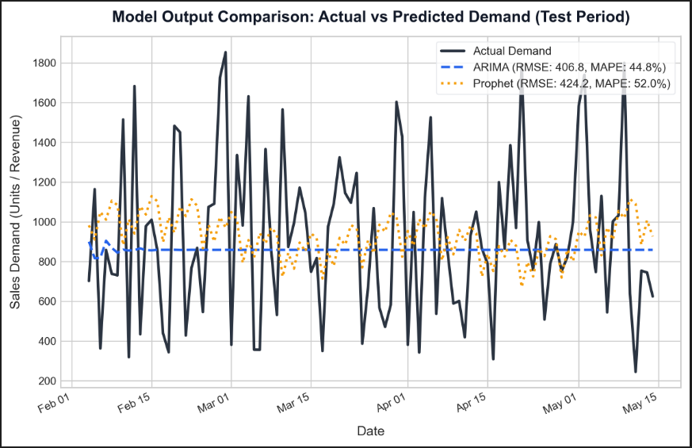
Fig. 15. Actual vs. predicted demand on the 100-day hold-out window.
Fig. 16 presents the same comparison as a grouped bar chart of the three error metrics, where lower is better. In every group the ARIMA bar (dark blue) is shorter than the Prophet bar (orange). MAE and RMSE are in rupees and MAPE is in percent, which is why the MAPE bars are much shorter; the three groups should be compared within the group, not across groups.
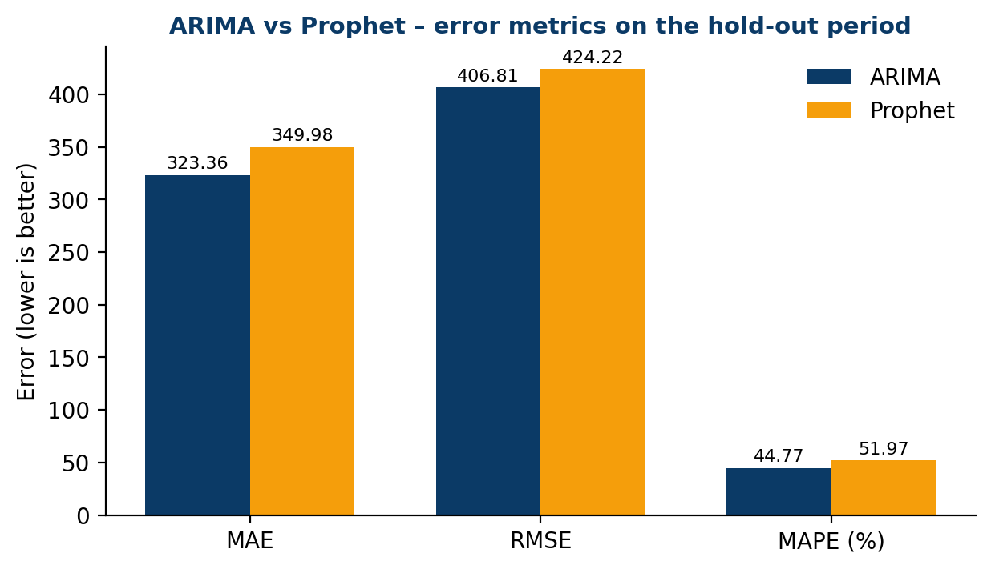
Fig. 16. Error metrics of ARIMA and Prophet on the hold-out period (lower is better).
Aspect | ARIMA | Prophet
Forecast shape | Almost constant level | Weekly oscillation
Follows spikes | No | No
Error (MAE / RMSE / MAPE) | Lower on all three | Higher on all three
Training time | 0.27 s | 4.37 s
Explicit holiday effects | No | Yes (India calendar)
Tuning needed | Order selection | Mostly automatic
TABLE XI. OBSERVED BEHAVIOUR OF THE TWO MODELS ON THE HOLD-OUT WINDOW
Table XI gathers the observed behaviour. The two models fail in different ways: ARIMA effectively predicts a typical level, while Prophet predicts a weekly pattern that does not match the realized weekly pattern closely enough to help on this series. A model that captures both, for instance Prophet with an autoregressive error term or an ensemble, is therefore a promising direction.

C. Size of the Difference
ARIMA’s advantage is consistent but modest. Relative to Prophet, ARIMA’s MAE is lower by 7.6% ((349.98 − 323.36)/349.98), its RMSE by 4.1%, and its MAPE by 7.2 percentage points, a relative reduction of about 13.9%. The smaller gap in RMSE than in MAE suggests that both models miss the large spikes by a similar amount, and that ARIMA’s advantage may lie mostly in the typical day rather than in the extremes. The practical value of the system therefore lies as much in the automatic, transparent comparison as in the size of the gap: on another series the ranking could reverse, and the same pipeline would select Prophet without any change. With a single split and no significance test, the ranking should be read as indicative rather than conclusive.

D. Functional and Data-Quality Tests
Faults were injected into the clean dataset to test the pipeline (Table XII). Adding duplicate and missing rows lowered the quality score from 100% to 95.6%, with 5 duplicates and 15 missing values detected, and an artificial sales spike of 10,413.9 was flagged because it exceeded the IQR upper bound of 2,294.1, being about 4.5 times that bound. An automated pytest suite covering cleaning, quality scoring, forecasting, and the end-to-end flow also passed in full. Because the system has no REST back end, API testing tools were not applicable and the pytest suites take their place.
ID | Test | Result
TC-01 | Upload CSV/Excel file | 500 rows loaded without errors
TC-02 | Inject duplicate and missing rows | Score fell 100% to 95.6%; 5 duplicates, 15 missing found
TC-03 | Insert artificial sales spike | Spike 10,413.9 flagged (IQR upper bound 2,294.1)
TC-04 | Run both models on hold-out | ARIMA selected (RMSE 406.8, MAPE 44.8%)
TABLE XII. FUNCTIONAL TEST CASES AND RESULTS
Each test case exercises one hand-over between modules. TC-01 checks the input layer: the file loads and the Date and Sales columns validate with no missing values. TC-02 checks the cleaning and scoring modules together, confirming that data faults reduce the quality score by a visible amount and are counted. TC-03 checks the anomaly module on a fault that is large by construction. TC-04 checks that the forecasting and evaluation modules run both models on the same window and select the better one. Together they cover the pipeline from upload to selection; they do not test forecast accuracy, which is evaluated separately in Section VII-B.

E. Dashboard Output
In the final run, a 30-day forecast beginning on 15 May 2025 selected ARIMA and gave a total predicted demand of 20,251, an average daily demand of 675, and a decreasing trend of 12.4%, together with the automatic business insight to avoid overstocking as demand softens (Fig. 14). Fig. 17 shows the lower part of the Forecast page. In the Historical vs Forecast Graph, the blue line is the historical daily sales from January 2024 to May 2025 and the short orange dashed segment at the right end is the predicted demand for the next 30 days, drawn beyond the last observed date. Section 4, Model Metrics and Data Export, expands into a table of MAE, RMSE, and MAPE for ARIMA and Prophet, matching Table X, and below it a table of the forecasted values by date that the user can export for planning.
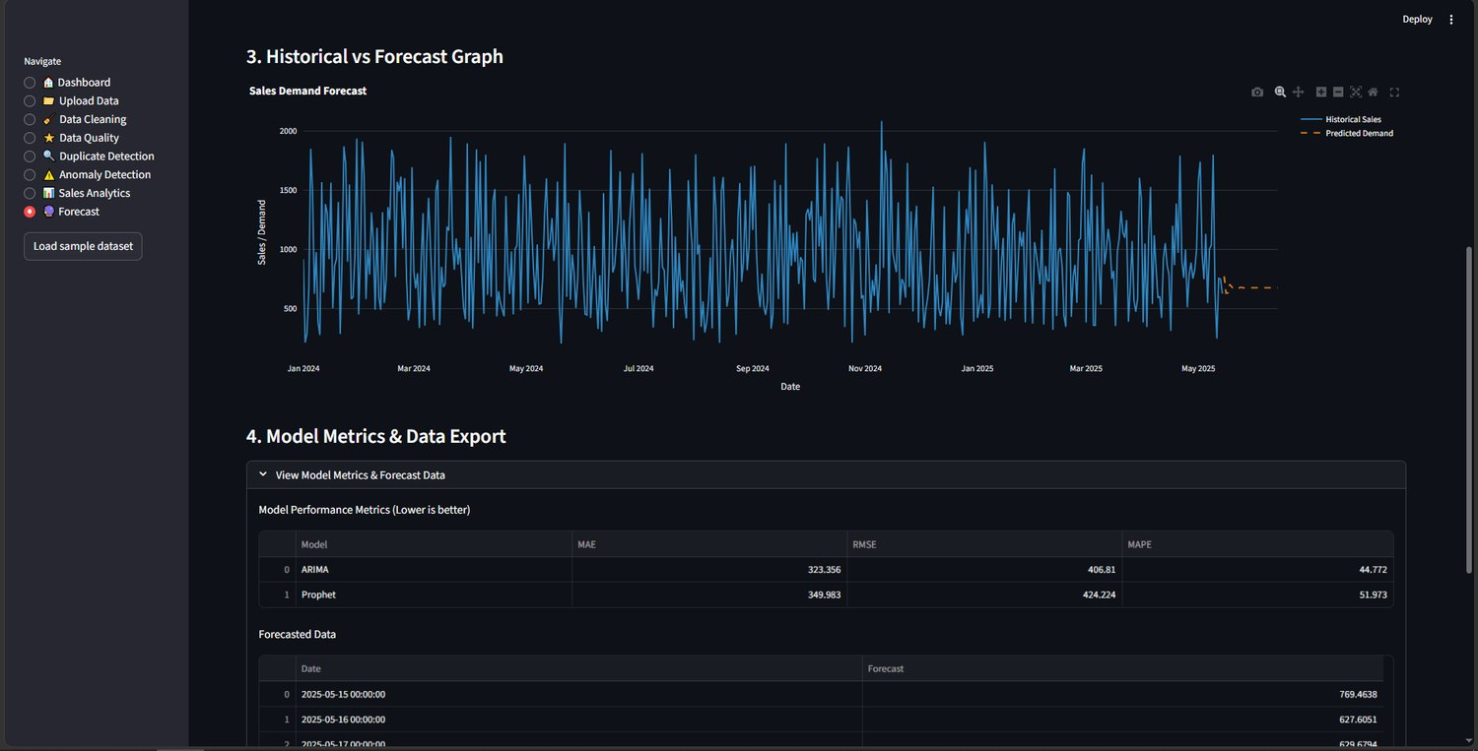
Fig. 17. Forecast page of the DemandIQ dashboard: historical vs. forecast graph and model metrics.

F. Discussion
Prophet’s main strengths are yearly seasonality and holiday effects, which need a multi-year history; with only 500 days it could use the weekly pattern and holidays, which may explain why the simpler ARIMA model scored lower errors. In Fig. 15 the ARIMA forecast flattens to an almost constant level, as is typical of multi-step ARIMA forecasts on a noisy series (Section V-D), whereas Prophet follows the weekly cycle but with a larger average error. Demand spikes and weekend peaks produced the largest errors, while steady weekdays were forecast best.
A MAPE of about 45% shows that day-by-day sales in this dataset are very volatile, so the results are best read as a comparison between the two models and a baseline, not as production-grade accuracy. Two simple calculations put the numbers in context. ARIMA’s MAE of 323.36 is about 34% of the overall mean daily net sales of ₹946, and its RMSE of 406.81 is about 43% of that mean. The MAPE of 44.77% is higher than the MAE-to-mean ratio because percentage errors are inflated on low-sales days, where the denominator is small, which is the instability of MAPE described in [11]. Since the 7-day moving average in Fig. 12 is stable while the daily values swing widely, most of the variation in this series is day-level noise that no univariate model can predict, and a forecast near the typical level is hard to beat. A naive or seasonal-naive baseline [4] was not evaluated and should be added in future work; it would show how much of the remaining error is irreducible.
The handling of missing dates deserves a note. When calendar days are absent from the file, the dashboard can fill them with zero, as in the demonstration. This is appropriate when an absent day really means no sales, but it would pull the series down, and inflate percentage errors, if the day is missing only because the record was lost. The Maggi series has no gaps, so the setting had no effect on the reported results, but users of other files should choose it deliberately, and the data-quality score helps by exposing missing records before the choice is made.
From a deployment point of view, the training times matter for an interactive tool. ARIMA’s 0.27 s allows the model comparison to be re-run whenever the user changes the input file or the forecast period, while Prophet’s 4.37 s is still acceptable for a single run. The data-quality stage is equally important in practice: the fault-injection results show that a corrupted upload would be visible as a lower quality score before any forecast is shown, which is the behaviour a manager needs in order to know when not to trust the output.

G. Relation to Prior Results
The ranking found here agrees with the ARIMA-over-Prophet result reported in [3] on retail data, even though the datasets differ in size and structure, and it is compatible with the finding in [13] that the best single model varies from series to series. It does not contradict the M5 results [14], where tree-based learners led, because those learners were trained across thousands of related series whereas this work forecasts one short series. The comparison is therefore best taken as evidence that, for a single short retail series, a simple statistical model is a strong first candidate and that a system should verify this on the data at hand instead of assuming it.

H. Practical Interpretation for Planners
For an inventory planner, the output of the Forecast page supports three kinds of decision. The total predicted demand over the horizon indicates the order quantity to cover, the average daily demand indicates the replenishment rate, and the trend and business insight indicate whether to build or reduce stock. In the demonstration, a decreasing trend of 12.4% leads to the advice to avoid overstocking. Because the hold-out MAPE is about 45%, a planner should treat a single daily forecast with caution and rely more on the horizon total and the trend, which average out day-level noise; the dashboard shows the evaluation metrics next to the forecast so that this uncertainty is not hidden. The quality score gives a second, independent signal: a forecast produced from a file with a low quality score should be checked before it is used.

I. Reproducing the Experiment
The reported results can be reproduced in a few steps. Install Python 3.10 or later and the libraries pandas, numpy, rapidfuzz, statsmodels, prophet, scikit-learn, streamlit, plotly, matplotlib, and pytest in a virtual environment, and start the dashboard with the streamlit run command. Open the Upload Data page and load the Maggi file or press Load sample dataset; the preview should show 500 rows and 10 columns. Run the automated cleaning (500 rows reviewed, 500 retained), open Data Quality (100%), Duplicate Detection (no exact or near duplicates at the 80% threshold), and Anomaly Detection with the IQR algorithm and Flag Only (bounds [−451.02, 2294.06], 0 anomalies). On the Forecast page choose 30 days, Auto Select, and zero fill for missing dates, and press Run Forecast; the page should report ARIMA as the selected model with the metrics of Table X. Running the pytest suites completes the check.

VIII. LIMITATIONS AND FUTURE WORK

A. Limitations
This work has several limitations. First, ARIMA and Prophet are univariate in their standard form; region, channel, pack-size, and price effects are not modelled, and only daily totals are forecast. Second, the system has been validated on a single dataset of 500 days for one product, and the short history prevents learning yearly seasonality, so conclusions about relative model performance may not transfer to other contexts. Third, absolute errors are high (MAPE of 44.77% for the selected model) and no naive baseline was evaluated. Fourth, telling a genuine promotional spike from a data error requires business context, which is why anomalies are flagged for review rather than removed automatically. Finally, the dashboard has not yet been evaluated with real users, and it has no login, no persistent storage, and no cloud deployment.

B. Threats to Validity
Internal validity. A single chronological split was used, so the reported errors depend on which 100 days were held out; a rolling-origin evaluation would show the variability. ARIMA orders and Prophet settings were not tuned extensively, and different settings could change the ranking. External validity. The Maggi dataset covers one product family and under a year and a half of daily records, so the result that ARIMA beats Prophet should not be generalized to longer or more seasonal series. Construct validity. MAPE is sensitive to small actual values, so it was reported together with MAE and RMSE [11]. Conclusion validity. No statistical test of the difference between the two forecasts was performed, and no prediction intervals are reported, so the difference of a few percentage points could lie within sampling noise.
Mitigation. Several of these threats can be reduced with little effort. A rolling-origin scheme reuses the same code on several earlier cut-off dates. A seasonal-naive baseline adds one more candidate to the comparison. Reporting MASE [11] beside MAPE removes the dependence on small actual values. None of these changes would alter the architecture of the system.

C. Future Work
Future work is grouped into four directions. Evaluation. The first priority is rolling-origin evaluation against a naive or seasonal-naive baseline, with a statistical test of the difference between models and prediction intervals around each forecast. This would turn the present single-split comparison into a more reliable estimate of out-of-sample accuracy.
Models and features. Exogenous regressors such as price and promotions can be added, since the correlation analysis shows that quantity and discount move together. Machine-learning candidates such as gradient boosting [15] or LSTM networks can be added as further branches of the pipeline, and ensembles of statistical and machine-learning forecasts, which the evidence in [13] suggests can improve accuracy, can be tested. Hyperparameter tuning of ARIMA orders and Prophet change points is also planned.
Data and scope. The system should be tested on additional datasets, including longer histories that allow yearly seasonality, and extended to region- and variant-level forecasts using the categorical attributes already present in the data. Anomaly detection can be improved by applying the IQR and Z-score rules to seasonal residuals so that predictable holiday peaks are not flagged.
System. Planned system work includes model explainability in the dashboard, cloud deployment with user authentication and data-privacy controls, persistent storage so that past forecasts and quality reports can be tracked over time, integration with billing or point-of-sale systems, and a usability study with retail planners.

D. Deployment, Privacy, and Ethical Considerations
Sales invoices are commercially sensitive. The current design keeps all data on the user’s own machine, reads it into memory, and sends nothing to an external service; the only external input is the public-holiday calendar bundled with the forecasting library. The same property means that there is no authentication, no role separation, and no encryption of stored data, because nothing is stored. A cloud version would need login, access control, and data-protection measures before real business data is uploaded. Forecasts also carry a responsibility to avoid over-reliance: the dashboard therefore reports error metrics beside every forecast and flags data that may be unreliable, so that users can judge how much weight to give the output.

IX. CONCLUSION
This paper presented DemandIQ, an end-to-end sales and demand forecasting system that integrates data cleaning with an audit trail, weighted quality scoring, duplicate and anomaly detection, and dual-model (ARIMA and Prophet) forecasting behind an interactive dashboard. On a Maggi sales dataset of 500 daily records, ARIMA was selected automatically, outperforming Prophet on MAE (323.36 vs 349.98), RMSE (406.81 vs 424.22), and MAPE (44.77% vs 51.97%) while training about 16 times faster, and the functional tests detected all injected data faults.
All six objectives set in Section II were addressed: data faults are quantified in a single quality score (objective 1); anomalies are flagged without being discarded (2); both models are trained on the cleaned series (3) and compared on a held-out window with automatic selection (4); the whole pipeline is available through a dashboard for non-technical users (5); and the evaluation protocol is chronological and leakage-free (6). Unlike prior work that evaluates forecasting models in isolation, DemandIQ treats data quality and model comparison as parts of a single pipeline, aimed at forecasts that are both transparent and usable by business stakeholders. The high absolute errors indicate room for improvement with longer histories and richer features.
Objective | Evidence
1. Quality score | 100% on clean data; 95.6% after injecting 5 duplicates and 15 missing values
2. Anomaly detection | Spike of 10,413.9 flagged above the IQR bound of 2,294.1; none flagged on clean data
3. Train both models | ARIMA and Prophet fitted on 400 days; 0.27 s and 4.37 s
4. Evaluate and select | MAE, RMSE, MAPE on 100 days; ARIMA selected
5. Dashboard | Eight pages from upload to forecast and export
6. Leakage-free protocol | Chronological 80/20 split, no shuffling, identical test window
TABLE XIII. OBJECTIVES AND SUPPORTING EVIDENCE
Looking ahead, the same architecture can host additional forecasting branches and additional data-quality checks without redesign, which is the main reason for building the system as a pipeline of independent modules. The next steps are rolling-origin evaluation, a naive baseline, more datasets, and a usability study with retail planners, so that the transparent baseline presented here can mature into a dependable decision-support tool.

ACKNOWLEDGMENT
The authors thank Dr. N. Sunanda, Associate Professor, Department of CSE, KLH (Deemed to be University), Bowrampet Campus, for guidance and feedback throughout this project.

REFERENCES
[1] S. J. Taylor and B. Letham, “Forecasting at scale,” The American Statistician, vol. 72, no. 1, pp. 37–45, 2018.
[2] G. E. P. Box and G. M. Jenkins, Time Series Analysis: Forecasting and Control. San Francisco: Holden-Day, 1970.
[3] M. R. Hasan, M. A. Kabir, R. A. Shuvro, and P. Das, “A comparative study on forecasting of retail sales,” arXiv:2203.06848, 2022.
[4] R. J. Hyndman and G. Athanasopoulos, Forecasting: Principles and Practice, 3rd ed. Melbourne, Australia: OTexts, 2021.
[5] Maggi sales dataset (CSV), 500 daily invoice records, 1 Jan. 2024 – 14 May 2025.
[6] W. McKinney, “Data structures for statistical computing in Python,” in Proc. 9th Python in Science Conf. (SciPy), 2010, pp. 56–61.
[7] RapidFuzz Documentation. [Online]. Available: https://rapidfuzz.github.io/RapidFuzz/
[8] V. Chandola, A. Banerjee, and V. Kumar, “Anomaly detection: A survey,” ACM Computing Surveys, vol. 41, no. 3, pp. 1–58, 2009.
[9] S. Seabold and J. Perktold, “Statsmodels: Econometric and statistical modeling with Python,” in Proc. 9th Python in Science Conf. (SciPy), 2010, pp. 92–96.
[10] F. Pedregosa et al., “Scikit-learn: Machine learning in Python,” Journal of Machine Learning Research, vol. 12, pp. 2825–2830, 2011.
[11] R. J. Hyndman and A. B. Koehler, “Another look at measures of forecast accuracy,” International Journal of Forecasting, vol. 22, no. 4, pp. 679–688, 2006.
[12] Streamlit Documentation. [Online]. Available: https://docs.streamlit.io
[13] S. Aras, İ. D. Kocakoç, and C. Polat, “Comparative study on retail sales forecasting between single and combination methods,” Journal of Business Economics and Management, vol. 18, no. 5, pp. 803–832, 2017.
[14] S. Makridakis, E. Spiliotis, and V. Assimakopoulos, “The M5 accuracy competition: Results, findings, and conclusions,” International Journal of Forecasting, vol. 38, no. 4, pp. 1346–1364, 2022.
[15] T. Chen and C. Guestrin, “XGBoost: A scalable tree boosting system,” in Proc. 22nd ACM SIGKDD Int. Conf. Knowledge Discovery and Data Mining, 2016, pp. 785–794.
[16] E. Rahm and H. H. Do, “Data cleaning: Problems and current approaches,” IEEE Data Engineering Bulletin, vol. 23, no. 4, pp. 3–13, 2000.

