Roll: 2420030148
Name: Anudeep

Kubernetes
- Install Docker Desktop and make sure it is running.
- Open PowerShell as Administrator.
- Install Minikube using: winget install Kubernetes.minikube
- Check Minikube using: minikube version
- Install kubectl using: winget install -e --id Kubernetes.kubectl
- Check kubectl using:
kubectl version --client
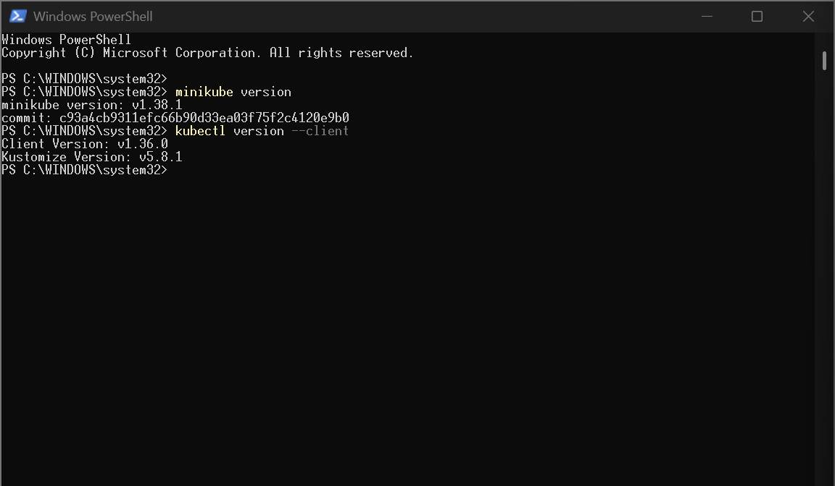
- Start Minikube using: minikube start --driver=docker
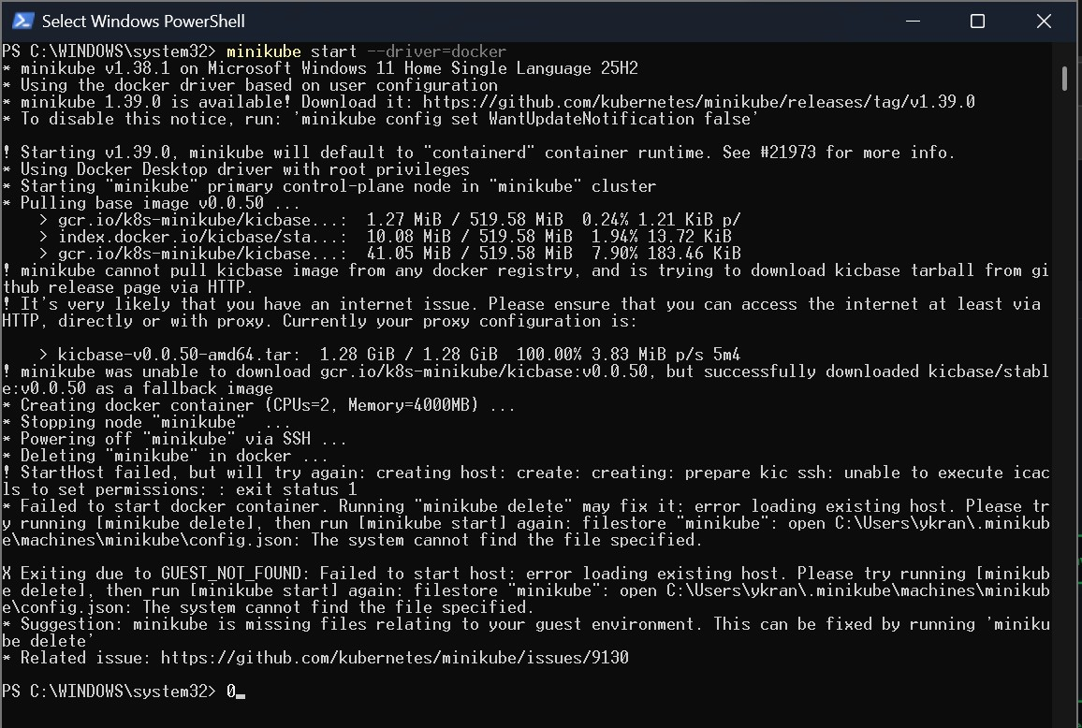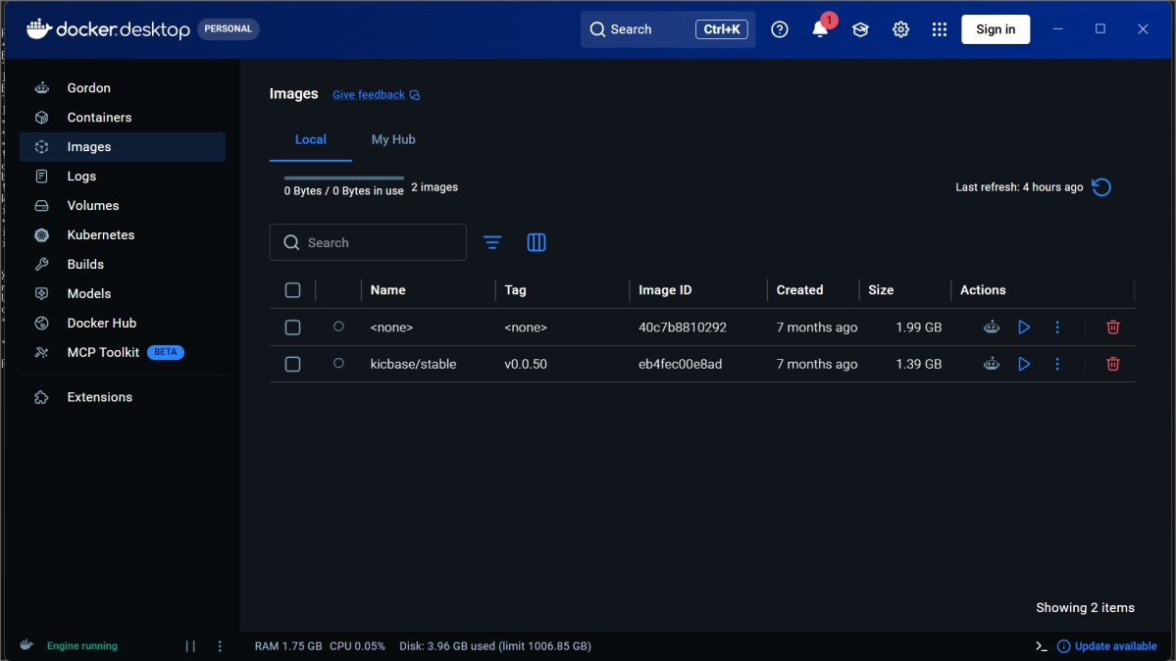
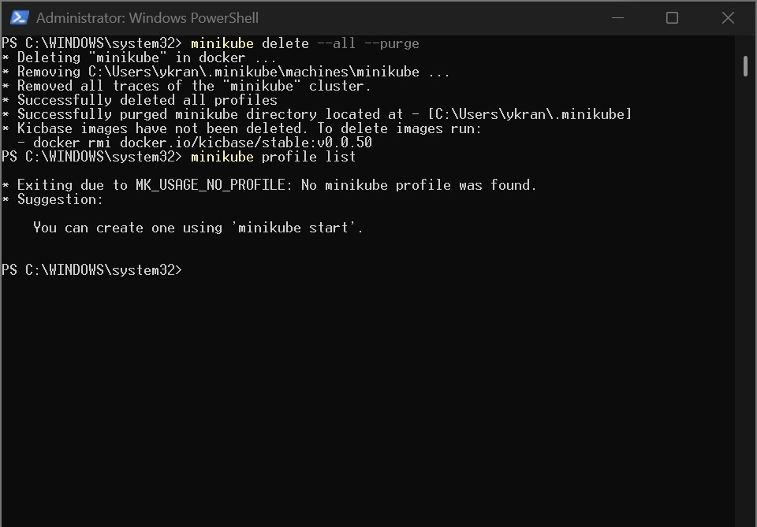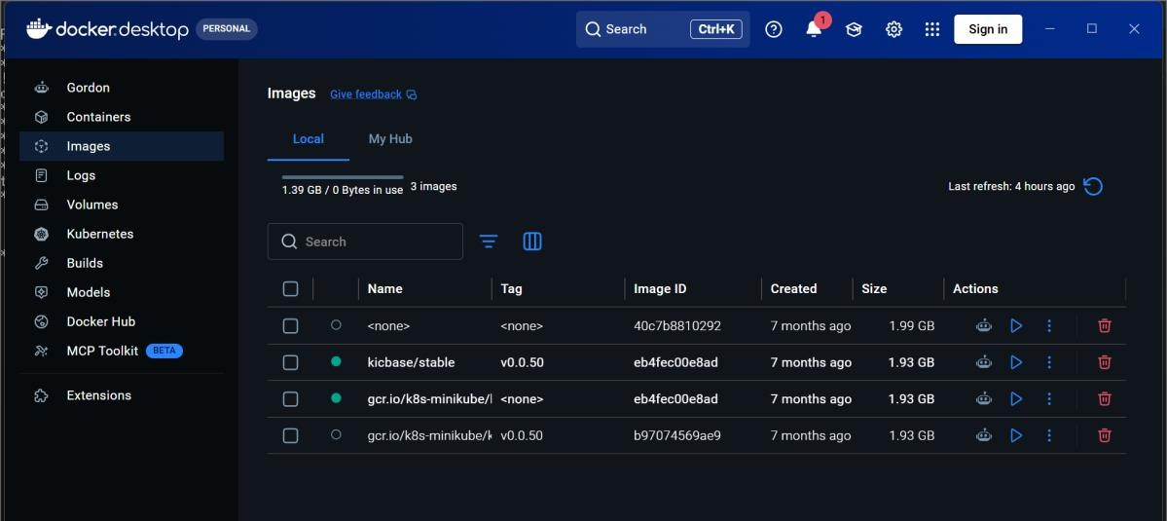
- Check the cluster status using: minikube status
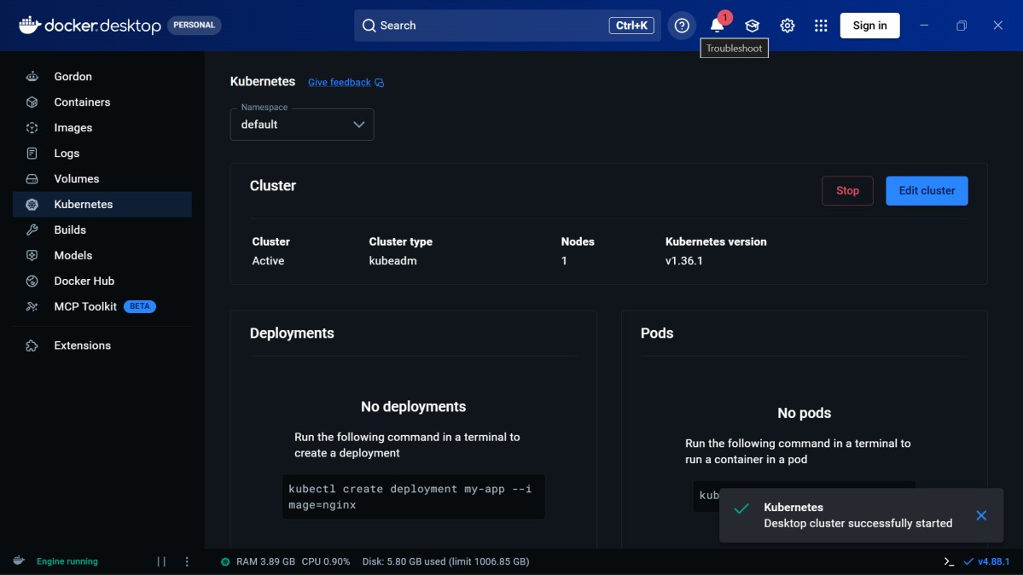
- Check the Kubernetes node using: kubectl get nodes
- Create a file named nginx-pod.yaml and add the Nginx Pod configuration.
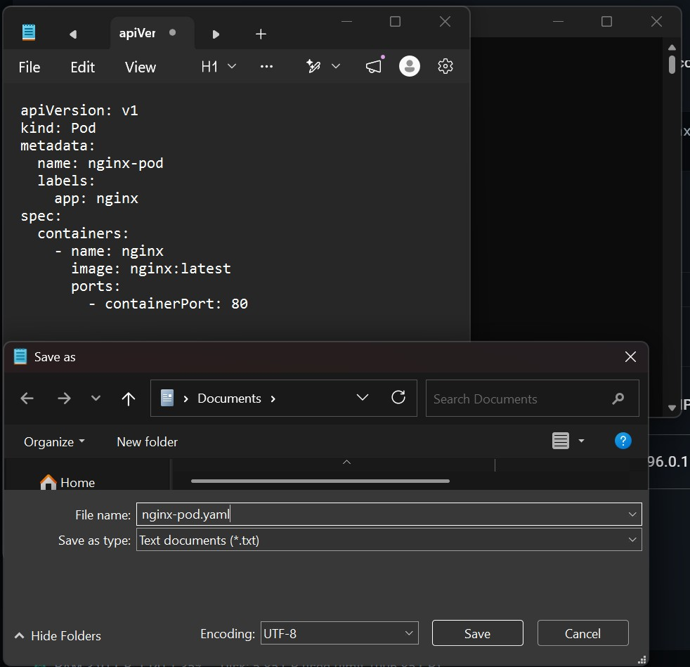
- Deploy the Nginx Pod using: kubectl apply -f nginx-pod.yaml
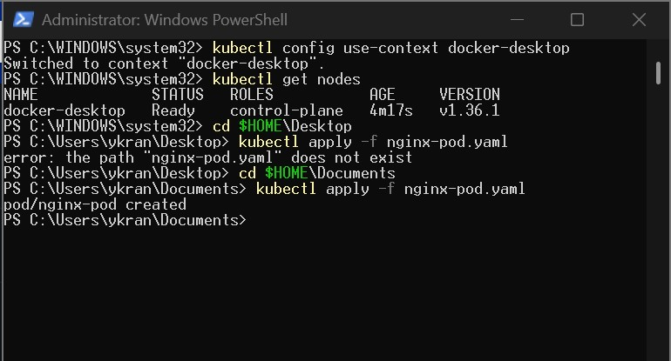
- Check the Pod status using: kubectl get pods
- View Pod details using:
kubectl describe pod nginx-pod
- Access Nginx using: kubectl port-forward pod/nginx-pod 8080:80
- Open http://localhost:8080 in the browser.
- Verify that the Welcome to nginx! page is displayed.
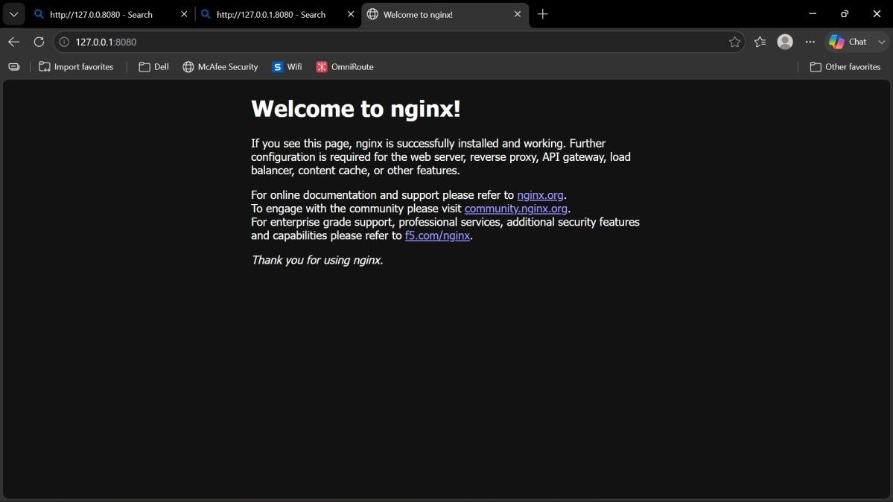
- View Nginx logs using: kubectl logs nginx-pod
- Delete the Pod using: kubectl delete -f nginx-pod.yaml
- Stop Minikube using:
minikube stop

