**Varsity League Soccer StatPad**

**Group ID:** BUDT702_Project_0504_11

**Group Members:** Abhinandan Gupta, Avi Choudhary, Anudeep Koneru, Shashank Bisht

**Mission Statement:**

To conduct a comprehensive analysis of the performance of the Maryland Men’s Soccer team across recent seasons, and to derive valuable insights regarding team dynamics in various match settings. Furthermore, the aim is to assess individual player performance by examining detailed statistics, contributing to a holistic understanding of player contributions and their impact on overall team success.

**Mission Objectives:**

1. What is the correlation between goals, assists and fouls with player position?
2. How can we analyze the relationship between different match statistics, such as shots on target, fouls, and goals scored, for both home and away teams
3. What is the win/loss statistics for a team playing Home and Away and how much does attendance affect team performance?
4. Is there a correlation between the spectator count and player performance? If yes, which forward player performs the best when there are more spectators watching.

**ER Diagram**

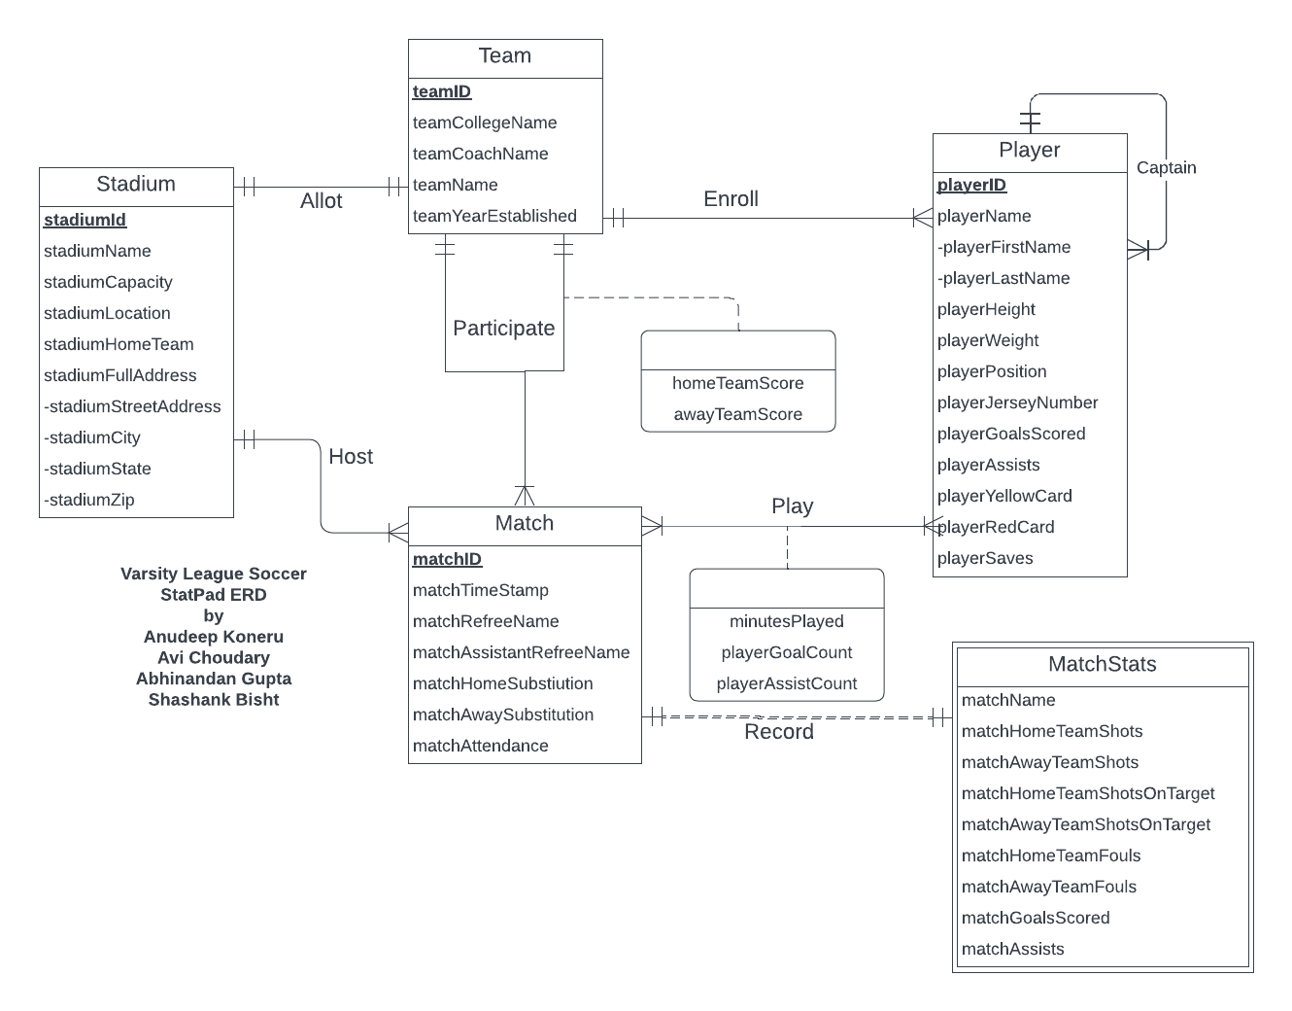

**Relations:**

Stadium (**stadiumId**, stadiumName, stadiumCapacity, stadiumLocation, stadiumHomeTeam, stadiumStreetAddress, stadiumCity, stadiumState, stadiumZip)

Team (**teamId**, teamCollegeName, teamCoachName, teamName, teamYearEstablished, *stadiumId*)

Player (**playerId**, playerFirstName, playerLastName, playerHeight, playerWeight, playerPosition, playerJerseyNumber, playerGoalsScored, playerAssists, playerYellowCardCount, playerRedCard, playerSaves, *teamId*, *playerIdCaptain*)

Match (**matchId**, matchTimeStamp, matchRefreeName, matchAssistantRefreeName, matchHomeSubstitution, matchAwaySubstitution, matchAttendance, *stadiumId*)

MatchStats (***matchId***, matchName, matchHomeTeamShotsOnTarget, matchAwayTeamShotsOnTarget, matchHomeTeamFouls, matchAwayTeamFouls, matchGoalsScored, matchAssists)

Play (***playerId***, ***matchId,*** minutesPlayed, playerGoalCount, playerAssistCount)

Participate (***teamIdFirst***, ***teamIdSecond***, ***matchId***, homeTeamScore, awayTeamScore)

|  |
| --- |

**Business Rules:**

* [R1] When a team has a stadium and is participating in the season, the stadium cannot be deleted or updated from the database.
* [R2] When a team is deleted in the database, all associated players should also be deleted.
* [R3] When a team is updated in the database, all associated players should also be updated.
* [R4When a captain is removed from the team, the players captained by the captain should not be deleted.
* [R5]When a captain is updated in the team, the players captained by the captain should not be updated.
* [R6] When a stadium is deleted in the database all the corresponding matches are deleted.
* [R7] When a stadium is updated in the database all the corresponding matches are updated.
* [R8]When a match is deleted from the database the match stats are deleted as well.
* [R9] When a match is updated in the database the match stats are updated as well.
* [R10] When a player is involved in a match , the player's data cannot be updated or deleted.
* [R11] When a match is deleted from the database , the player match involvement detail is also deleted.
* [R12] When a match detail is updated in the database, the corresponding player match involvement detail is also updated.
* [R13] When a team is involved in a match, the participation details cannot be updated or deleted.
* [R14] When a match is deleted, the participation details should also be deleted from the database.
* [R15] When a match is updated, the participation details should also be updated in the database.

**Referential Integrity Actions:**

| Relation | Foreign Key | Base Relation | Primary Key | BusinessRule | ON DELETE | Business Rule | ON UPDATE |
| --- | --- | --- | --- | --- | --- | --- | --- |
| Team | stadiumId | Stadium | stadiumId | R1 | NO ACTION | R1 | NO ACTION |
| Player | teamId | Team | teamId | R2 | CASCADE | R3 | CASCADE |
| Player | playerIdCaptain | Player | playerIdCaptain | R4 | NO ACTION | R5 | NO ACTION |
| Match | stadiumId | Stadium | stadiumId | R6 | CASCADE | R7 | CASCADE |
| MatchStats | matchId | Match | matchId | R8 | CASCADE | R9 | CASCADE |
| Play | playerId | Player | playerId | R10 | NO ACTION | R10 | NO ACTION |
| Play | matchId | Match | matchId | R11 | CASCADE | R12 | CASCADE |
| Participate | teamIdFirst | Team | teamId | R13 | NO ACTION | R13 | NO ACTION |
| Participate | teamIdSecond | Team | teamId | R13 | NO ACTION | R13 | NO ACTION |
| Participate | matchId | Match | matchId | R14 | CASCADE | R15 | CASCADE |

**Sample Data for Relations:**

**Stadium** (S01, Ludwig Field, 7000, College Park, Maryland, 7898 Championship Ln, College Park, Maryland, 20742)

**Team** (T01, University of Maryland, Sasho Cirovski, Maryland, 1946, S01)

**Player** (P02, Griffith, Colin, 5’10, 160lb, FWD, 9, 3, 5, 2, 0, 0, T01, P01)

**Match** (M01, 2022-08-25 18:00:00, Heber Estreda, Nickrod Fateh, 5, 7, 1882, S01)

**MatchStats** (M01, UMD vs NHS, 5, 1, 13, 15, 3, 2)

**Play** (P02, M01, 85, 1, 1)

**Participate** (T01, T02, M01, 2, 1)