KONERU LAKSHMAIAH EDUCATION FOUNDATION
PROJECT DOCUMENTATION
DATABASE SYSTEMS ENGINEERING & DISTRIBUTED BACKEND DEVELOPMENT
(25CS1302E)

CONTRACTSENTINEL AI
Detect Risks. Expose Anomalies. Protect Every Contract.
AI-powered contract risk analysis platform

Academic Details | Value
Academic Year / semester | Y25 2026-2027 odd sem
Section | Sec 7
Team | Team 3

Roll Number | Name of Student
2520030136 | PARVATHAREDDY PRANAW REDDY
2520030087 | ANUDEEP POTNURU
2520030592 | PUDOTA ASRITHA CHOWDARY

Guide Name and Signature: ______________________________

DECLARATION
We hereby declare that the project report entitled “ContractSentinel AI” is a record of the work carried out by the project team listed below as part of the course DATABASE SYSTEMS ENGINEERING & DISTRIBUTED BACKEND DEVELOPMENT (25CS1302E). The implementation, design, analysis, database work, AI/NLP pipeline, microservices, testing and deployment details documented in this report are based on the supplied project source code, project presentation and abstract.
The report is prepared for academic documentation and reflects the implemented project structure and the capabilities represented in the supplied materials. Where a component is described as a future enhancement, it is kept separate from the currently implemented functionality.
Roll Number | Name | Signature
2520030136 | PARVATHAREDDY PRANAW REDDY | ________________
2520030087 | ANUDEEP POTNURU | ________________
2520030592 | PUDOTA ASRITHA CHOWDARY | ________________

CERTIFICATE
This is to certify that the project report entitled “ContractSentinel AI” is a bonafide project report prepared by the students listed below in partial fulfillment of the requirements associated with DATABASE SYSTEMS ENGINEERING & DISTRIBUTED BACKEND DEVELOPMENT (25CS1302E), Y25 2026-2027 Trimester - 4, Section 7, Team 3.
The report presents the system design, implementation, database engineering, AI/NLP processing, microservices, testing and deployment approach of the ContractSentinel AI project.
Role | Name / Signature
Project Guide | ________________________________________
Course Coordinator | ________________________________________
Department / HOD | ________________________________________

ACKNOWLEDGEMENT
The successful completion of ContractSentinel AI involved the combined effort of the project team and the academic environment that supported the work. We express our sincere gratitude to the faculty members and academic coordinators who provided direction, feedback and the opportunity to apply database systems, distributed backend development, AI/NLP and software engineering concepts in an integrated project.
We also acknowledge the value of the technical tools and frameworks used during development, including React, TypeScript, FastAPI, PostgreSQL, MongoDB, OpenAI API, LangChain, Docker, Kubernetes and the associated development and observability tooling.
Finally, we thank everyone who contributed directly or indirectly to the completion, testing and documentation of the project.

ABSTRACT
ContractSentinel AI is an AI-powered web application designed to simplify and improve the analysis of legal and corporate contracts. Reviewing lengthy agreements manually can be time-consuming and may make it difficult to identify hidden risks, unusual clauses, financial obligations, or unfavorable conditions. The system addresses this problem by automatically analyzing uploaded PDF and DOCX contracts using Natural Language Processing and Artificial Intelligence.
ContractSentinel AI extracts and analyzes individual clauses related to payment terms, termination, liability, confidentiality, intellectual property, renewal, penalties, jurisdiction, data privacy, and other important contractual conditions. It identifies potentially risky clauses, suspicious wording, contradictions, undefined terms, and abnormal provisions, assigning appropriate risk levels and confidence scores. The system also generates a simple, easy-to-understand summary of the agreement and highlights important contractual points for quick review.
For each identified risk, the application explains why the clause may be problematic and provides a suggested safer alternative. An overall contract risk score helps users quickly understand the potential level of concern. The web-based dashboard presents the analysis through interactive risk indicators, clause highlights, summaries, and downloadable reports. ContractSentinel AI is intended to support individuals, businesses, and legal professionals by making preliminary contract review faster, more structured, and easier to understand, while recognizing that final legal decisions should be made with appropriate professional advice.

TABLE OF CONTENTS
Chapter 1 Introduction
1.1 Background of the Project
1.2 Problem Statement
1.3 Scope of the Project
1.4 Objectives
1.5 Importance of the Application
1.6 Target Users / Audience
Chapter 2 System Requirements
2.1 Hardware Requirements
2.2 Software Requirements
2.3 Development Tools and Frameworks
Chapter 3 Technology Stack
3.1 Frontend
3.2 Backend
3.3 Database Layer
3.4 AI / NLP Layer
3.5 Document Processing
3.6 Version Control and Supporting Tools
Chapter 4 System Architecture
4.1 High-Level Architecture
4.2 Architecture Components
4.3 Layer-wise Operation
4.4 Microservice Communication
4.5 Deployment Architecture
Chapter 5 Design
5.1 Use Case Design
5.2 Database Schema
5.3 Contract Analysis Pipeline
5.4 API and Service Interaction
5.5 Risk Model
Chapter 6 Implementation
6.1 Module-wise Implementation
6.2 Authentication and Authorization
6.3 Contract Upload and Parsing
6.4 Clause Detection
6.5 AI Risk Analysis
6.6 Vector Search and RAG
6.7 Reporting
6.8 Frontend Implementation
Chapter 7 Features
7.1 Main Features
7.2 Dashboard
7.3 Contract Upload and History
7.4 Clause Analysis and Safer Alternatives
7.5 Fraud and Anomaly Alerts
7.6 Reports and Downloads
7.7 Analytics
7.8 Profile and Settings
Chapter 8 Testing
8.1 Testing Strategy
8.2 Backend Tests
8.3 AI and Clause Detection Tests
8.4 Microservice Tests
8.5 CO1-CO6 Verification
8.6 Build and Static Validation
8.7 Test Results
Chapter 9 Deployment
9.1 Local Setup
9.2 Docker Compose
9.3 Kubernetes
9.4 CI/CD Pipeline
9.5 Observability
Chapter 10 Challenges and Limitations
10.1 Challenges
10.2 Solutions
10.3 Current Limitations
Chapter 11 Future Enhancements
11.1 Multilingual Support
11.2 Version Comparison
11.3 Legal-Specific LLM
11.4 Jurisdiction Rules
11.5 E-signature and CLM
11.6 Mobile Application
Chapter 12 Conclusion
12.1 Project Summary
12.2 Achievements
12.3 Skills and Learning Outcomes
Chapter 13 References
Appendices
Appendix A Project Structure
Appendix B API Summary
Appendix C Setup and User Guide
Appendix D Selected Code Snippets
Appendix E Test Evidence

CHAPTER 1 — INTRODUCTION

1.1 Background of the Project
Contracts are used across employment, vendor, rental, service, technology and other business relationships. Their legal language can be lengthy and difficult to interpret, particularly when important obligations are distributed across multiple clauses. The project presentation identifies payment terms, termination, liability, confidentiality, intellectual property, renewal, penalties, jurisdiction and data privacy as examples of areas that can carry significant contractual implications.
ContractSentinel AI was developed as an AI-powered web application for preliminary contract analysis. The supplied abstract describes the central objective as making contract review faster, more structured and easier to understand by automatically processing uploaded documents and presenting risk information in a dashboard.
The implementation extends this concept into a backend-oriented architecture. The source code contains a React/Vite frontend, a FastAPI analysis backend, a Node.js activity service, a Spring Boot reporting service, a .NET 8 API gateway, PostgreSQL with pgvector, MongoDB, and deployment/observability configurations.

1.2 Problem Statement
The project addresses the difficulty of identifying hidden contractual risks quickly. Manual reading of long agreements can require substantial time and domain knowledge. Keyword searching may locate words without explaining their contractual significance, while a generic summarizer may not provide a structured risk score, clause-level findings, anomaly indicators or safer alternatives.
- Hidden risks may be embedded in unusual or unfavorable clauses.
- Financial exposure can arise from penalties, fees, liability and one-sided obligations.
- Contradictory clauses, undefined terms and conflicting dates can be difficult to detect manually.
- Non-expert users may not know what a safer alternative clause could look like.
- A structured preliminary review can help users identify areas requiring closer attention before professional legal review.

1.3 Scope of the Project
The project scope covers document ingestion, text extraction, clause segmentation, AI/rule-based risk analysis, fraud and anomaly warnings, risk scoring, plain-language summaries, safer alternatives, vector search/RAG capabilities, dashboards, history, reports, authentication, analytics, activity logging and deployment infrastructure.
The implementation supports PDF, DOCX and TXT file types at the backend level. The project abstract and presentation specifically emphasize PDF and DOCX contract analysis. OCR support is present in the document-processing dependency configuration for scanned PDF handling.

1.4 Objectives
- Automatically extract and classify contractual clauses from uploaded documents.
- Detect risky, suspicious, contradictory, undefined and abnormal contractual terms.
- Generate clause-level risk levels, confidence scores and an overall 0–100 contract risk score.
- Explain detected risks and provide safer alternative wording.
- Provide an interactive dashboard with contract history, risk indicators, highlights and downloadable reports.
- Implement a scalable backend using SQL, NoSQL, vector search and multiple service frameworks.
- Demonstrate database engineering, REST APIs, microservices, caching/rate limiting, deployment and observability aligned with CO1–CO6.

1.5 Importance of the Application
The application provides a structured first-pass view of a contract. Its value lies in organizing information that is otherwise distributed across lengthy documents: the overall risk score, individual clause findings, important points, fraud warnings, explanations and suggested alternatives. The project presentation explicitly positions the system as a preliminary review aid rather than a replacement for professional legal advice.

1.6 Target Users / Audience
- Individuals who need an initial understanding of a contract before seeking further advice.
- Businesses reviewing vendor, service, employment or other corporate agreements.
- Legal professionals who may use structured automated findings as an initial review aid.
- Students and developers studying database systems, AI/NLP integration and polyglot microservice architecture.

CHAPTER 2 — SYSTEM REQUIREMENTS

2.1 Hardware Requirements
The supplied source does not define a single fixed hardware specification. Because the system can be run with Docker Compose and can also be deployed through Kubernetes, practical requirements depend on whether the full stack, only the frontend, or a subset of services is being executed.
Component | Practical Development Requirement | Purpose
Processor | Multi-core CPU recommended | Runs frontend, backend, databases and microservices concurrently.
Memory | At least 8 GB recommended for full local stack | Supports PostgreSQL, MongoDB, application services and container runtime.
Storage | Several GB available | Project source, Docker images, database volumes, uploads and reports.
Network | Local network / internet as required | Required for package installation and OpenAI API access when configured.
Display | Standard desktop/laptop display | Frontend dashboard and API development.

2.2 Software Requirements
Software / Platform | Version or Range Evidenced | Role
Python | >= 3.11; CI uses 3.12 | FastAPI backend and verification scripts
FastAPI | >= 0.115.0 | Core REST API
React | 18.3.1 in frontend package | Web UI
TypeScript | 5.7.2 | Frontend typing
Vite | 6.0.5 | Frontend build and development server
Tailwind CSS | 3.4.17 | UI styling
PostgreSQL | 16 image in Docker Compose | Primary relational database
pgvector | PostgreSQL extension / pgvector image | Vector storage and similarity search
MongoDB | 7-jammy image | Activity/audit document data
Node.js | 20 in CI configuration | Activity microservice
Spring Boot | 3.2 implementation | Report microservice
.NET | 8 | API gateway
Docker / Docker Compose | Used by project configuration | Containerized deployment
Kubernetes | Manifests supplied | Orchestration
Prometheus / Grafana | Configured | Monitoring and metrics

2.3 Development Tools and Frameworks
- VS Code or an equivalent development environment can be used to work with the project source.
- GitHub Actions is configured for CI/CD.
- Swagger/OpenAPI is exposed by the FastAPI and .NET components for API inspection.
- pytest is used for backend tests and Jest is used for the Node.js activity service.
- Alembic manages PostgreSQL schema migrations.
- SQLAlchemy provides the relational persistence layer in the FastAPI backend.

CHAPTER 3 — TECHNOLOGY STACK

3.1 Frontend
The frontend is a React 18.3.1 single-page application written in TypeScript and built with Vite. Tailwind CSS supplies utility-based styling, while React Router provides navigation. Axios is used for HTTP communication, React Query is included for query management, Framer Motion supports UI motion, and Lucide React supplies interface icons.
The source contains dedicated pages for landing, login, registration, dashboard, upload, analysis, history, report, profile and settings. Reusable components include clause cards, fraud alert cards, document viewer functionality, charts, risk badges, layout components and toast notifications.

3.2 Backend
The main backend is implemented using Python FastAPI. The code follows a layered organization containing API routes, dependencies, core configuration and security, database models/session management, repositories, schemas and services. Async SQLAlchemy is used for relational database access, while Pydantic provides request/response validation.
Authentication uses JWT access/refresh tokens and bcrypt-compatible password hashing. Role-aware dependencies are present for access control. The API also includes CORS, security headers, request identification and Prometheus metrics support.

3.3 Database Layer
PostgreSQL is the primary relational database. The supplied SQL schema contains 13 tables and uses UUID keys, foreign keys, CHECK/UNIQUE constraints, JSONB fields, timestamps and enumerated types. The schema is described as 3NF-oriented in the project architecture documentation.
MongoDB is used for flexible activity and audit data. The implementation includes an asynchronous MongoDB driver, activity endpoints and aggregation-oriented service logic. The architecture therefore uses polyglot persistence: structured contractual data in PostgreSQL and flexible activity-oriented data in MongoDB.

3.4 AI / NLP Layer
The AI analysis layer uses LangChain and the OpenAI API when an API key is configured. The analysis service also contains a rule-based heuristic fallback so the system can continue to produce structured results without an available LLM configuration. Risk levels are mapped from numeric scores into LOW, MEDIUM, HIGH and CRITICAL categories.

3.5 Document Processing
PyMuPDF is used for PDF extraction and python-docx for DOCX extraction. The document parser normalizes extracted text. Optional OCR dependencies include pytesseract, pdf2image and Pillow for scanned-document workflows. The parser exposes a common ParsedDocument representation to the rest of the analysis pipeline.

3.6 Version Control and Supporting Tools
The project contains GitHub Actions configuration, Dockerfiles, Docker Compose, Kubernetes manifests, Prometheus configuration and optional OpenTelemetry support. The source also contains deployment scripts and a verification runner covering the course outcomes.

CHAPTER 4 — SYSTEM ARCHITECTURE

4.1 High-Level Architecture
ContractSentinel AI follows a polyglot microservices architecture. The frontend communicates with an API gateway and backend services. The FastAPI service handles core contract processing and analysis, the Node.js service handles activity/audit operations and real-time events, and the Spring Boot service handles contract report records and related operations.
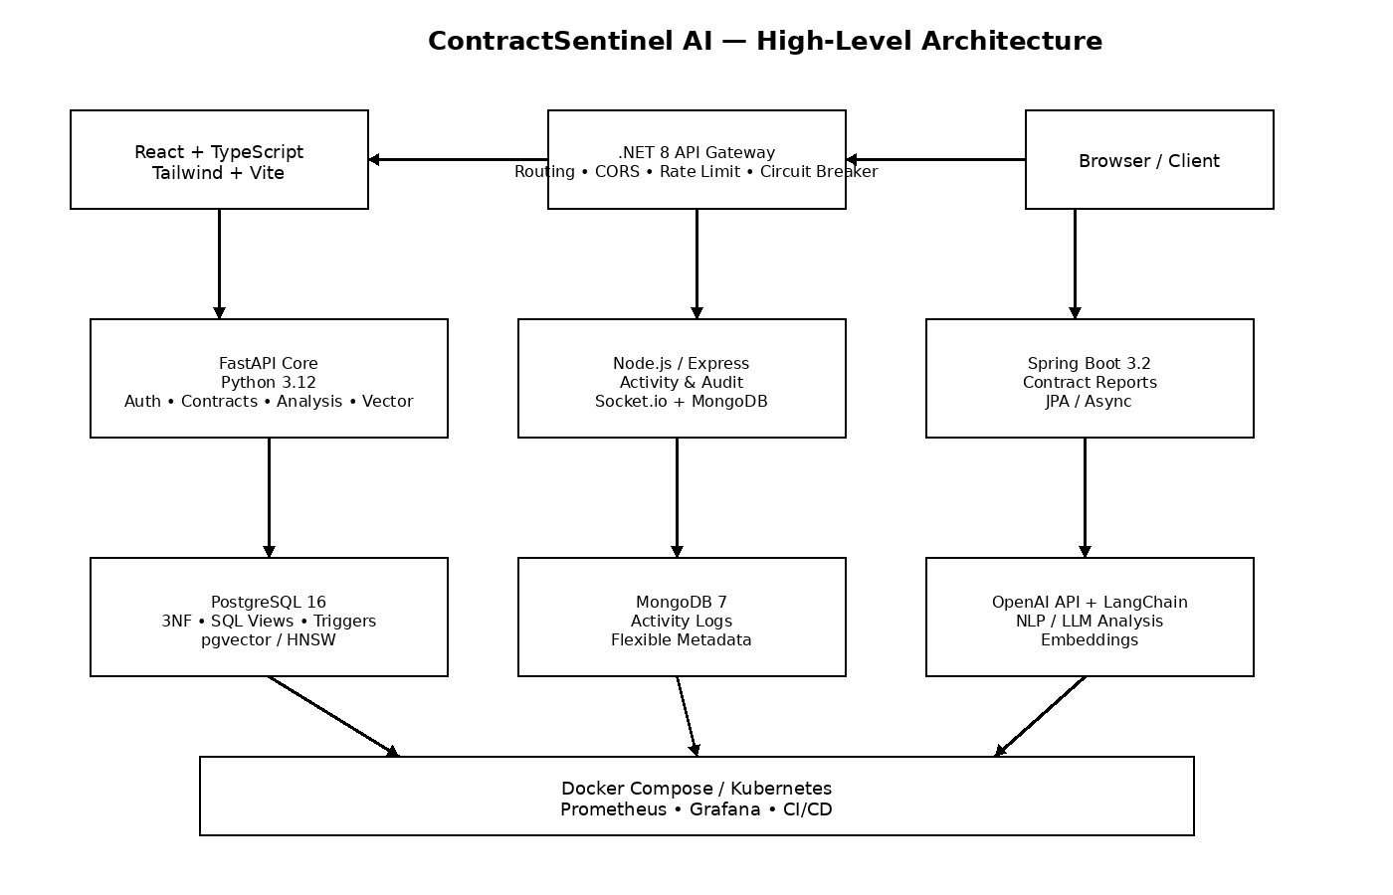
Figure 4.1 High-level architecture derived from the supplied project source and architecture documentation.

4.2 Architecture Components
Component | Technology | Primary Responsibility
Client | React + TypeScript + Vite | Upload, dashboard, analysis visualization, history and reports
API Gateway | .NET 8 | Routing, gateway status/health, CORS and distributed service access
Core Analysis Service | FastAPI / Python | Authentication, contract lifecycle, parsing, AI analysis, analytics and vector APIs
Activity Service | Node.js / Express | Activity events, audit operations, statistics and Socket.io streaming
Report Service | Spring Boot 3.2 | Contract report persistence, statistics and asynchronous report generation
Relational DB | PostgreSQL + pgvector | Contracts, analyses, clauses, users, reports and embeddings
Document DB | MongoDB 7 | Flexible activity/audit information
AI Services | OpenAI API + LangChain | LLM analysis, summaries, safer clause rewrites and embeddings

4.3 Layer-wise Operation
- The user uploads a contract through the React interface.
- The request is routed to the application backend.
- The contract service validates ownership and stores document metadata.
- The document parser extracts text from PDF, DOCX or TXT input.
- The clause detection service splits the extracted text into logical clauses.
- The AI analysis service evaluates clauses through the LLM path or heuristic fallback.
- Risk findings, confidence values, explanations, safer alternatives and summary information are persisted.
- Vector services can chunk and embed the contract and provide similarity or RAG queries.
- The frontend retrieves analysis data and presents dashboards, clause cards, alerts and reports.

4.4 Microservice Communication
The .NET gateway exposes routing capabilities to upstream services. The Node.js activity service uses Express middleware and Socket.io to support activity events. The Spring Boot service uses Spring MVC/JPA and includes an asynchronous report-generation operation. The project source also includes health aggregation so the gateway can check upstream service availability.

4.5 Deployment Architecture
Docker Compose defines the complete local stack, including PostgreSQL, MongoDB, FastAPI, Node.js, frontend, gateway, Spring Boot report service and monitoring components. Kubernetes manifests define namespace, ConfigMap, Secret, Deployments, PersistentVolumeClaims, Services and Ingress resources. This allows the same logical system to be demonstrated locally or orchestrated in a cluster.

CHAPTER 5 — DESIGN

5.1 Use Case Design
Actor | Representative Use Cases
User | Register, log in, upload contract, view contracts, start analysis, view analysis, inspect risks, query history, download reports, perform vector/RAG queries, manage profile.
Administrator / Analyst | Role-controlled access, analytics, activity monitoring and report-related operations where enabled by the backend.
System | Parse documents, detect clauses, calculate risk, generate warnings, store activity, generate reports, expose health/metrics.

5.2 Database Schema
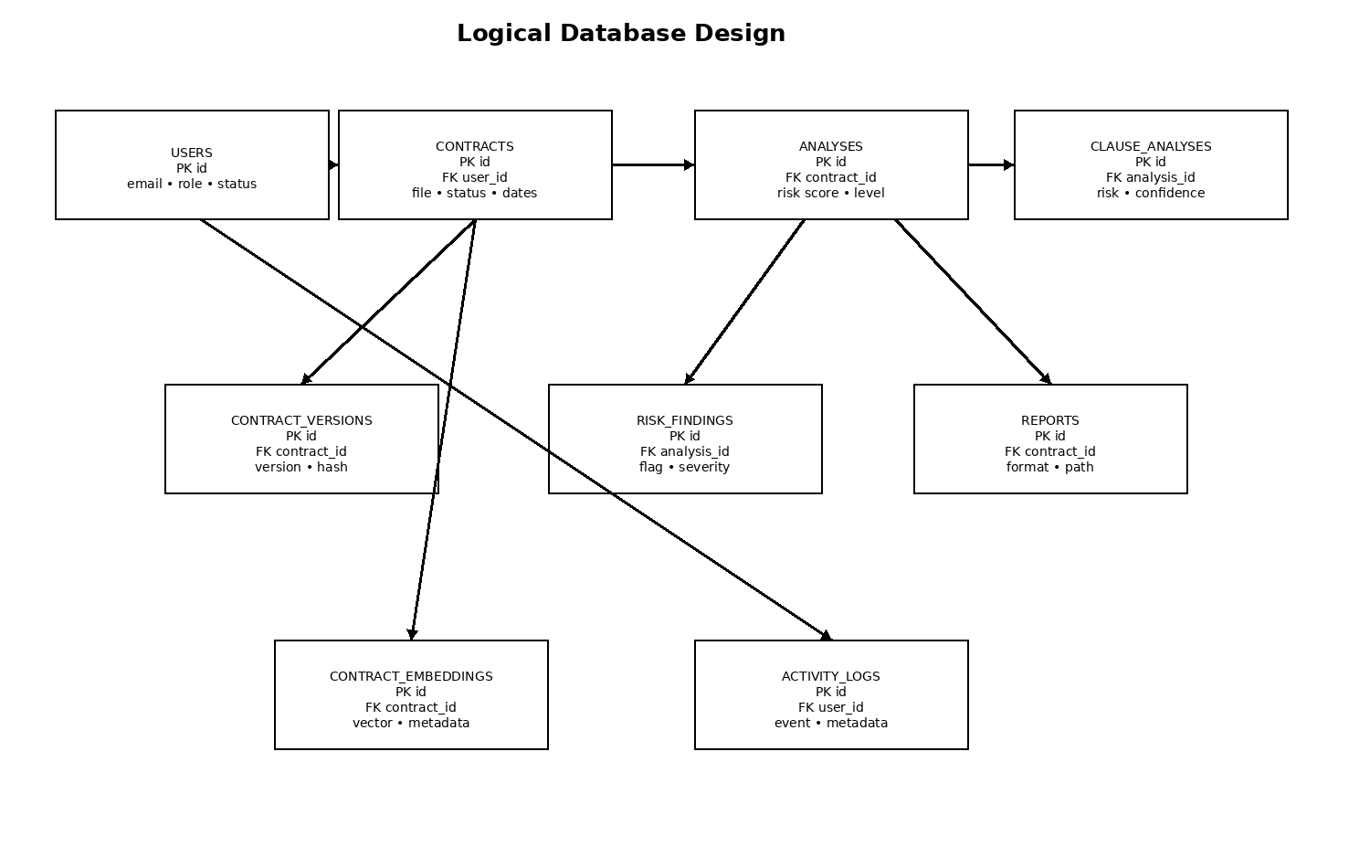
Figure 5.1 Logical relational design based on the supplied PostgreSQL schema.
Table | Purpose | Key Relationship
users | Accounts, roles and status | Root user entity
contracts | Uploaded contract metadata and extracted text | FK → users
contract_versions | Versioned contract files | FK → contracts, users
analyses | Overall analysis result | FK → contracts, users
clause_analyses | Clause-level findings | FK → analyses
risk_findings | Structured risk findings | FK → analyses
reports | Generated report records | FK → contracts, analyses, users
contract_embeddings | Vector/RAG chunks | FK → contracts
activity_logs | User/system activity | FK → users
tags / contract_tags | Contract tagging | Many-to-many
refresh_tokens | Authentication refresh tokens | FK → users
payments | Payment-related records | FK → users

5.3 Contract Analysis Pipeline
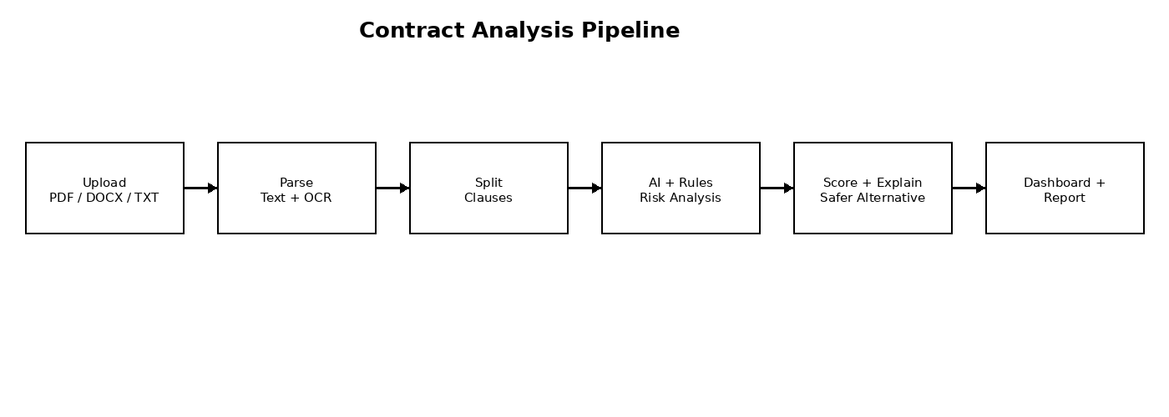
Figure 5.2 Contract analysis flow.

5.4 API and Service Interaction
The FastAPI API is organized under /api/v1. Major groups cover authentication, contracts, analysis, analytics, activity, reports, vector operations and health. The implementation exposes more than 30 FastAPI routes when the individual endpoints across these modules are counted.

5.5 Risk Model
Risk Level | Score Range | Meaning in the implementation
LOW | 0–34 | Lower automated risk indication
MEDIUM | 35–64 | Moderate risk indication requiring review
HIGH | 65–84 | High-risk indication requiring closer attention
CRITICAL | 85–100 | Critical automated risk indication

The project defines risk flags such as unlimited liability, automatic renewal, hidden fees, termination restrictions, broad indemnification, non-compete provisions, jurisdiction risk, confidentiality imbalance, arbitration, one-sided payment terms, IP ownership issues, data privacy concerns, vendor lock-in, contradictory clauses, conflicting dates, missing signatures, impossible timelines, excessive penalties, blank references, undefined terms, scam indicators and hidden obligations.

CHAPTER 6 — IMPLEMENTATION

6.1 Module-wise Implementation
Module | Main Source Area | Implementation Responsibility
Authentication | backend/app/api/v1/auth.py; services/auth.py | Signup, login, refresh tokens and current-user access
Contracts | backend/app/api/v1/contracts.py; services/contracts.py | Upload, metadata, extraction, listing, retrieval and deletion
Document Parsing | services/document_parser.py | PDF, DOCX and TXT extraction and normalization
Clause Detection | services/clause_detection.py | Heading/paragraph based clause splitting and title inference
AI Analysis | services/ai_analysis.py | LLM analysis, heuristic fallback, summaries, rewrites and risk scoring
Vector / RAG | services/vector_store.py; api/v1/vector.py | Chunking, embeddings, similarity search, hybrid search and RAG
Analytics | api/v1/analytics.py | Dashboard, risk distribution and advanced SQL demonstrations
Activity | api/v1/activity.py + Node service | Audit logs, statistics and real-time activity
Reports | services/report.py + Spring Boot service | Report generation and report records

6.2 Authentication and Authorization
The authentication API supports signup, login, refresh and current-user retrieval. Passwords are processed through the security layer rather than being stored in plain text. JWT tokens provide stateless authentication, while dependencies enforce access to protected resources.

6.3 Contract Upload and Parsing
The contract endpoint accepts uploaded files and creates a contract record. The contract service tracks filename, type, storage path, file size, SHA-256 hash, status and extracted text. Parsing is delegated to DocumentParserService. PDF extraction uses PyMuPDF, DOCX extraction uses python-docx, and OCR is available through the optional OCR dependency set.

6.4 Clause Detection
ClauseDetectionService first attempts to split text using heading patterns and falls back to paragraph-based segmentation. Titles are inferred from the resulting chunks so that the analysis layer can return clause-level records suitable for dashboard display.

6.5 AI Risk Analysis
AIAnalysisService first obtains clauses and then attempts an LLM analysis when the OpenAI configuration is available. If the LLM path is unavailable, a heuristic analysis path scores clauses according to predefined risk patterns. Each ClauseResult includes title, text, risk level, risk score, confidence, reason, legal reasoning, business impact, safer alternative and detected flags.
The implementation's fallback logic provides deterministic behavior for demonstration and testing. The project therefore has a two-layer analysis strategy: generative analysis when configured and rule-based analysis as a fallback.

6.6 Vector Search and RAG
The vector service chunks contract text using sentence-aware overlapping chunks. Embeddings can be generated using the OpenAI embedding model configured in settings or a deterministic hash-based fallback. PostgreSQL pgvector is used for native similarity search when available, with a Python cosine-similarity fallback. Hybrid search combines vector and keyword scores, with the implementation defaulting to 70% vector weight and 30% keyword weight.
The RAG service indexes a contract, retrieves relevant chunks for a question and provides a structured retrieval pipeline. Adapter classes for Pinecone and Weaviate are also included as interchangeable vector integration options.

6.7 Reporting
The FastAPI report endpoint generates downloadable reports in JSON, Markdown or PDF format according to the supported report format enumeration. The separate Spring Boot report service persists report records and exposes report retrieval, user statistics, high-risk report queries and an asynchronous generation endpoint.

6.8 Frontend Implementation
The frontend provides separate pages for dashboard, upload, analysis, history, report, profile and settings. The AnalysisPage presents an executive legal summary, fraud warnings, plain-English deal points, critical highlights and clause analysis with safer alternatives. The DashboardPage includes recent contracts, fraud/trap signals and historical risk score information. The HistoryPage contains a contract comparison matrix.
Example 6.1 Simplified FastAPI analysis route from the supplied implementation.
@router.post("/analyze")
async def analyze_contract(
contract_id: UUID,
user: User = Depends(current_user),
db: AsyncSession = Depends(get_db),
):
service = AnalysisService(db)
return await service.analyze(contract_id, user.id)

CHAPTER 7 — FEATURES

7.1 Main Features
- PDF and DOCX contract analysis emphasized by the project abstract and presentation, with TXT support also present in the backend implementation.
- Clause extraction for payment, termination, liability, IP, renewal, penalties, jurisdiction, privacy and related areas.
- Risk detection from LOW through CRITICAL with confidence values.
- Fraud and anomaly alerts for suspicious wording, contradictions, missing signatures, conflicting dates and other defined indicators.
- Safer alternatives and explanations for risky clauses.
- Overall contract risk score from 0 to 100.
- Interactive dashboard, contract history and downloadable reports.
- SQL, NoSQL and vector data storage.
- Microservice architecture with health checks, monitoring and deployment automation.

7.2 Dashboard
The dashboard page is designed to provide a high-level view of recent contracts, risk-related signals and historical risk scores. The source code also contains chart components for visual analytics.

7.3 Contract Upload and History
The upload page includes a drop-zone style workflow and demo contracts. Contract history is backed by the API and the frontend history page includes a comparison matrix. Contract metadata includes filename, file type, size, hash, status and extracted information.

7.4 Clause Analysis and Safer Alternatives
Each analyzed clause is represented as a structured record. The frontend ClauseCard component is designed to show the clause text, risk information and safer alternative. This supports the project's central goal of turning complex contractual language into actionable preliminary review information.

7.5 Fraud and Anomaly Alerts
The analysis engine includes explicit checks for blank references, missing signatures, suspicious wording, contradictory clauses, conflicting dates, impossible timelines, scam indicators and other abnormal patterns. FraudAlertCard provides a dedicated UI element for these findings.

7.6 Reports and Downloads
The report page presents a Contract Guardian AI Report with summary, key findings, fraud alerts and highest-risk clauses. The backend supports JSON, Markdown and PDF report formats through the report service.

7.7 Analytics
The analytics API includes dashboard aggregates, risk distribution, top risky clauses, window-function demonstrations, CTE demonstrations, subquery demonstrations, catalog information and clause-flag distributions. These endpoints directly support the database engineering objectives of the course.

7.8 Profile and Settings
The frontend includes profile and settings pages. Settings exposes appearance/display controls and an API target endpoint setting, while the profile page provides user information.

CHAPTER 8 — TESTING

8.1 Testing Strategy
Testing is implemented at multiple levels: FastAPI backend tests, focused AI and clause-detection tests, Node.js activity service tests, frontend build/type checking, and a dedicated CO1–CO6 verification script. The repository also contains CI/CD steps for automated testing and security scanning.

8.2 Backend Tests
The main backend test file contains 31 pytest test functions. These cover health, signup, login, invalid authentication, protected access, refresh tokens, contract listing, analytics endpoints, vector operations, activity logging, heuristic analysis, clause detection, chunking, cosine similarity, deterministic embeddings and password/JWT helpers.

8.3 AI and Clause Detection Tests
The dedicated AI test module contains tests for detection of unlimited-liability risk and generation of a safer clause alternative. The clause detection test verifies splitting of numbered sections. These tests directly exercise the core NLP/risk-analysis support logic.

8.4 Microservice Tests
The Node.js activity service includes four Jest tests. The service itself contains Express middleware, authentication-aware activity endpoints, MongoDB integration and Socket.io event handling.

8.5 CO1-CO6 Verification
The repository includes verify_all_outcomes.py, a dedicated verification runner covering the six course outcomes. The supplied project documentation reports 28 automated verification checks. The CO1–CO6 status document separately reports 31 passed backend tests, while the README describes the combined backend command as 34 tests when the focused AI and clause-detection tests are included. These are different test groupings, not interchangeable counts.

8.6 Build and Static Validation
For this documentation build, the supplied Python source was statically compiled with Python's compileall facility and passed without syntax errors. The supplied package.json files were parsed successfully, and the Docker Compose and Kubernetes YAML manifests were syntactically parsed successfully. These checks validate source/configuration structure; they do not replace a live deployment run.

8.7 Test Results
Test / Verification Area | Source Evidence | Documented Result
Backend main suite | backend/tests/test_full_suite.py | 31 test functions present; project status file reports 31 passed.
AI analysis | backend/tests/test_ai_analysis.py | 2 focused tests present.
Clause detection | backend/tests/test_clause_detection.py | 1 focused test present.
Node activity | services/node-activity/tests/activity.test.js | 4 Jest tests present.
CO1–CO6 verification | scripts/testing/verify_all_outcomes.py | Project README/presentation report 28 verification checks.
Python syntax validation | Supplied source tree | PASS in static compile check.
JSON/YAML validation | package.json, Compose, Kubernetes | PASS in static parsing check.

The project CI configuration also includes frontend build/type checking, Node.js tests, backend tests, security scanning with Trivy and TruffleHog, and Docker build/push steps. The CI file intentionally uses continue-on-error for some checks, so the existence of a CI step should not by itself be interpreted as proof that every external scan always succeeds.

CHAPTER 9 — DEPLOYMENT

9.1 Local Setup
- Install the required runtimes and package managers for Python, Node.js, Java and .NET as applicable to the services being run.
- Configure the environment values from the supplied .env.example files.
- Install backend dependencies and frontend dependencies.
- Initialize or start PostgreSQL and MongoDB, or use the supplied Docker Compose configuration.
- Run database migrations with Alembic when using the FastAPI database.
- Start the FastAPI backend, frontend, Node.js activity service, Spring Boot report service and .NET gateway as required.

9.2 Docker Compose
Example 9.1 Full-stack container startup command from the project README.
docker compose up --build
Service | Port | Purpose
Frontend | 8080 | Web UI
FastAPI | 8000 | Core API / Swagger
Node.js Activity | 3001 | Activity and audit service
Spring Boot Reports | 8082 | Report microservice
.NET Gateway | 5000 | API gateway
Prometheus | 9090 | Metrics
PostgreSQL | 5432 | Relational database
MongoDB | 27017 | Document database

9.3 Kubernetes
The Kubernetes manifest defines a dedicated namespace, ConfigMap, Secret template, PostgreSQL deployment and persistent volume, MongoDB deployment and persistent volume, backend deployment, services and ingress-related resources. The backend is configured with two replicas in the supplied manifest, while the database services use persistent storage.

9.4 CI/CD Pipeline
The GitHub Actions workflow runs backend tests, frontend build/type checks, Node.js service tests, security scanning and Docker build/push steps. The pipeline is triggered for pushes to main/develop and pull requests targeting main, with container publishing configured for the main branch.

9.5 Observability
Prometheus metrics are exposed by the backend and a Prometheus configuration is included. Grafana is included in the Compose monitoring stack. OpenTelemetry support is configurable in the FastAPI application, and request identifiers are used to improve traceability across service calls.

CHAPTER 10 — CHALLENGES AND LIMITATIONS

10.1 Challenges
- Processing contracts in multiple document formats while preserving meaningful text structure.
- Identifying clauses when agreements use inconsistent headings and paragraph structures.
- Combining generative AI output with deterministic risk rules.
- Maintaining structured relational data while also supporting flexible activity data and vector search.
- Coordinating multiple frameworks and runtimes in a single project.
- Providing safe fallback behavior when external AI configuration is unavailable.
- Managing deployment configuration across local Docker and Kubernetes environments.

10.2 Solutions Applied
- Dedicated document parser service with format-specific extraction paths.
- Heading- and paragraph-based clause detection.
- Hybrid LLM plus heuristic analysis architecture.
- PostgreSQL for normalized core data and MongoDB for flexible activity information.
- pgvector and a Python similarity fallback for vector operations.
- Health checks, API gateway routing and service isolation.
- Containerization and configuration templates for repeatable deployment.

10.3 Current Limitations
The project is a preliminary contract-review aid. Automated risk findings can identify patterns and produce useful explanations, but they do not constitute legal advice or a definitive legal interpretation. LLM-based outputs also depend on model configuration and input quality.
The project source contains fallback vector embeddings and heuristic risk analysis for demonstration. These fallbacks enable operation without external AI services but are not equivalent to production-grade semantic models.
The Kubernetes and Docker configurations include placeholder/default secrets and development-oriented values. These must be replaced with secure production secrets before real deployment. The supplied CI workflow also uses continue-on-error in several verification/security steps, so production CI policy would require additional hardening.

CHAPTER 11 — FUTURE ENHANCEMENTS

11.1 Multilingual Support
The presentation proposes multilingual support for Indian and global languages. This could extend document parsing, clause detection, risk explanation and safer alternatives beyond English contracts.

11.2 Version Comparison
Contract version comparison could use the existing contract_versions schema to highlight textual and risk-related changes between drafts, allowing users to understand how obligations changed.

11.3 Legal-Specific LLM
A legal-domain model or fine-tuned model could improve terminology handling and domain-specific clause interpretation, subject to appropriate validation and legal governance.

11.4 Jurisdiction Rules
The presentation proposes jurisdiction-aware rule checking against local laws and acts. This would require carefully maintained legal rules and would need to preserve the distinction between automated assistance and professional legal advice.

11.5 E-signature and CLM
Integration with electronic-signature and contract-lifecycle-management systems could connect review, approval, signing and renewal workflows.

11.6 Mobile Application
A mobile client could allow contract upload, scanning and review on mobile devices while retaining the same backend analysis services.

CHAPTER 12 — CONCLUSION

12.1 Project Summary
ContractSentinel AI combines contract document processing, NLP/AI analysis, rule-based risk detection, vector search, structured persistence and microservices into one web-based platform. The project addresses the need for a fast and structured preliminary review of lengthy contracts by presenting risk information at both overall and clause levels.

12.2 Achievements
- Implemented a web dashboard for contract upload and analysis.
- Implemented PDF/DOCX document processing with backend support for TXT.
- Implemented clause extraction and risk analysis with LLM and heuristic paths.
- Implemented risk levels, confidence scores, explanations and safer alternatives.
- Implemented PostgreSQL relational schema with advanced SQL objects.
- Implemented MongoDB activity/audit functionality.
- Implemented pgvector-based and fallback vector search capabilities.
- Implemented FastAPI, Node.js, Spring Boot and .NET services.
- Implemented Docker Compose and Kubernetes deployment configurations.
- Implemented CI/CD and observability configurations.
- Implemented automated tests and CO1–CO6 verification tooling.

12.3 Skills and Learning Outcomes
The project demonstrates practical skills in relational database design, advanced SQL, NoSQL persistence, vector search, REST API development, authentication, asynchronous programming, microservice integration, frontend engineering, containerization, Kubernetes, CI/CD, monitoring and AI/NLP integration.
The project presentation maps these implementation areas to CO1 through CO6: relational database engineering; SQL/NoSQL/vector databases; RESTful APIs and JWT authentication; multi-framework backend development; caching/rate limiting/circuit-breaker patterns; and deployment/observability.

CHAPTER 13 — REFERENCES
The following sources were used as the basis for this project documentation:
- ContractSentinel AI project presentation supplied as ContractSentinel_AI_Presentation.pptx.
- ContractSentinel AI project abstract supplied as dbe dbs abstract.pdf.
- CONTRACT-GUARDIAN-AI project source archive supplied as CONTRACT-GUARDIAN-AI-merged.zip.
- Project README and architecture documentation contained in the supplied source archive.
- PostgreSQL schema, indexes, views, triggers, functions and advanced SQL scripts contained in the supplied source archive.
- FastAPI, SQLAlchemy, Alembic, Pydantic and related backend source modules contained in the supplied source archive.
- React, TypeScript, Tailwind CSS and Vite frontend source modules contained in the supplied source archive.
- Docker Compose, Kubernetes, GitHub Actions, Prometheus and supporting deployment configurations contained in the supplied source archive.
Technology names are reported here because they are explicitly represented in the supplied implementation and project materials. No external project facts have been added to replace missing source information.

APPENDICES

Appendix A — Project Structure
CONTRACT-GUARDIAN-AI/
├── backend/
│ ├── app/
│ │ ├── api/v1/
│ │ ├── core/
│ │ ├── db/
│ │ ├── repositories/
│ │ ├── schemas/
│ │ └── services/
│ ├── migrations/
│ └── tests/
├── frontend/
│ └── src/
├── database/
│ ├── sql/
│ └── seeds/
├── services/
│ ├── dotnet-gateway/
│ ├── node-activity/
│ └── springboot-contract/
├── kubernetes/manifests/
├── monitoring/
├── scripts/
├── docs/
├── demo/
├── docker-compose.yml
└── .github/workflows/ci-cd.yml

Appendix B — API Summary
Module | Method | Path
activity.py | GET | /logs
activity.py | GET | /stats
activity.py | GET | /mongo/status
activity.py | GET | /mongo/collections
activity.py | POST | /mongo/demo-crud
analysis.py | POST | /analyze
analysis.py | POST | /generate-summary
analysis.py | POST | /rewrite-clause
analysis.py | GET | /contracts/{contract_id}/analysis
analysis.py | GET | /analyses/{analysis_id}
analysis.py | GET | /history
analytics.py | GET | /dashboard
analytics.py | GET | /risk-distribution
analytics.py | GET | /top-risky-clauses
analytics.py | GET | /window-functions
analytics.py | GET | /cte-demo
analytics.py | GET | /subquery-demo
analytics.py | GET | /catalog
analytics.py | GET | /clause-flags-distribution
auth.py | POST | /signup
auth.py | POST | /login
auth.py | POST | /refresh
auth.py | GET | /me
contracts.py | POST | /upload
contracts.py | POST | /{contract_id}/extract-text
contracts.py | GET | /{contract_id}
contracts.py | GET | /{contract_id}/text
contracts.py | DELETE | /{contract_id}
health.py | GET | /health
reports.py | POST | /download-report
vector.py | POST | /index
vector.py | POST | /search
vector.py | POST | /rag/query
vector.py | POST | /embed
vector.py | POST | /chunk
vector.py | GET | /cosine-demo
vector.py | GET | /adapters/status

Appendix C — Setup and User Guide
A typical user flow is: create an account or log in → upload a supported contract → wait for parsing and analysis → review the overall risk score → inspect clause-level findings → read fraud/anomaly alerts → review safer alternatives → open history/report pages → download the required report format.
For local development, the repository README provides Docker Compose startup instructions and separate commands for backend tests, Node.js tests and frontend build. The FastAPI service exposes Swagger documentation under /docs when the backend is running.

Appendix D — Selected Code Snippets
Example D.1 Risk-level mapping from backend constants.
class RiskLevel(StrEnum):
LOW = "LOW"
MEDIUM = "MEDIUM"
HIGH = "HIGH"
CRITICAL = "CRITICAL"
def risk_level_from_score(score: int) -> RiskLevel:
if score >= 85:
return RiskLevel.CRITICAL
if score >= 65:
return RiskLevel.HIGH
if score >= 35:
return RiskLevel.MEDIUM
return RiskLevel.LOW
Example D.2 Core analysis-service flow.
async def analyze(self, contract_id: UUID, user_id: UUID) -> Analysis:
contract = await self.contract_service.get_owned(contract_id, user_id)
if not contract.extracted_text:
contract = await self.contract_service.extract_text(contract)
result = await self.ai.analyze_contract(contract.extracted_text)
# Persist overall analysis and clause-level findings
...
Example D.3 Full-stack deployment command.
docker compose up --build

Appendix E — Test Evidence
Evidence Item | Observed / Reported
Python source syntax | PASS during static compileall validation
Package JSON parsing | PASS for frontend and Node activity package files
Docker Compose YAML parsing | PASS
Kubernetes YAML parsing | PASS
Backend test functions | 31 in main suite + 2 AI + 1 clause-focused test
Node activity tests | 4 Jest tests
CO1–CO6 verification | 28 checks reported by project README/presentation

The test counts are intentionally presented by test grouping. The supplied materials use different totals for the backend test suite and the broader CO verification workflow; the report does not merge those numbers into a single unsupported total.

