DBSE&DBS
Roll No: 2520030087
Name: P. Anudeep
Query-1:
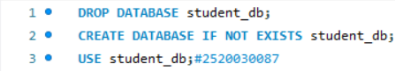
Query-2:
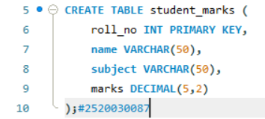
Query-3:
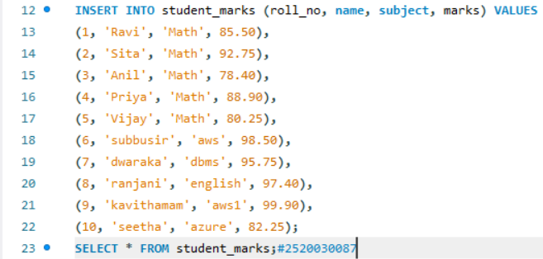
Student_marks1:
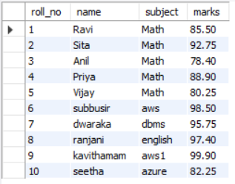
Query-4:
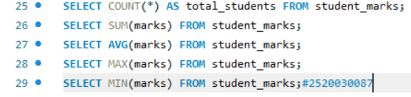
Result2:
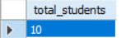
Result3:
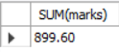
Result4:
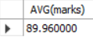
Result5:
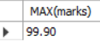
Result6:
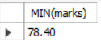
Query-5:
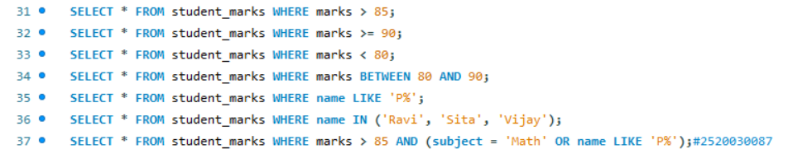
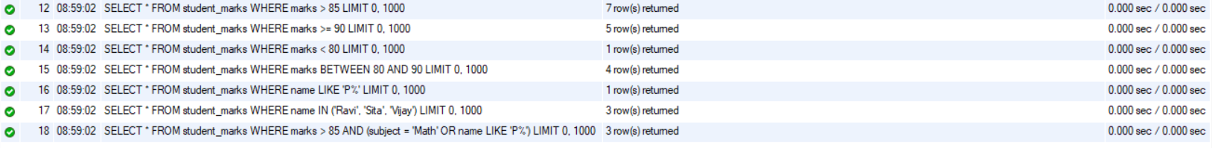
Student_marks7:
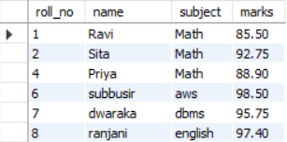
Student_marks8:
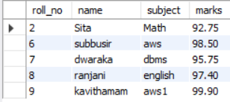
Student_marks9:
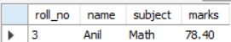
Student_marks10:
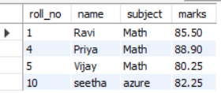
Student_marks11:
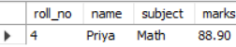
Student_marks12:
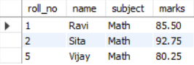
Student_marks13:
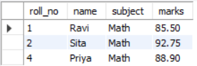

Query-6:
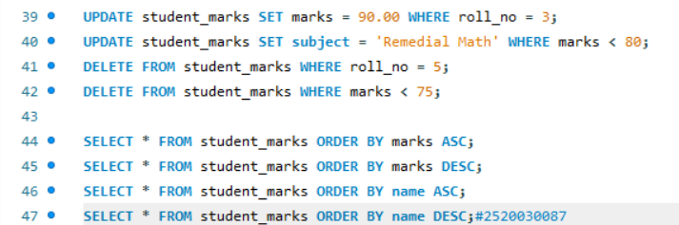
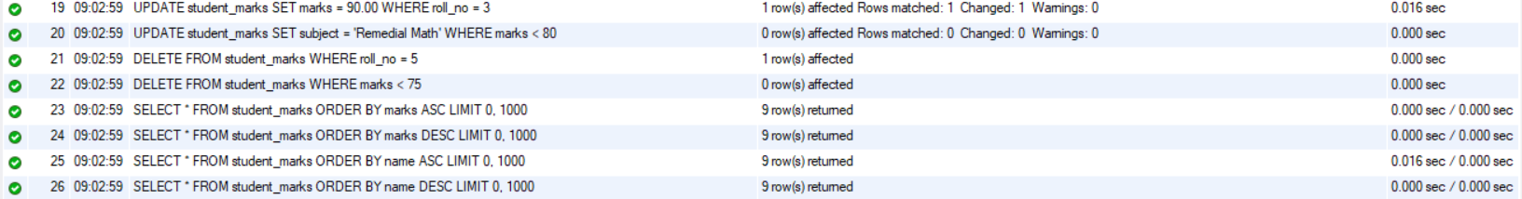
Student_marks14:
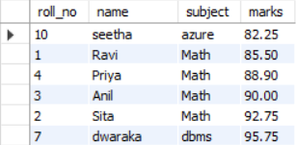
Student_marks15:
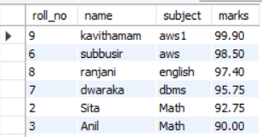
Student_marks16:
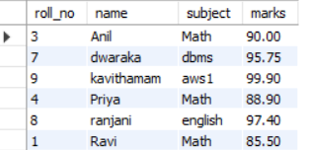
Student_marks17:
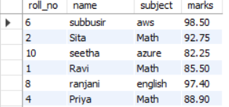

Query-7:
Result18:
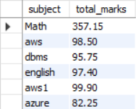
Result19:
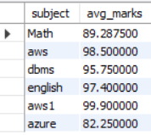
Result20:
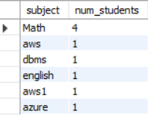
Query-8:
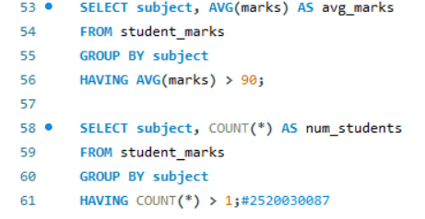
Result21:
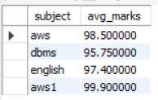
Result22:
