DBSE&DBS
Roll No: 2520030087
Name: P. Anudeep
Query-1:
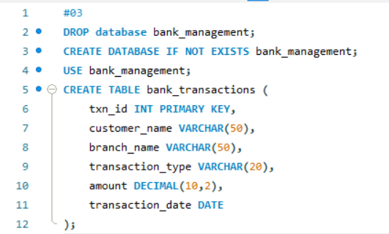
Query-2:
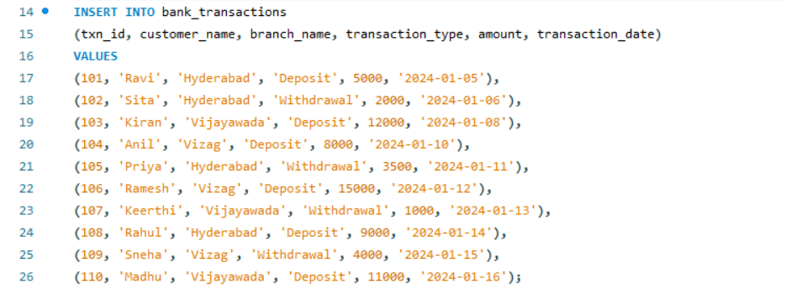
Query-3:
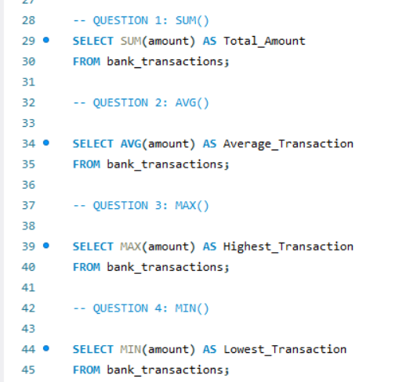
Result1:

Result2:

Result3:

Result4:
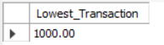
Query-4:
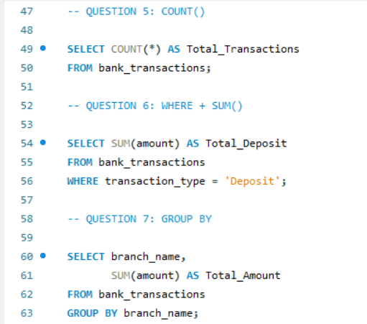
Result5:
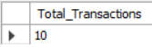
Result6:

Result7:
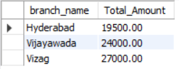
Query-5:
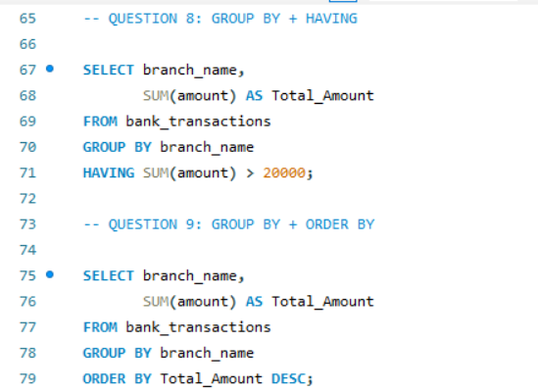
Result8:
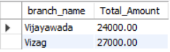
Result9:
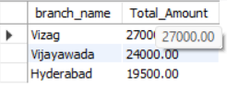
Query-6:
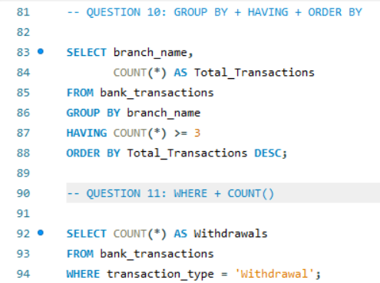
Result-10:
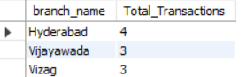
Result-11:

Query-7:
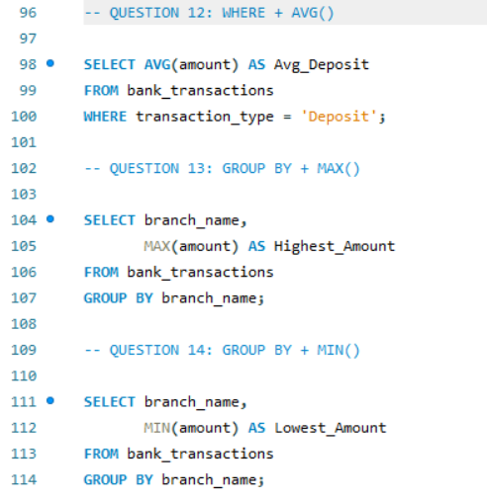
Result12:
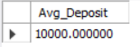
Result13:
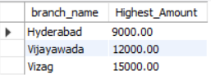
Result14:
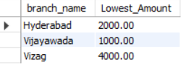

Query-8:
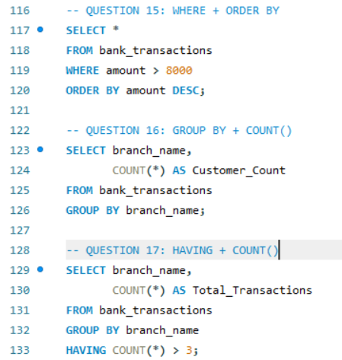
Result:
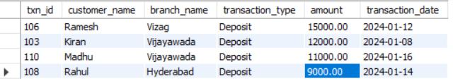
Result16:
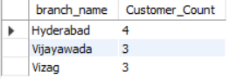
Result17:
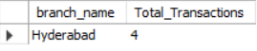
Query-9:
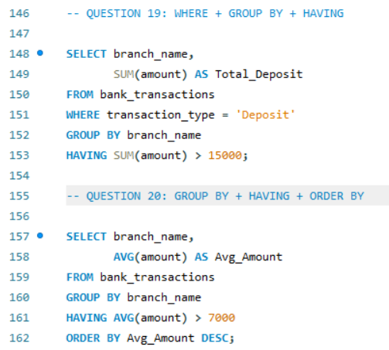
Result18:
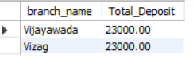
Result19:
