DBSE&DBS
Roll No: 2520030087
Name: P. Anudeep
Query-1:
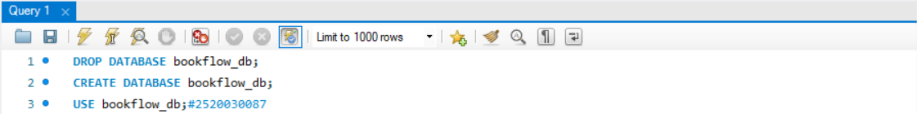
Query-2:
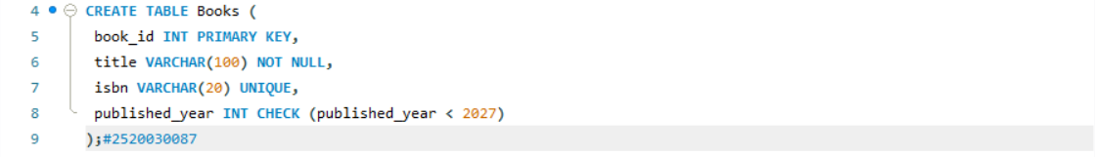
Query-3:
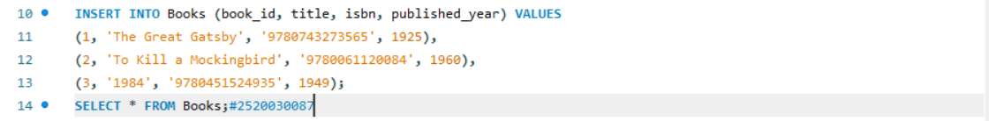
Query-4:
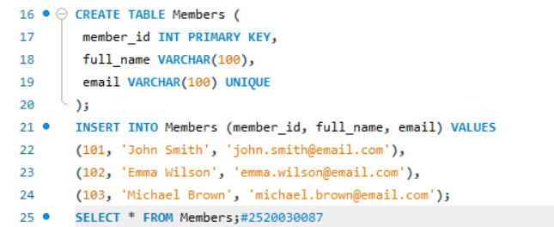

Query-5:
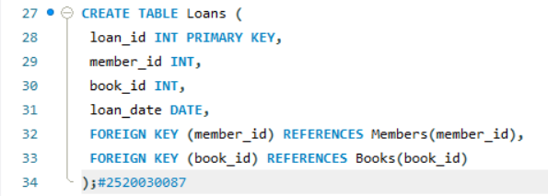
Query-6:
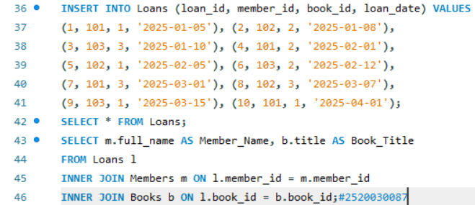
Query-7:
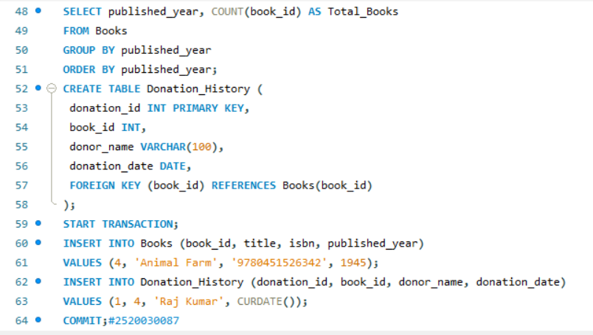
Query-8:
Books15:
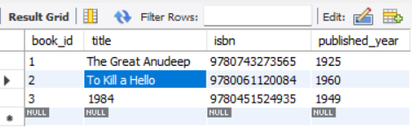
Members16:

Loans17:
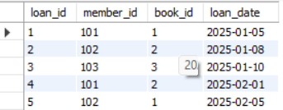
Result18:

Result19:
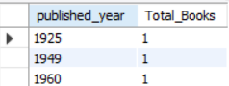
Books20:
