OSSP_WEEK_1_SKILL

Step 1 — Open Ubuntu Terminal
Press: Ctrl + Alt + T
You should see something similar to:

Step 2 — Update Ubuntu
Run:
sudo apt update
Enter your Ubuntu password when asked.
Then run:
sudo apt upgrade -y
Wait until the commands finish.

Step 3 — Install GCC, Make, Git, strace and pstree
Run:
sudo apt install build-essential git strace psmisc -y
Verify GCC:
gcc --version
Verify Git:
git --version
Verify Make:
make --version
Verify strace:
strace -V
Verify pstree:
pstree –version

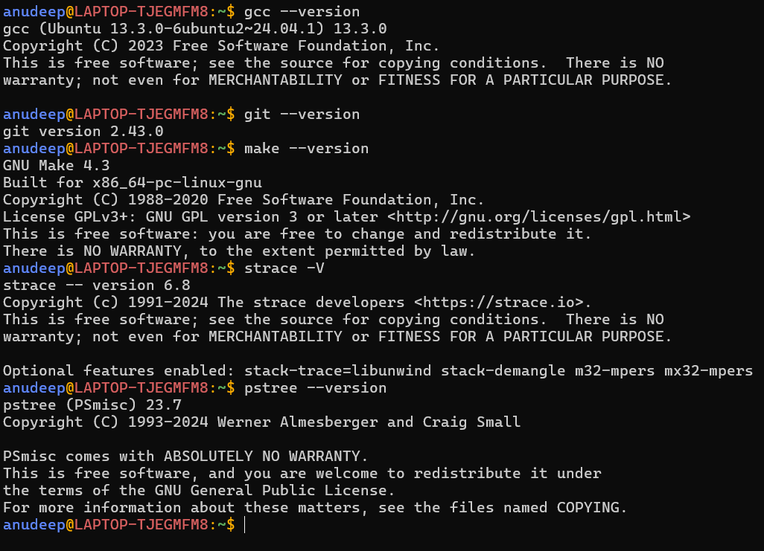

Step 4 — Configure Git
Set your name:
git config --global user.name "Your Name"
Example:
git config --global user.name "Laxman Reddy"
Set your email:
git config --global user.email "your-email@example.com"
Check:
git config --global –list
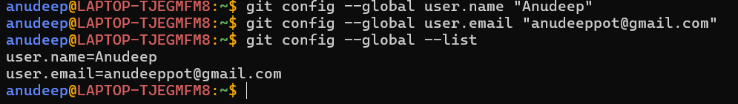

Step 5 — Create Your Project Folder
mkdir -p ~/ossp_process_lab
cd ~/ossp_process_lab
Check location:
Pwd
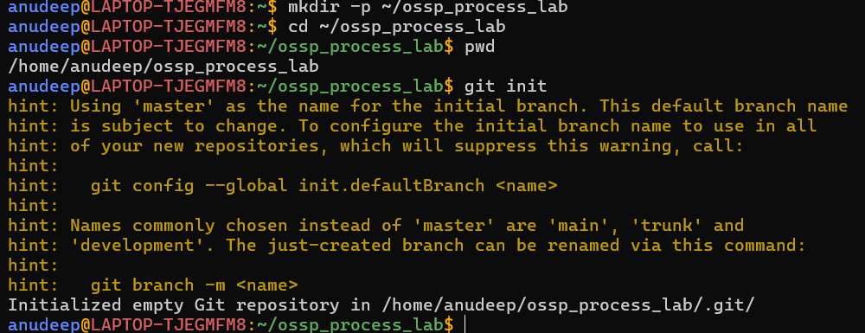

Step 6 — Create Git Repository
git init

Step 7 — Create Project Structure
mkdir -p src include build
touch README.md Makefile src/process_demo.c
Check:
find . -maxdepth 2 -print
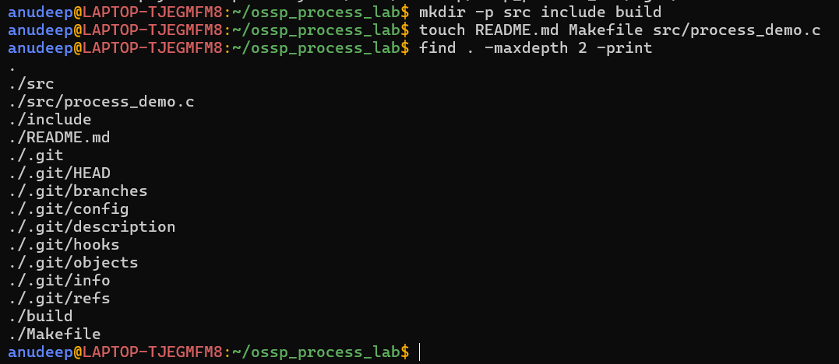

Step 8 — Check the Shell
echo $SHELL
ps -p $$ -f
pstree -p $$
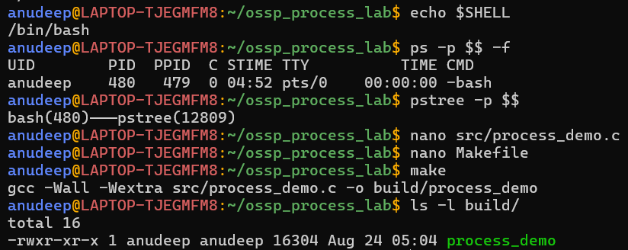

Step 9 — Create the C Program
Open the source file:
nano src/process_demo.c
Paste this exact program:
#include <stdio.h>
#include <stdlib.h>
#include <unistd.h>
#include <sys/types.h>
#include <sys/wait.h>
int main()
{
pid_t pid;
printf("Parent PID: %d\n", getpid());
pid = fork();
if (pid < 0)
{
perror("fork failed");
return 1;
}
else if (pid == 0)
{
printf("Child PID: %d\n", getpid());
printf("Child Parent PID: %d\n", getppid());
execlp("ls", "ls", "-l", NULL);
perror("exec failed");
exit(1);
}
else
{
printf("Parent is waiting for child...\n");
wait(NULL);
printf("Parent: child completed.\n");
}
return 0;
}
Save: Ctrl + O → Enter → Ctrl + X

Step 10 — Create the Makefile
nano Makefile
Paste:
CC = gcc
CFLAGS = -Wall -Wextra
TARGET = build/process_demo
SOURCE = src/process_demo.c
all: $(TARGET)
$(TARGET): $(SOURCE)
$(CC) $(CFLAGS) $(SOURCE) -o $(TARGET)
run: $(TARGET)
./$(TARGET)
clean:
rm -f $(TARGET)
IMPORTANT: The command lines in the Makefile must begin with a TAB, not spaces.
Save: Ctrl + O → Enter → Ctrl + X

Step 11 — Compile Using Make
make
ls -l build/

Step 12 — Run the Program
./build/process_demo

Step 13 — Run Using the Makefile
make run

Step 14 — Check the Process Tree
pstree -p
ps --forest -f

Step 15 — Observe the Parent-Child Relationship
./build/process_demo

Step 18 — Run strace
strace -f ./build/process_demo

Step 19 — Trace Only Process-Related Calls
strace -f -e trace=process ./build/process_demo

Step 20 — Save strace Output
strace -f -e trace=process ./build/process_demo 2> strace_output.txt
cat strace_output.txt

Step 21 — Check Git Status
git status

Step 22 — Add Project Files
git add .
git status

Step 23 — Create Git Commit
git commit -m "Initial OSSP process abstraction lab"
git log --oneline

Step 24 — Clean the Build
make clean
ls -l build/

Step 25 — Build Again
make
ls -l build/

Step 26 — Final Run
make run

Step 16 — Understand fork()
Before fork(), there is one process. After fork(), there are two processes: the parent and the child.
Parent
|
fork()
/ \
/ \
Parent Child
| |
wait() exec()
In the child, fork() returns 0. In the parent, fork() returns the child's PID. A negative value indicates failure.

Step 17 — Understand exec()
The child executes:
execlp("ls", "ls", "-l", NULL);
The exec() call replaces the child process image with the ls program. If exec() succeeds, statements after it are not executed.
