OSSP_SKILL_2

Step 1 – Open Terminal
Press Ctrl + Alt + T

Step 2 – Check GCC
gcc –version
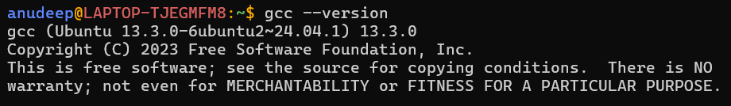

Step 3 – Install GCC if required
sudo apt update
sudo apt install build-essential -y
gcc –version
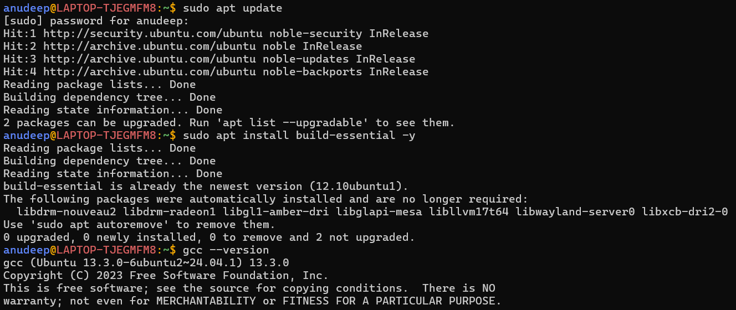

Step 4 – Create Project Folder
mkdir -p ~/ossp_practical3
cd ~/ossp_practical3
pwd
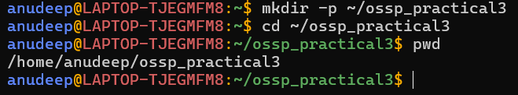

Step 5 – Create C File
nano myshell.c

Step 6 – Save the File
After pasting the program below into nano:
#include <stdio.h>
#include <stdlib.h>
#include <unistd.h>
#include <termios.h>
#include <sys/types.h>
#include <sys/wait.h>
#include <string.h>
#define MAX_INPUT 1024
void disableRawMode(struct termios *original)
{
tcsetattr(STDIN_FILENO, TCSAFLUSH, original);
}
int main()
{
struct termios original, raw;
char input[MAX_INPUT];
int index;
char *args[100];
while (1)
{
index = 0;
printf("\nmyShell> ");
fflush(stdout);
if (tcgetattr(STDIN_FILENO, &original) == -1)
{
perror("tcgetattr");
return 1;
}
raw = original;
raw.c_lflag &= ~(ICANON | ECHO);
if (tcsetattr(STDIN_FILENO, TCSAFLUSH, &raw) == -1)
{
perror("tcsetattr");
return 1;
}
while (1)
{
char ch;
if (read(STDIN_FILENO, &ch, 1) <= 0)
break;
if (ch == '\n' || ch == '\r')
{
input[index] = '\0';
printf("\n");
break;
}
if (ch == 127 || ch == '\b')
{
if (index > 0)
{
index--;
printf("\b \b");
fflush(stdout);
}
continue;
}
if (ch == 4)
{
disableRawMode(&original);
printf("\n");
return 0;
}
if (index < MAX_INPUT - 1)
{
input[index++] = ch;
putchar(ch);
fflush(stdout);
}
}
disableRawMode(&original);
if (index == 0)
continue;
if (strcmp(input, "exit") == 0)
{
printf("Exiting shell...\n");
break;
}
int count = 0;
char *token = strtok(input, " ");
while (token != NULL && count < 99)
{
args[count++] = token;
token = strtok(NULL, " ");
}
args[count] = NULL;
if (count == 0)
continue;
pid_t pid = fork();
if (pid < 0)
{
perror("fork");
}
else if (pid == 0)
{
execvp(args[0], args);
perror("Command execution failed");
exit(1);
}
else
{
waitpid(pid, NULL, 0);
}
}
return 0;
}

- Press Ctrl + O
- Press Enter
- Press Ctrl + X

Step 7 – Check the File
Ls

Step 8 – Compile
gcc myshell.c -o myshell
ls -l
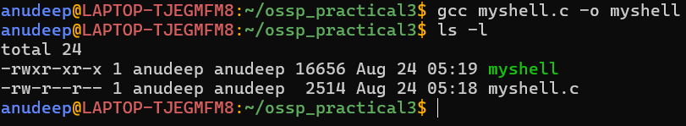

Step 9 – Run the Shell
./myshell
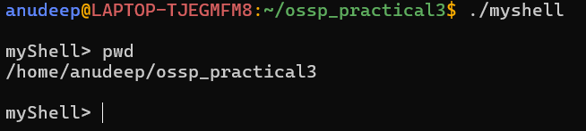

Step 10 – Test pwd
pwd

Step 11 – Test ls
Ls
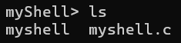

Step 12 – Test ls -l
ls -l
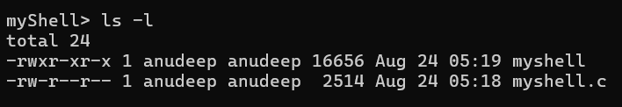

Step 13 – Test uname
Uname
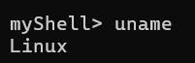

Step 14 – Test date
Date
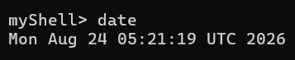

Step 15 – Test multi-word command
echo Hello OSSP
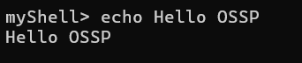

Step 16 – Test Backspace
Type: pwdd
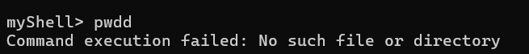
Press Backspace once, then press Enter.

Step 17 – Test empty input
At myShell>, press Enter without typing anything.
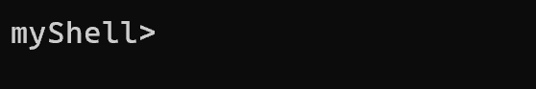

Step 18 – Test exit
Exit
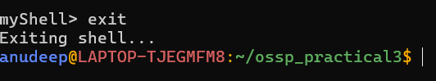

Step 19 – Test Ctrl+D
./myshell
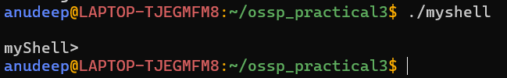
At myShell>, press Ctrl + D.

