OSSP – WEEK-3 – PRACTICAL
To develop a C program using fork() that creates a parent and child process, displays PID, PPID and process states, and observes process state transitions using ps, top and /proc.
NAME: P. ANUDEEP
ROLL NO: 2520030087
Step 1: Open UBUNTU terminal
Open the Ubuntu terminal.
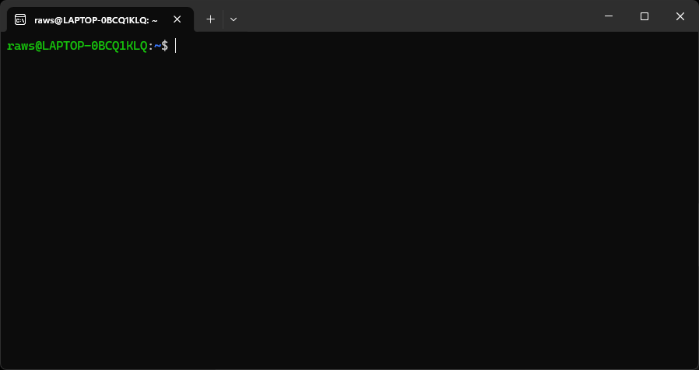
Step 2: Create the C file
Type:

nano process_state.c

Press Enter.
Step 3: Paste the program
Paste the complete C program into nano.

#include <stdio.h>
#include <unistd.h>
#include <sys/types.h>
#include <sys/wait.h>
#include <stdlib.h>

int main()
{
pid_t pid;

printf("Parent process starting...\n");
printf("Parent PID: %d\n", getpid());
printf("Parent PPID: %d\n", getppid());

pid = fork();

if (pid < 0)
{
printf("Fork failed\n");
return 1;
}

if (pid == 0)
{
printf("\n--- Child Process ---\n");
printf("Child PID: %d\n", getpid());
printf("Child PPID: %d\n", getppid());
printf("Child State: Running\n");

printf("Child entering Waiting state...\n");
sleep(30);

printf("Child State: Running again\n");
printf("Child is terminating...\n");

exit(0);
}
else
{
printf("\n--- Parent Process ---\n");
printf("Parent PID: %d\n", getpid());
printf("Parent PPID: %d\n", getppid());
printf("Parent State: Running\n");

printf("Parent waiting for child...\n");
wait(NULL);

printf("Parent State: Running\n");
printf("Child has terminated.\n");
printf("Parent is terminating...\n");
}

return 0;
}

Then press:
Ctrl + O

You will see:
File Name to Write: process_state.c

Press Enter.

Then press:
Ctrl + X

You are back at the terminal.
Step 4: Compile the program
Type:

gcc process_state.c -o process_state

Press Enter.

If there is no error message, compilation was successful.
Step 5: Run the program
Type:
./process_state

Press Enter.

You will see output similar to:

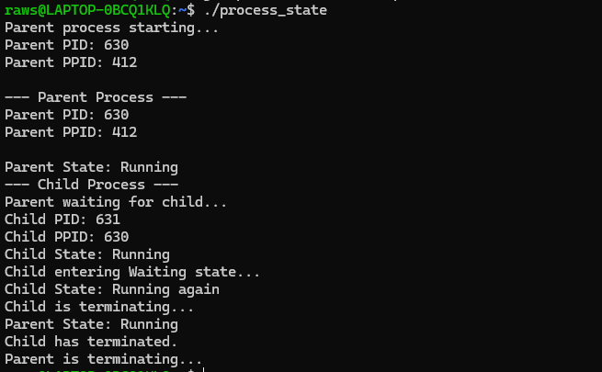
The actual PID numbers will be different on your computer.
Step 6: Understand fork()
After fork():

fork()
|
--------------
| |
Parent Child
| |
PID PID
| |
wait() sleep()
| |
Waiting Waiting
| |
| Running
| |
| Terminated
|
Running
|
Terminated

The child gets its own PID, while its PPID is the PID of the parent.
Step 7: Observe processes using ps
While the program is running, open another Ubuntu terminal.

First run:

ps -ef | grep process_state

Press Enter.
You can also use:

ps -o pid,ppid,state,cmd

You will see columns such as:
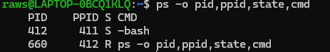

Here:
PID → Process ID
PPID → Parent Process ID
S → Process state
CMD → Command being executed

Step 8: Observe the Waiting state
The child contains:

sleep(10);

During this time, check:

ps -o pid,ppid,state,cmd
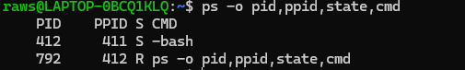

Step 9: Observe using /proc
Find the PID of the child from the program output.

For example, if the child PID is 2501, type:

cat /proc/2501/status

Press Enter.
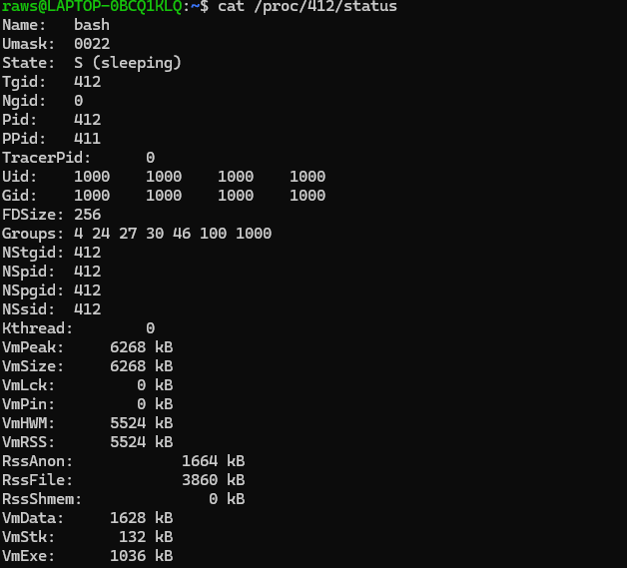

Look for:

Name: process_state
State: S (sleeping)
Pid: 2501
PPid: 2500

This shows the child's process state, PID and PPID.
Step 10: Observe the parent using /proc
If the parent PID is 2500, type:

cat /proc/2500/status

The parent is waiting for the child because the program uses:

wait(NULL);
Step 11: Observe using top
Run:

top

Press Enter.
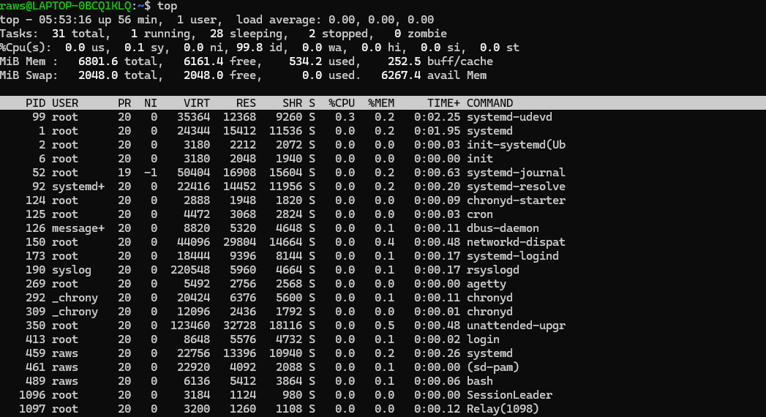

You will see a continuously updating process list.

Look for the process_state process.

To exit top, press:

q
Step 12: Observe process state transitions
The experiment demonstrates the following general sequence:

Process Created
|
v
Ready
|
v
Running
/ \
/ \
v v
Waiting Terminated
|
v
Running
|
v
Terminated

For this program:
Process creation – fork() creates parent and child
Running – Parent and child execute their code
Waiting – Child waits during sleep(10)
Waiting – Parent waits using wait(NULL)
Running – Child continues after sleep()
Terminated – Child exits
Running – Parent continues after wait()
Terminated – Parent finishes.
Step 13: Conclusion
The C program successfully creates a parent and child process using fork(). The PID and PPID of both processes are displayed. The wait() and sleep() functions allow the process states to be observed at different stages. Linux monitoring tools such as ps, top, and /proc can be used to observe process information and state transitions.

