**Software Requirements**

**Specification**

**for**

**Bank Management System**

**Version 1.0**

**Prepared by**

|  |  |  |
| --- | --- | --- |
| **Anudeep S** | **B210457CS** | **anudeep_b210457cs@nitc.ac.in** |
| **Saurav S** | **B210573CS** | **saurav_b210573cs@nitc.ac.in** |
| **R Gnanadeep** | **B210455CS** | **revuri_b210455cs@nitc.ac.in** |
| **Afthab Hyder** | **B210443CS** | **afthab_b210443cs@nitc.ac.in** |

**Instructor: Dr. K. A. Abdul Nazeer**

**Course: Database Management Systems**

**Date: 20/10/2023**

***Software Requirements Specification for Library Management System Page 2***

**Contents**

**Introduction 1**

Document Purpose 1

Product Scope 1

Intended Audience and Document Overview 1

Definitions, Acronyms and Abbreviations 2

Document Conventions 2

References and Acknowledgments 2

**Overall Description 3**

Product Overview 3

Product Functionality 3

Design and Implementation Constraints 4

Assumptions and Dependencies 4

**Specific Requirements 5**

External Interface Requirements 5

User Interfaces 5

Hardware Interfaces 5

Software Interfaces 5

Functional Requirements 6

Use Case Model 7

Login - U1 8

Register - U2 8

Donate - U3 9

Search - U4 10

Request Arrival - U5 11

Issue - U6 12

Add New Book - U7 13

Update Database - U8 14

Delete Book - U9 15

View History - U10 16

Return - U11 17

Renew - U12 18

Pay Fine - U13 19

**Other Non-functional Requirements 21**

Performance Requirements 21

***Software Requirements Specification for Library Management System***

***Page 3***

|  |  |
| --- | --- |
| Safety and Security Requirements | 21 |
| Software Quality Attributes | 21 |

|  |  |
| --- | --- |
| **1** | **Introduction** |

This project is a prototype for Bank Management System, an application with the intent to facilitate various operations performed in a bank including fund transfer between user accounts, requesting loans, checking bank details etc. This section provides a basic overview of the aim of the project, significance and utility of the software product to be formed, along with focussing on the targeted set of users.

# 1.1 Document Purpose

The main purpose of this document is to provide a detailed analysis of the Bank Management System project. This document reflects on both the functional and non-functional requirements needed for achieving the objectives of the product. The project offers a convenient and easy circulation system for establishing an efficient channel between users and the bank administration with regard to maintaining records of users, fund transfers, loan requests and other operations being performed. The document also focuses on the external interface requirements involving both hardware and software interfaces. It also lays emphasis on the functionalities of the system in addition to the interaction between the system and the users with the help of use case diagrams.

# 1.2 Product Scope

The Library Management System provides a better productive environment for library users as well as the staff members reducing the cost of library operations than the existing system, which is moreover manual in the performance of certain tasks. The application to be developed will be beneficial in giving an easier user interface as any user can simply register/login to their account which serves as the library card, search for the desired books/journals by means of title/author/subject/ISBN and issue them. In the case of renewal, the application handles the invalid renewals and hence the payment of a fine by validating the number of renewals performed by the user.

The Library Management System thus delivers a secure and reliable platform for handling library information providing additional flexibility and convenience to the library users.

# 1.3 Intended Audience and Document Overview

The document is intended to serve several groups of audience members.

* Firstly the SRS will be referenced by the system designers to create the design of the application.
* Secondly, the developers and testers shall view to ensure if the requirements have been met.
* Thirdly, the library manager/admin and users who are the client for the project shall review the SRS to get an understanding of the basic product functionalities.
* The application maintenance staff can also review the document for future modifications to get clarity on the present functionality.

The next section of the document, the Overall Description, gives an overview of the functionality of the product with the help of a high-level description diagram of the product. It describes the informal requirements, which is then used to establish a context for the detailed technical and functional requirements and the use case diagrams of the third section, Specific requirements. The fourth section lays importance on the non-functional requirements of the production, including performance and safety and security requirements.

# 1.4 Definitions, Acronyms and Abbreviations

|  |  |  |
| --- | --- | --- |
| S.No | Abbreviation/Term | Definition(s) |
| 1 | ISBN | International Standard Book Number |
| 2 | SRS | Software Requirements Specifications |
| 3 | NITC | National Institute of Technology, Calicut |
| 4 | LMS | Library Management System |
| 5 | User | A student or staff of NITC |
| 6 | Librarian | Super Admin of the system |
| 7 | Database | Stores the catalog of the books available in the library and details of the users |

**1.5 Document Conventions**

This document follows the IEEE formatting requirements.

# 1.6 References and Acknowledgments

* Fundamentals of Database Systems by Ramez Elmasri
* [Use-Case Diagram- Tutorialspoint](https://www.tutorialspoint.com/uml/uml_use_case_diagram.htm)
* IEEE. IEEE Std 830-1998 IEEE Recommended Practice for Software Requirements

Specifications. IEEE Computer Society, 1998

|  |  |
| --- | --- |
| **2** | **Overall Description** |

# 2.1 Product Overview

This LMS will serve as an interface for the NITC community. The registered users will have the facility to search for books, checkout and return the books, donate old books, view the transaction history and additionally make requests for new arrivals. Real-time information about the books present in the library will be presented upon search. The system will not permit renewal of the same book for a consecutive period of 3 times. In case of delayed return of the books, the user must pay a fine.

The librarian will act as a super admin, who will have direct access to the database to add/delete/update. In order to validate these privileges, there will be a separate login for the librarians.

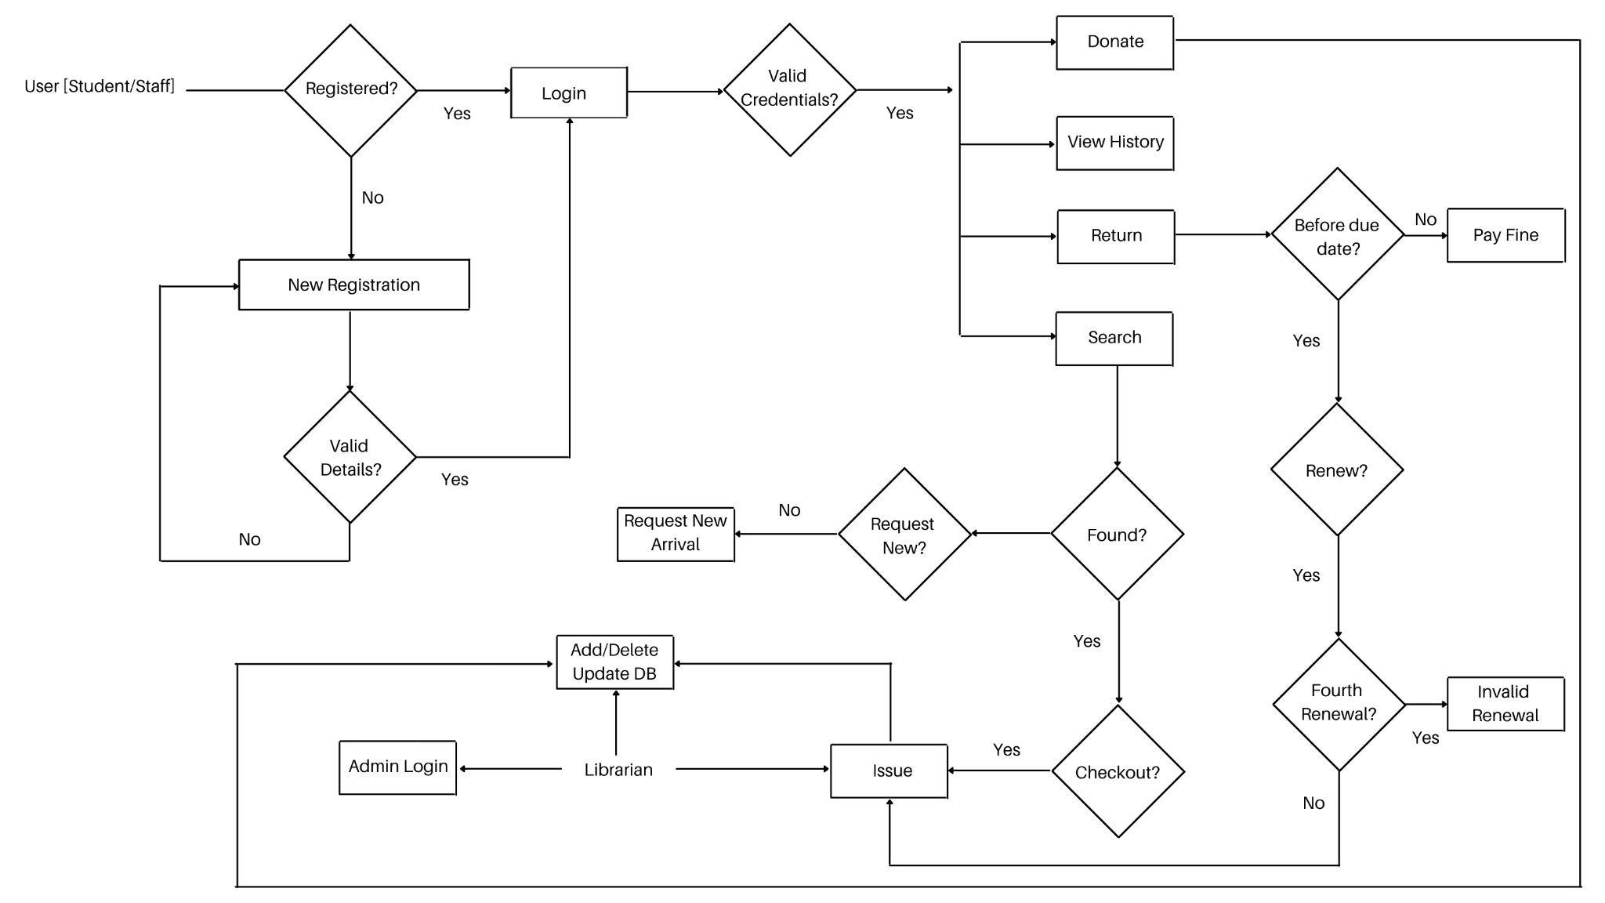

# 2.2 Product Functionality

The LMS will permit:

* Any member of the NITC community can register to this system using their Roll

Number/Employee ID.

* The registered users to log in to access the facilities

The users to

* Search for a book based on ISBN/title/author/subject.
* Check out an available book
* Request for new arrivals
* Return the book and pay dues in case of a late return
* View the transaction history
* Donate old books

The librarian to

* Login using valid credentials
* Issue the books that the user wishes to checkout
* Add/Delete/Update the database

# 2.3 Design and Implementation Constraints

Any issuing/deletion of the book from the catalog must be updated in the database. The dues to be paid must be calculated correctly. The users will be able to access this via any computer with Internet connectivity. In order to enter the system, the users, as well as the librarians, must enter valid credentials.

# 2.4 Assumptions and Dependencies

The assumptions are:

* The data of all the books available and registered users must be stored in a database
* The system must have storage capacity and render fast access to the database
* The system will be available at all times
* The users know English as the interface will be entirely in English The dependencies are:
* The hardware and software mentioned
* The super admin (librarian) should have a basic idea about the functioning of the system
* The database must be updated upon issuing/renewing/donation

|  |  |
| --- | --- |
| **3** | **Specific Requirements** |

# 3.1 External Interface Requirements

## 3.1.1 User Interfaces

* The design or layout of every form will be very clear and very interactive to the user.
* User when opening the application, it opens to a login page.
* In the login page, the user can enter the password and user ID and then log in to the application.
* Then it will give the successful login message.
* If the user is a new user, then the page redirects to a Register page.
* In the screen layout, the background colour is very light and the graphics and font style will be in a proper and well-organized manner. (Colours will be beneficial for the colourblind.)
* The user will be able to search any data from the record by using proper guidelines shown on the webpage.
* The design is simple and all the different interfaces follow a standard template.
* This software will be easily understandable and operable by the user.
* Required tasks such as viewing the details of the book upon search, the librarian can update after every transaction and requesting for renewal/ returning a book can be operated by the respective actor.

## 3.1.2 Hardware Interfaces

Processor: Pentium(R) Dual-core CPU

Hard Disk: 50GB

RAM: 2GB or more

## 3.1.3 Software Interfaces

|  |  |
| --- | --- |
| **Software Used** | **Description** |
| Operating System | We have chosen the Windows operating system for its best support and user-friendliness. |
| Database | Flask,a server-side tool based on python programming language and PostgreSQL, an open-source relational database management system when combined together is capable of delivering highly unique solutions. |
| HTML & CSS , JS(React) | To implement the frontend of the application we have chosen  HTML, CSS and JS |

# 3.2 Functional Requirements

F1: The system shall allow a user or librarian to register into the system. The details of the user are added to the database on registration.

F2: The system shall allow a user or librarian to log in to the system after verifying the user credentials. After verifying the details a valid user is logged into the system.

F3: The system shall not allow a user to log in to the system if the user provides invalid credentials. The system shall display an error message stating ‘Invalid Credentials’.

F4: The system shall allow the user and librarian to search the database for books by book title, author name, tag and the latest books.

F5: The system shall display the list of books requested by the user.

F6: The system shall allow a user to request new arrivals if he/she finds that the book he/she is looking for is not available by searching the database.

F7: The system shall allow the librarian to issue a book requested by the user if the book is available. The librarian can check if the book is available by searching for the particular book and retrieving its status information. The database is updated on the issuing of a book.

F8: The system shall allow a librarian to add new books to the library. The database is updated indicating the addition of the new book.

F9: The system shall allow a librarian to delete books from the library. The database is updated indicating the corresponding deletion.

F10: The system shall allow a user to view his transaction history.

F11: The system shall allow the librarian to view all the transaction history of all the users of the system.

F12: The system shall allow a librarian to mark the return of a book by a user. The database is updated on the return of a book.

F13: The system shall allow a user to pay a fine if he/she is returning the book after the due date. The amount to be paid is generated by the system.

F14: The system shall allow a user to renew a book for a maximum of 3 times. The user can extend the deadline for the return of a book by renewing.

F15: The system shall not allow a user to renew a book if the number of times he/she renewed the book exceeds 3. The system displays an error message ‘Invalid Renewal’.

F16: The system shall allow a user to donate a book to the library. If the book already exists in the library the count of that book is increased in the database. If it doesn’t exist, then a new book is added to the database.

F17: The system shall send notifications to the user on renewals and return dates.

F18: The system shall allow the librarian to update the database on the addition or deletion of new books into the library.

F19: The system shall allow the user to check out a book from the library.

# 3.3 Use Case Model

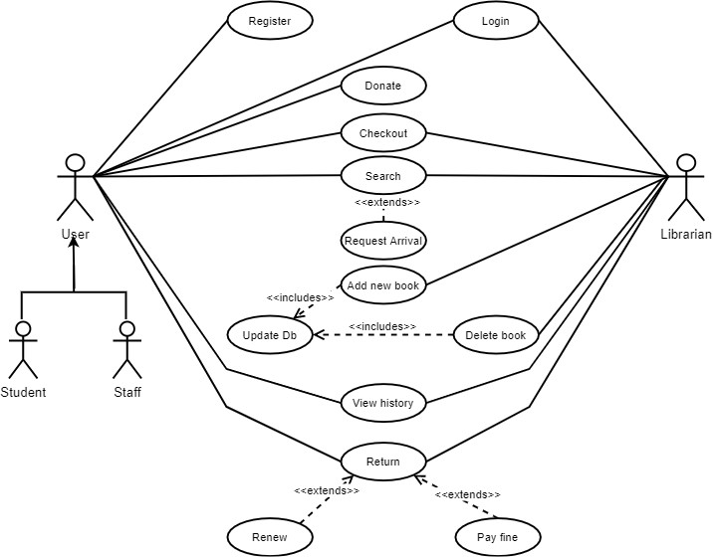

## 3.3.1 Login - U1

**Author –** Ganesh G

**Purpose** - To log in to the system.

**Requirements Traceability –** F2, F3

**Priority** - High

**Preconditions** -

1. The user/librarian must have valid user login credentials.

**Post conditions** -

1. The user successfully logs into the system.

**Actors** – User, Librarian

**Extends –** None

**Flow of Events**

1. **Basic Flow -**
   * The user/librarian tries to log in with his login credentials. ● The user/librarian logs in successfully.
2. **Alternative Flow -**
   * The user tries to log in with the wrong credentials.
   * The system shows a message indicating that the credentials are invalid.
   * The system redirects to Register a new user page.
3. **Exceptions -**
   * A registered user enters the wrong credentials.

**Includes** -None

**Notes/Issues** - None

## 3.3.2 Register - U2

**Author –** Ganesh G

**Purpose** - To Register a new user to the system.

**Requirements Traceability –** F1

**Priority** - High

**Preconditions** - The user must not be a registered user.

**Post conditions** -

1. The user successfully completes the registration.
2. The user login credentials are saved in the system database.

**Actors** – User

**Extends –** None

**Flow of Events**

1. **Basic Flow -**
   * A new user registers into the system.
   * The user login credentials are stored in the database.
2. **Alternative Flow -**
   * A registered user tries to register again.
   * The system shows a message indicating that the userid is already registered in the system.
   * The system then redirects to the login page.
3. **Exceptions -**
   * Submitting invalid user details during registration.

**Includes** -None

**Notes/Issues** - None

## 3.3.3 Donate - U3

**Author –** Ganesh G

**Purpose** - The user can donate books to the library.

**Requirements Traceability –** F1, F2, F16

**Priority** - Low

**Preconditions** -

1. The user must have a valid login credential.

**Post conditions** -

1. The donated book is verified and details of the book are added to the database.

**Actors** – User

**Extends –** No

**Flow of Events**

1. **Basic Flow -**
   * The user must be logged in to the system.
   * The book that needs to be donated is submitted and the book is verified.
   * After verification, the details of the book are updated in the database.
2. **Alternative Flow -**
   * The donated book is verified.
   * If any damage is found, then the book is returned to the donated user.

**Includes** None

**Notes/Issues** - None

## 3.3.4 Search - U4

**Author –** Pavithra Rajan

**Purpose** - The user/librarian can search for a book

**Requirements Traceability –** F1, F2, F4, F5

**Priority** - High

**Preconditions** -

1. The user/librarian must be logged in to the system
2. The database must be updated with the status of the book after each issue/addition/deletion of the book from the system.

**Post conditions** -

1. The books related to the particular search will be retrieved.

**Actors** – User, Librarian

**Extends –** U5

**Flow of Events**

1. **Basic Flow** -
   * The user/librarian will enter the title/name of the author/tags
   * Based on these, the system will show the books associated with it
2. **Alternate Flow** -
   * The book based on the given filter is not present in the catalog(database) ● A message will be shown indicating this to the user/librarian

**Includes** - None

**Notes/Issues** - None

## 3.3.5 Request Arrival - U5

**Author –** Pavithra Rajan

**Purpose** - Request of the arrival of a new book which doesn’t exist in the library

**Requirements Traceability –** F1, F2, F4, F5, F6

**Priority** - Medium

**Preconditions** -

1. The user must be logged in to the system
2. The database must be updated with the status of the book after each issue/addition/deletion of the book from the system.
3. The user must search the catalog and ensure that the book doesn’t exist in the library

**Post conditions** -

1. The requests made must be stored for further proceedings

**Actors** – User

**Extends –** None

**Flow of Events**

1. **Basic Flow** -
   * The user making the request will be able to enter the title of the book and the author name.
   * After hitting submit, a request will be made
2. **Alternate Flow -**
   * If the title of the book or the name of the author is missing then a pop-up would indicate ‘missing attribute’
   * Only after entering both the fields, the user will be able to make a request

**Includes**- None

**Notes/Issues** - None

## 3.3.6 Issue - U6

**Author –** Vishnu C

**Purpose** - To issue a library book

**Requirements Traceability –**F1, F2, F7, F19

**Priority** - High

**Preconditions** -

1. The librarian should have valid credentials to log in to the system.
2. The user to whom the book is to be issued must be registered in the system.
3. The librarian must verify the requested book is present in the system.

**Post conditions** -

1. The book will be issued to the user

**Actors** – Librarian

**Extends –** None

**Flow of Events**

1. **Basic Flow -**
   * The user request the librarian to issue a book
   * The librarian verifies the user and the availability of the book
   * The librarian updates the database and records the transaction
   * The book is issued to the user
2. **Alternative Flow -**
   * The librarian finds that the user cannot be issued the book due to authentication issue or due to pending fine
   * The librarian closes the issue stating “Invalid Credentials” or “Unpaid Dues”
3. **Exceptions -**
   * A book might be issued to a user who does not have the requirements

**Includes** - None

**Notes/Issues** - Any relevant notes or issues that need to be resolved

## 3.3.7 Add New Book - U7

**Author –** Vishnu C

**Purpose** - To add a new book to the library

**Requirements Traceability –** F1, F2, F8, F18

**Priority** - High

**Preconditions** -

1. The librarian should have valid credentials to log in to the system.
2. The librarian must ensure that the book to be added is in good condition.

**Post conditions** -

1. The new book is added to the library
2. The database is updated indicating the addition of the new book to the library.

**Actors** – Librarian

**Extends –** None

**Flow of Events**

1. **Basic Flow -**
   * The librarian verifies the new book is in good condition
   * The librarian enters the details of the book if a previous copy does not exist.
   * The book is added to the library.
   * The corresponding change is reflected in the database.
2. **Alternative Flow -**
   * The librarian finds that a previous copy of the book is present, raising a “Book already exists” warning.
   * The librarian increments the number of copies of the previous book.
   * The book is added to the library.
   * The corresponding change is reflected in the database.
3. **Exceptions -**
   * The librarian finds that the book to be added is in poor condition or the content does not abide by the library norms. ● The book is not added to the library.

**Includes** - U8

**Notes/Issues** - None

## 3.3.8 Update Database - U8

**Author –** Vishnu C

**Purpose** - To update the database following the required functionalities.

**Requirements Traceability –** F1, F2, F18

**Priority** - High

**Preconditions** -

1. The librarian should have valid credentials to update the database.

**Post conditions** -

1. The database is updated reflecting an addition or deletion of a book or reflecting a transaction (issuing/renewing/returning)

**Actors** – Librarian

**Extends –** None

**Flow of Events**

1. **Basic Flow -**
   * The librarian uses their credentials to access the database via the system.
   * The librarian performs the required update in the database which can be wither regarding the books or regarding the transactions
2. **Alternative Flow -**
   * The librarian fails to authenticate with the system and gets restricted database access with the error message “you are not authorized to perform the action”
3. **Exceptions -**
   * The librarian ignorantly performs an unintended update leading to loss or corruption of data

**Includes -** None

**Notes/Issues** - None

## 3.3.9 Delete Book - U9

**Author –** Rose S Jose

**Purpose** - To delete a book from the library

**Requirements Traceability –** F1, F2, F9

**Priority** - Medium

**Preconditions** -

1. The librarian should have valid credentials to log in to the system.
2. The librarian must ensure that the book to be deleted is no longer needed.

**Post conditions** -

1. The requested book is deleted from the library.
2. The database is updated indicating the deletion of the book from the library.

**Actors** – Librarian

**Extends –** None

**Flow of Events**

1. **Basic Flow -**
   * The librarian finds that a book in the library is no longer needed.
   * The librarian requests for the deletion of the book.
   * The particular book is deleted from the library.
   * The corresponding change is reflected in the database.
2. **Alternative Flow -**
   * The librarian requests for the deletion of a book not in the library.
   * The system shows an error message ‘Book not found’ and redirects him to the dashboard.
3. **Exceptions -**
   * The librarian accidentally deletes a book that was not intended to be deleted.

**Includes** - U8

**Notes/Issues** - None

## 3.3.10 View History - U10

**Author –** Rose S Jose

**Purpose** - To view the history of all transactions happening in the library

**Requirements Traceability –** F1, F2, F10, F11

**Priority** - Medium

**Preconditions** -

1. The user and the librarian should be logged into the system.

**Post conditions** -

1. The user can successfully view his transaction history.
2. The librarian can successfully view all the transaction history in the system.

**Actors** – User, Librarian

**Extends –** None

**Flow of Events**

1. **Basic Flow -**
   * The user requests to view his transaction history.
   * The system displays all the transactions he/she has made in the system.
2. **Alternative Flow -**
   * The librarian requests to view the transaction history of the system or of a particular user.
   * The system displays all the transactions that have happened in the system or the history of the particular user.
3. **Exceptions -**
   * The Librarian requests to view the history of a non-existent user.
   * The user or librarian aborts the view operation midway through.

**Includes** - None

**Notes/Issues** - None

## 3.3.11 Return - U11

**Author –** Rose S Jose

**Purpose** - To return a book back to the library.

**Requirements Traceability –** F1, F2, F12, F17

**Priority** - High

**Preconditions** -

1. The user and librarian should be logged into the system.
2. The user should not have any pending fines to pay.
3. The librarian should make sure that the return book is not damaged.
4. The user receives a notification on the due date.

**Post conditions** -

1. The book is successfully returned.
2. The library database is updated indicating the return of the book.

**Actors** – User, Librarian

**Extends –** U12, U13

**Flow of Events**

1. **Basic Flow -**
   * The user requests for the return of a book.
   * The librarian ensures that the book is not damaged and the user doesn't have any fines to be paid.
   * The librarian marks the return of the books and updates the database reflecting the change.
2. **Alternative Flow -**
   * The user requests for the return of a book.
   * The librarian finds that the book is damaged or has pending fines.
   * The user is directed to pay the pending fines or the fine for damaging the book.
3. **Exceptions -**
   * The user tries to return a book that does not exist in the database.

**Includes** - None

**Notes/Issues** - None

## 3.3.12 Renew - U12

**Author –** Shada Faisal

**Purpose** - To renew a book that has been issued

**Requirements Traceability –** F1, F2, F7, F14

**Priority** - Medium

**Preconditions** -

1. The book must be issued to the user.
2. The book must be brought for renewal before the due date.
3. The book must not be renewed more than three times.

**Post conditions** -

1. The book is renewed or re-issued with the user

**Actors** – Librarian

**Extends –** U11

**Flow of Events**

1. **Basic Flow -**
   * The user requests for renewal.
   * The librarian verifies that the book has not been renewed more than twice before and is in the same condition.
   * The librarian re-issues if the above condition was met.
2. **Alternative Flow -**
   * The user requests a renewal.
   * The librarian confirms that it is the fourth renewal.
   * The renewal is canceled and the book is returned to the library.
3. **Exceptions -**
   * The user requested a renewal past the due date.
   * The system imposes a fine on the user and prompts them to return the book for re-issuing it.

**Includes -** None

**Notes/Issues** - Any relevant notes or issues that need to be resolved

## 3.3.13 Pay Fine - U13

**Author –** Shada Faisal

**Purpose** - To pay a fine for the overdue of the issued book.

**Requirements Traceability –** F1, F2, F12, F13

**Priority** - Medium

**Preconditions** -

1. The book must be issued to the user.
2. There must be an issued book that is past its due date.
3. The Overdue book is returned to the library.

**Post conditions** -

1. The user has paid the fine.

**Actors** – User, Librarian

**Extends –** U11

**Flow of Events**

1. **Basic Flow -**
   * The user returns a book.
   * The librarian verifies whether the book is past its due date or not.
   * If the book is returned past its due date, the librarian requests the user to pay an overdue fine.
   * The librarian updates the database.
2. **Alternative Flow -**
   * If the returned book is within the due date.
   * Then the book is returned and the librarian updates the database.
3. **Exceptions -**
   * The user has lost the book and has to bear the actual cost of the book.

**Includes** - None

**Notes/Issues** - None

|  |  |
| --- | --- |
| **4** | **Other Non-functional Requirements** |

# 4.1 Performance Requirements

The search retrievals depend upon the updates made to the system. This system is designed to interact with students and staff (faculty and non-faculty members) across the campus.

The system will respond to the user in less than a second of submitting a request. The view of history may take a few seconds extra. Overall, the performance will be fast and accurate.

The system will be capable of handling a large amount of data and hence accommodate a high number of books, user transaction history, user credentials, etc.

# 4.2 Safety and Security Requirements

The system will store all the data in a secure database. The interacting users will be able to view information but will not have the privilege to modify/edit it. This privilege will be given to the librarian (super admin) and only they have the right to update the database. These are the two different types of accessors and have varying access constraints.

In terms of the safety aspect, the system does not pose a threat to its users. To combat attacks by malware, backing up the database is advised.

# 4.3 Software Quality Attributes

**4.3.1 Reliability**

The system will not lag and will provide instant and accurate results to all the users.

**4.3.2 Adaptability**

The system can be extended to other organizations as well.

**4.3.3 Maintainability**

In case of errors, it can be rectified by any developer due to the ease of maintenance.

## 4.3.4 Portability

The system can be deployed on any machine. The quality of the database is maintained to be user-friendly.

## 4.3.5 Cost-effectiveness

This system is less in cost and bearable to any organization.

**Appendix A – Data Dictionary**

|  |  |
| --- | --- |
| Librarian | They are the super admins who can manage users as well as maintain and issue the library books to the users. Additionally, they ensure that the database is updated after each transaction. |
| User | They are either students or staff who needs to access the books and services via the LMS |
| Database | A database is an organized collection of data, generally stored and organised on a computer |
| Catalog | A complete list of bibliographic items (books) |
| ISBN | An ISBN is essentially a product identifier used by publishers, booksellers, libraries, internet retailers and other supply chain participants for ordering, listing, sales records and stock control purpose |
| National Institute Of Technology (NITC) | The organization for which the application is developed |
| React | A front-end JavaScript library that is used to build the UI components and the user interfaces |
| Flask | A python web framework used to develop web-applications |

**Appendix B - Group Log**

|  |  |
| --- | --- |
| Meeting Day | Timings |
| 18/10/2021 | 06:15 - 08:00 PM |
| 19/10/2021 | 02:30 - 03:30 PM |
| 24/10/2021 | 01:00 - 03:00 PM |
| Name | Contributions |
| Ganesh G | External Interface Requirements- User  Interfaces,Software Interfaces, Use case  Diagram, Use case #1,#2,#3 |
| Pavithra Rajan | Product Overview, Product Functionality, Design  and Implementation, Assumptions and  Dependencies, Flowchart, Other Non-Functional  Requirements, Use Case #4, #5, #6 |
| Rose S Jose | Functional Requirements, Use Case #9, #10,  #11,Definitions, Acronyms and Abbreviations |
| Shada Faisal | Document Purpose, Product Scope, Intended Audience and Document Overview, Use case #12,#13 |
| Vishnu C | External Interface Requirements-Hardware Interface, Use Cases #6,#7,#8, Definitions,  Acronyms and Abbreviations |