Empid:-6148 Selenium tool

Selenium :- Selenium is a tool for testing the software. There is no need of learning a test scripting language because Selenium provides a playback tool for authoring functional tests without learning it.

QTP stands for Quick Test Professional. It is an automated functional testing tool.

Selenium

Selenium is an Open source tool hence no license required.

There is a Low resource consumption during test scripts execution.

There is a customer support in Selenium that is dedicated HP support.

There is relyment for parameterization on any one of the supported programming language.

Some supported environments in Selenium are Android, iOS, Windows, Linux, Mac, Solaris.

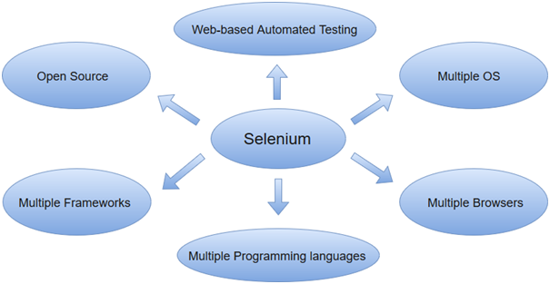

QTP

License is required.

In QTP there is a High resource consumption.

There is a customer support in QTP that is selenium community forums

For parameterization in QTP, built-in tools are available.

QTP supports only Windows.

There is a support for test on both web