**Lab2 : Big Data Analytics & Applications**

**Name:** Anudeep Vattipalli

**ID:** 16158489

**ScreenShot 1:** Recording values of FOUR readings from sensor tag (GPS coordinates, gyroscope values, accelerometer, timestamp, )

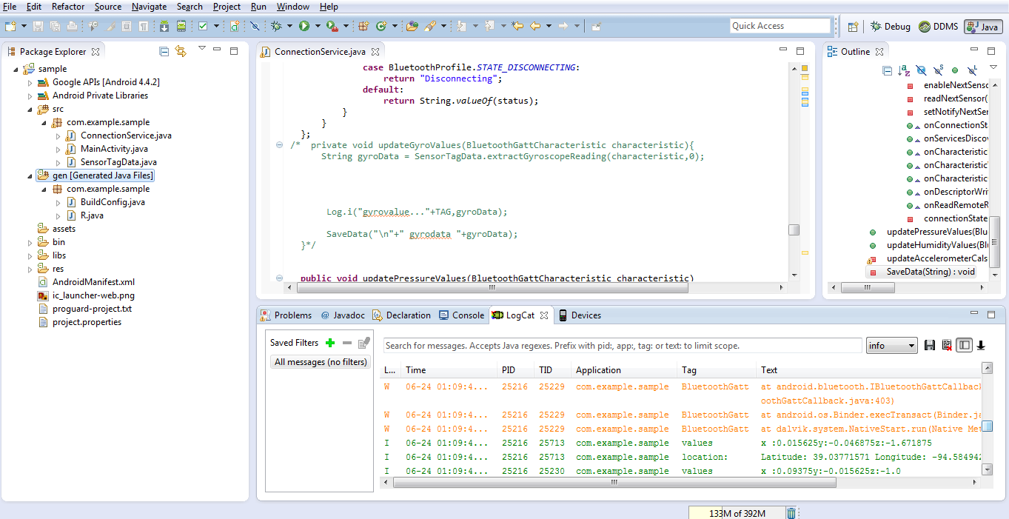

**Screenshot 2:** Creationg of sensor.txt file in mobile under folder Data2

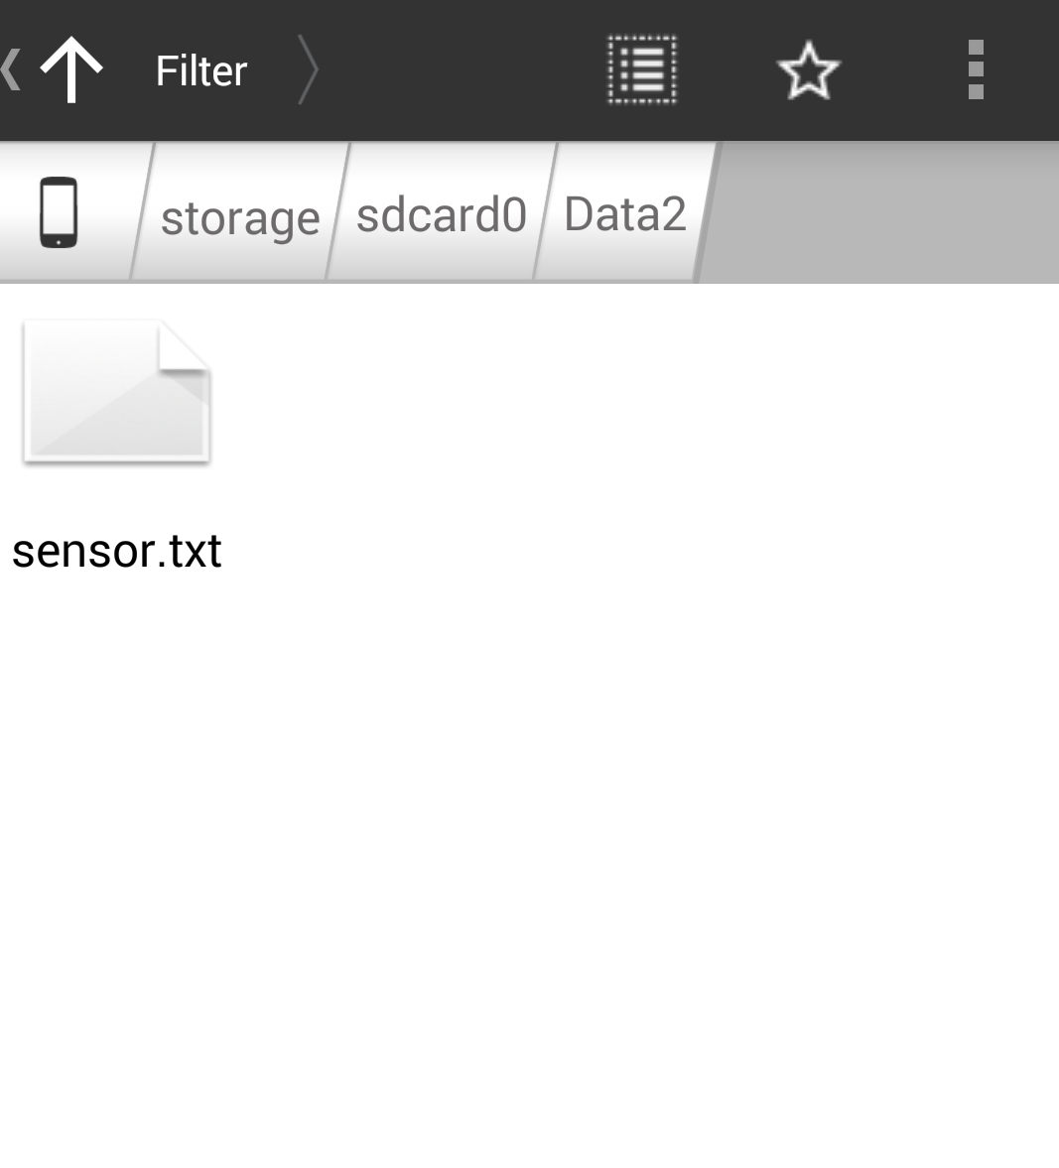

**Screenshot 3:** Text file created after recording values from sensor tag.

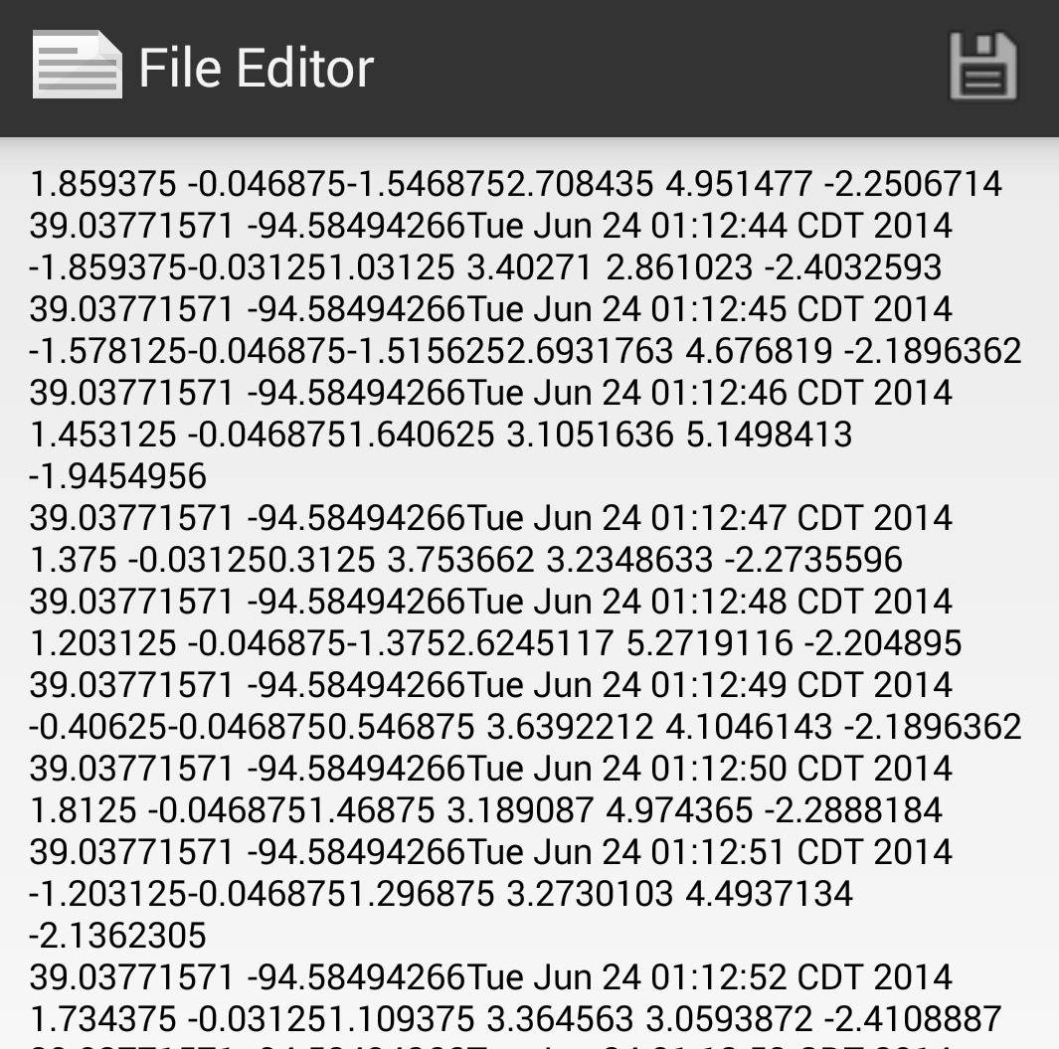

**Screenshot 4:** Creation of database table in HBase **ST8**

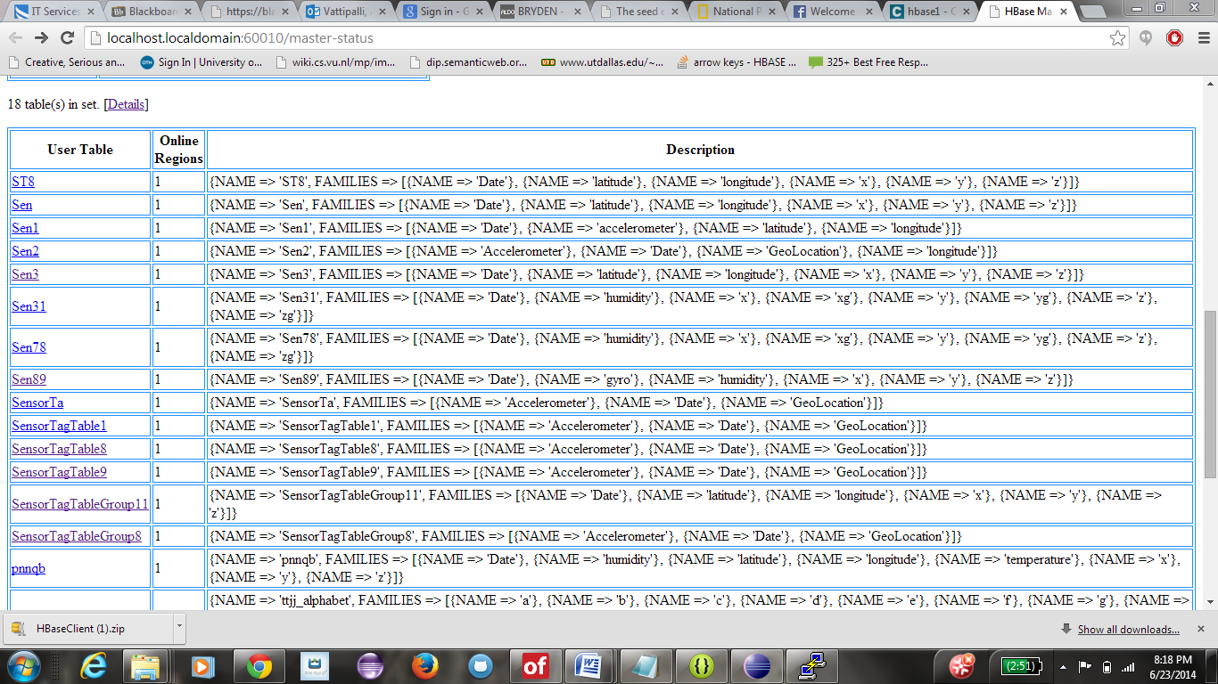

**Screenshot 5:** Table page where insertion requests are being updated.

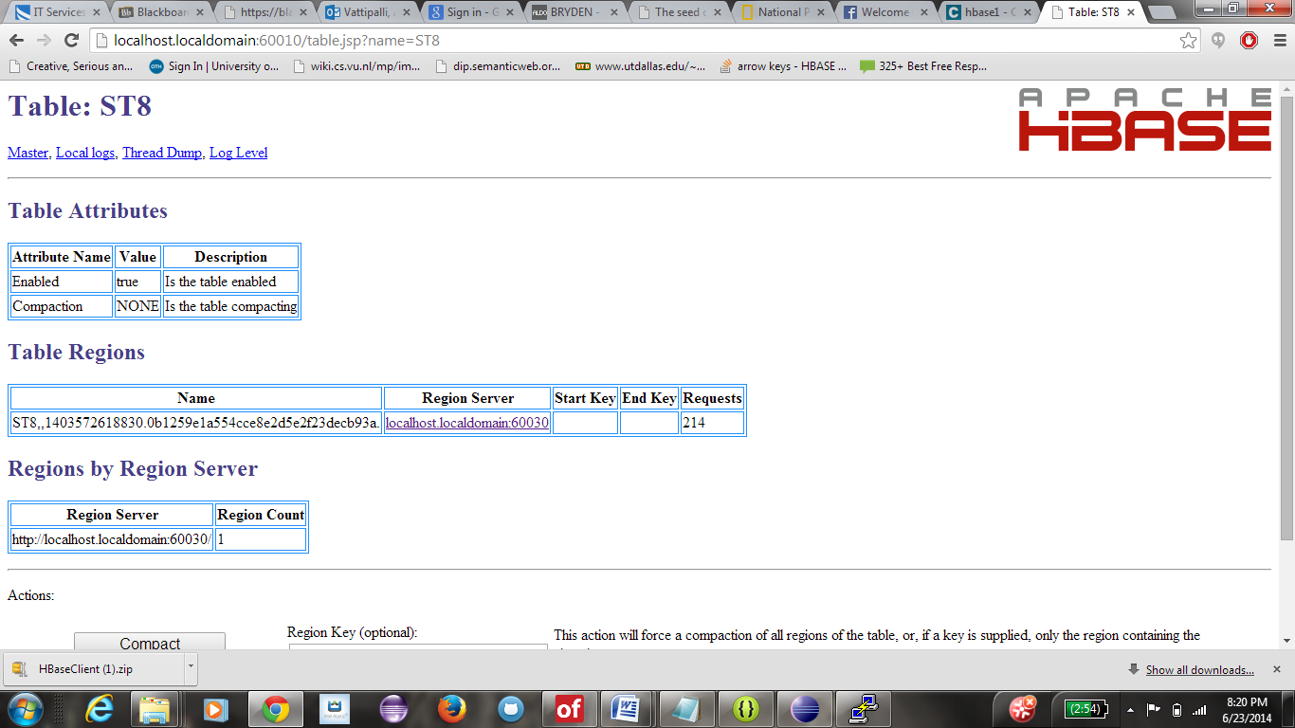

**Screenshot 6:** Log values inserted into table retrieved from HBase.

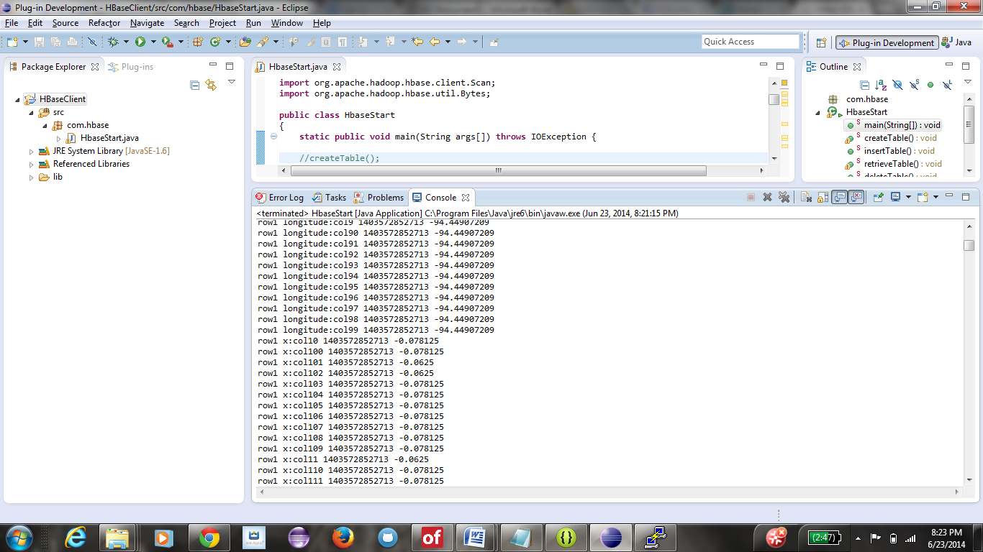

**Screenshot 7:** Table **ST8** deleted from DB.

