**CS 5590BD – BIG DATA ANALYTICS**

**LAB4 REPORT**

**Name: Anudeep Vattipalli (16158489)**

**Data is saved upon Hbase Retrieval Operation:**

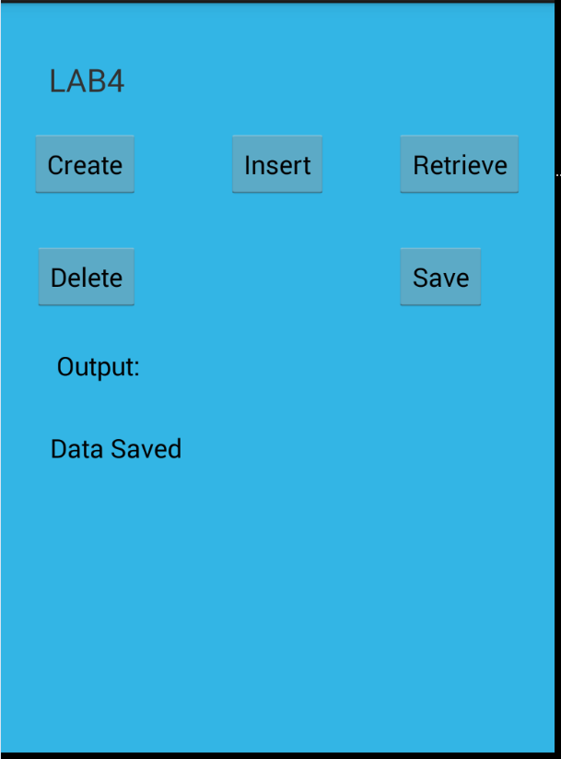

Training files: right to left gesture

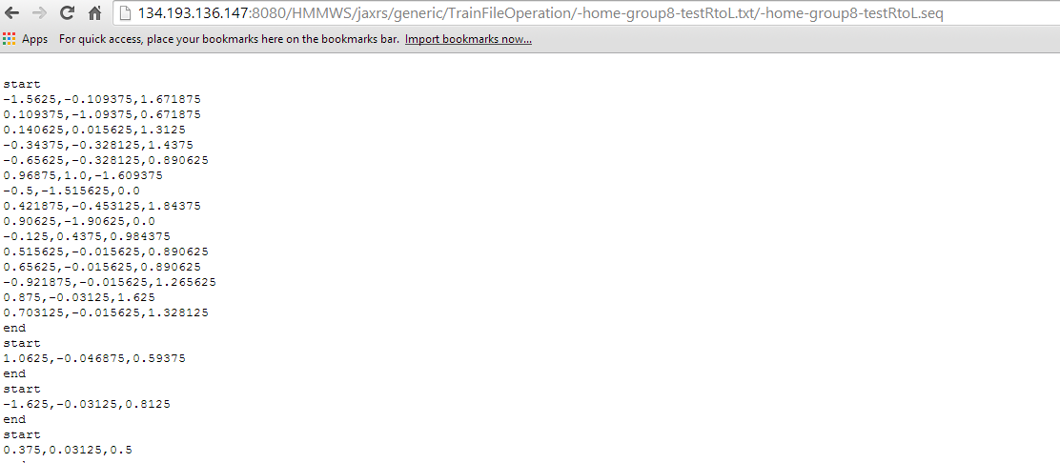

Top to bottom gesture:

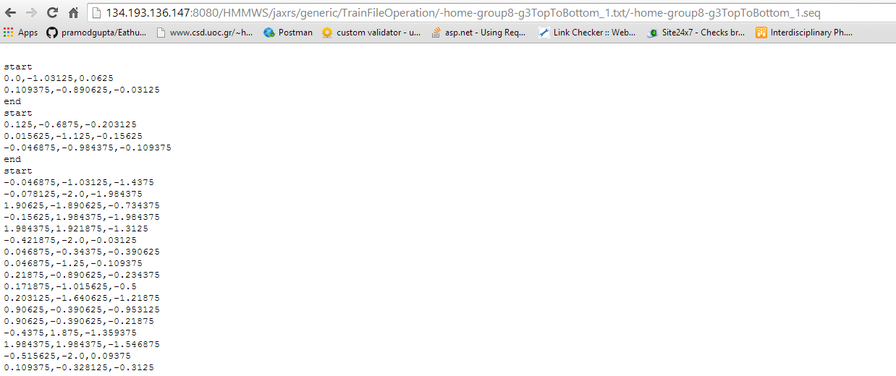

Left to right gesture:

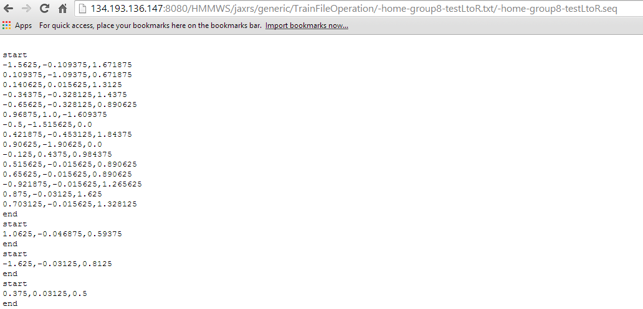

Testing file: combination file

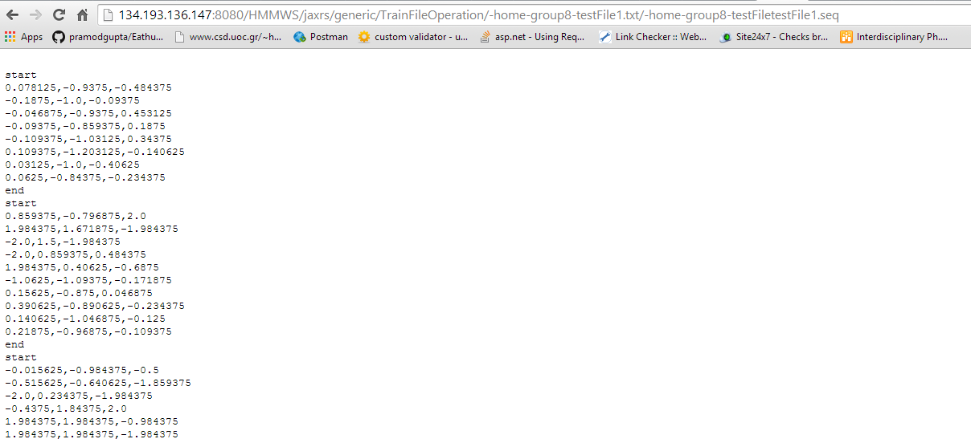

**REST SERVICE:**

URL: http://134.193.136.147:8080/HMMWS/jaxrs/generic/HMMTrainingTest/-home-group8-testLtoR.seq/-home-group8-testRtoL.seq/-home-group8-g3TopToBottom_1.seq/-home-group8-testFiletestFile1.seq