# CS551 – LAB1 ASSIGNMENT

**Name: Anudeep Vattipalli Student ID: 16158489**

**1)**

**UML Class Diagram for Home Security System:**



Class diagram for home security systems consists of login, controller System, Keypad, Response, Sensor, Display, caller Registry, alarm, entry Sensor, smoke Detector, flood Detector, temperature Detector classes. Each of the detector classes will have their respective device ID and will provide details if triggering an alarm. Sensors class is a generalized class for all the detector classes (flood, temperature, smoke, entry). Detector classes inherit the sensor class which uses the time and device ID attributes. Display, caller Registry and Alarm classes inherit the properties from Response class.

**UML Sequence Diagram for Home Security System:**

In the sequence diagram depicted for the security system, if there is any deviation from the regular values set by the owner, respective detector class requests for triggering of alarm to the sensor class. The sensor class then notifies to owner and operator besides performing additional functionalities such as calling to effected individuals to report the message, triggering the alarm, turn on specific lights and specify to owner which particular device has turned on. The operator can turn the system off by providing authentication details to the controller system.



**2) Github Account Creation**

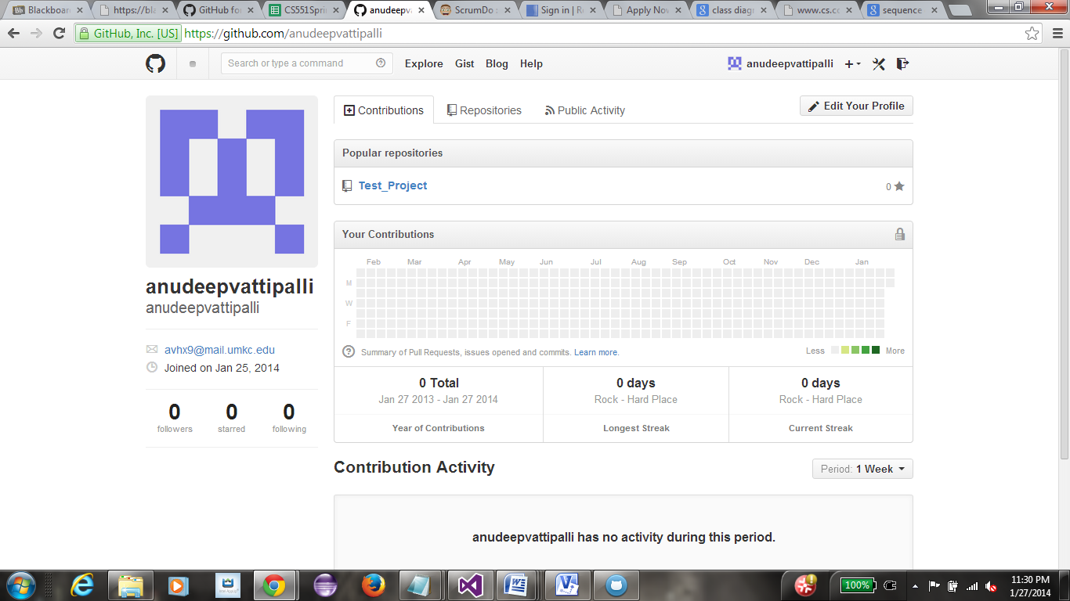

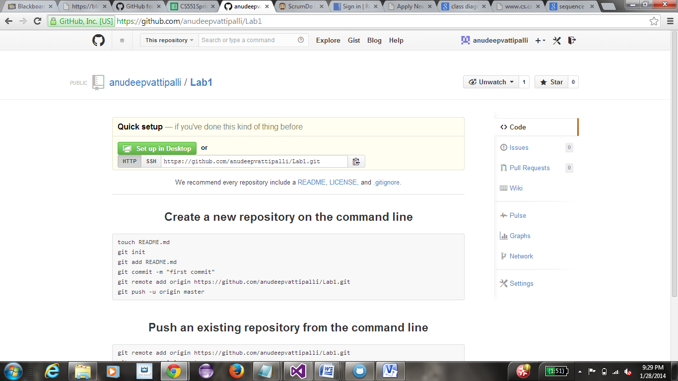

**3) Creation of a ScrumDo account and defining task/plan/delivery of lab1 assignment:**

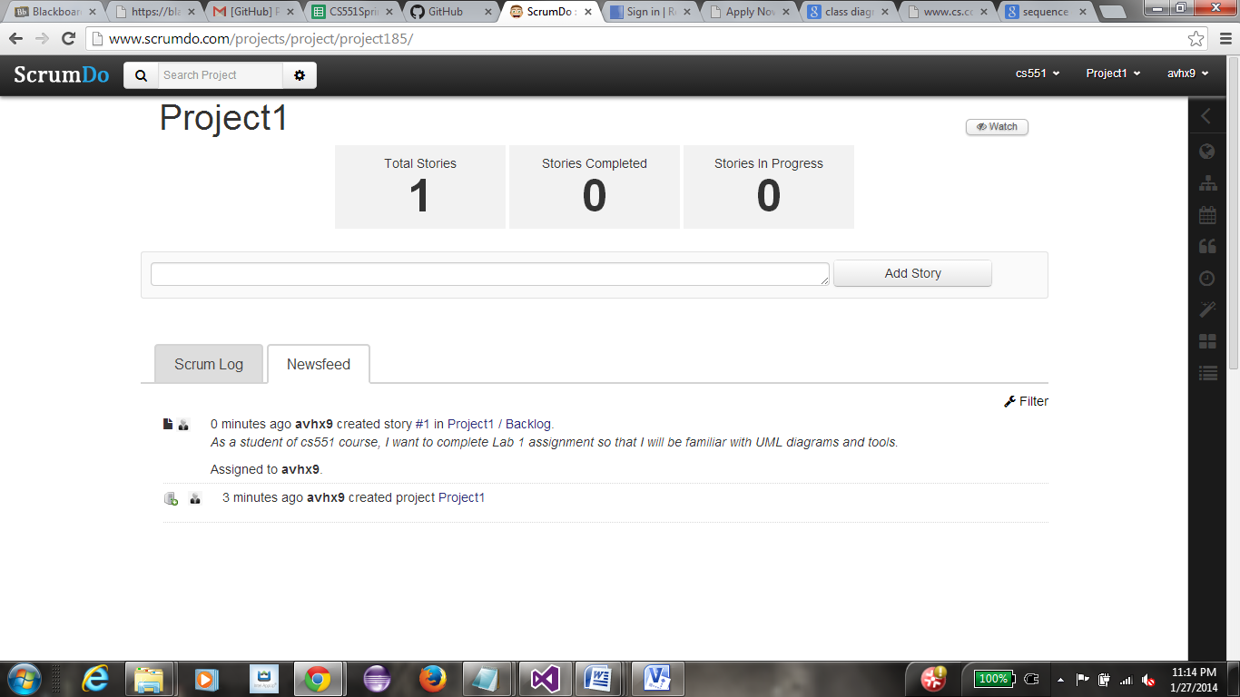

**New iteration for the activities to be implemented using the iteration planning**

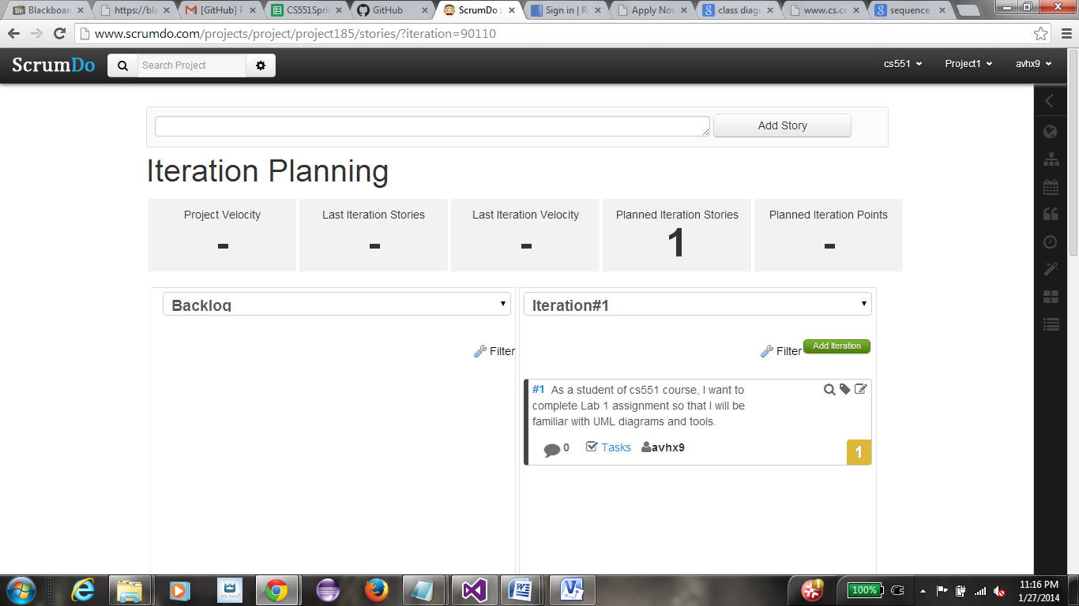

**Writing first Epic for the ScrumDo account. As a student, I want to complete lab 1 assignment.**

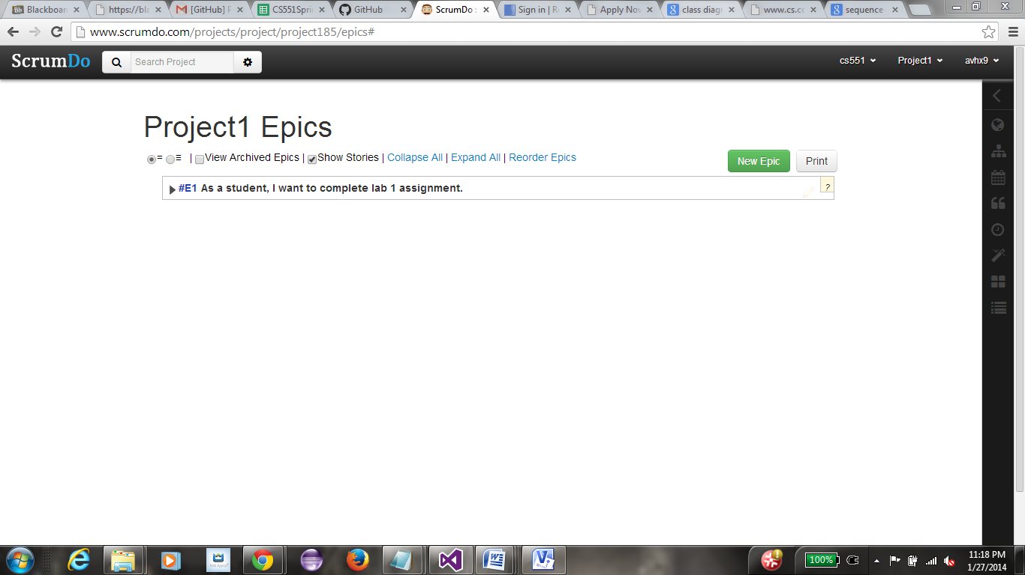

**Listing of Todo items and shifting the activity across Doing, Reviewing and Done status as we proceed.**

