**Advanced Software Engineering – Lab 2 Assignment**

**Name: Anudeep Vattipalli**

**ID: 16158489**

I have worked on creating a home page and customizing the web based mobile application relating to my project. A home page contains a redirecting to link asking the user to plan an event according to his need.

**Jsfiddle Link:** <http://jsfiddle.net/j45Lr/38/>

Technologies used: HTML , CSS, jquery mobile and java script.

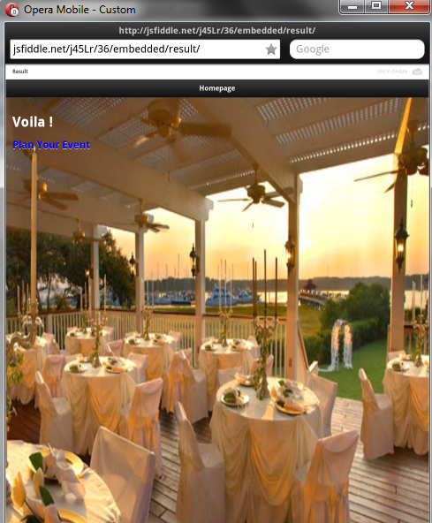

Upon clicking ‘Plan Your Event’ user will be redirected to the below provided screen where one can choose desired type of event before getting into much details pertaining to it. This page contains different kinds of event such as Restaurant, Live Event, Theme Decorators, Food Services, Photography, Google Maps & Weather.

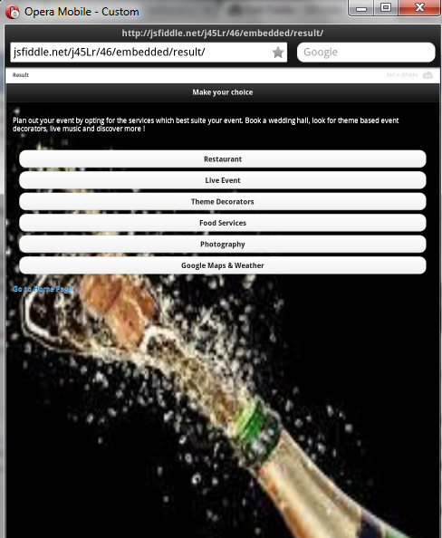

Upon clicking Restaurant Page user is redirected to below page where user can pick a restaurant of his choice in the mentioned list.

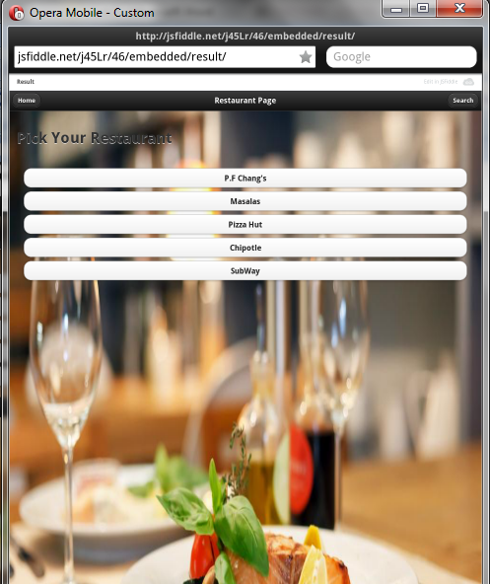

In the main page the user can check for map directions from a start point to end point and also check weather prediction. Weather updates has been layered on top of maps and one can look weather prediction for the next 10 days. Below screen is Map & Weather Forecast page, where user will be redirected to Google Maps Service – Direction and Weather on button click event.

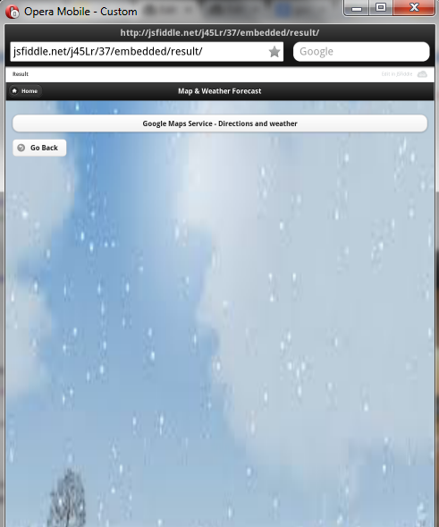

In the below mentioned Route Map & Weather Forecast page the used can select a start location and an end destination place through a list of available options in the drop down list. There are three modes of travel provided to the user walking, driving and bicycling. Upon selecting the drop downs, a route map is displayed and also weather is mentioned. All these services have been applied using Google Map & Weather Services.

