**Advanced Software Engineering – Lab 3 Assignment**

**Name: Anudeep Vattipalli**

**ID: 16158489**

I have worked on adding up google custom search engine, pie charts, mashup icons of facebook and twitter and also local database storage on client side.

**Jsfiddle Link:** http://jsfiddle.net/j45Lr/136/

Technologies used: HTML , CSS, jquery mobile and java script.

Below is the registration page using which a customer registers himself before accessing the website further.

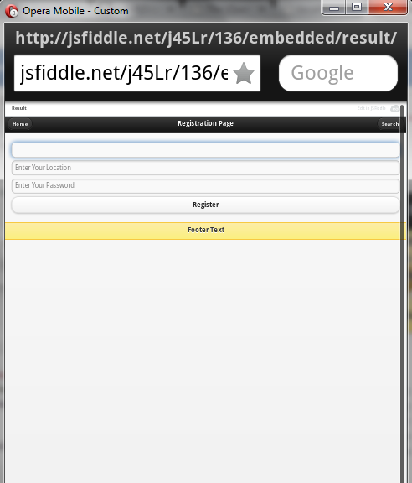

In the below screenshot, user Samar is registering with his unique username and password using which he laters logins to the website with those credentials.

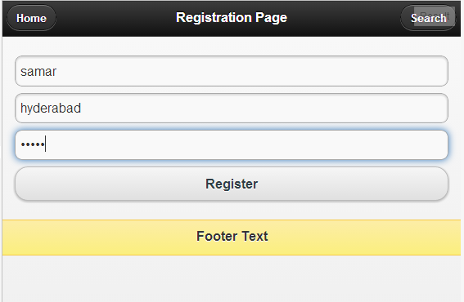

After completing registration, user logins with his credentials and is redirected to main page where the user can view list of events which one can plan. This page also contains mash up links of facebook and twitter redirecting to either tweet about the page or liking in facebook.

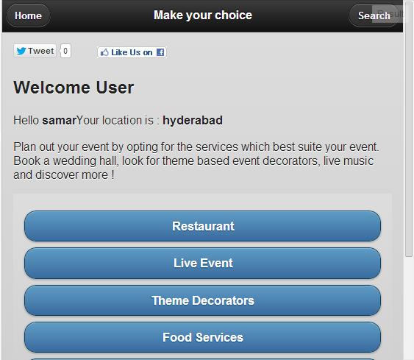

In the below shown screenshot, the user is navigating through restaurants page where we have a google custom search bar.

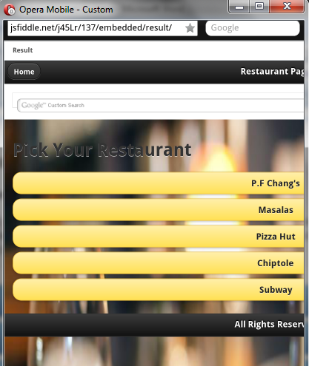

Below is the search result of various links upon searching for restaurants in Kansas city.

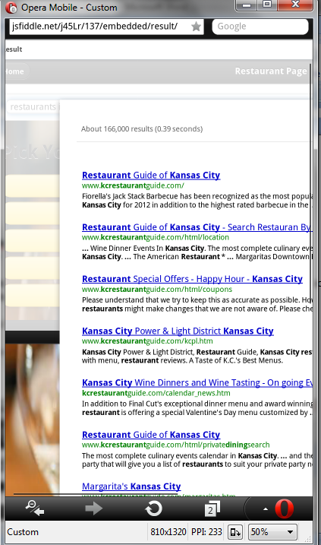

Below is a screen shot of Subway restaurant page in our website which gives details pertaining to subway and also its sales over the past five years using a pie chart.

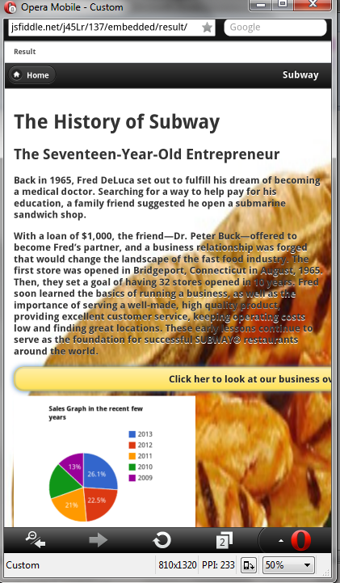

Restful Web Service:

