**Lab 3 Report:**

**Name:** Anudeep Vattipalli

**Id:**  16158489

**Sensor Data Collection:**

Accelerometer and Date values:

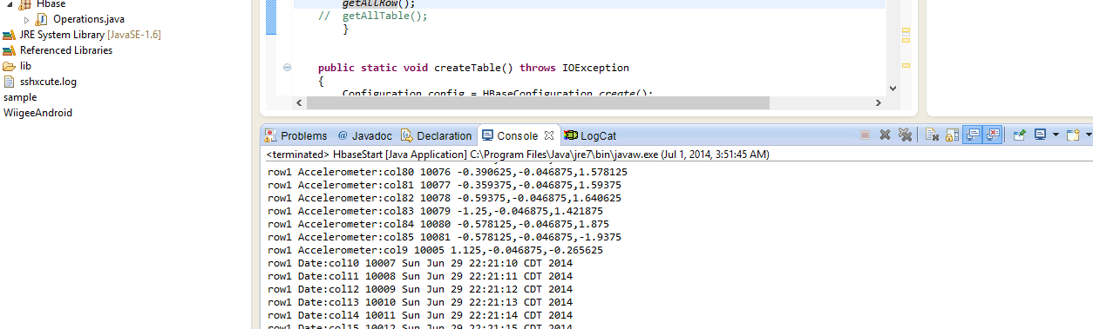

Geolocation and gyroscope values:

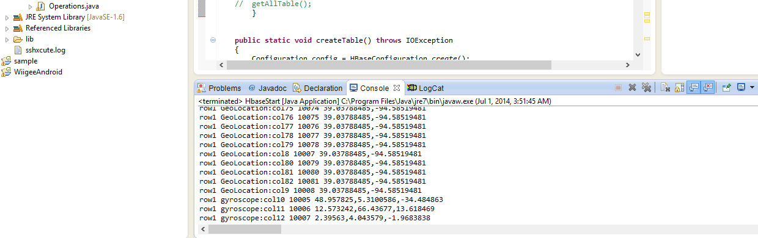

**File transfer using web service: (connectSSH)**

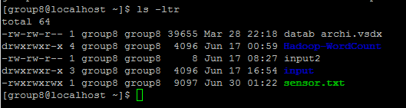

**Glassfish Installation, Deployment and Launch of web service:**

Installing glassfish before deployment and launch of web services.

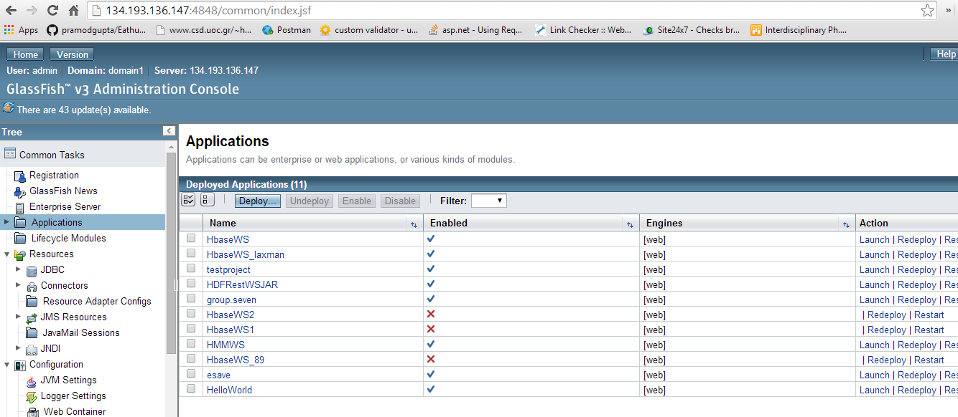

**HBase CRUD Operations: (Using Web services)**

**Creation of table:**

Successful

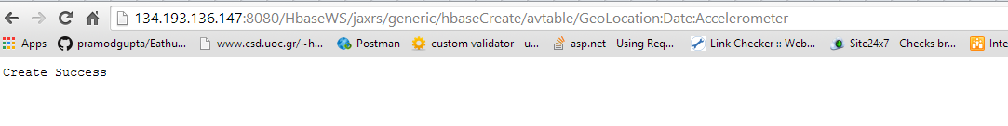

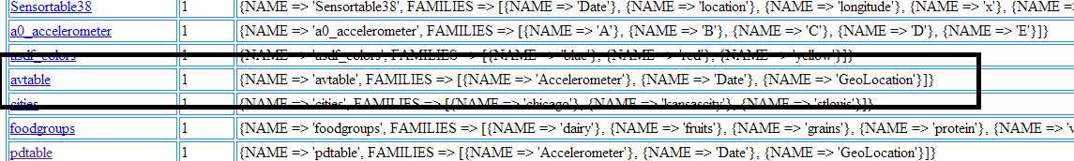

**Inserting values into the table:**

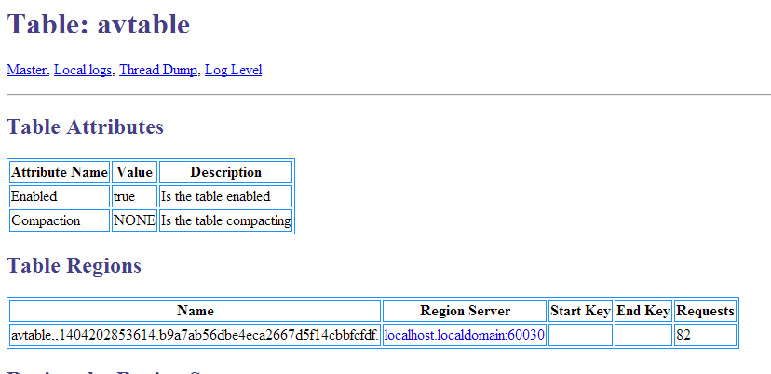

**Retrieving the values from table:**

Accelerometer values retrieved:

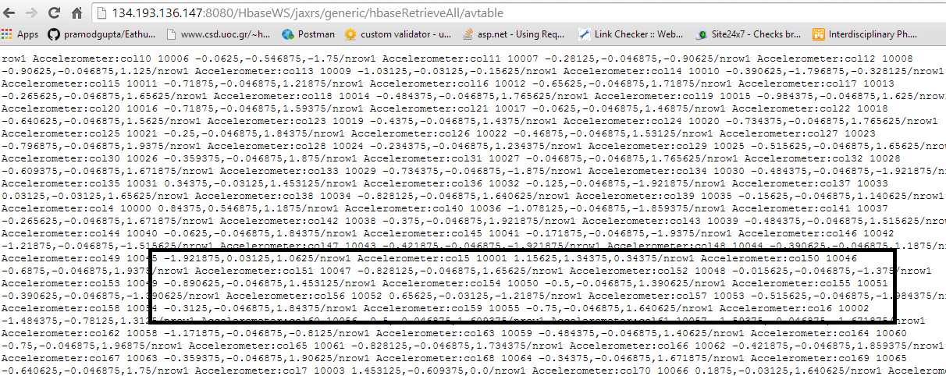

**Date and Geo location values retrieved:**

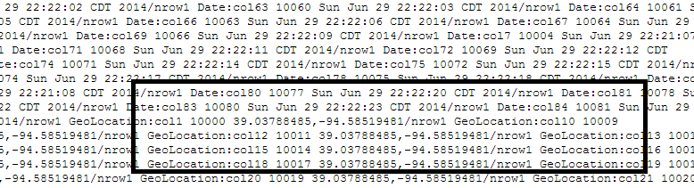

**Deletion of table:**

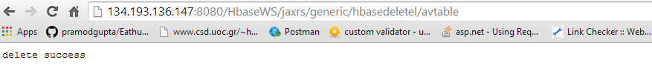

**Creation of table by calling web services in methods:**

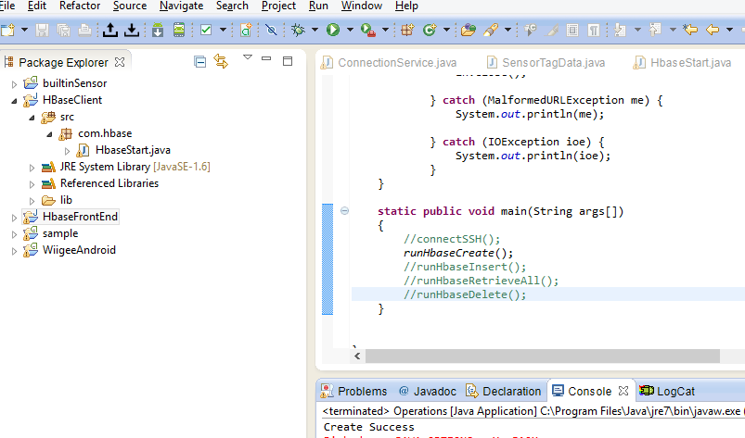

**Deletion of tables by calling web services in table:**

