**CS551 Advanced Software Engineering – Lab 4**

Anudeep Vattipalli

16158489

**Implementation of SOAP Web Service on android:**

I have created a web service with four methods GetAllItems, GetItem, GetPlace, GetPrice. Various food items have been listed under item list and each food item has a unique ID. And also each Item ID is associated to a place and a price.

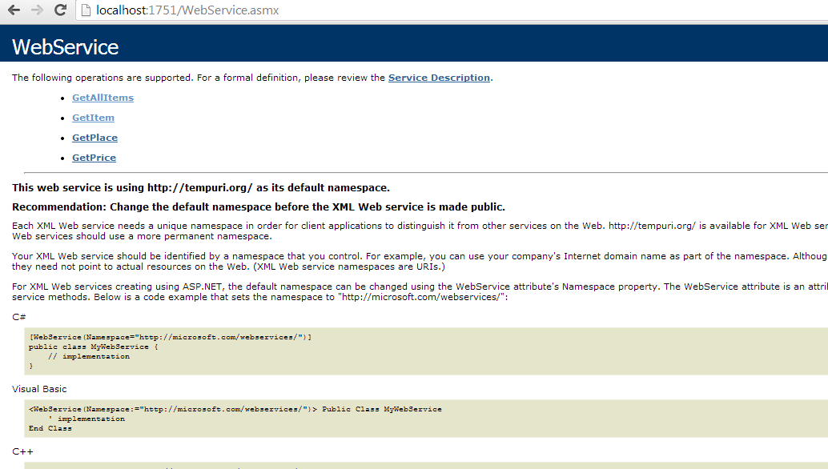

On clicking GetItem method, we will be able to see parameter Item ID which invoked will display an item associated to that ID.

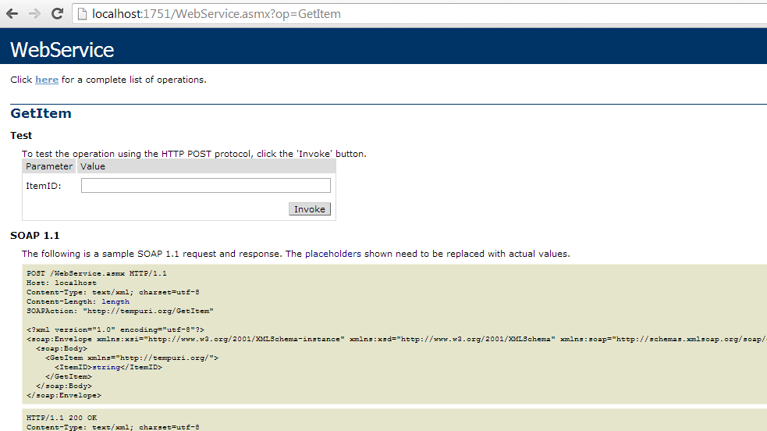

Below is the Item associated to Item Value ‘1’.

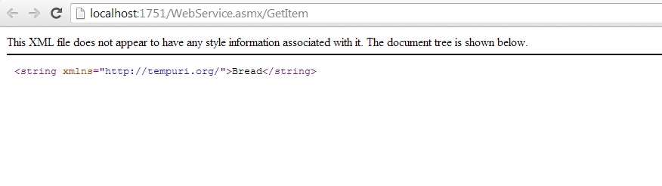

Below is the Item associated to Item Value 2.

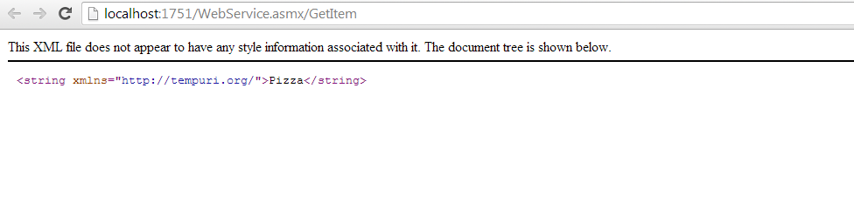

GetPlace refers to place by parameter value of ItemID.

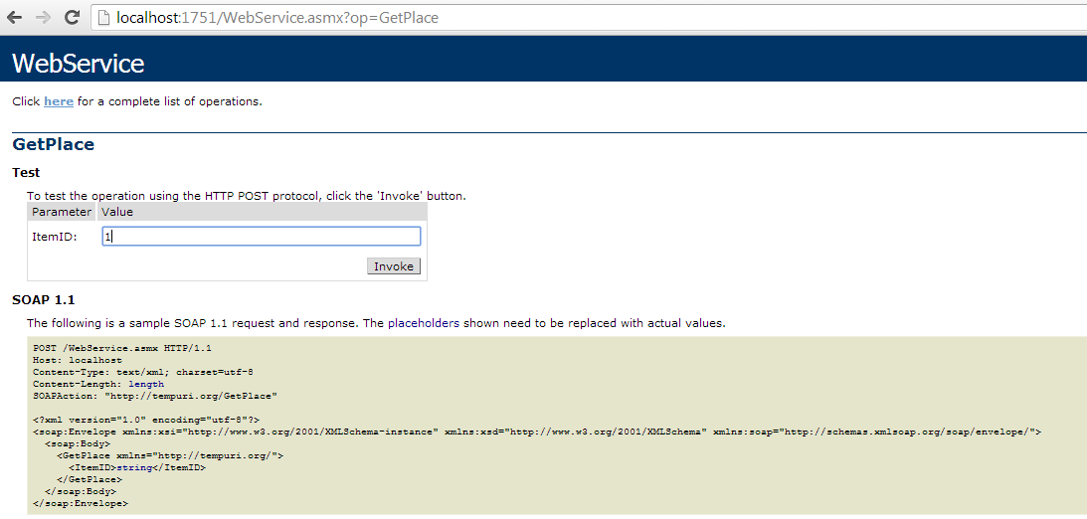

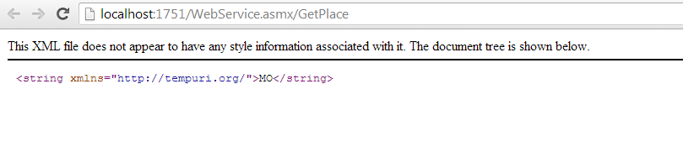

When a soap service is called from an android application, using the given value of ItemID, the item name has been displayed.

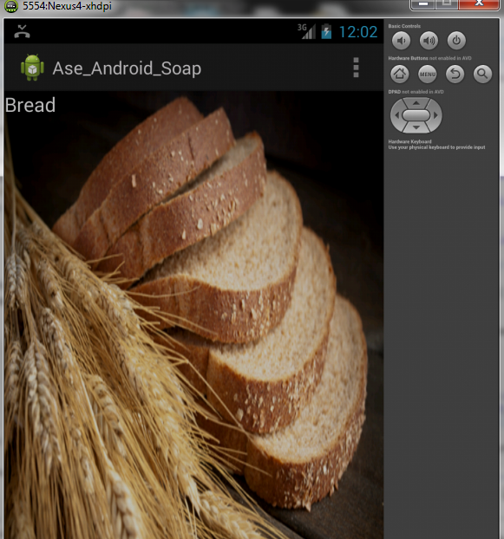

**Implementation of SOAP web service using Local Databases:**

Below is a webservice to insert, delete and retrieve details of registered users.

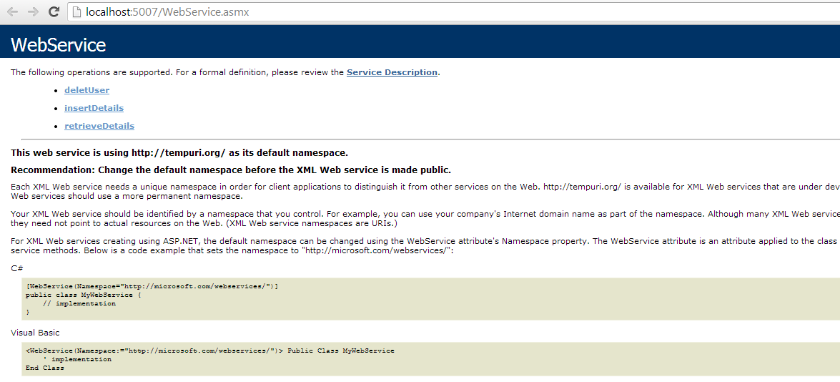

Below, insertDetails method has been called and the following values have been entered for inserting into table.

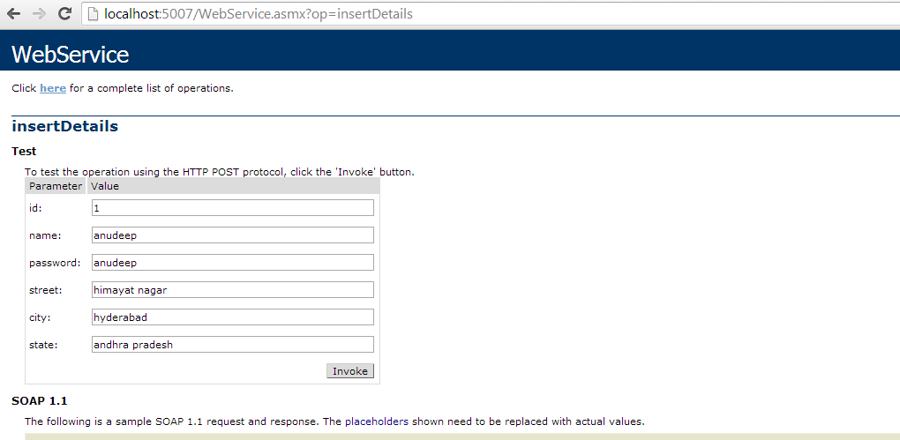

After successful insertion the following message is displayed.

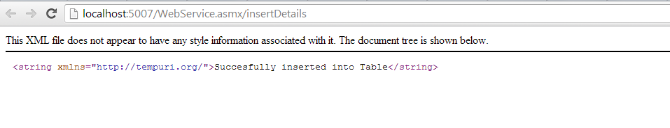

Retrieve details method can be invoked to retrieve details of users with username and password.

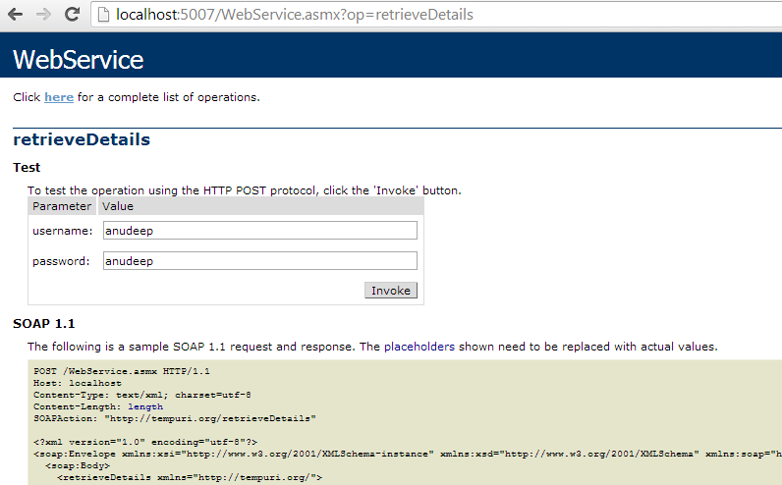

Details from users table is displayed in the below shown form.

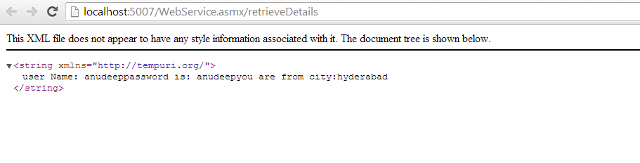

For invoking deleteUser method, name of the user is to be entered.

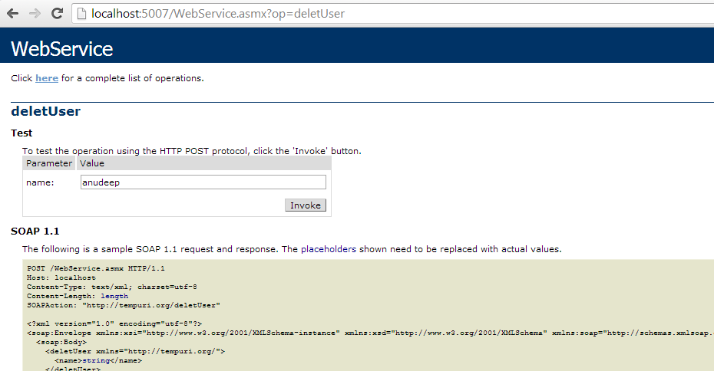

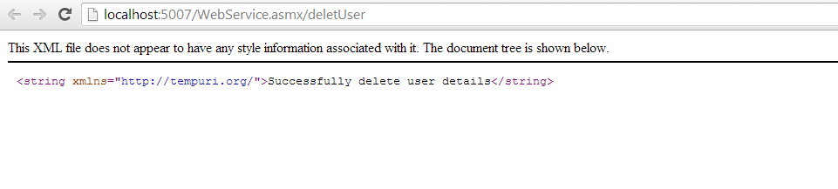

**Implementation of REST Services with Local Database:**

Successful insertion of values into a table.

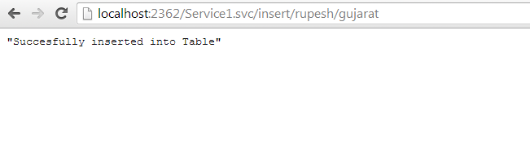

Table below shows the values have been entered.

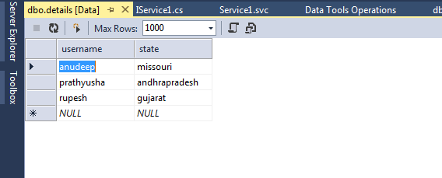

Below screen shot shows details being retrieved from details table.

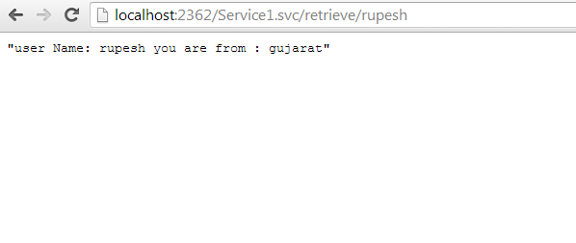

**Below is the code snippet of android SOAP Webservice implementation:**

package com.trail.ase_android_soap;

import org.ksoap2.SoapEnvelope;

import org.ksoap2.serialization.SoapObject;

import org.ksoap2.serialization.SoapPrimitive;

import org.ksoap2.serialization.SoapSerializationEnvelope;

import org.ksoap2.transport.HttpTransportSE;

import android.os.Bundle;

import android.os.StrictMode;

import android.app.Activity;

import android.view.Menu;

import android.widget.TextView;

public class MainActivity extends Activity {

private static String SOAP_ACTION = "http://tempuri.org/GetItem";

private static String NAMESPACE = "http://tempuri.org/";

private static String METHOD_NAME = "GetItem";

private static String URL = "http://kc-sce-cs551.kc.umkc.edu/aspnet_client/Group4/Menu/WebService.asmx";

/** Called when the activity is first created. */

@Override

public void onCreate(Bundle savedInstanceState) {

super.onCreate(savedInstanceState);

setContentView(R.layout.activity_main);

StrictMode.ThreadPolicy policy = new StrictMode.ThreadPolicy.Builder()

.permitAll().build();

StrictMode.setThreadPolicy(policy);

TextView data = (TextView) findViewById(R.id.textView2);

SoapObject request = new SoapObject(NAMESPACE, METHOD_NAME);

request.addProperty("ItemID", "1");

SoapSerializationEnvelope envelope = new SoapSerializationEnvelope(

SoapEnvelope.VER11);

envelope.dotNet = true;

envelope.setOutputSoapObject(request);

// Needed to make the internet call

HttpTransportSE androidHttpTransport = new HttpTransportSE(URL);

try {

// this is the actual part that will call the webservice

androidHttpTransport.call(SOAP_ACTION, envelope);

SoapPrimitive resultSet = (SoapPrimitive) envelope.getResponse();

String what = resultSet.toString();

System.out.println(what);

data.setText(what);

} catch (Exception e) {

e.printStackTrace();

}

}

@Override

public boolean onCreateOptionsMenu(Menu menu) {

// Inflate the menu; this adds items to the action bar if it is present.

getMenuInflater().inflate(R.menu.main, menu);

return true;

}

}