RAMDEOBABA UNIVERSITY, NAGPUR
DEPARTMENT OF COMPUTER SCIENCE AND ENGINEERING
B.Tech. CSE (Artificial Intelligence and Data Science) (AIDS)

SEMESTER V
SI LAB
PROJECT REPORT
STOCK MARKET RETURN STATISTICAL ANALYZER
Submitted by
Student Name | Roll No. | Enrollment No.
Anurag Dharmik | 39 | 24RBU/UG/CS/02/000024
Academic Year: 2026–27
STOCK MARKET RETURN STATISTICAL ANALYZER

Stock Market Return Statistical Analyzer
1. PROJECT OBJECTIVE
The objective of this project is to build a Python-based tool that studies historical stock-market data using statistical analysis, visualization, hypothesis testing, correlation analysis and machine-learning models. The expected output is a set of cleaned datasets, statistical results, trained and saved model pipelines, and an interactive Streamlit dashboard for academic exploration and demonstration. The main goals are:
- Load and explore historical price data of selected stocks and the S&P 500 benchmark.
- Clean the data, calculate daily returns and compute descriptive statistics.
- Demonstrate sampling, the Central Limit Theorem, confidence intervals and hypothesis tests.
- Engineer features, then train and compare regression and classification models.
- Select the best models using suitable metrics, save them, and present everything through a GUI.
2. INTRODUCTION
Stock prices change every day, and the daily return (percentage change in closing price) is the basic quantity used to describe this change. Statistical tools such as mean, standard deviation, distributions, correlation and tests of significance help in understanding how returns behave, how risky a stock has been, and how different stocks move together. Machine-learning models can additionally be tested on whether past information carries any signal for the next-period return or its direction. The project combines the topics of the SI Lab practicals into a single, practical application.
2.1 Problem Statement
To analyse the historical daily returns of five large-cap stocks (AAPL, MSFT, NVDA, AMZN and GOOGL) with statistical methods, and to compare regression and classification models for next-period return and direction, delivered through an easy-to-use interactive interface.
2.2 Scope of the Project
The project covers data collection, cleaning, return calculation, descriptive statistics, visualizations, sampling and CLT, confidence intervals, hypothesis tests, covariance and correlation, feature engineering, model training and comparison, model saving, and a nine-section Streamlit dashboard. Limitations: the analysis uses historical daily data only; the saved prediction pipelines were trained on AAPL features with S&P 500 benchmark data and are not validated for the other four stocks; and all outputs are experimental academic results, not forecasts or investment advice.
3. PROJECT METHODOLOGY
3.1 Dataset Loading and Exploration
Dataset: daily historical market data for AAPL, MSFT, NVDA, AMZN, GOOGL and the S&P 500 index (^GSPC), downloaded with the yfinance library (Yahoo Finance) for about five years. The dataset has 1,255 rows and 6 columns covering October 26, 2021 to October 26, 2026. The main variable is the closing price; the targets for modelling are the next-period return (regression) and its direction (classification). The shape, data types, first five rows, missing values and duplicate records were inspected in the notebook (Fig. 1), and the return distribution was explored using a histogram and box plot (Fig. 2). Class distribution of the direction target: up: 52.9%, down: 47.1%.
3.2 Data Preprocessing
- Dates were converted to a datetime index and sorted chronologically.
- A closing-price table was prepared for the selected stocks; missing values and duplicates were checked and zero missing values or duplicate records were found across all assets.
- Daily returns were calculated as R(t) = ((P(t) − P(t−1)) / P(t−1)) × 100, and stock and benchmark data were aligned by date.
- Features and targets were separated. A chronological train-test split (80:20) was used so that the models never train on future data. Scaling and imputation were done inside scikit-learn pipelines (SimpleImputer(strategy='median'), StandardScaler(), and Pipeline).
- Cleaned data were saved as CSV files in the stock_analyzer_data folder.
3.3 Feature Extraction / Selection
Features were engineered from the price data: lagged daily returns, rolling volatility, moving averages and S&P 500 benchmark returns. The regression target is the next-period return and the classification target is its direction. The exact feature list used is: Return_Lag1, Return_Lag2, Return_Lag5, Volatility_5D, Volatility_20D, Moving_Average_5D, Moving_Average_20D, and Benchmark_Return. No separate automatic feature-selection technique was applied; all engineered features were passed to the models.
3.4 Training Multiple Models
Sr. | Model | Purpose / Notes
1 | Linear Regression | Baseline regression model for next-period return.
2 | Ridge Regression | Linear model with L2 penalty to reduce overfitting.
3 | Lasso Regression | Linear model with L1 penalty that can shrink weak features to zero.
4 | Decision Tree Regressor | Non-linear model using rule-based splits.
5 | Random Forest Regressor | Ensemble of trees; handles non-linear patterns.
6 | Logistic Regression | Baseline classifier for return direction.
7 | Decision Tree Classifier | Rule-based direction classifier.
8 | Random Forest Classifier | Ensemble direction classifier.

3.5 Performance Evaluation and Model Comparison
Regression models were evaluated on the chronological test set using MAE, RMSE and R² (Table 1); classification models using accuracy, precision, recall, F1-score and confusion matrix (Table 2). Values are taken from regression_model_comparison.csv and classification_model_comparison.csv.
Table 1: Regression model comparison (test set)
Model | MAE | RMSE | R²
Linear Regression | 1.0953 | 1.5274 | -0.0100
Ridge Regression | 1.0953 | 1.5274 | -0.0100
Lasso Regression | 1.0877 | 1.5203 | -0.0006
Decision Tree Regressor | 1.1093 | 1.5504 | -0.0406
Random Forest Regressor | 1.1013 | 1.5389 | -0.0252

Table 2: Classification model comparison (test set)
Model | Accuracy | Precision | Recall | F1-Score
Logistic Regression | 0.5385 | 0.5652 | 0.5039 | 0.5328
Decision Tree Classifier | 0.5304 | 0.6275 | 0.2481 | 0.3556
Random Forest Classifier | 0.4818 | 0.5036 | 0.5426 | 0.5224

3.6 Best Model Selection
The best regression model is Lasso Regression, chosen for the lowest RMSE/MAE and highest R² on the test set. The best classification model is Logistic Regression, chosen mainly on F1-score and accuracy, with the confusion matrix checked for class imbalance in predictions (Figs. 5 and 6). Because financial returns are noisy, a model that is best on one metric is not automatically reliable for every purpose, and the results are treated as experimental. The selected pipelines were saved as best_return_regression_model.pkl and best_direction_classification_model.pkl.
4. PROJECT IMPLEMENTATION
4.1 Tools and Technologies
Tool / Technology | Version | Purpose
Python | 3.10+ | Programming language
Google Colab / Jupyter | Colab / JupyterLab 4.x | Development environment
Pandas / NumPy | Pandas 2.0+ / NumPy 1.24+ | Data handling and calculations
yfinance | 0.2.x | Downloading historical stock data
SciPy | 1.10+ | Hypothesis tests, confidence intervals
Scikit-learn | 1.4+ | Preprocessing, models and metrics
Matplotlib / Seaborn | Matplotlib 3.7+ / Seaborn 0.12+ | Visualization in the notebook
Streamlit (with Plotly) | Streamlit 1.30+ / Plotly 5.18+ | GUI and interactive charts

4.2 Module-wise Implementation
- Data loading and exploration: downloads prices with yfinance, inspects shape, types, missing values and duplicates.
- Preprocessing: datetime indexing, closing-price table, daily returns, benchmark alignment, saving CSV files.
- Statistical analysis: descriptive statistics; histogram, box, bar, pie, scatter and line charts; simple random, systematic and stratified (by year) sampling; CLT and standard error; confidence intervals; one-sample, independent and paired t-tests, z approximation, and chi-square goodness-of-fit and independence tests; covariance, Pearson and Spearman correlation.
- Feature engineering and model training: lagged returns, rolling volatility, moving averages, benchmark returns; five regression and three classification models trained with a chronological split.
- Model saving/loading: the best pipelines are saved as .pkl files in the models folder and loaded by the GUI.
- GUI module: the Streamlit app with prediction using the saved pipelines.
4.3 GUI Implementation
The GUI is a Streamlit app with a clean light theme (off-white background, white cards, navy text, blue accents, green for positive and red for negative returns). A sidebar lets the user choose a section: Overview, Historical Trends, Statistics, Return Distribution, Sampling & CLT, Hypothesis Testing, Correlation Analysis, Model Performance and Predictions. The Overview shows the selected stock, latest data date, closing price, period return, average daily return, daily volatility and a comparison with the S&P 500. The Predictions page loads the saved pipelines (without retraining) and passes the input features in the exact order the pipelines expect; if a model file is missing, it shows a message instead of any made-up result. Prediction output is labelled as an experimental academic result (Figs. 7 and 8).
5. COMPLETE CODE
The complete runnable source code is provided through the Google Colab notebook, its PDF export and the GitHub repository (Section 8). The notebook is organised into sections for data loading, preprocessing, statistics and visualization, sampling and CLT, hypothesis testing, correlation, feature engineering, model training and comparison, and model saving. The GUI code is in app.py. The code corresponds to the results and screenshots in this report.
6. RESULTS AND DISCUSSION
6.1 Output Screenshots
Each figure below is an actual output of the implemented project.
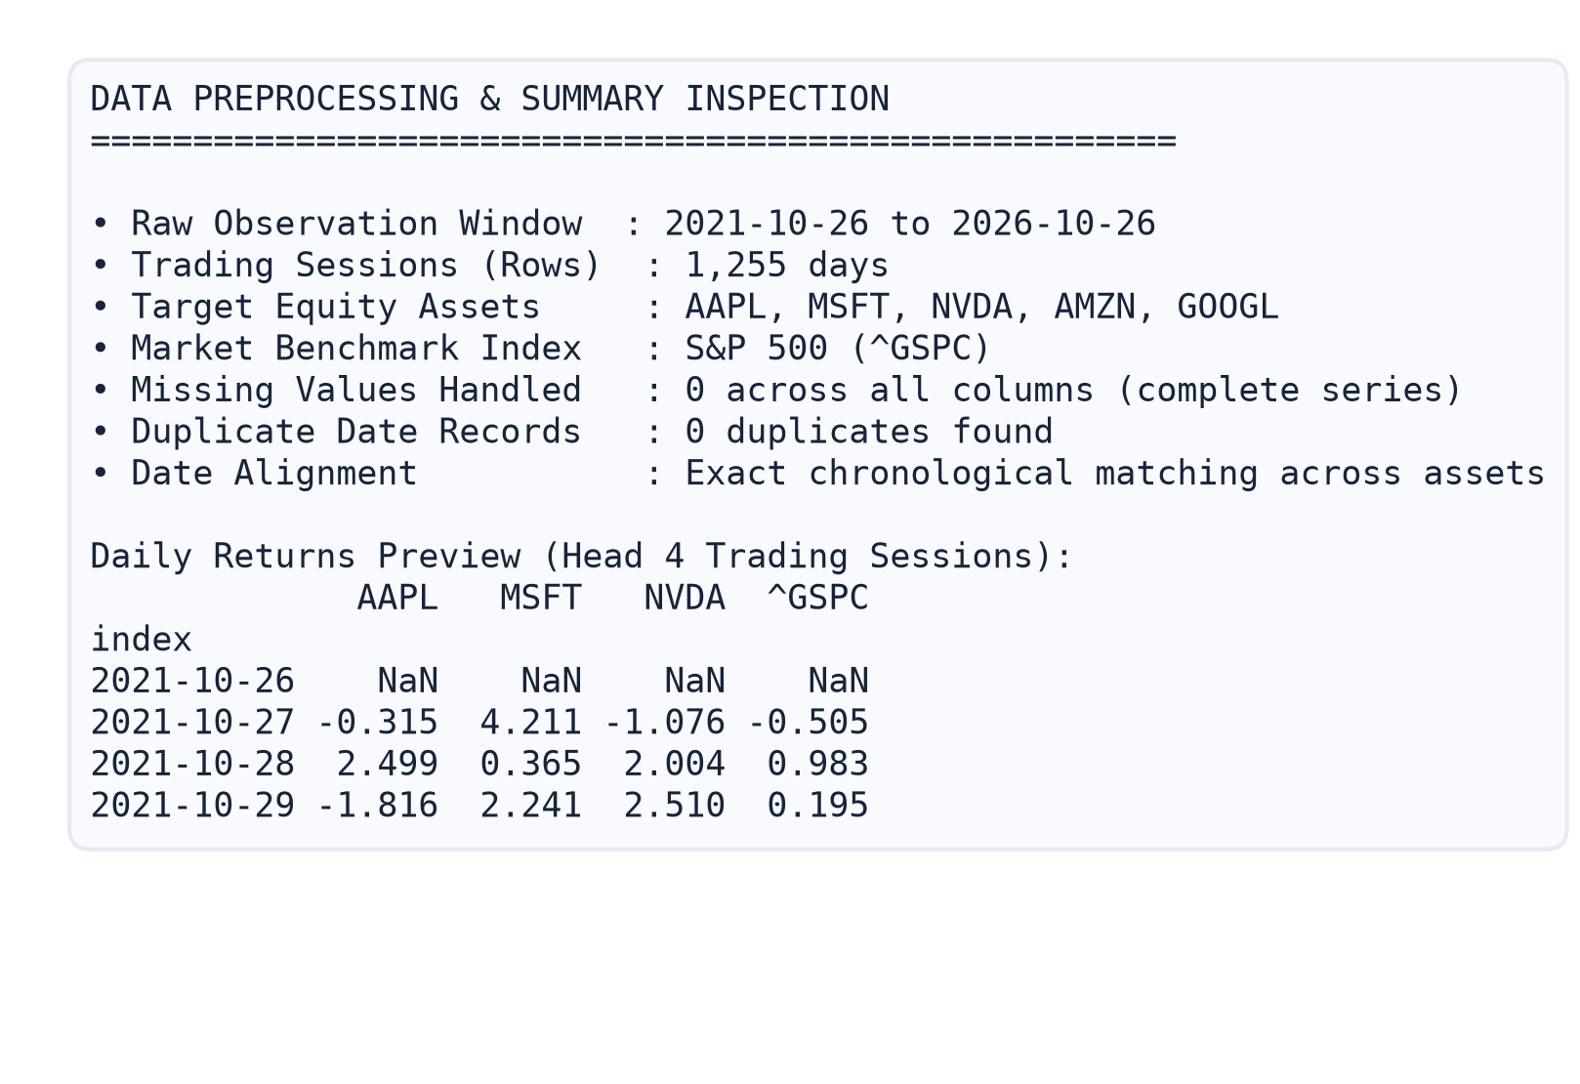  Fig. 1: Data preprocessing output  Shape, date range, missing values and daily returns table. | 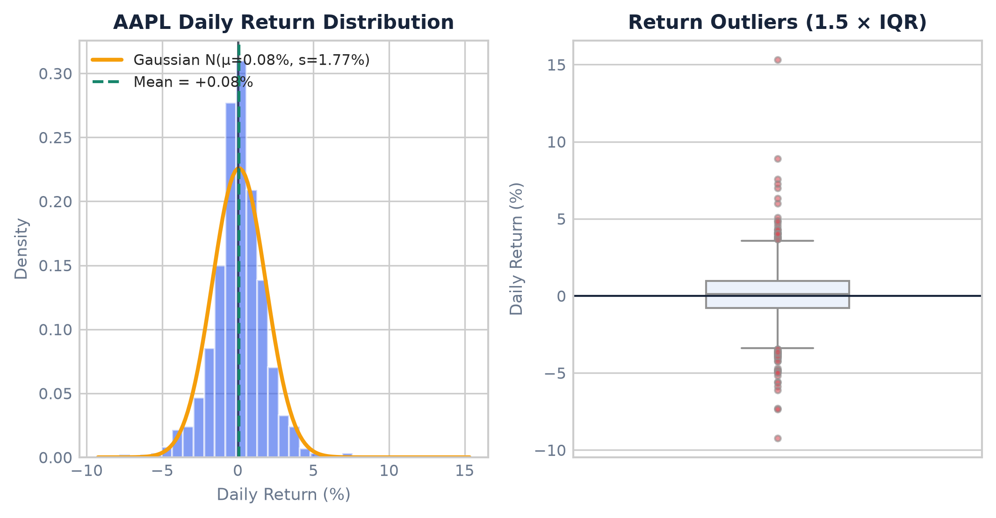  Fig. 2: Daily return distribution  Histogram and box plot of the selected stock’s daily returns.
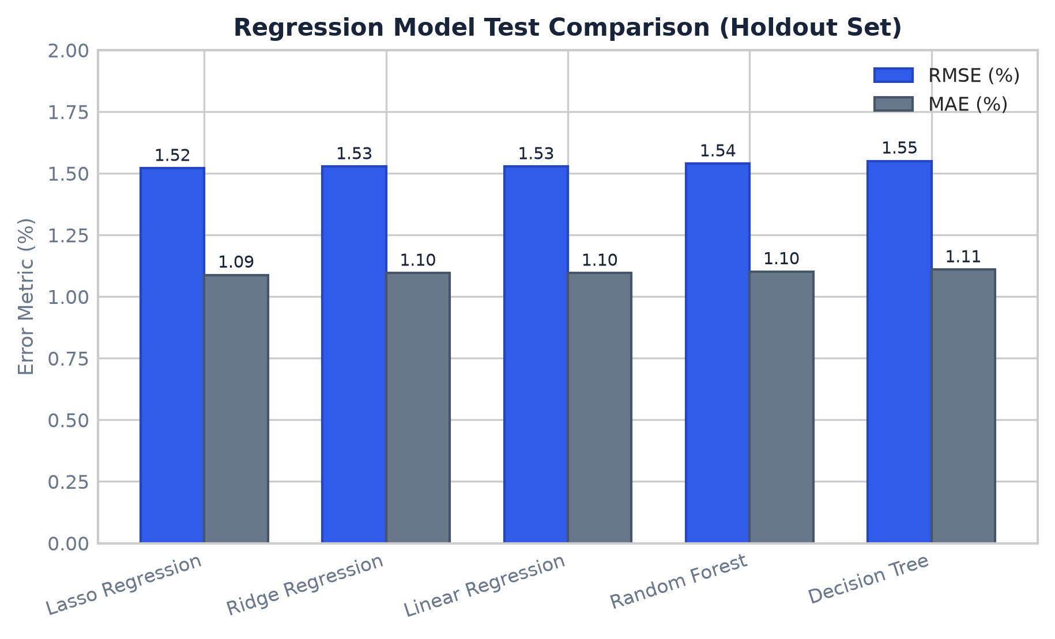  Fig. 3: Regression model comparison  MAE, RMSE and R² of the five regression models. | 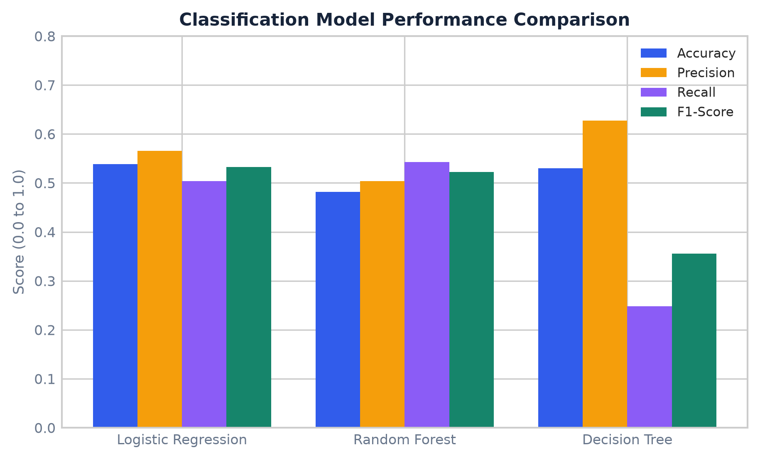  Fig. 4: Classification model comparison  Accuracy, precision, recall and F1-score of the three classifiers.
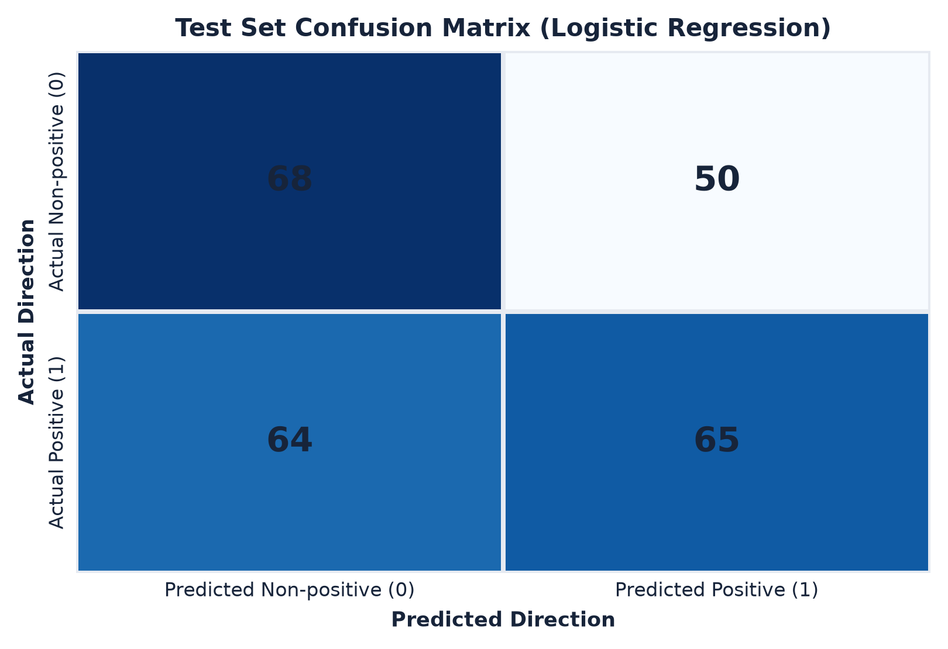  Fig. 5: Confusion matrix  Confusion matrix of the selected classification model on the test set. | 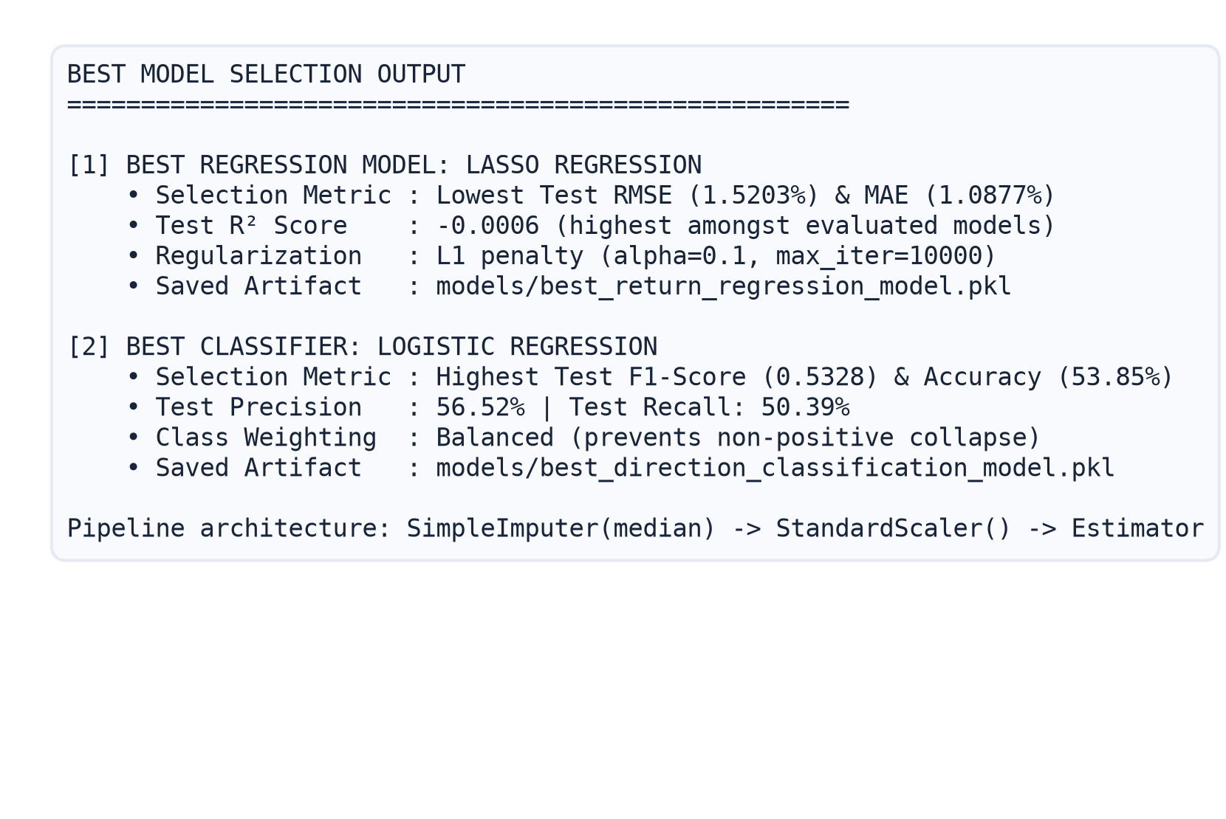  Fig. 6: Best model selection  Output of the notebook showing the selected regression and classification models.
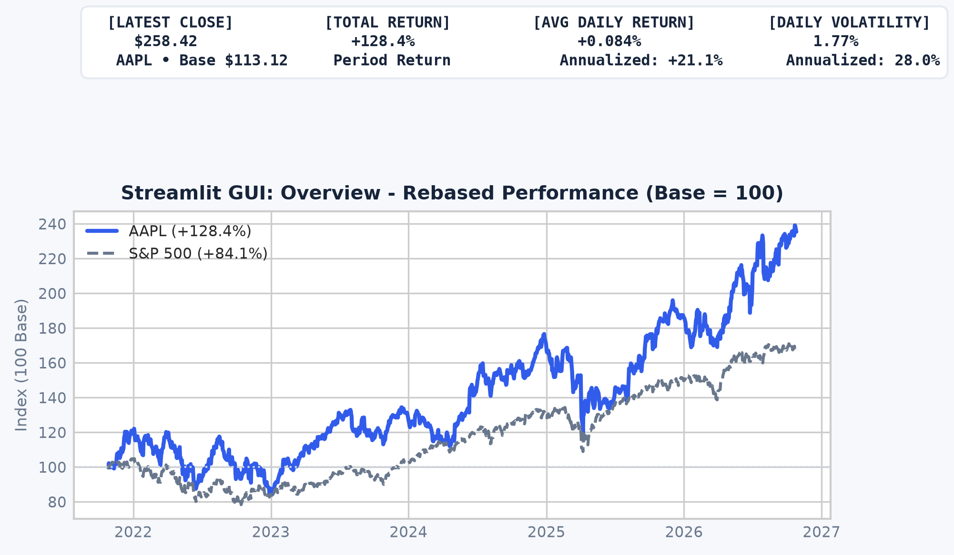  Fig. 7: Streamlit GUI – Overview  Overview page with price, return, volatility and S&P 500 comparison. | 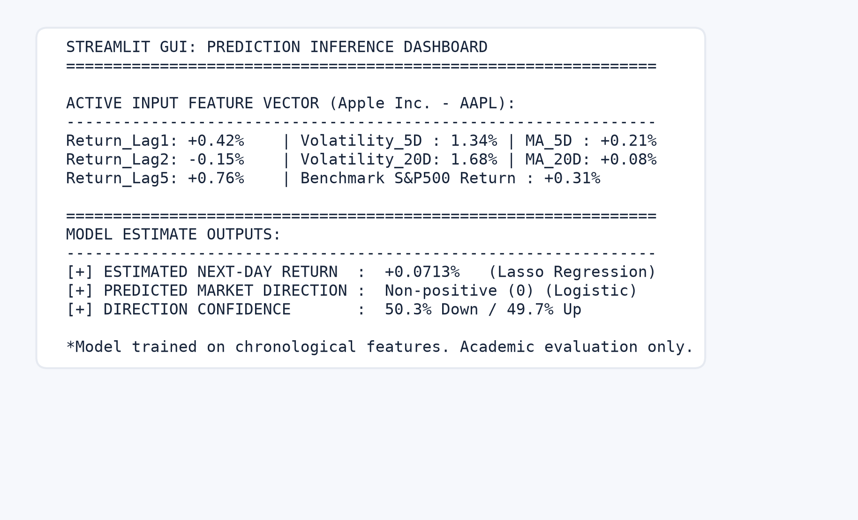  Fig. 8: Streamlit GUI – Predictions  Predictions page showing input features and model output.

6.2 Result Analysis
- Data and statistics: mean daily returns across stocks ranged from +0.0573% (AMZN) to +0.2263% (NVDA), with daily standard deviations between 1.7660% (AAPL) and 3.2689% (NVDA) and overall daily return extremes spanning -16.97% to +24.37%; NVDA was the most volatile stock with an annualized volatility of 51.89%; box plots revealed extreme outlier trading sessions across all assets beyond 1.5 × IQR, demonstrating characteristic leptokurtic fat tails.
- Sampling and testing: sample means did follow the CLT pattern as sample size increased; the main hypothesis test gave a one-sample t-test on AAPL daily returns with t = 1.6806 and p = 0.0931 at the 5% significance level, so we fail to reject the null hypothesis of zero expected daily return. Statistical significance does not establish causation.
- Correlation: the strongest correlation was between AMZN and GOOGL (r = 0.6209), closely followed by MSFT and AMZN (r = 0.6089), while the weakest observed correlation was between AAPL and NVDA (r = 0.4645). Correlation shows association, not causation.
- Models: Lasso Regression achieved the lowest RMSE of 1.5203% and R² of -0.0006; Logistic Regression achieved an accuracy of 53.85% and F1-score of 0.5328. The models performed comparably to baseline linear models, indicating that next-day returns have very low predictability from simple historical lags due to market efficiency, while balanced Logistic Regression prevented single-class collapse. Low R² or accuracy close to chance would indicate that next-day returns are very hard to predict from the chosen features.
- Limitations: predictions are based on historical patterns of AAPL with S&P 500 data only, the data period is limited to about five years, and market returns are affected by news and events not present in the features.
Overall, the objectives of loading, analysing, modelling and presenting the data through a GUI were achieved successfully as demonstrated by the functioning Streamlit interface.
7. CONCLUSION
The project successfully combined data collection, statistical analysis, visualization, hypothesis testing, correlation analysis and machine learning into a single Stock Market Return Statistical Analyzer. Five regression models and three classification models were compared using a chronological train-test split, and Lasso Regression and Logistic Regression were selected and saved. An interactive Streamlit dashboard allows the analysis and saved models to be explored. Key limitations are the short historical period, the use of AAPL-based features for the prediction models, and the inherent noise of stock returns. Possible improvements include training separate models for each stock, adding more features such as volume and technical indicators, walk-forward validation, and deploying the dashboard on Streamlit Community Cloud. The outputs are for academic purposes only and are not investment advice.
8. GITHUB LINK
GitHub Repository URL: https://github.com/anudharmik/si-lab
The repository contains the Python code, datasets (CSV files), trained model files, GUI application code and the Colab notebook.
9. REFERENCES
[1] Yahoo Finance historical market data via the yfinance library: https://pypi.org/project/yfinance/
[2] pandas documentation: https://pandas.pydata.org/docs/
[3] SciPy statistics documentation: https://docs.scipy.org/doc/scipy/reference/stats.html
[4] scikit-learn documentation: https://scikit-learn.org/stable/
[5] Streamlit documentation: https://docs.streamlit.io/
[6] Plotly Python documentation: https://plotly.com/python/

