10.9

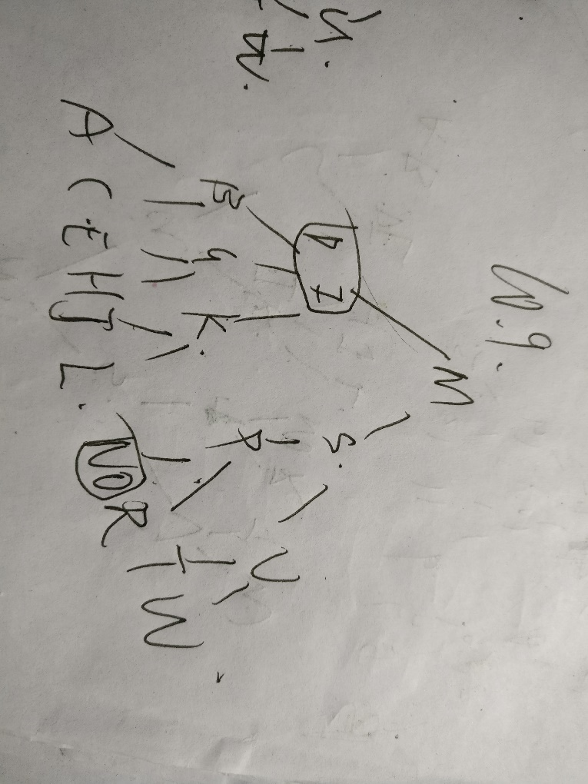

10.12

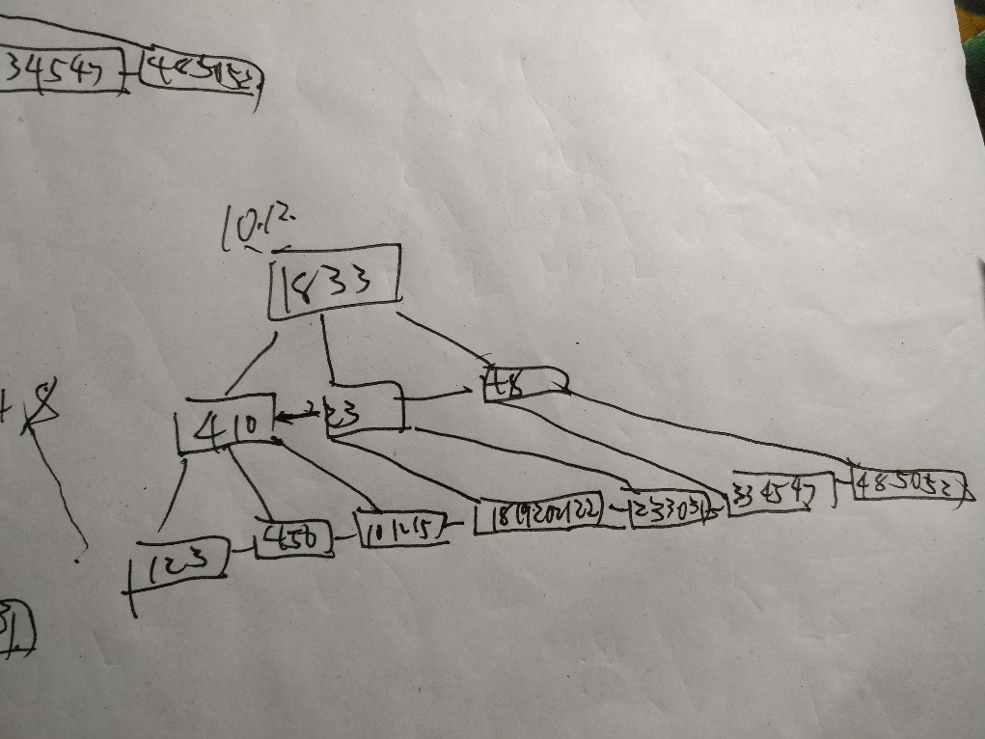

10.13

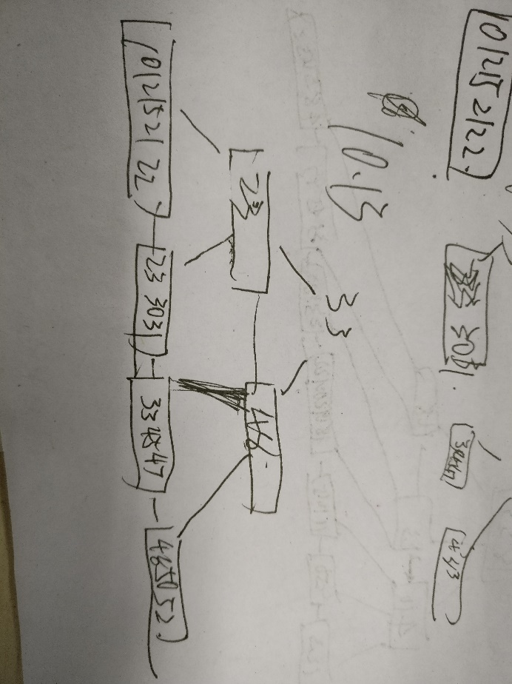

10.14

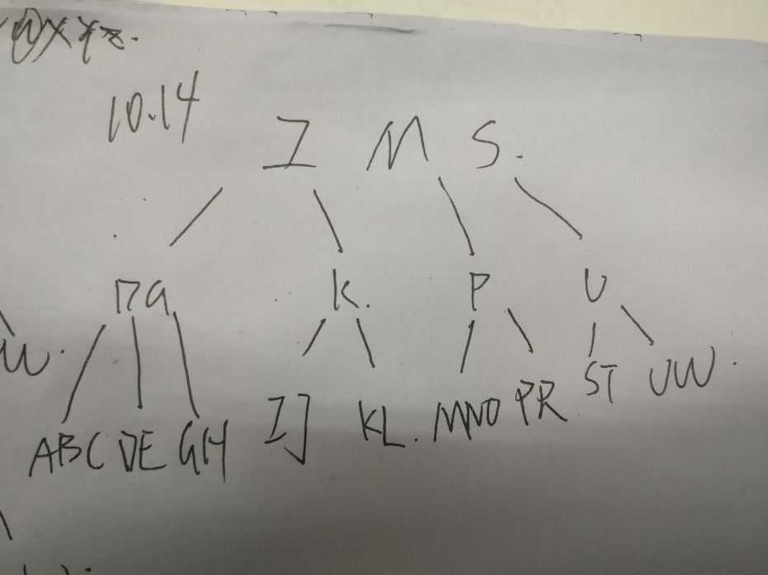

10.15

|  |  |  |
| --- | --- | --- |
|  | 至少 | 最多 |
| 1 | 0 | 15 |
| 2 | 16 | 1500 |
| 3 | 800 | 150000 |
| 4 | 40000 | 15000000 |
| 5 | 2000000 | 1500000000 |

10.16

|  |  |  |
| --- | --- | --- |
|  | 至少 | 最多 |
| 1 | 0 | 50 |
| 2 | 50 | 2500 |
| 3 | 1250 | 125000 |
| 4 | 31250 | 6250000 |
| 5 | 781250 | 312500000 |

11.3

11.4

11.5

11.6