Cloud Computing – Lab1

Anudit Nagar – E18CSE024

Explore AWS Services

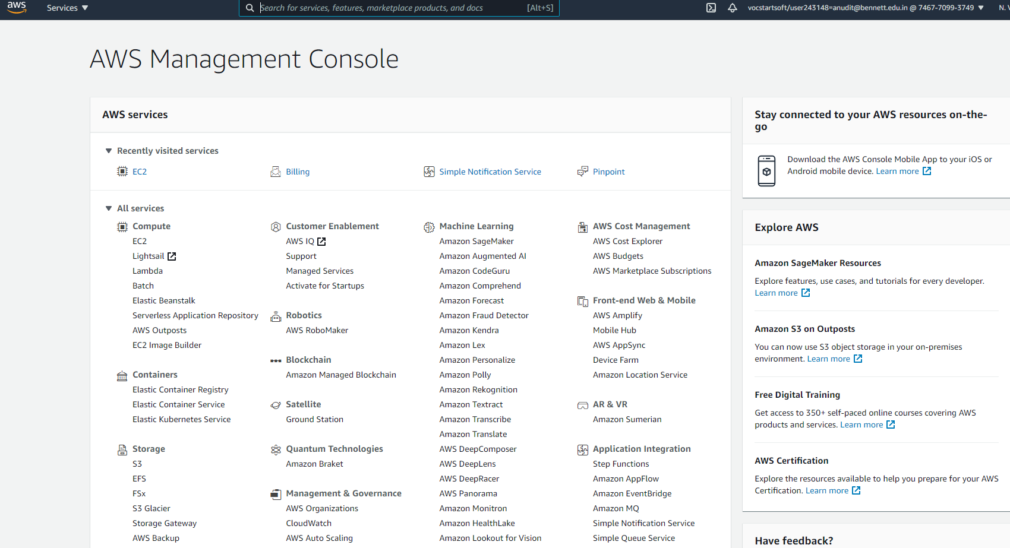

Create an EC2 Instance

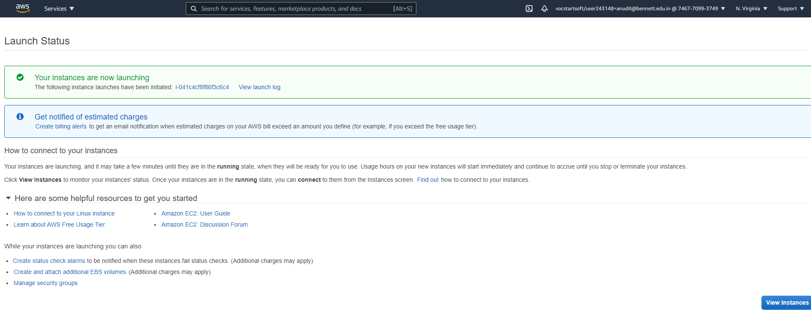

Connect to EC2 using Putty

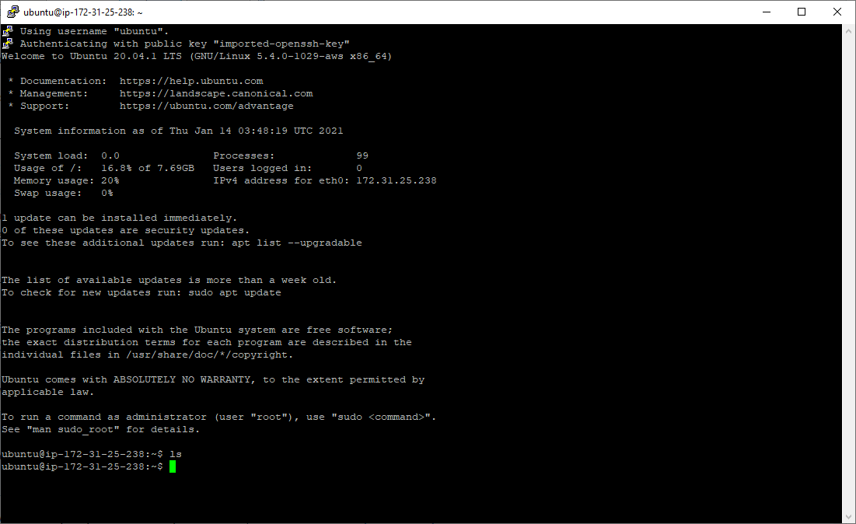

Start a Webserver using a static html webpage

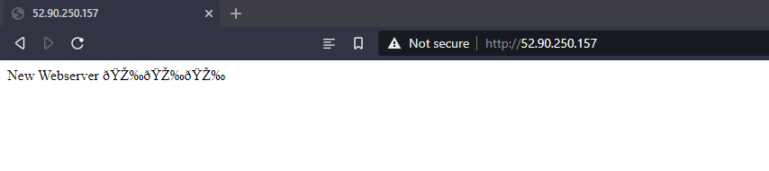

Create S3 Bucket and Interact

