**Cloud Computing – Lab 10**

**Anudit Nagar – E18CSE024**

Task 1 – Create S3 bucket

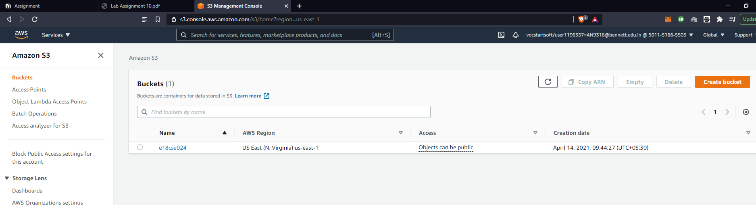

Task 2 – Explore bucket properties

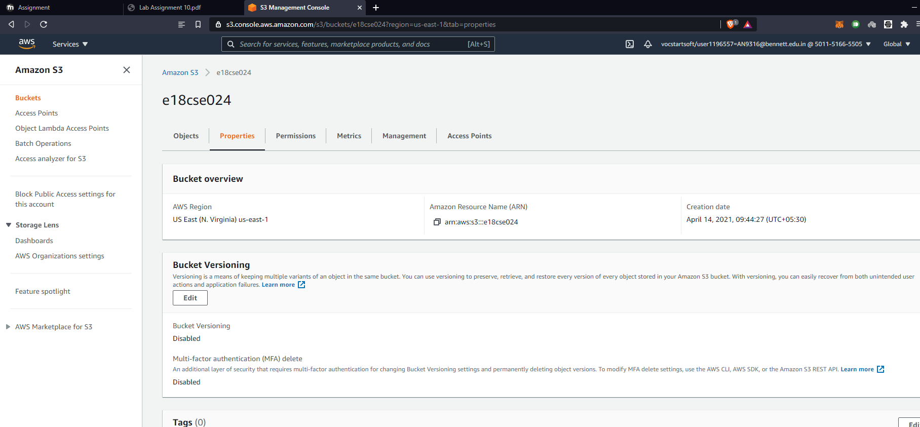

Task 3 – Upload file.

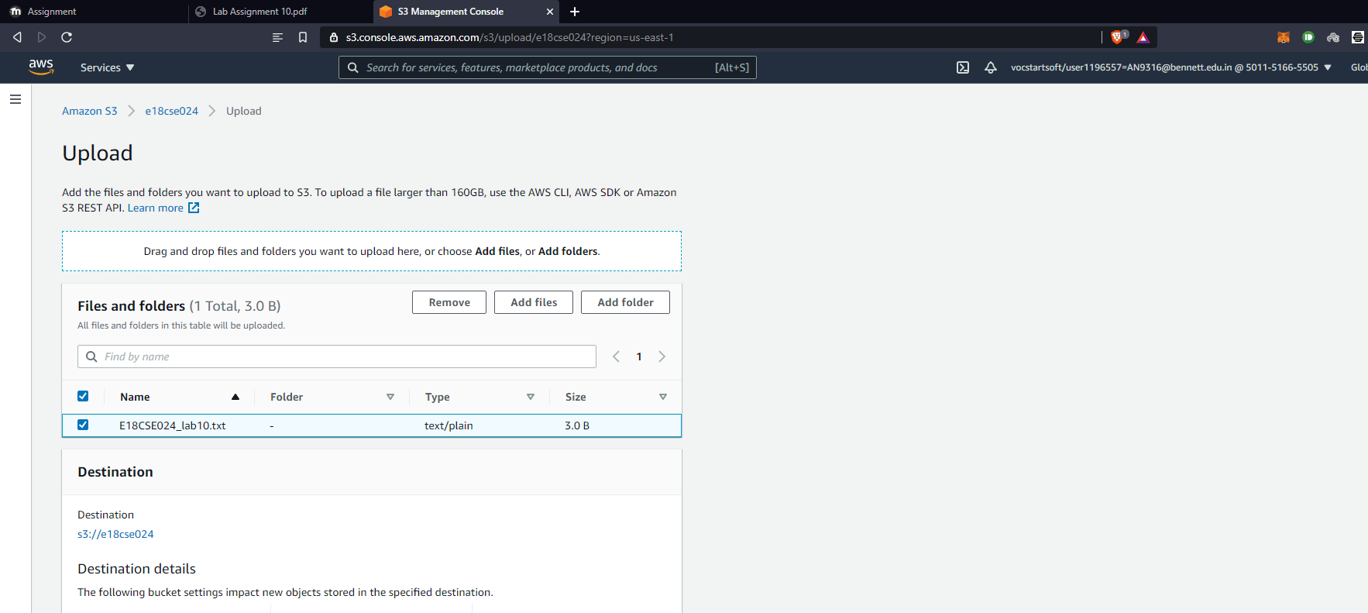

Task 4 – Upload file.

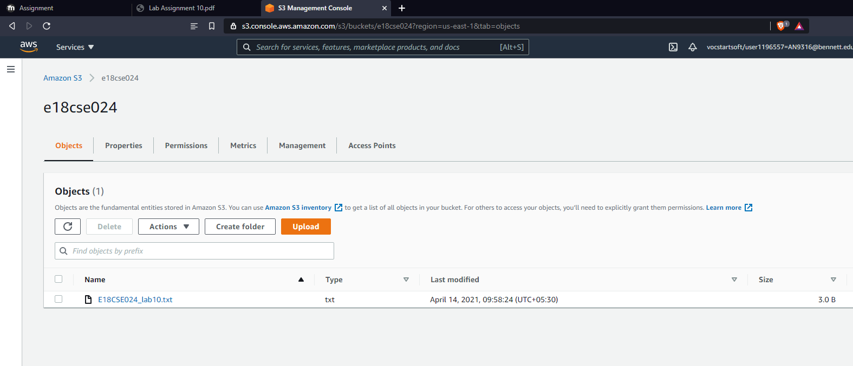

Task 5 – Make file public.

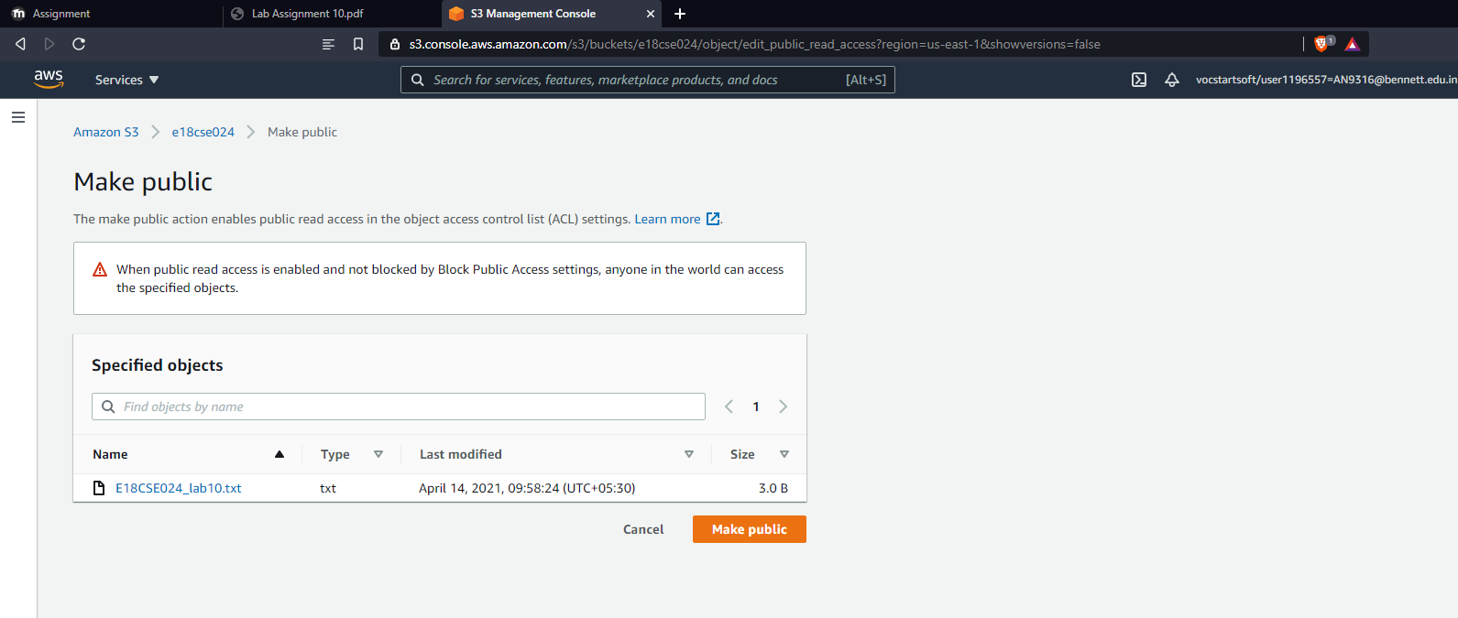

Task 5 – Check public access.

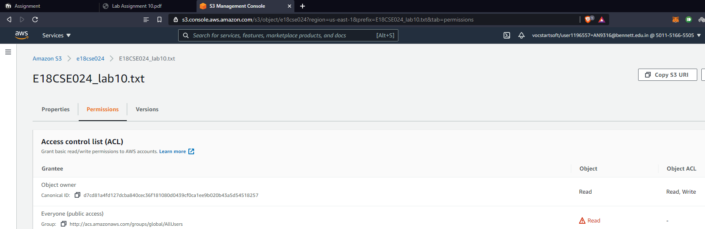

Task 6 – Make few changes and upload file.

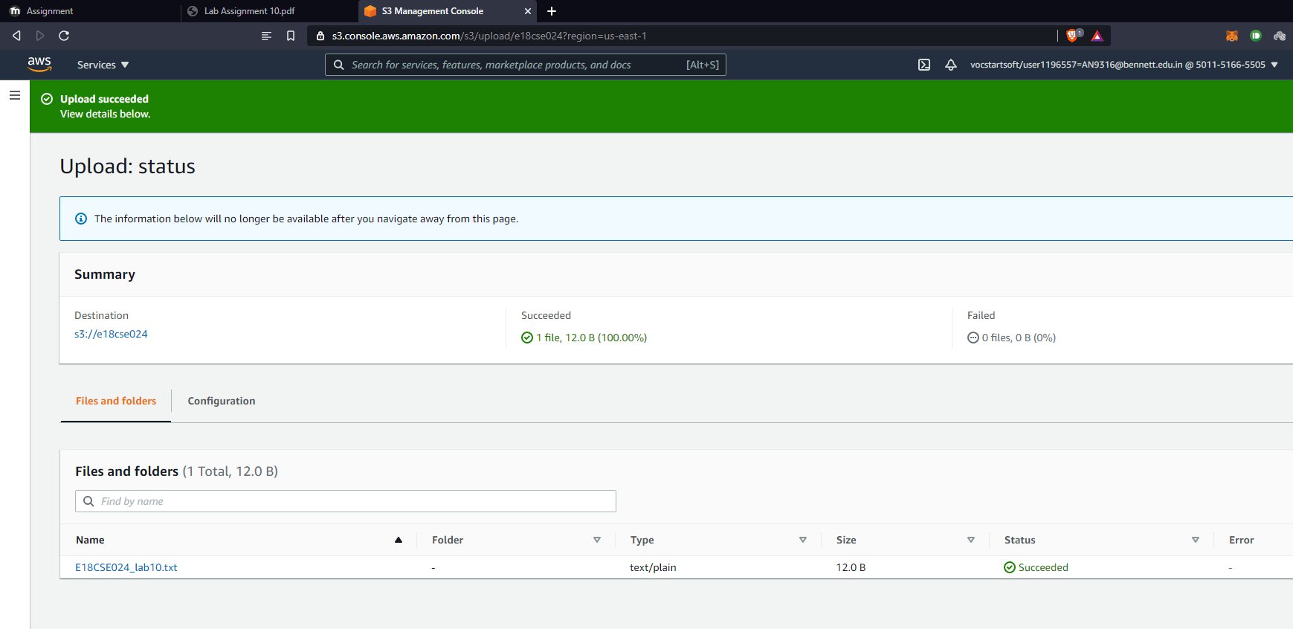

Task 8 – Check the updated file.

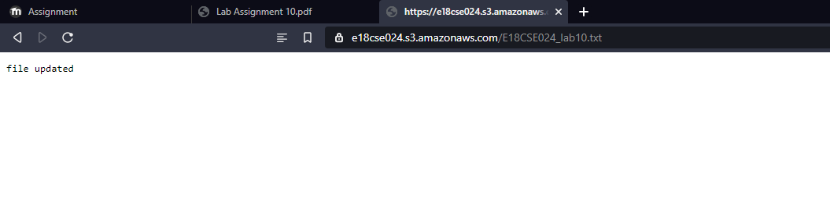

Task 9 – Enable versioning of S3 bucket.

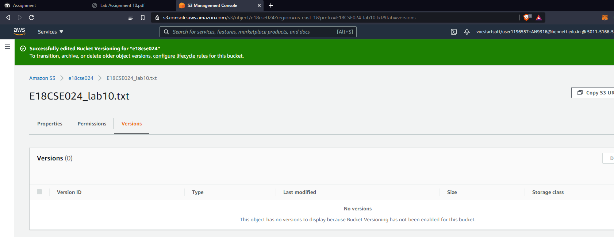

Task 10 – Find both the files in the S3 bucket.

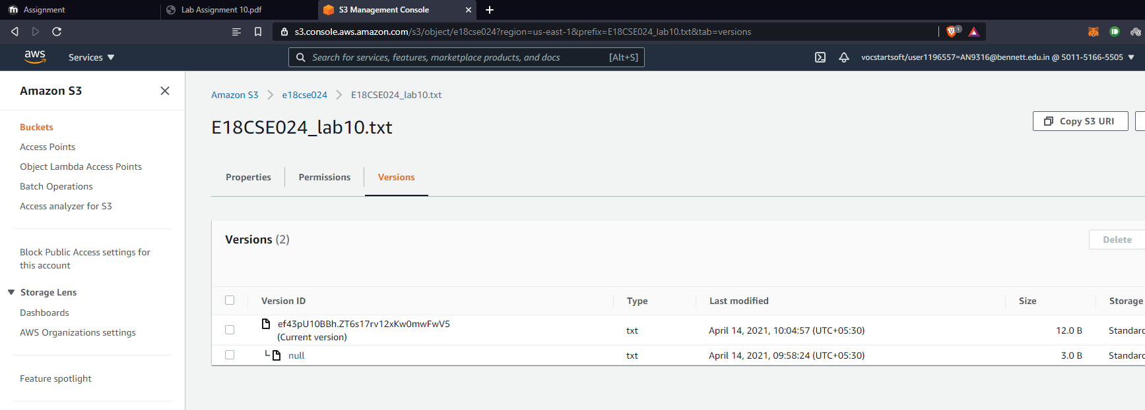

Task 11 – Delete file

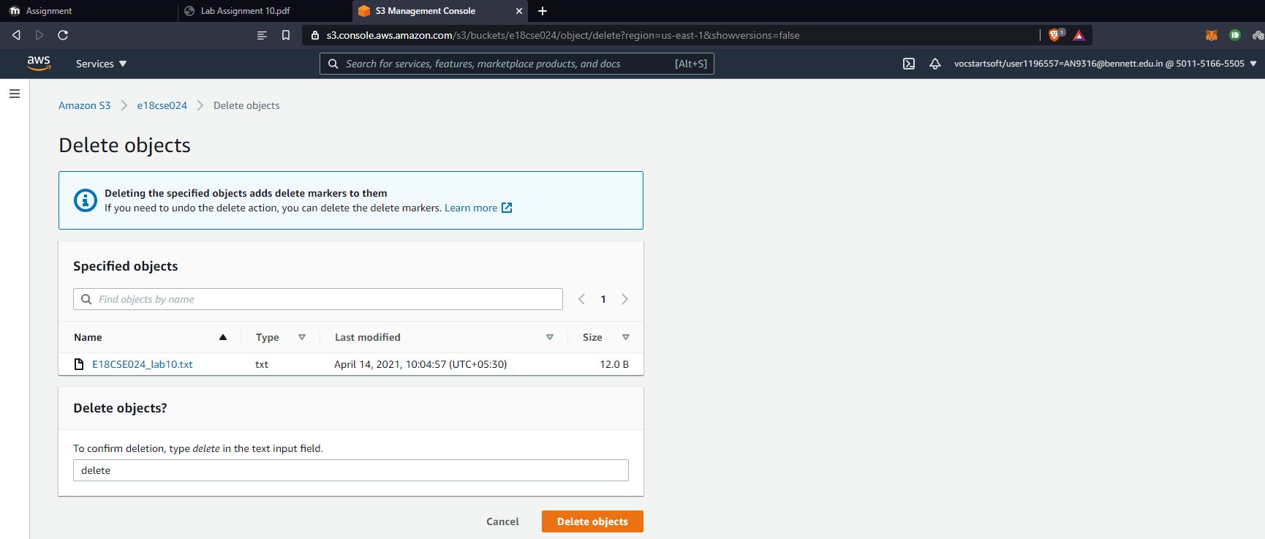

Task 12 – Show all the versions

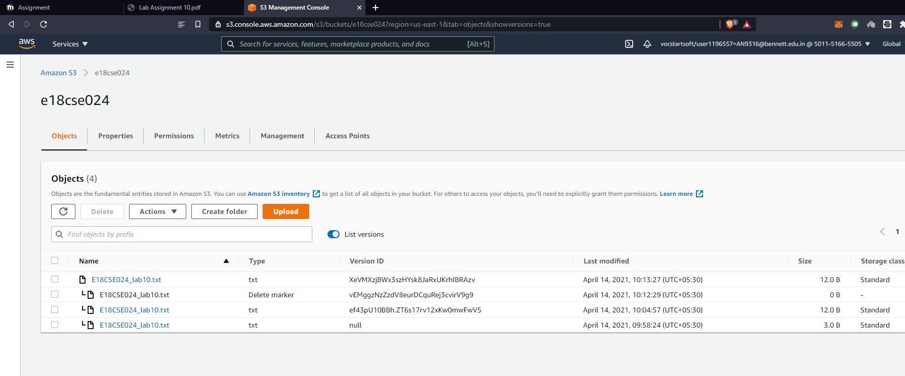

Task 13 – Perform cross region replication

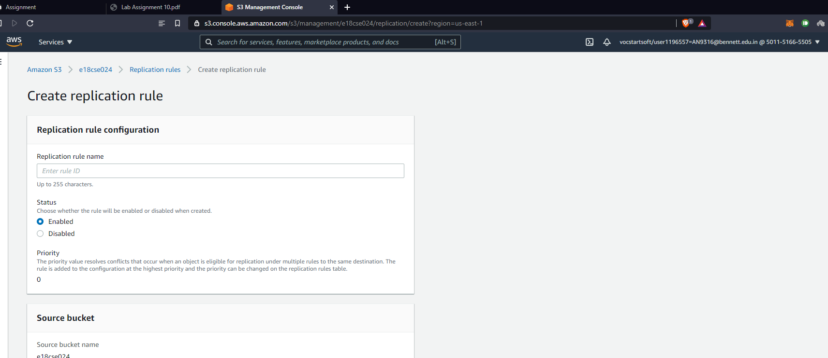

Task 14 – Configure lifecycle management

