**Cloud Computing – Lab 11**

**Anudit Nagar – E18CSE024**

Task 1 – Create Sagemaker Studio

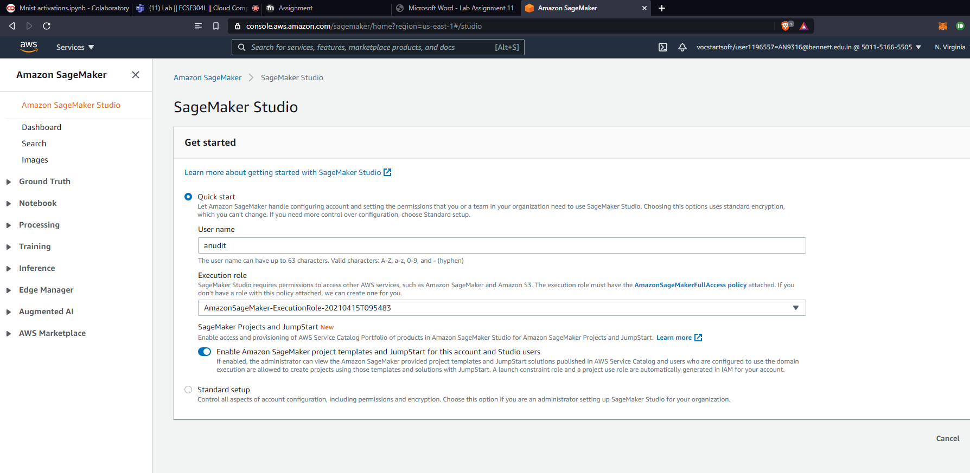

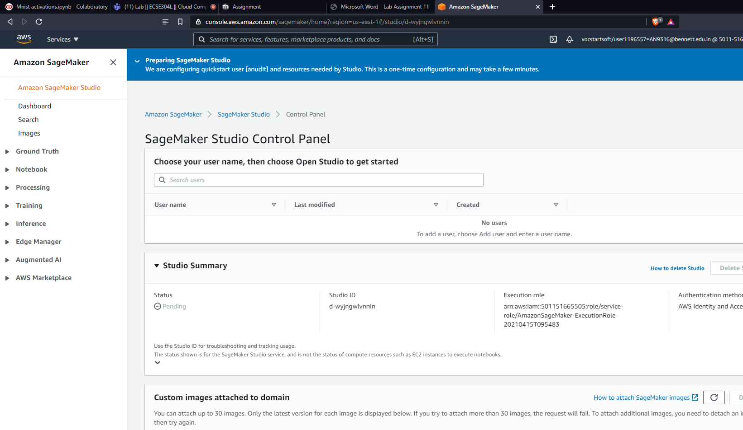

Task 2 – Explore examples on Sagemaker

