**Cloud Computing – Lab 12**

**Anudit Nagar – E18CSE024**

Task 1 – Go to AWS management console.

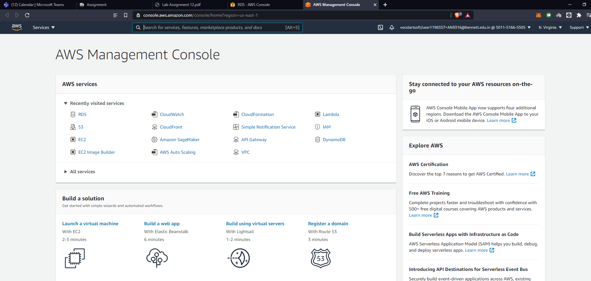

Task 2 – Understanding Amazon RDS

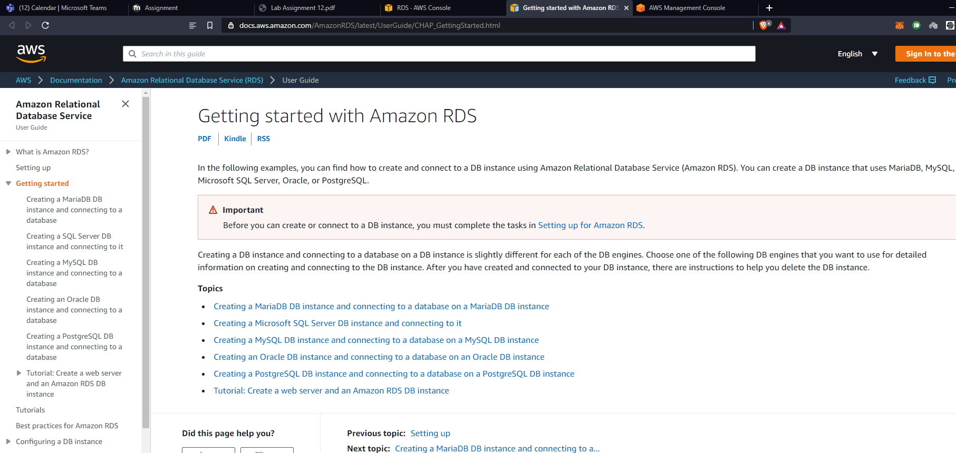

Task 3 – Create the RDS database by using RDS AWS service.

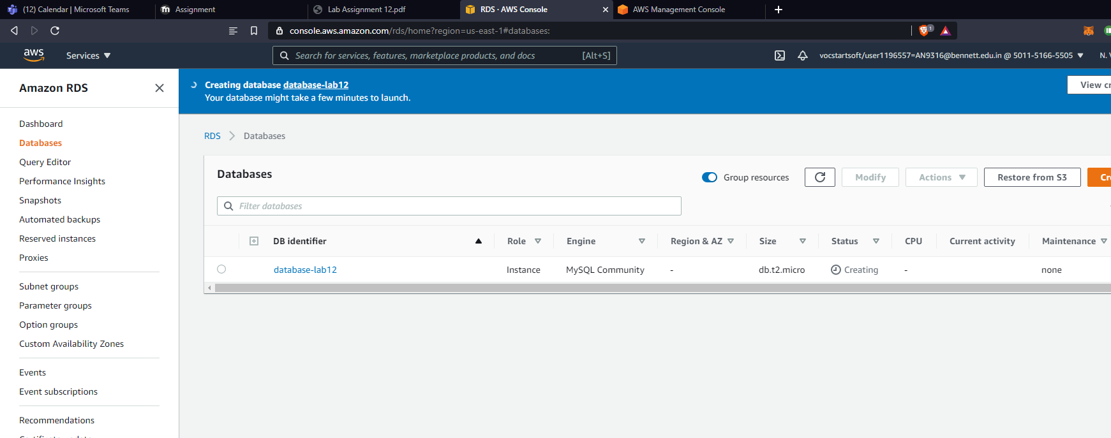

Task 4 – Setting up Amazon RDS for first time use

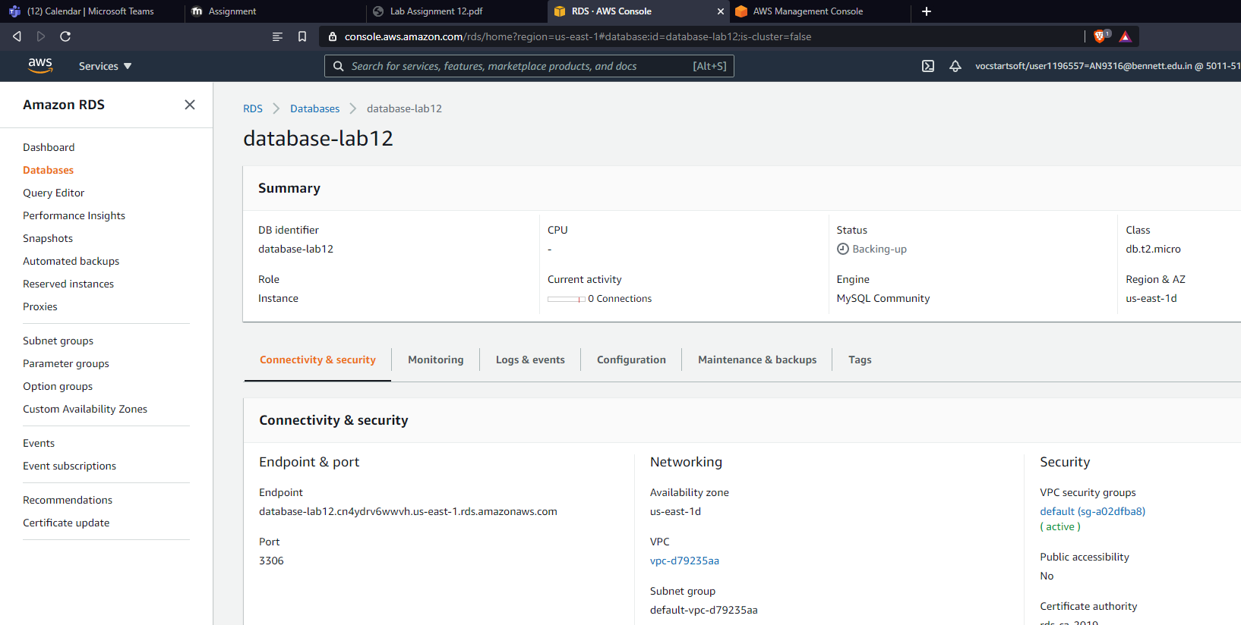

Task 5 – Understanding Amazon RDS DB instances

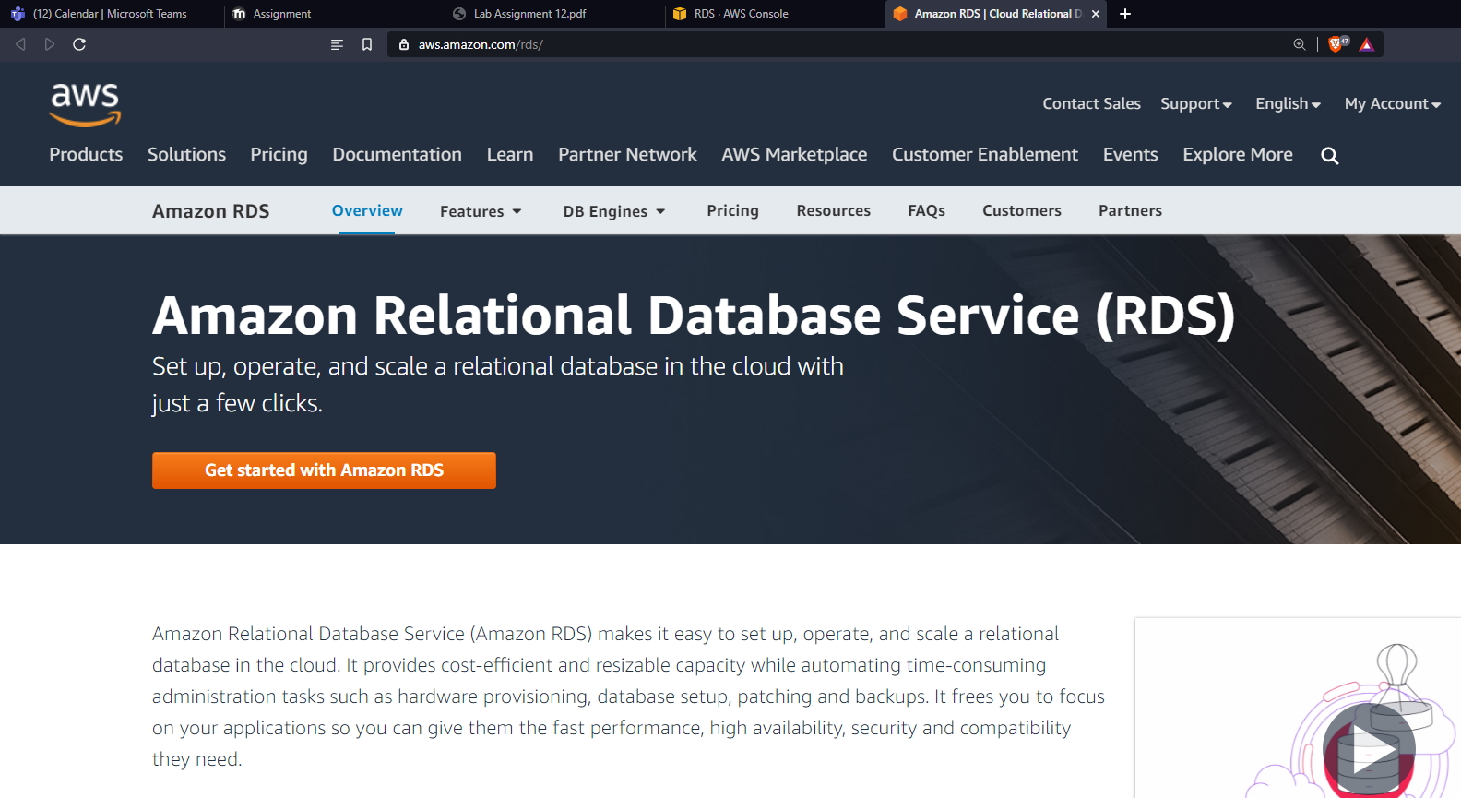

Task 6 – Creating a DB instance for production

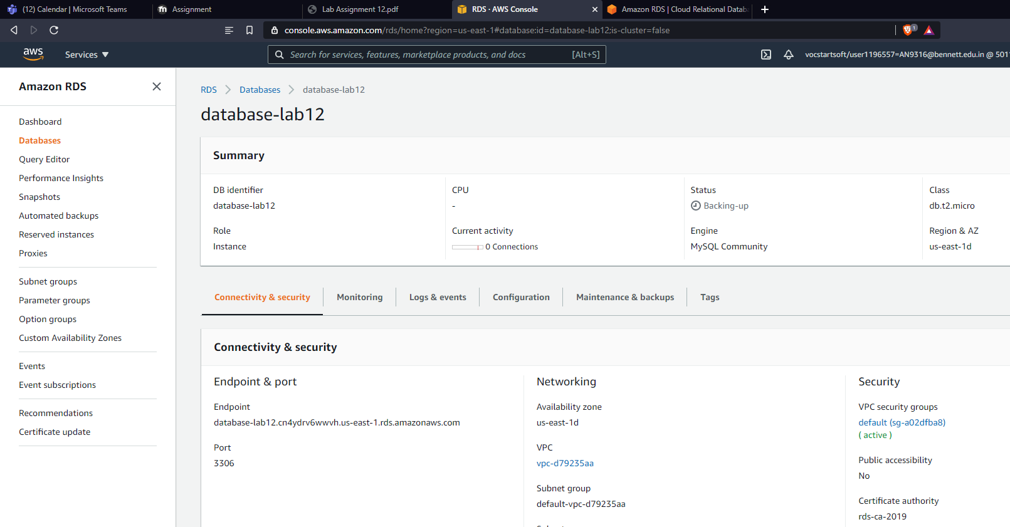

Task 7 – Managing security for your DB instance

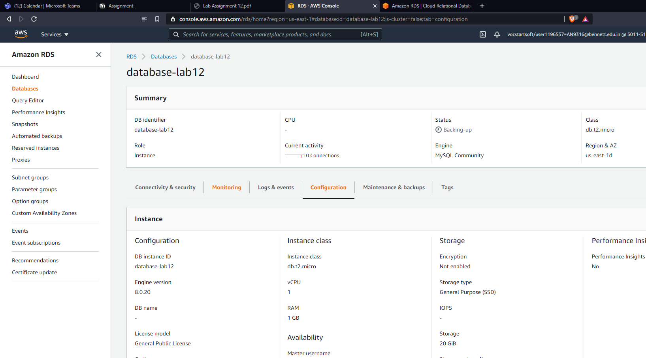

Task 8 – Connecting to your DB instance using MySql Workbench and command line

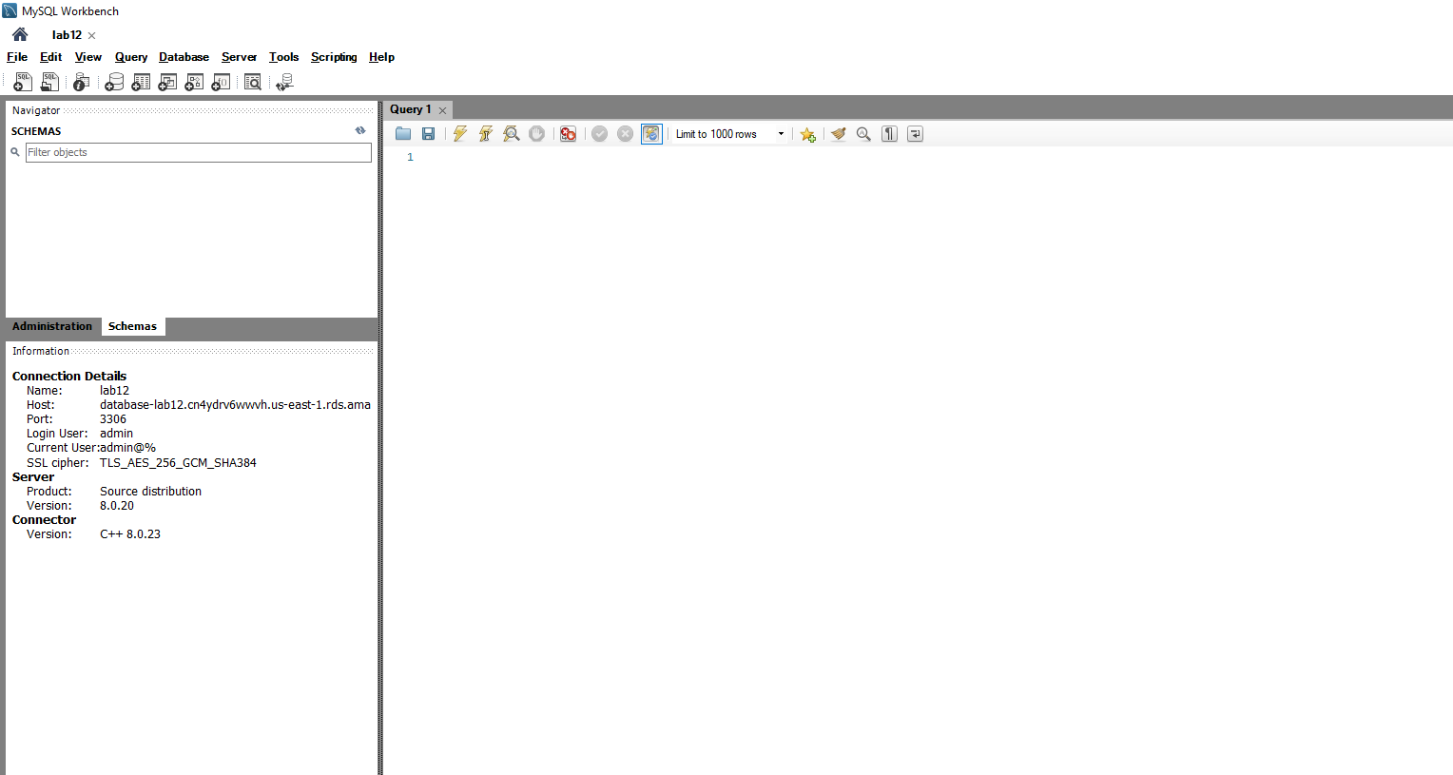

Task 10 – Create/import the HR database as attached to the file.

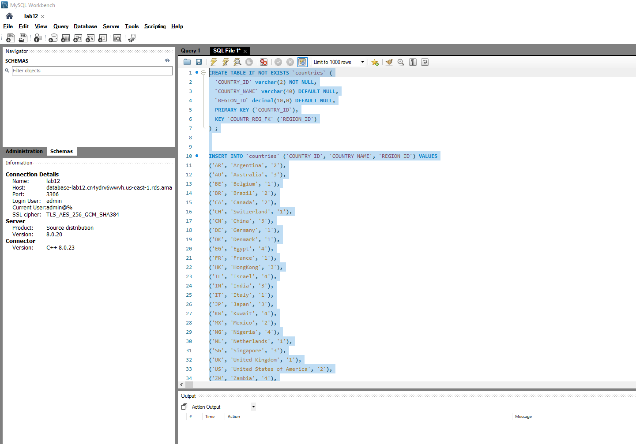

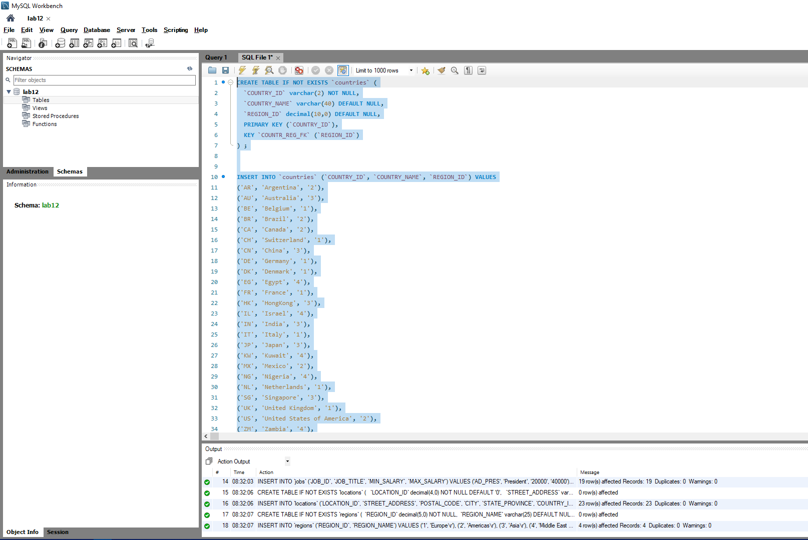

Task 11 – Monitoring a MySQL DB instance

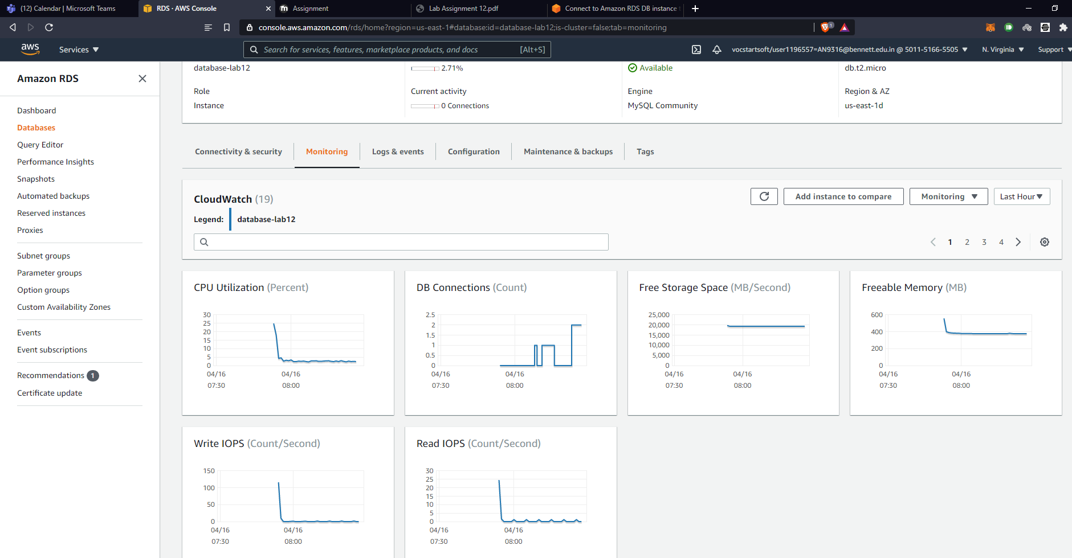

Task 12 – Execute a few of SQL queries and again monitor the database performance.

