**Lab 2**

**Anudit Nagar - E18CSE024**

Last 3 activities of Lab 1 because they were done in Lab 2.

**Task 4**: Working with AWS command line and perform Start, Stop and Terminate EC2 Instance using CLI.

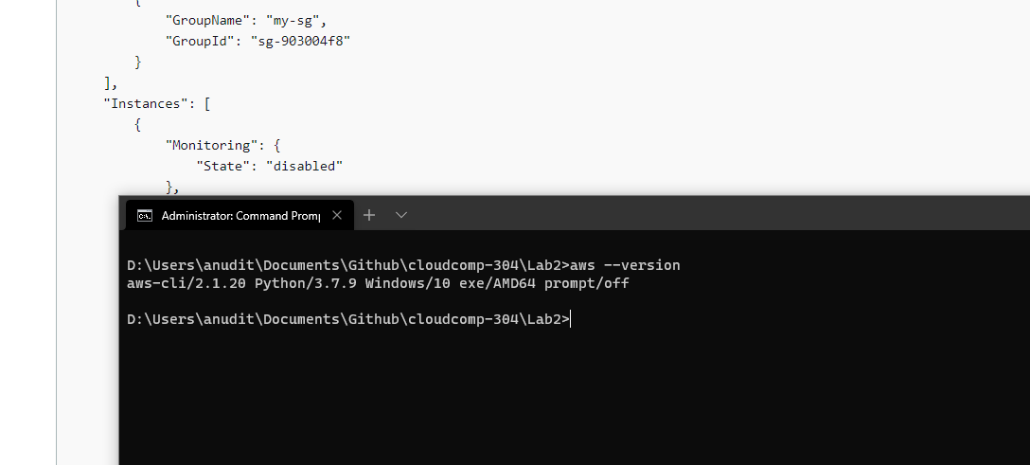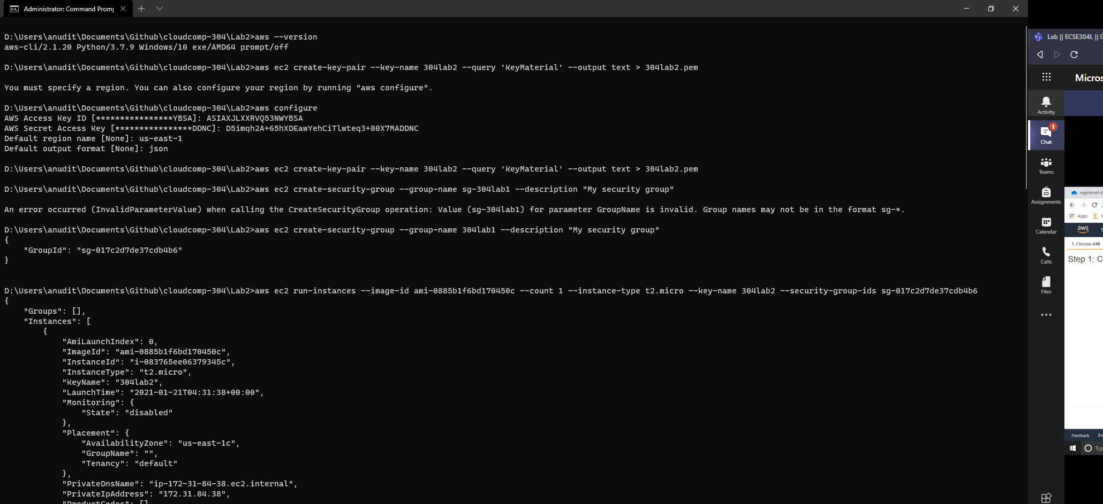

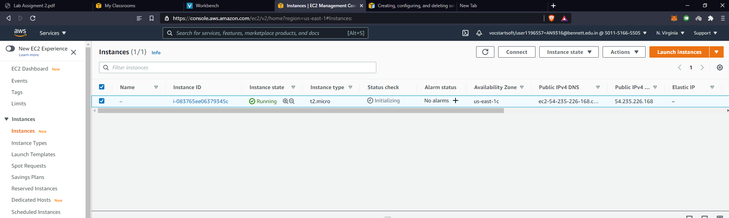

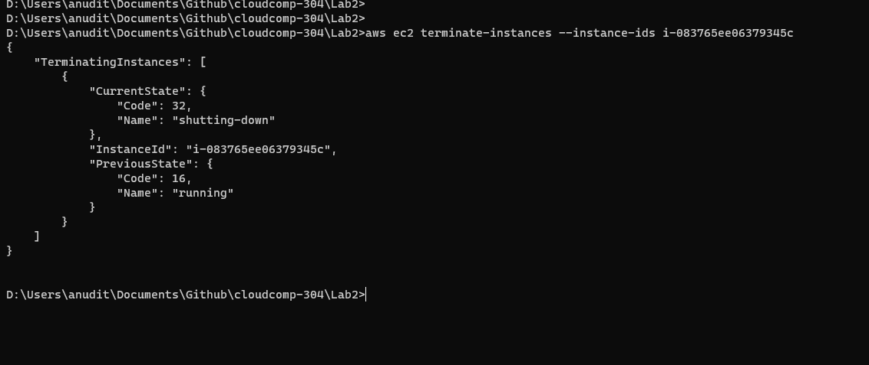

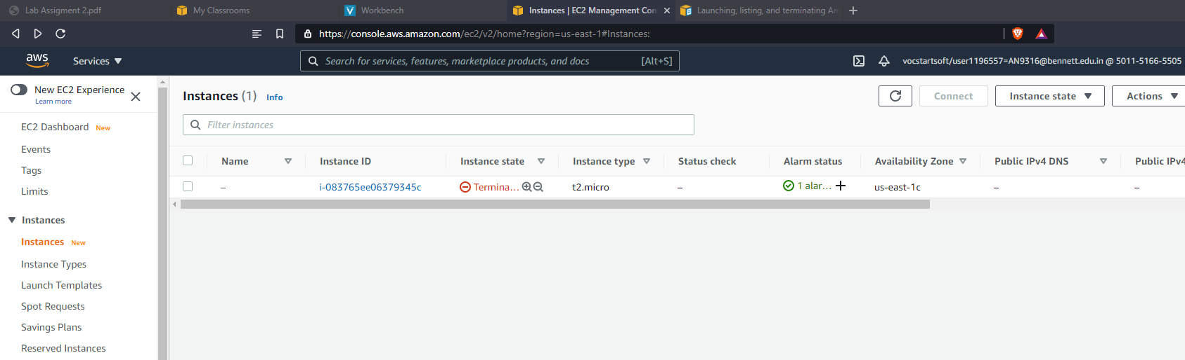

**Task 5:** Use of Simple Storage Service (S3), by creating AWS S3 bucket and Interact with AWS S3 service using AWS CLI. (Desirable tasks to be performed make bucket, remove bucket, upload object into bucket and explore all the bucket properties.)

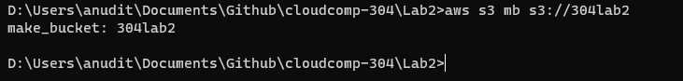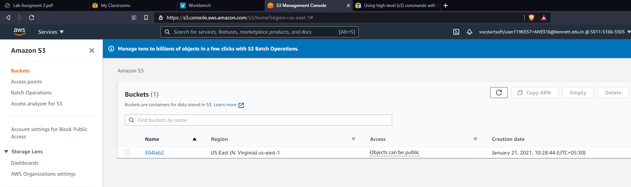

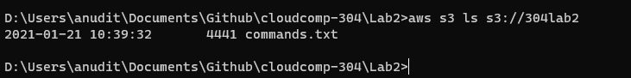



**Lab 2**

Create Instance 1 with root and additional EBS storage.

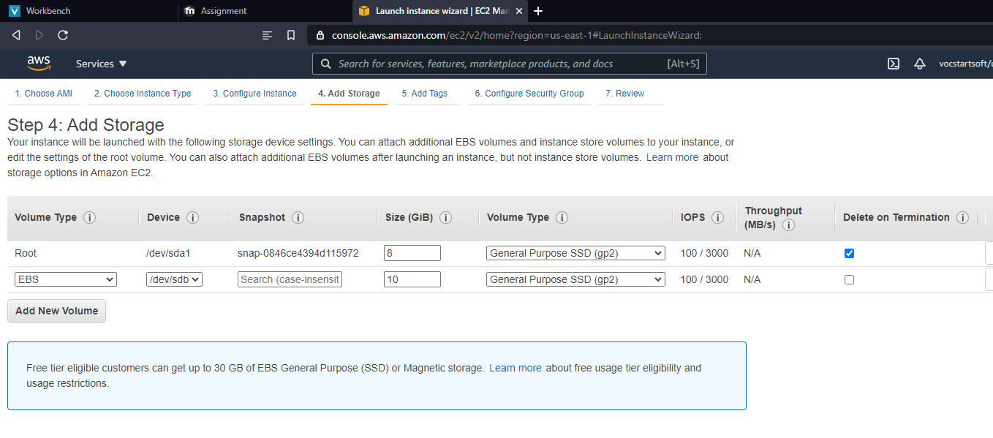

Create Instance 2 with just root volume.

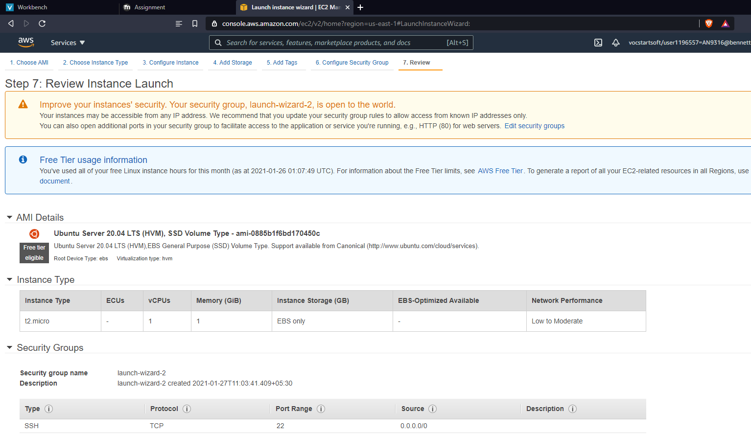

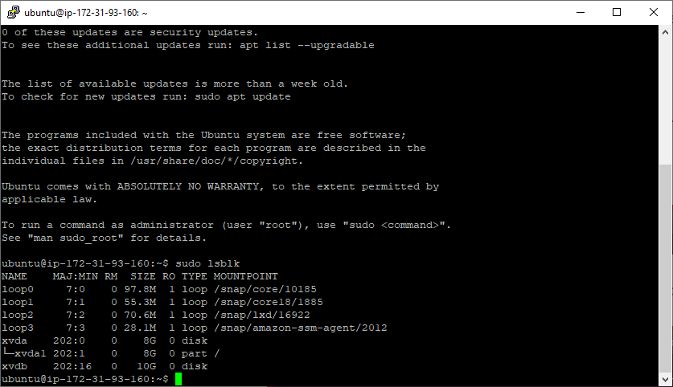10gb volume available for use on instance 1

Detach Volume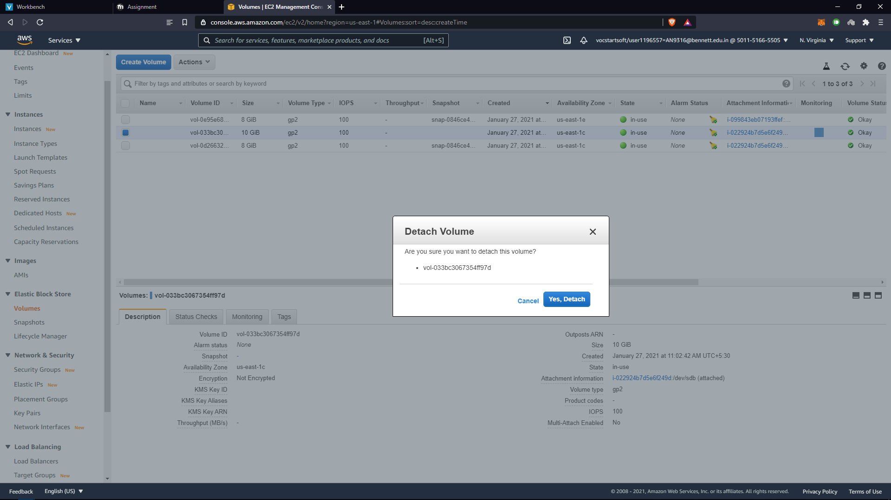

Attach to instance 2.

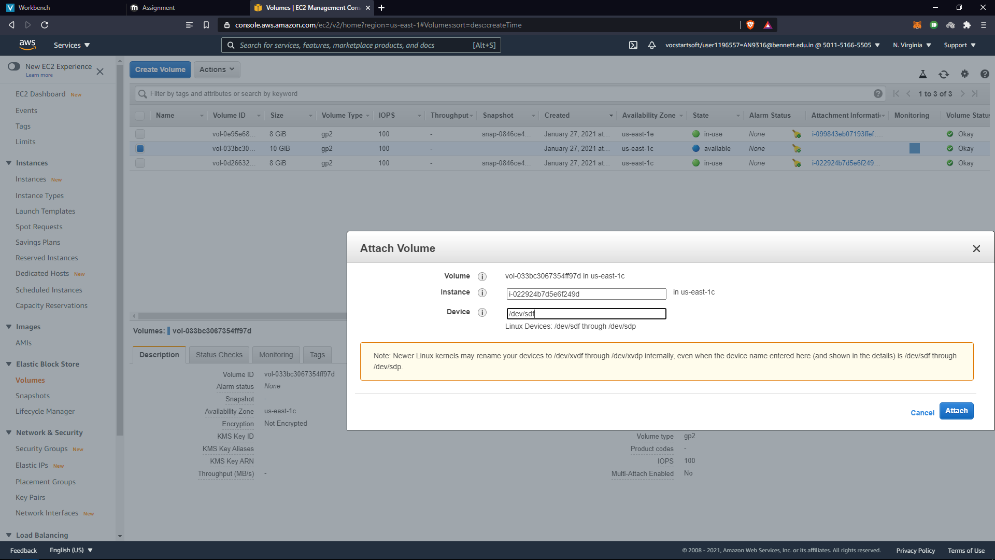

Delete storage volume.

