**Cloud Computing – Lab 4**

**E18CSE024 – Anudit Nagar**

**Peering in different Availability Zone.**

**Task 3, 4, 5, 6, 7**

Create VPC & Subnet in different region.

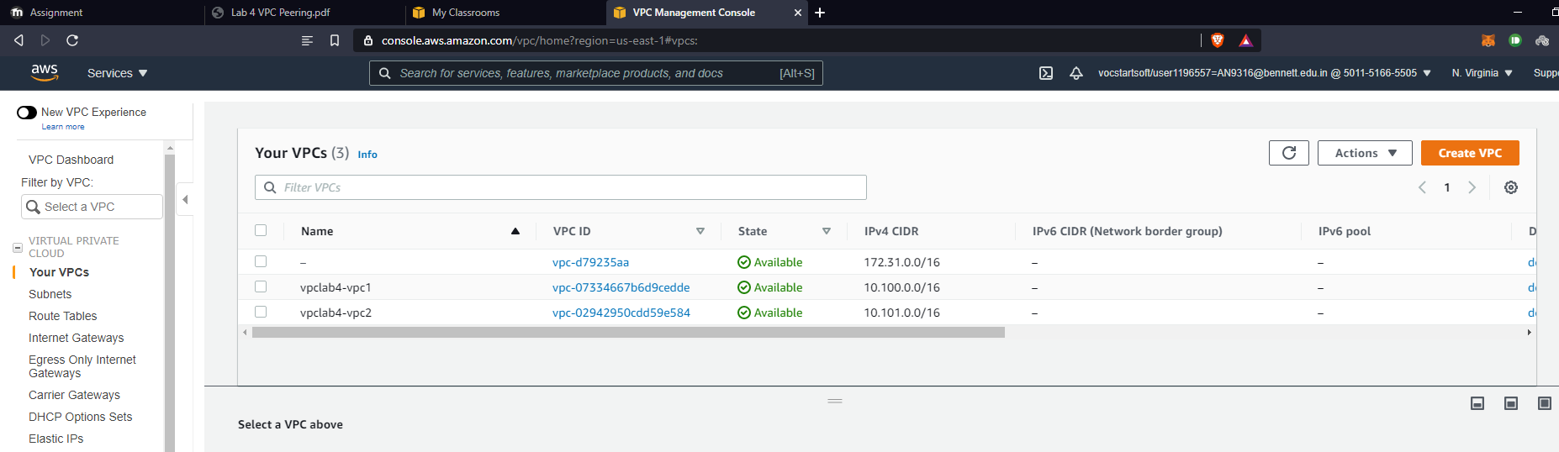

Create Instances in different regions.

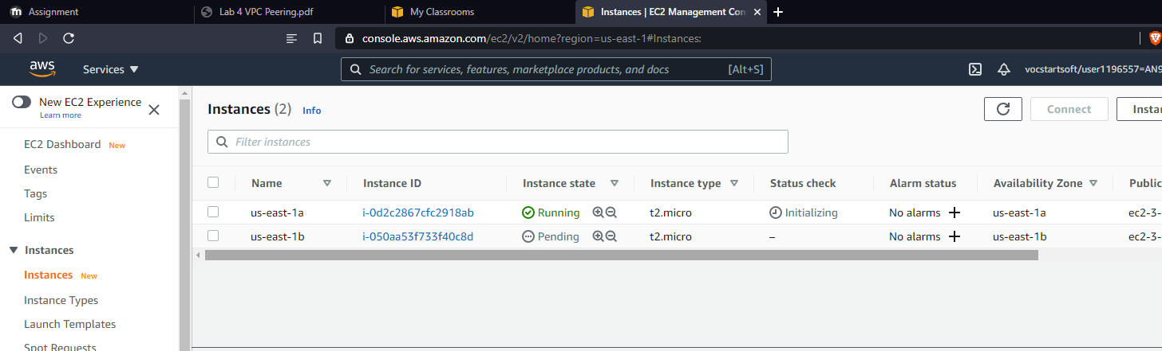

Try Pinging before peering. (Should not work)

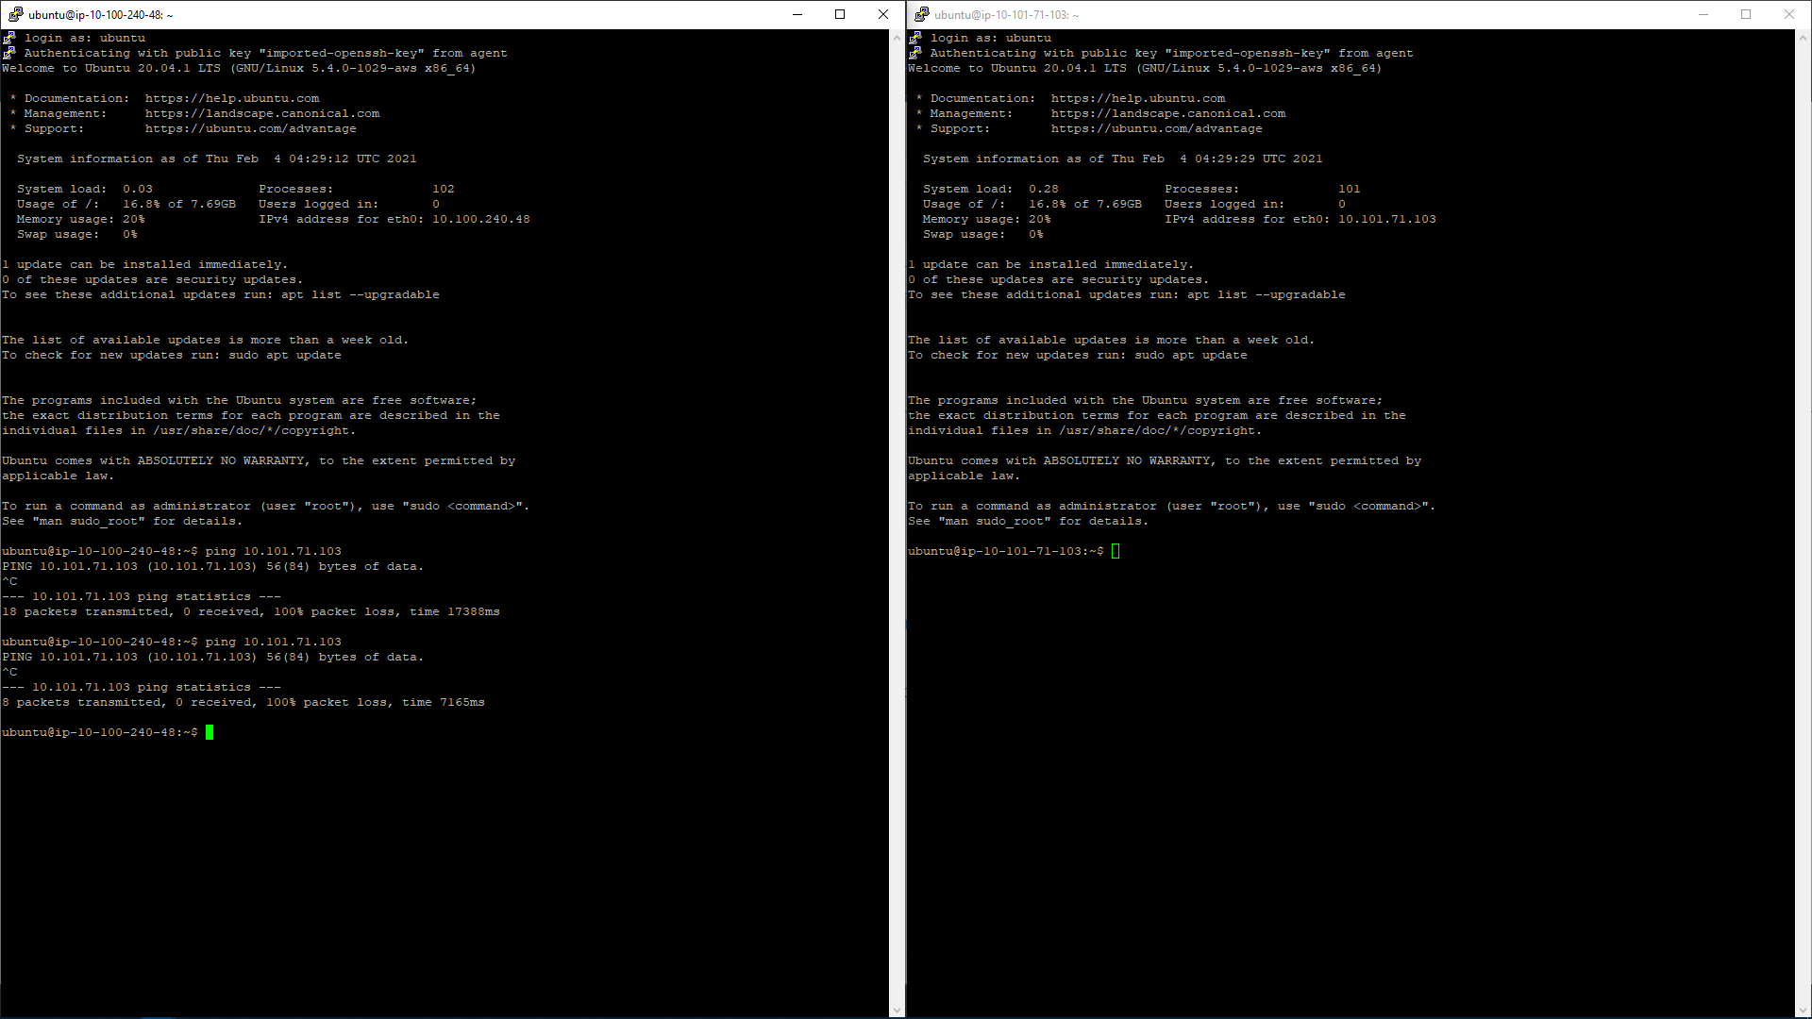

Create VPC Peering Connection

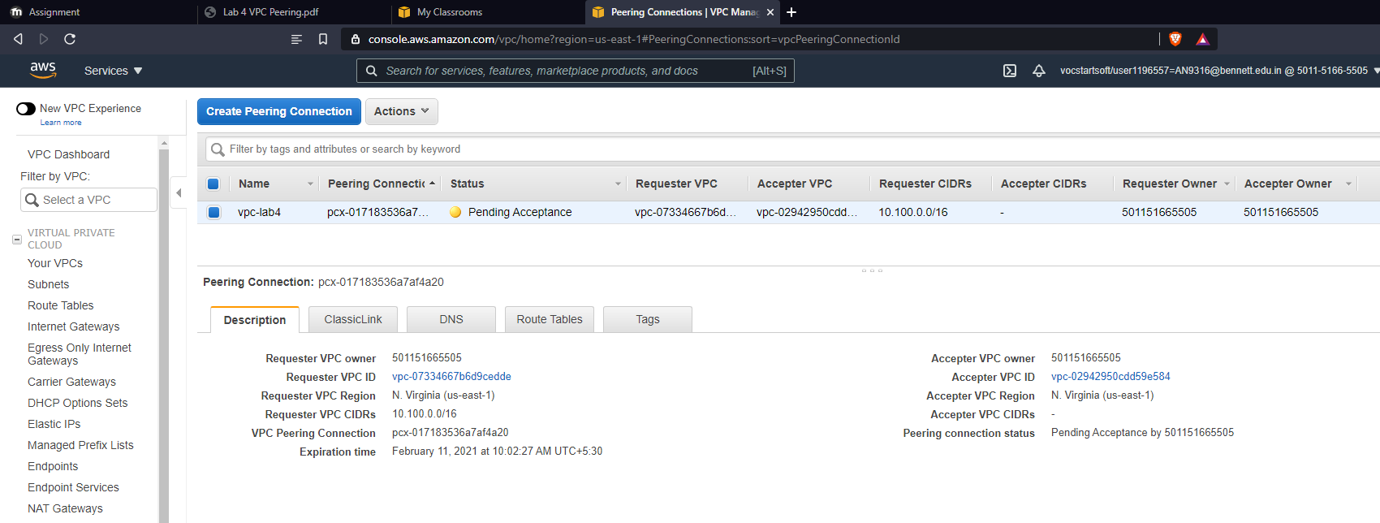

Ping to instance 2 from instance 1 works now.

