**Cloud Computing – Lab 6**

**Anudit Nagar - E18CSE024**

Create one Windows/Linux instance.

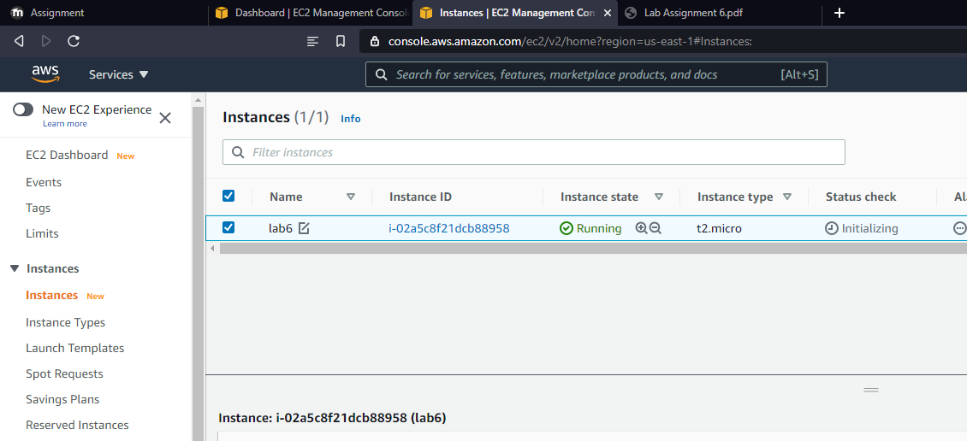

Create IAM Role

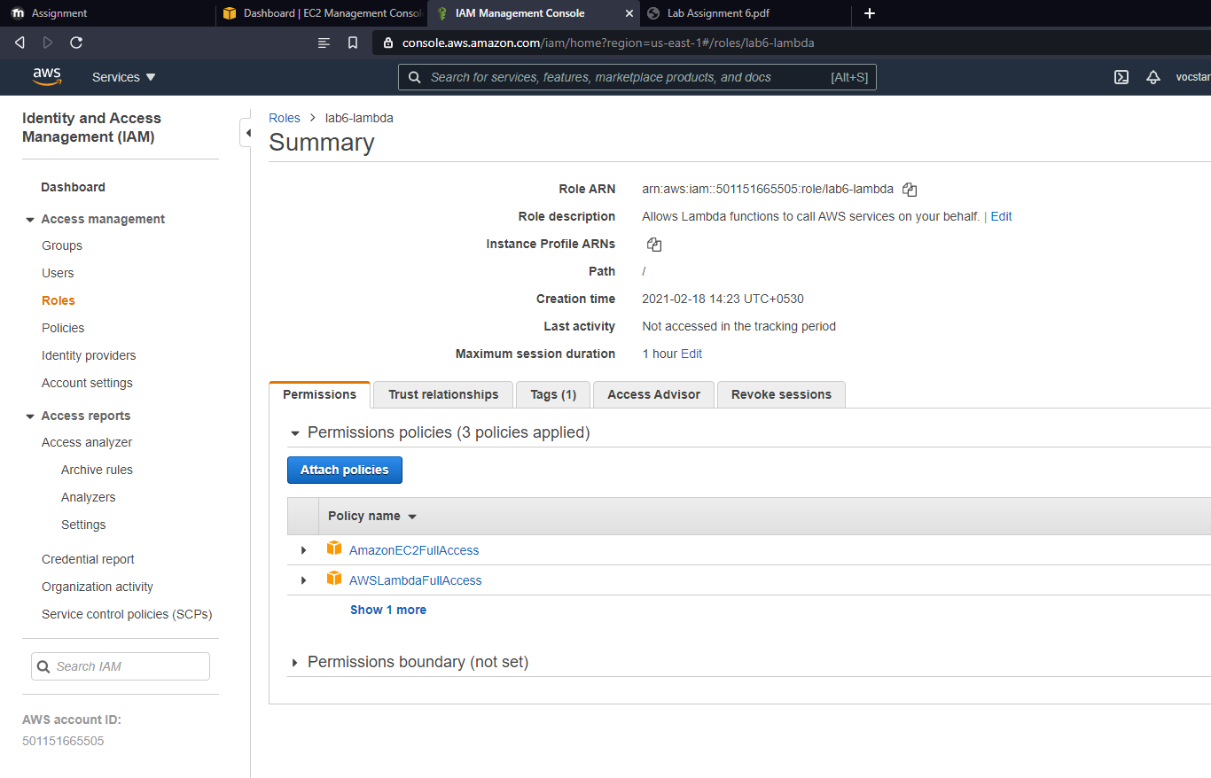

Create and test a new lambda function.

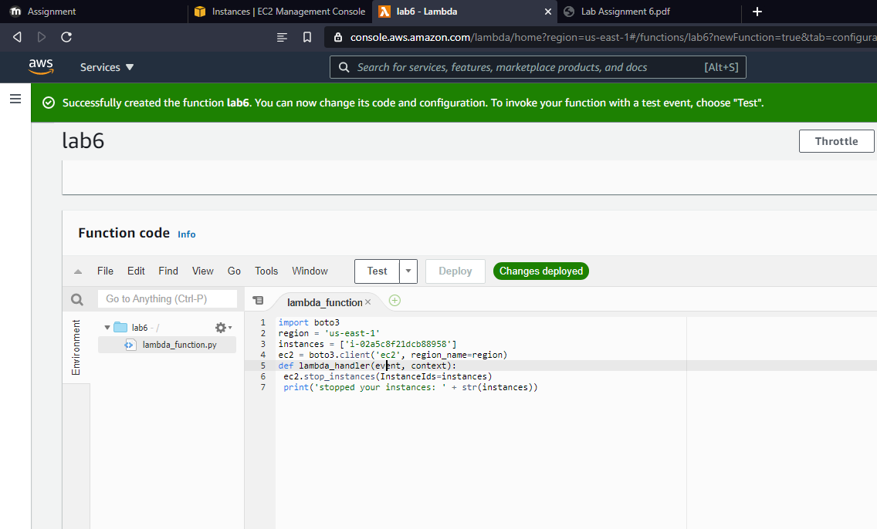

Create Trigger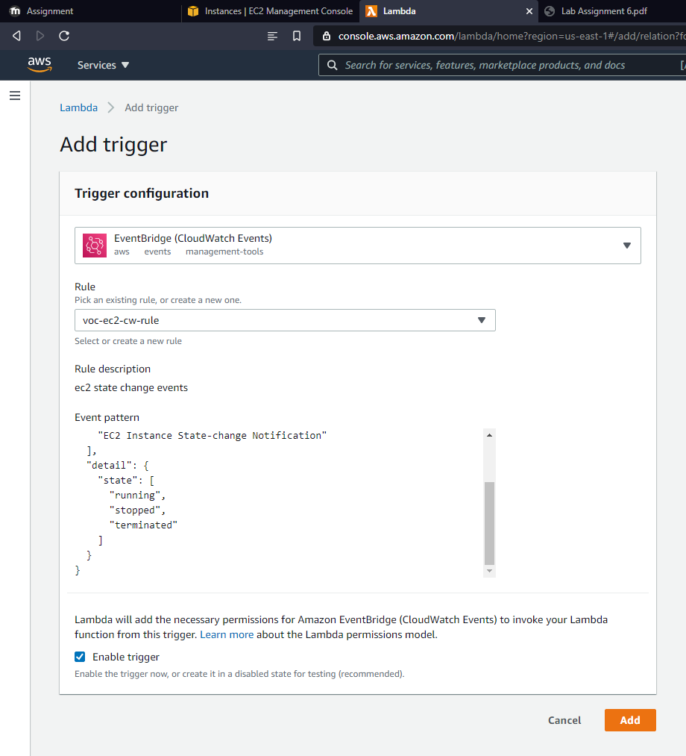

Trigger the function and terminate the ec2 instance.

