**Cloud Computing – Lab 7**

**Anudit Nagar – E18CSE024**

Task 1 – Create Bucket, Upload files, Enable Static Site hosting

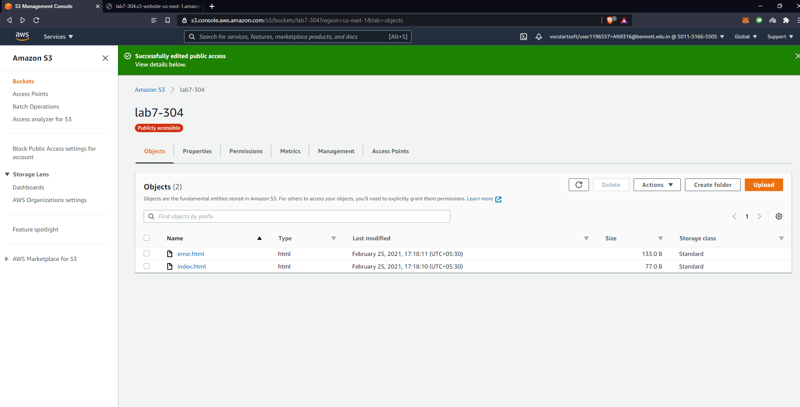

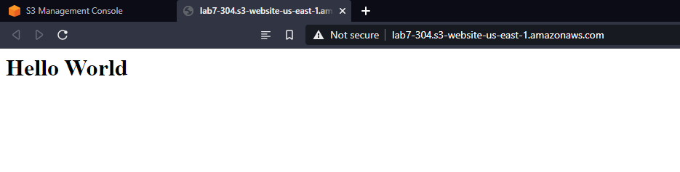

Task 2 – create lambda function, create test event.

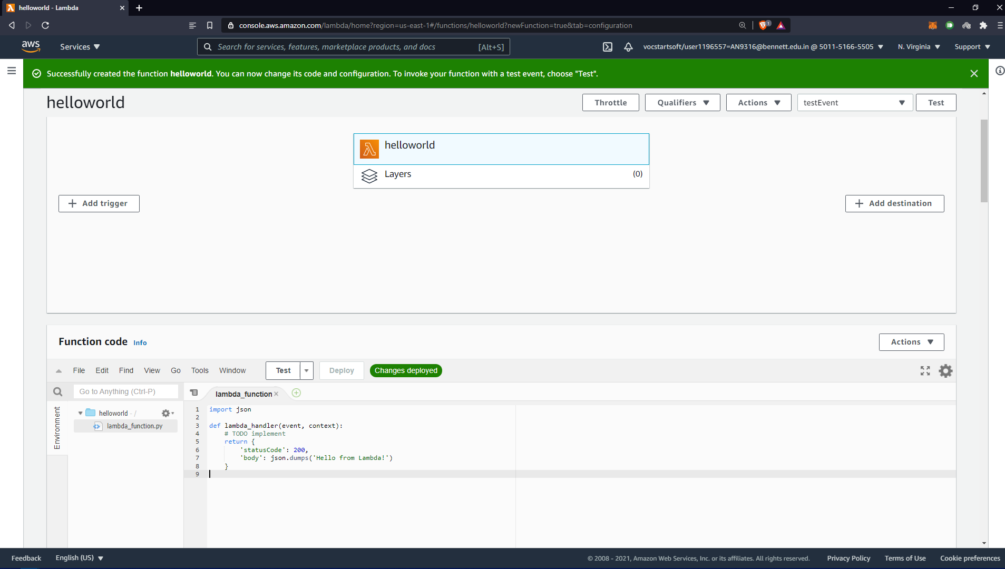

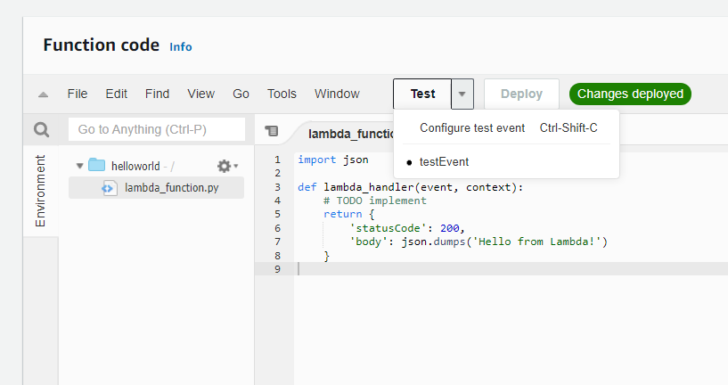

Task 3 – Create API, Create Routes, Enable CORS, Deploy API, Check API in Postman

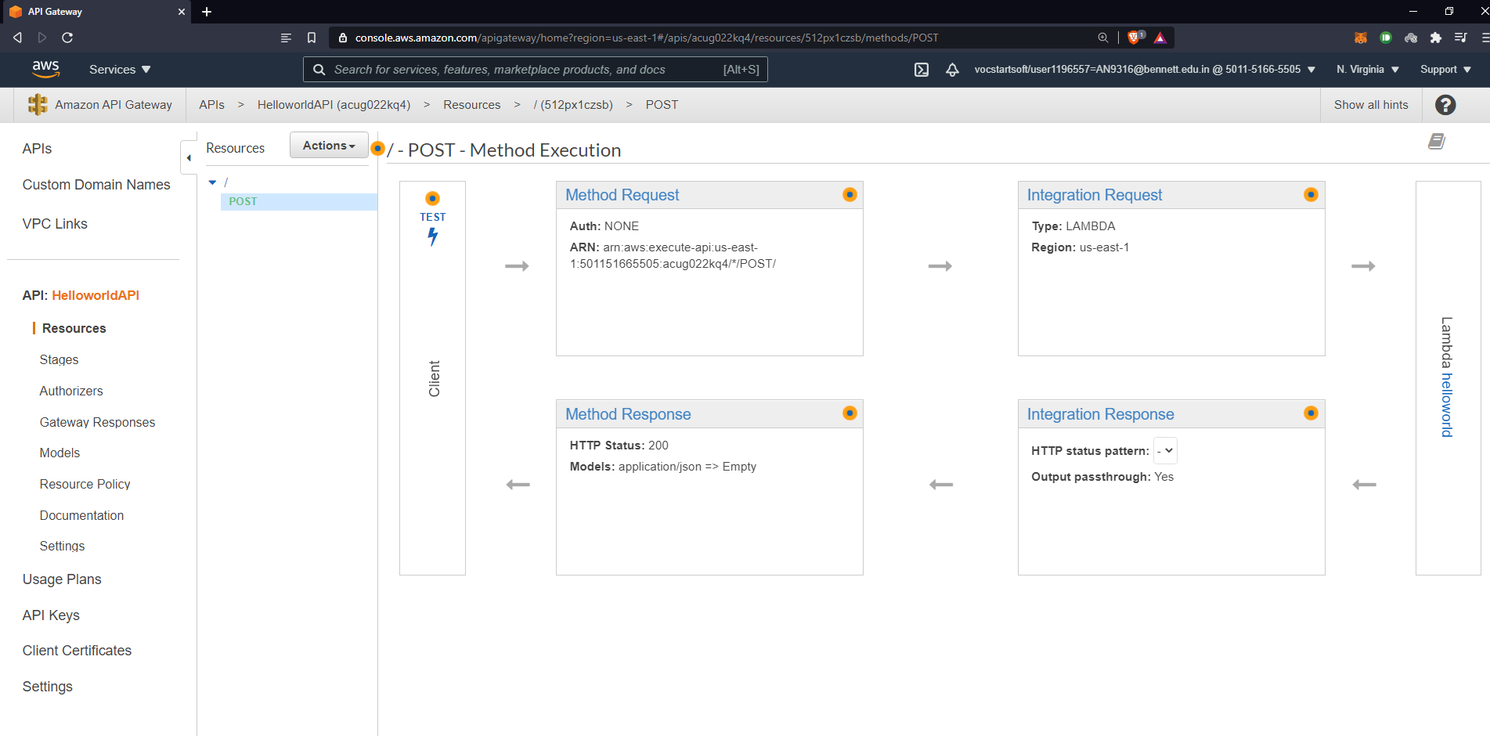

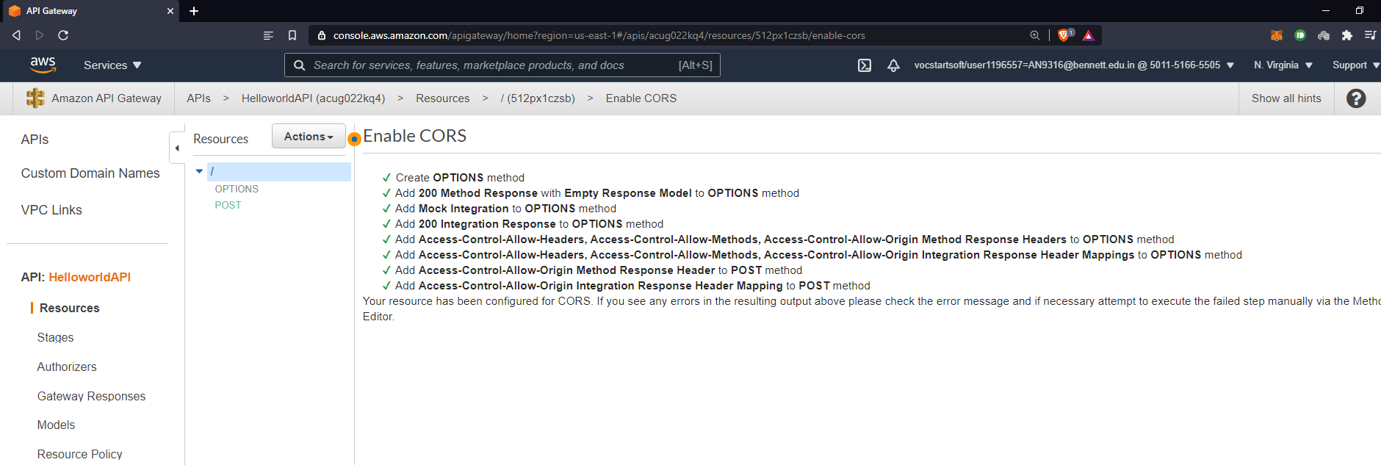

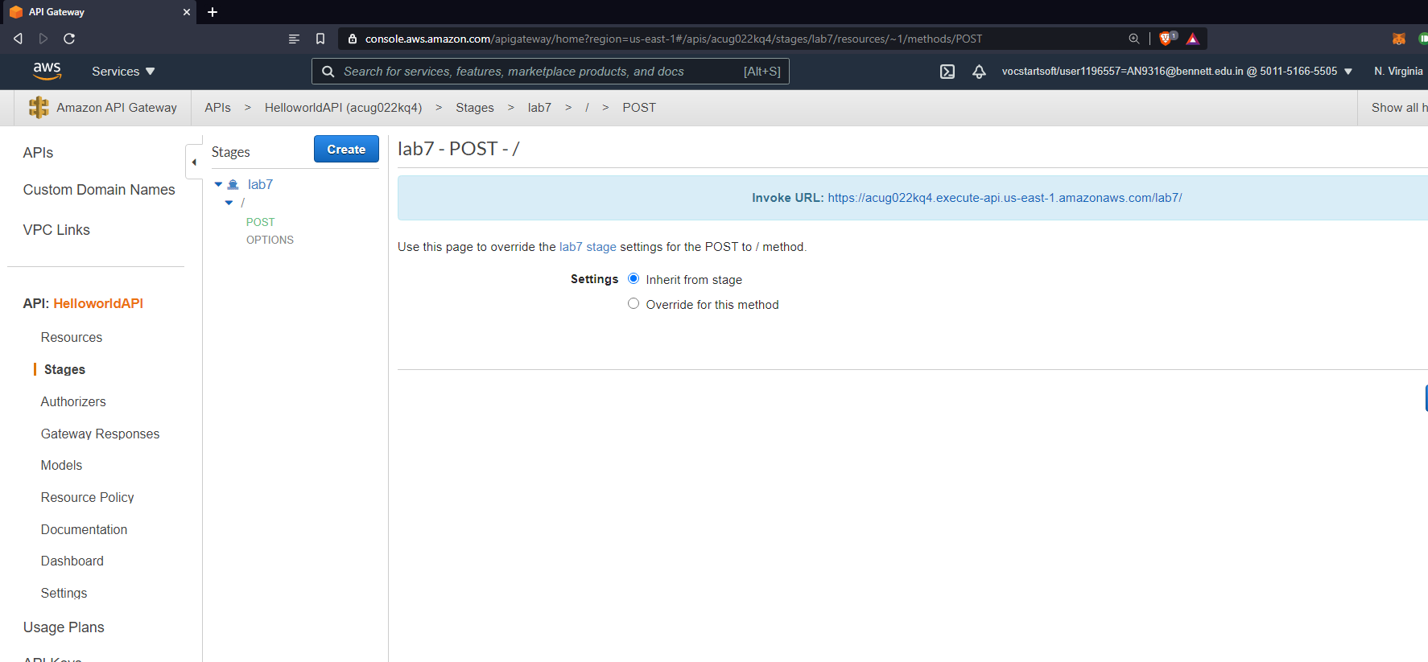

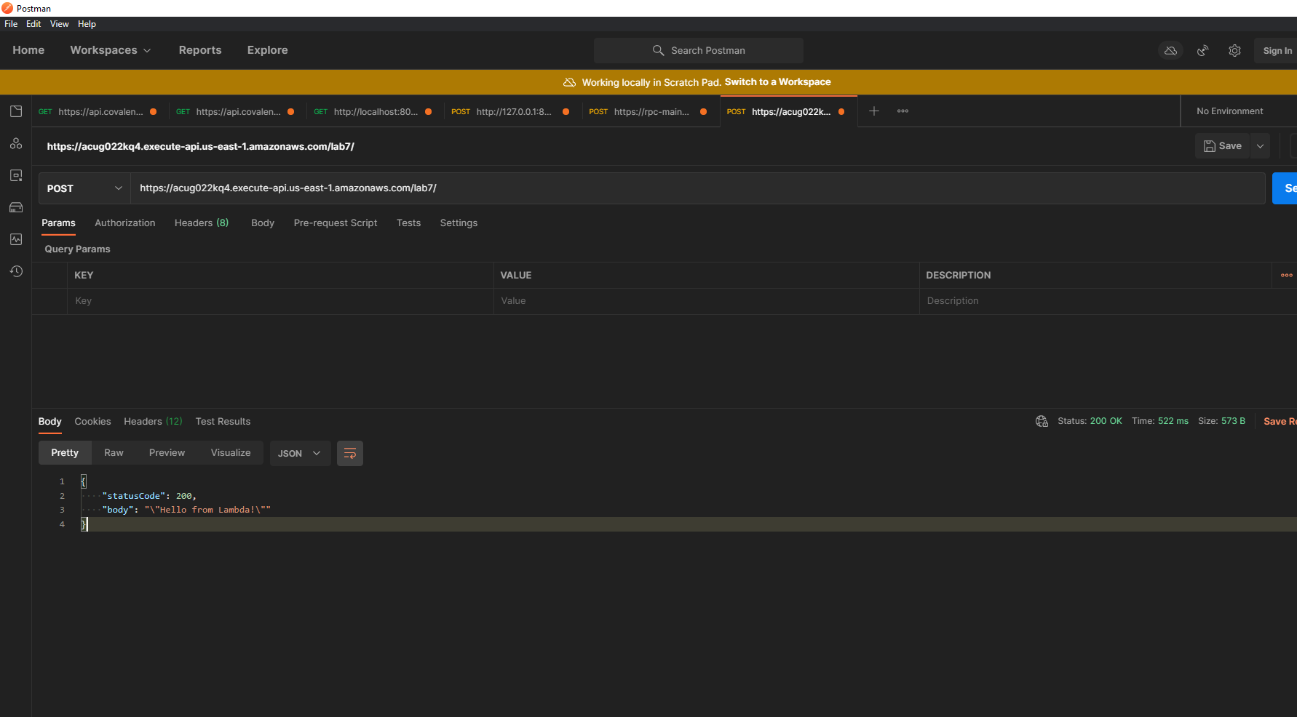

Task 4 – Create DynamoDB

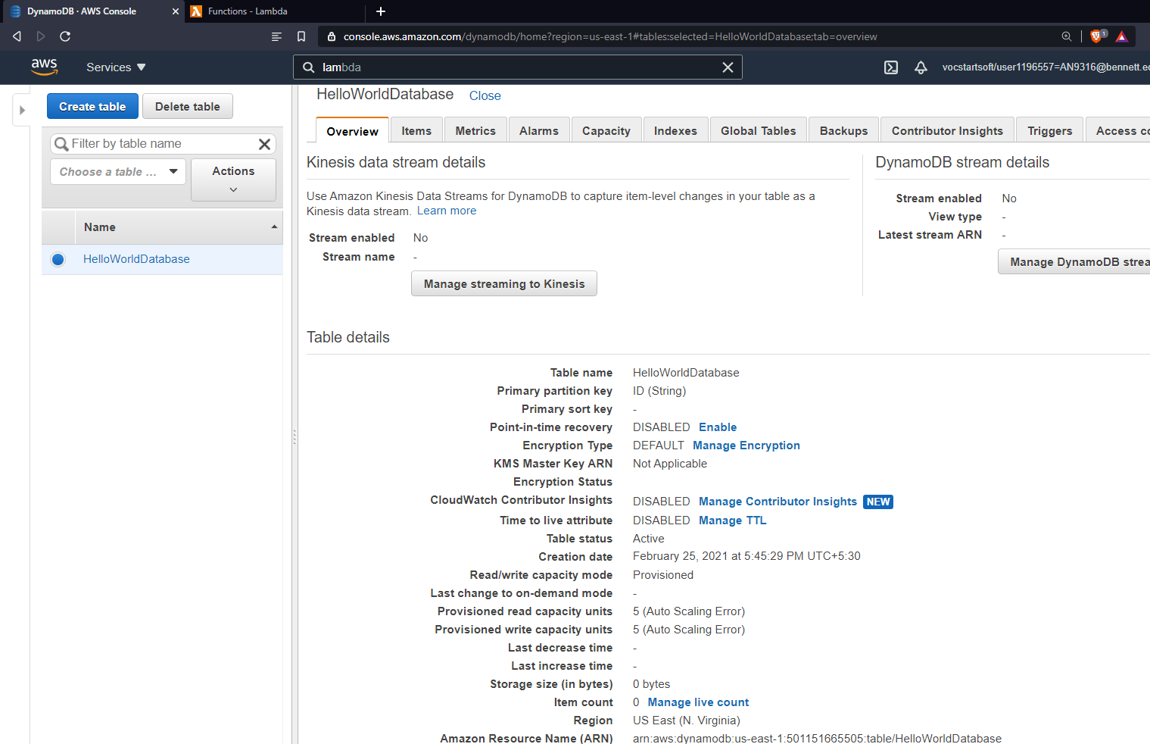

Task 5 – Update Lambda Permission and add policy.

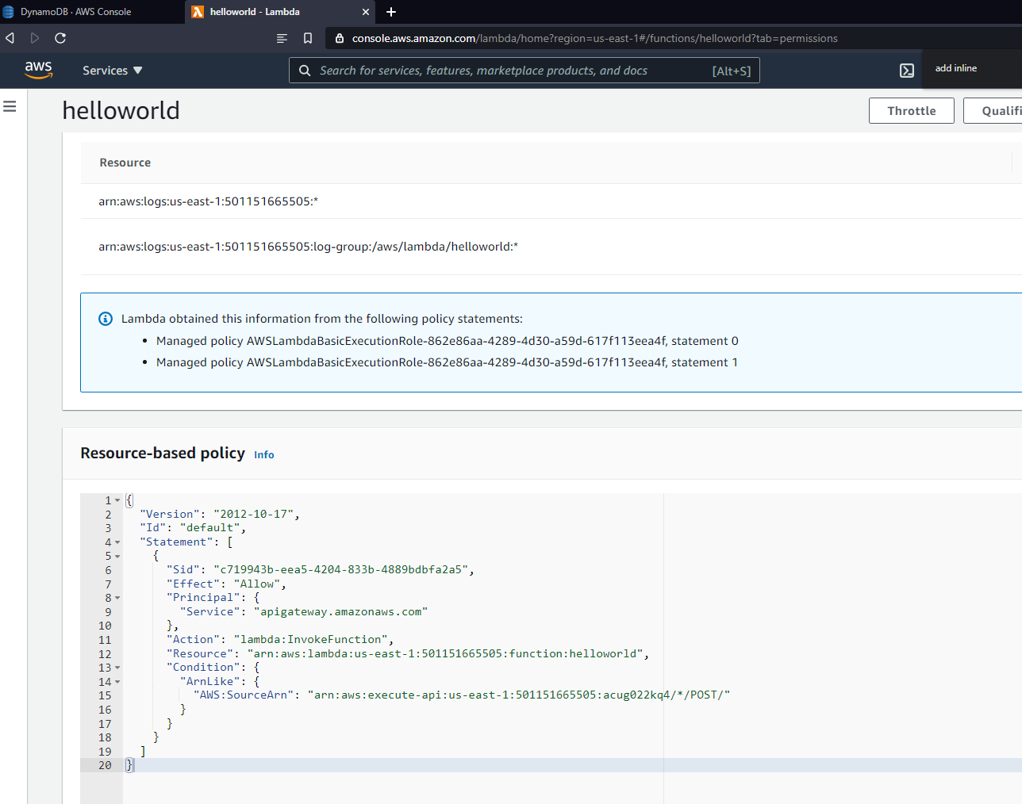

Task 6 – Save and Deploy new Lambda, Test Lamda.

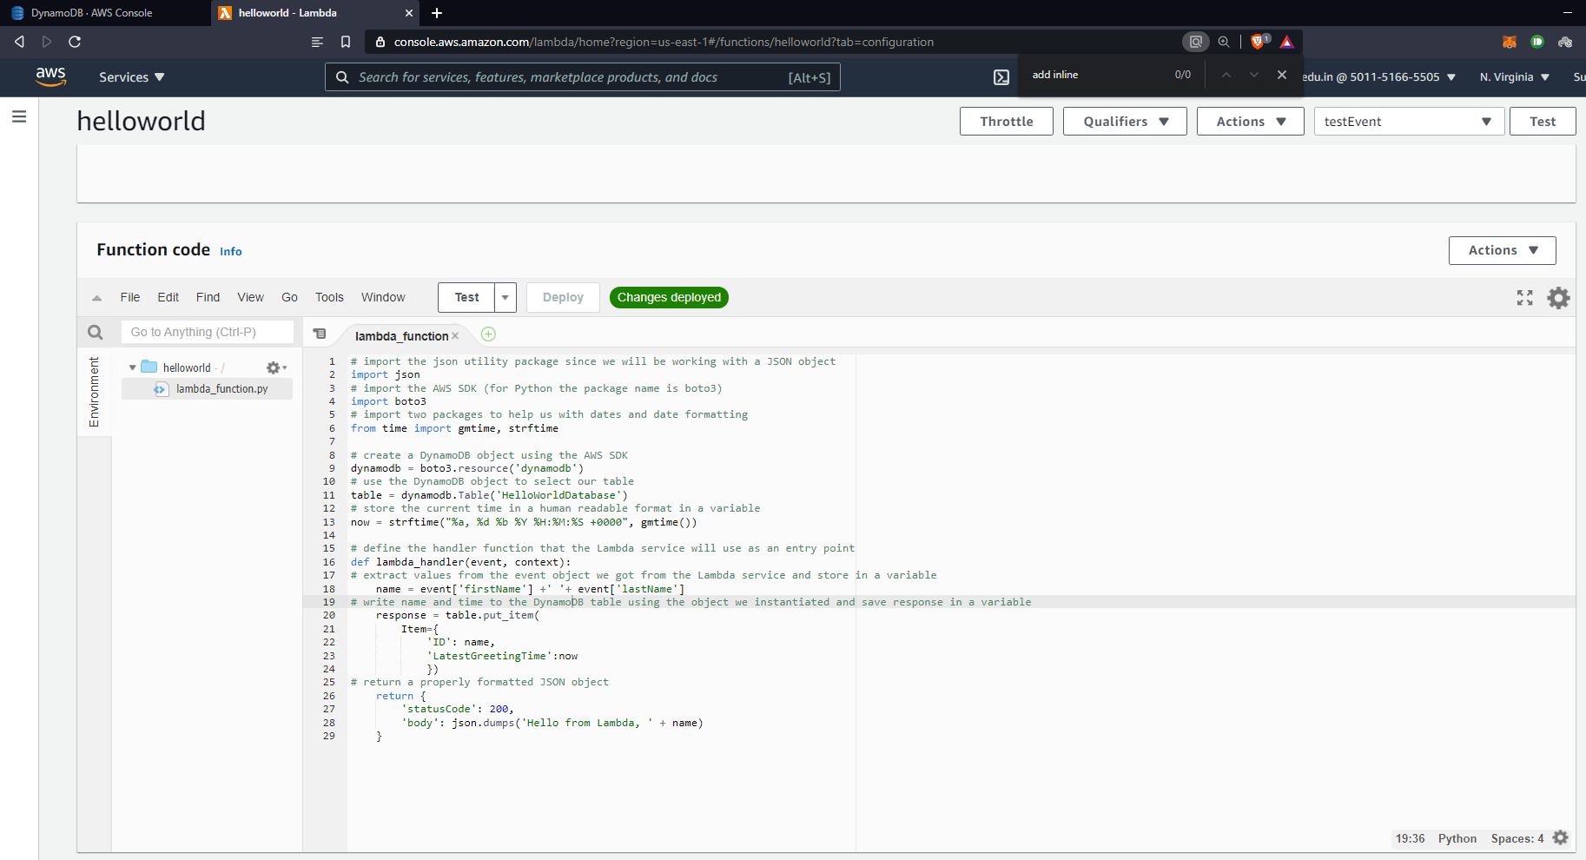

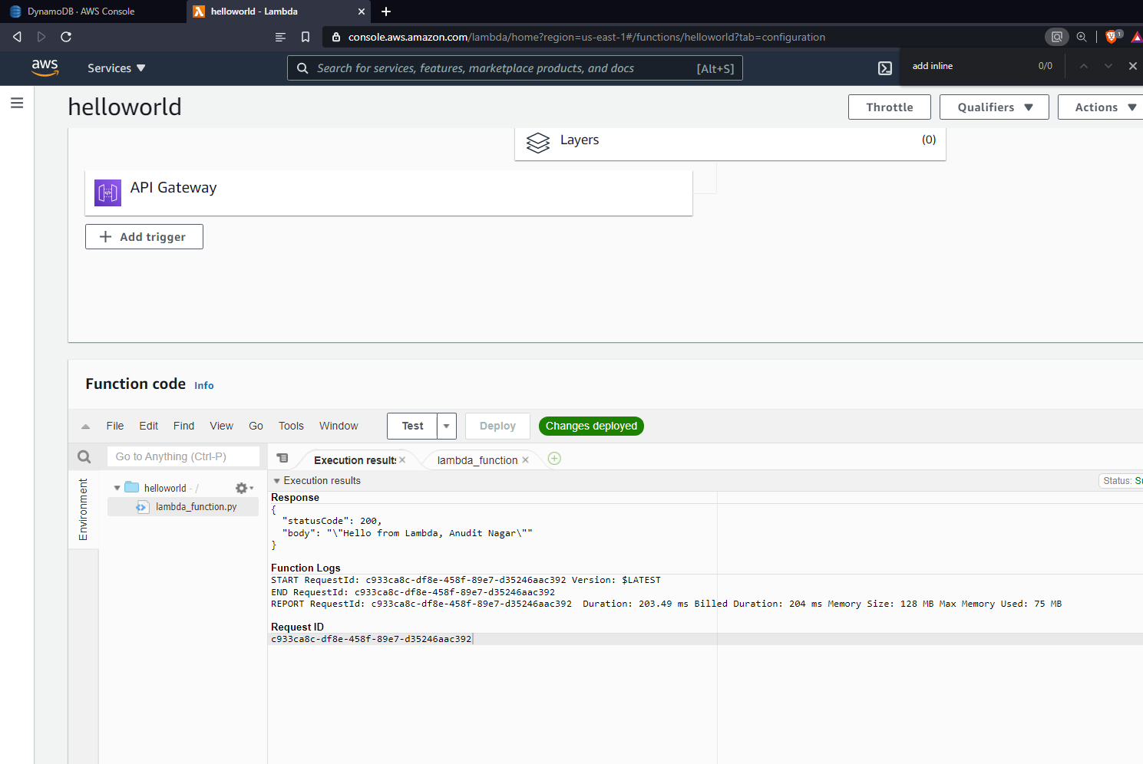

Task 7 – Add new html file to S3 and test.

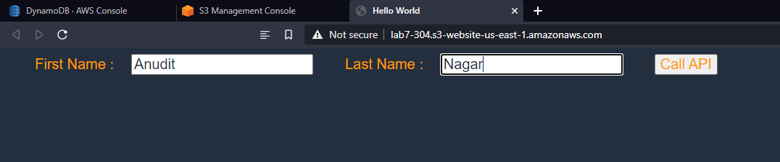

Task 8 – Check of value is in DynamoDB.

