**Cloud Computing – Lab 8**

**Anudit Nagar – E18CSE024**

Create Ec2 Instance

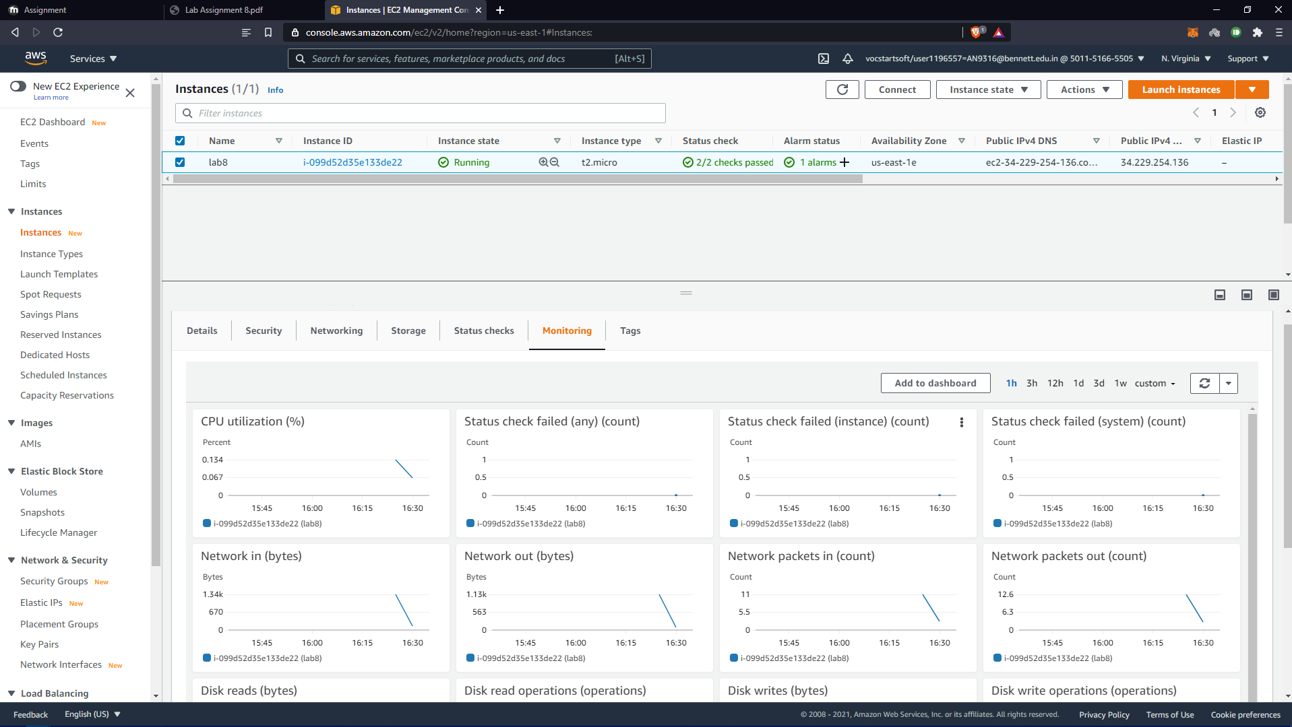

Create CloudWatch Alarm.

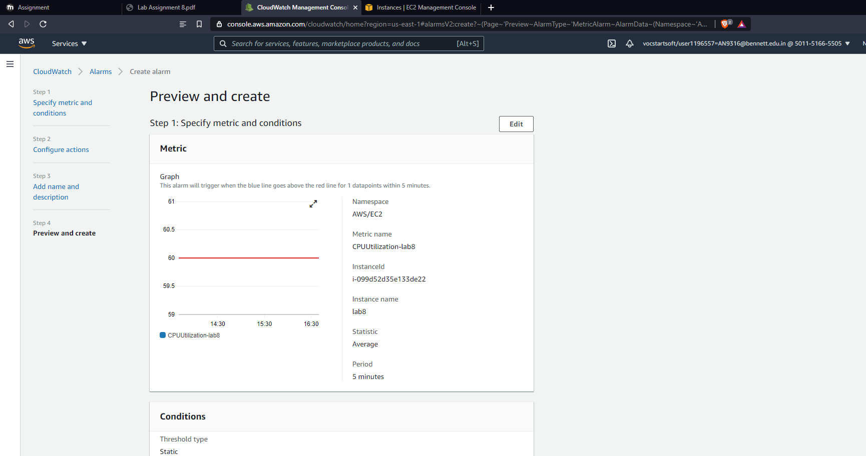

Start stress test.

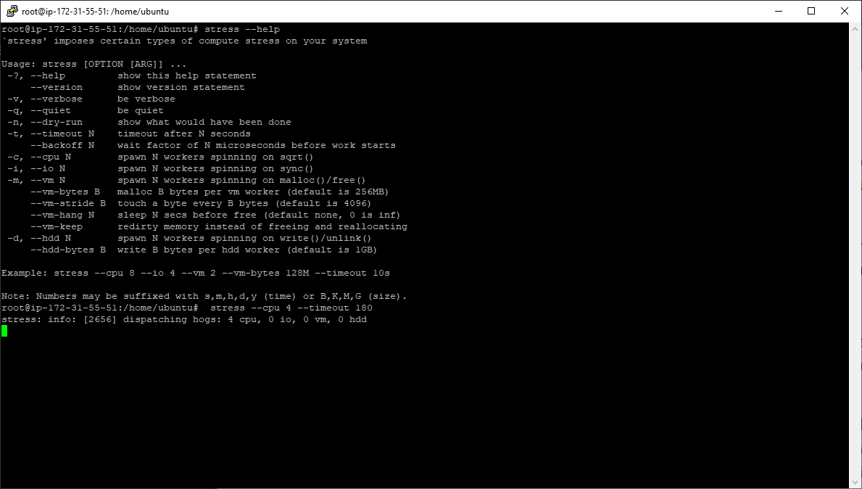

Increased Load on EC2 Instance.

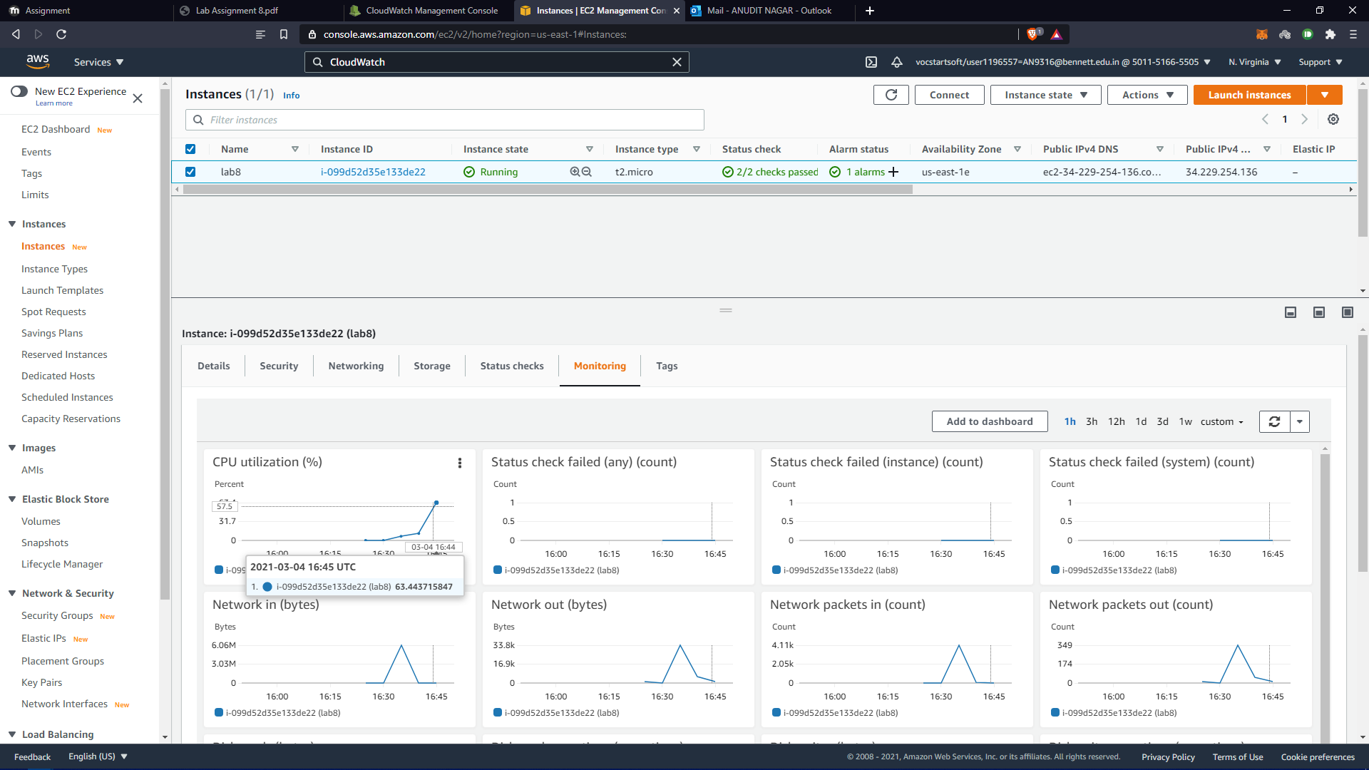

Alarm is Triggered.