**Cloud Computing – Lab 9**

**Anudit Nagar – E18CSE024**

Task 1 – Create CloudFormation Template

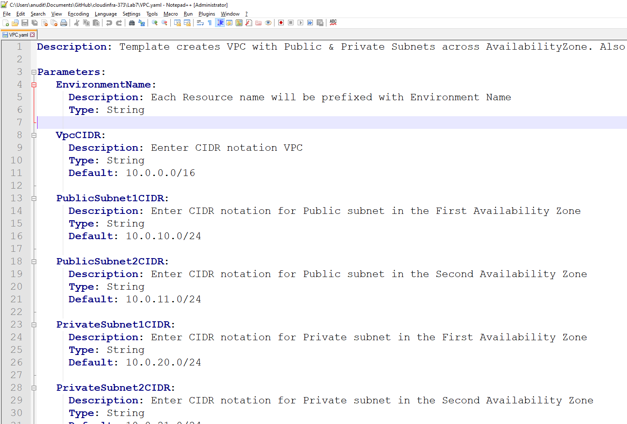

Task 2 – Create CloudFormation VPC

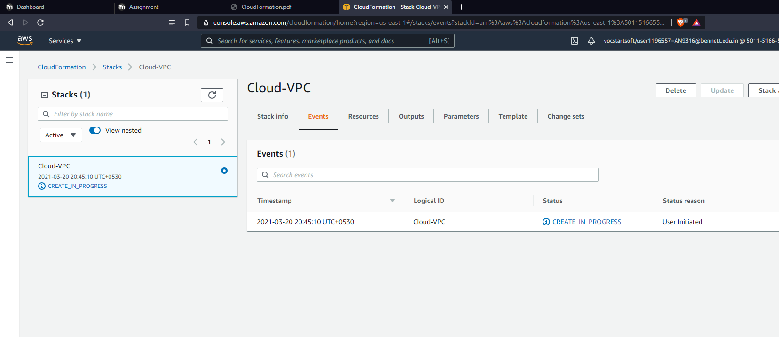

Check if all resources are created.

