Bus

In bus topology there is a main cable and all the devices are connected to this main cable through drop lines. There is a device called tap that connects the drop line to the main cable. Since all the data is transmitted over the main cable, there is a limit of drop lines and the distance a main cable can have.

Bus (Realtime)

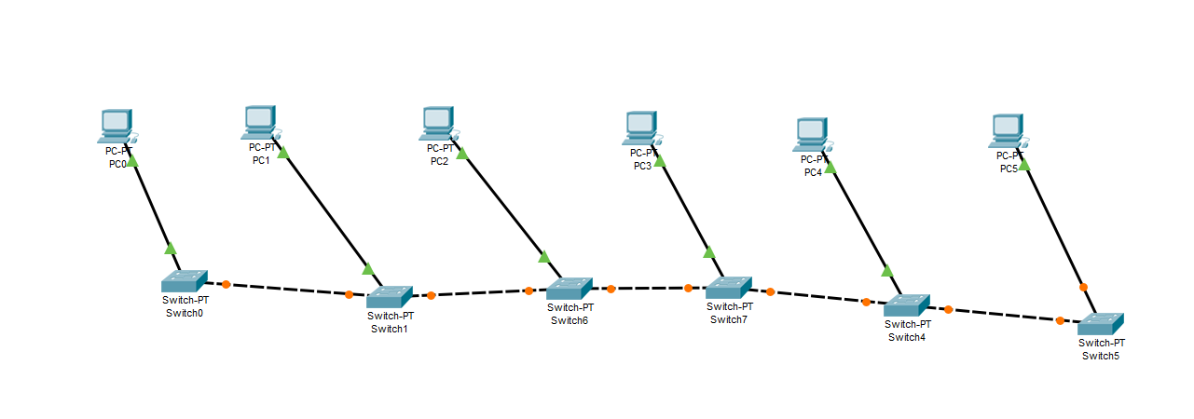

Bus (Simulation)

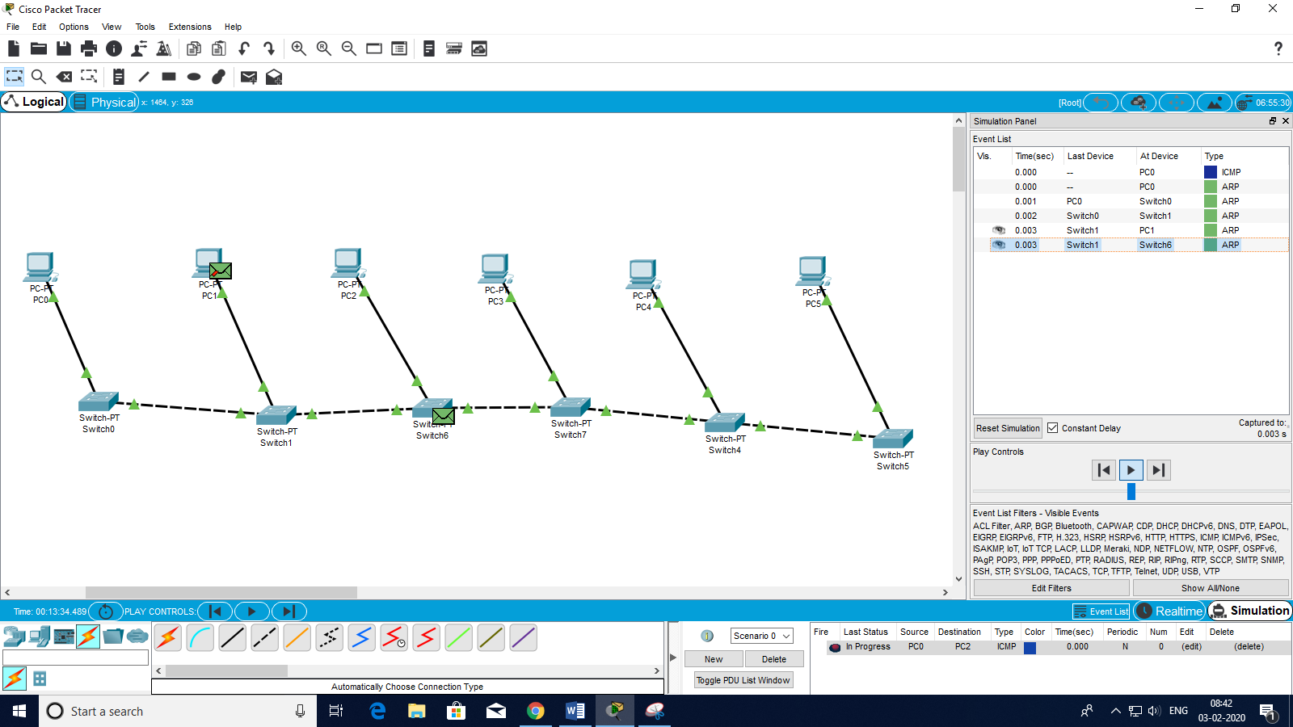

Bus (Ping)

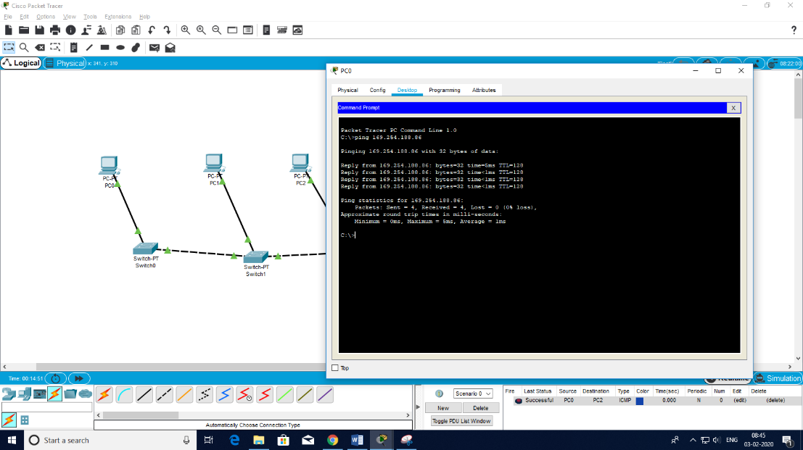

**Ring**

In ring topology each device is connected with the two devices on either side of it. There are two dedicated point to point links a device has with the devices on the either side of it. This structure forms a ring thus it is known as ring topology. If a device wants to send data to another device then it sends the data in one direction, each device in ring topology has a repeater, if the received data is intended for other device then repeater forwards this data until the intended device receives it.

**Ring (Real Time)**

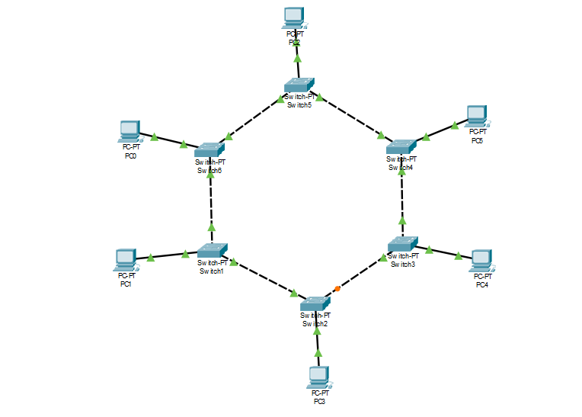

**Ring (Simulation)**

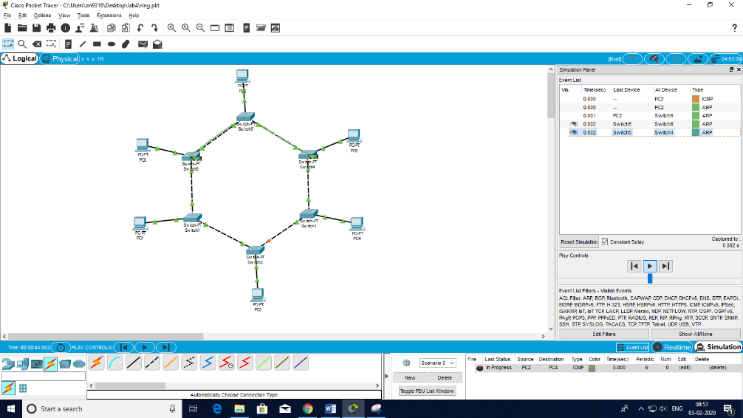

**Ring (Ping)**

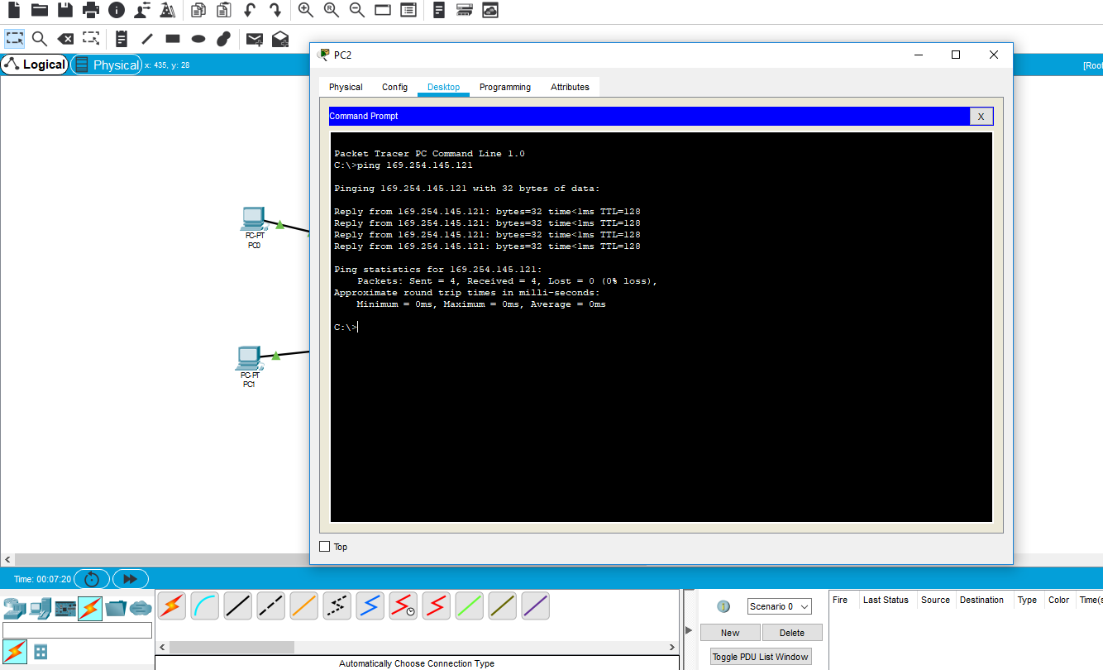

**Mesh**

In mesh topology each device is connected to every other device on the network through a dedicated point-to-point link. When we say dedicated it means that the link only carries data for the two connected devices only. Lets say we have n devices in the network then each device must be connected with (n-1) devices of the network. Number of links in a mesh topology of n devices would be n(n-1)/2.

**Mesh (Realtime)**

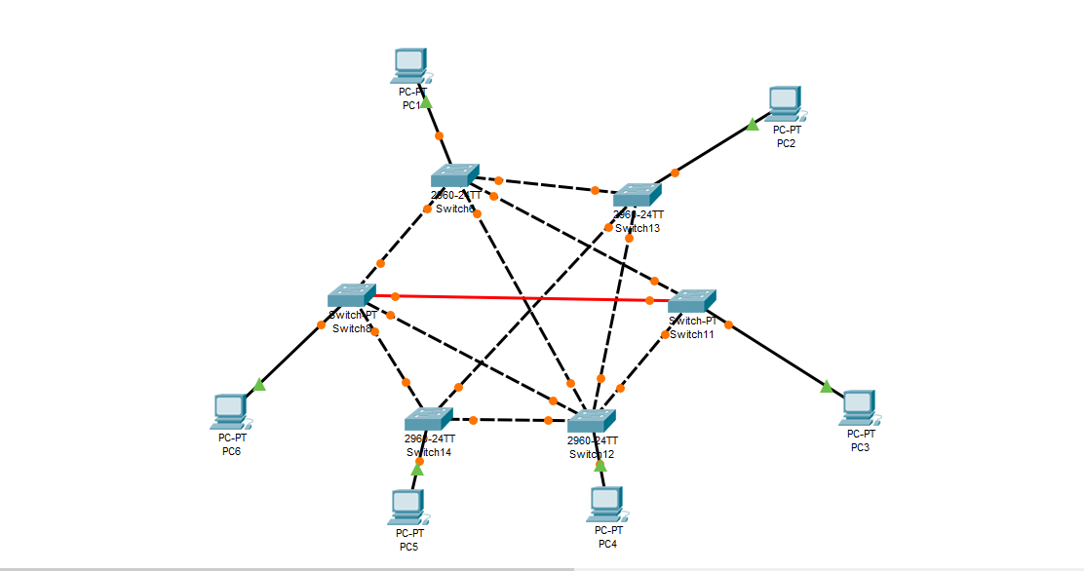

**Mesh (Simulation)**

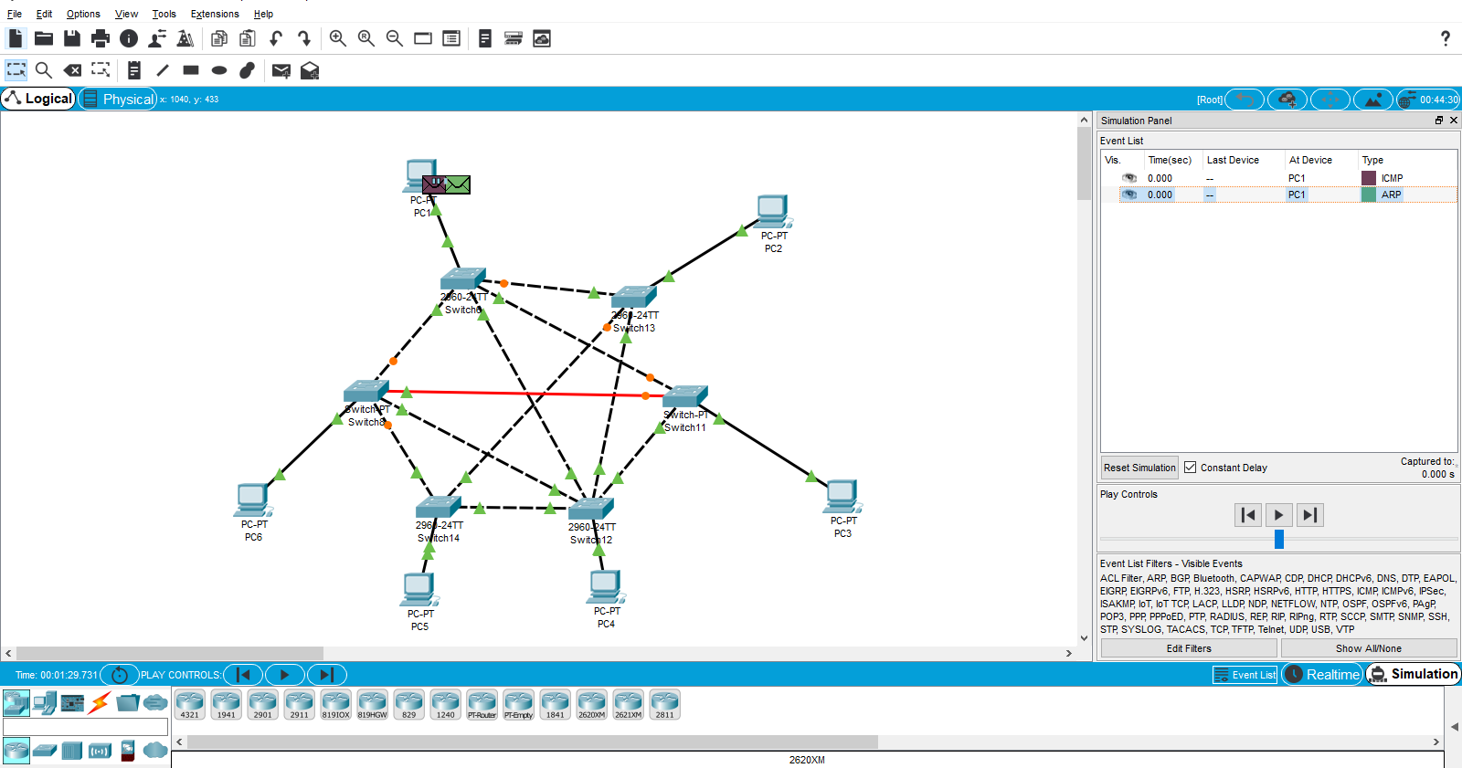

**Mesh (Ping)**



**Star**

In star topology each device in the network is connected to a central device called hub. Unlike Mesh topology, star topology doesn’t allow direct communication between devices, a device must have to communicate through hub. If one device wants to send data to other device, it has to first send the data to hub and then the hub transmit that data to the designated device.

**Star (Realtime)**

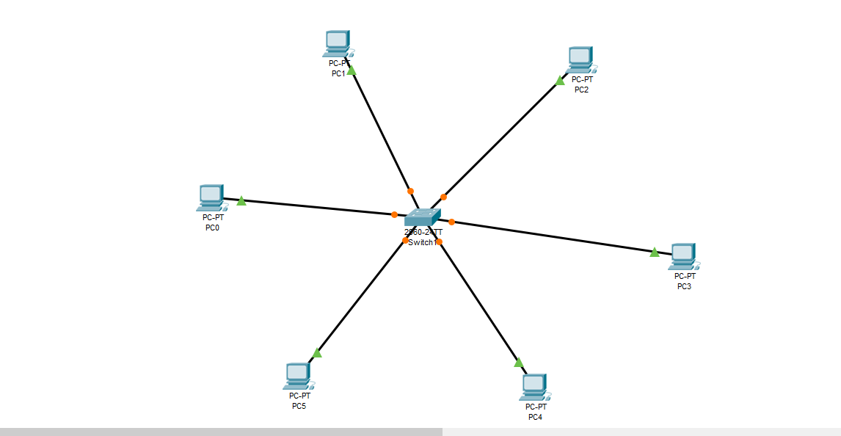

**Star (Simulation)**

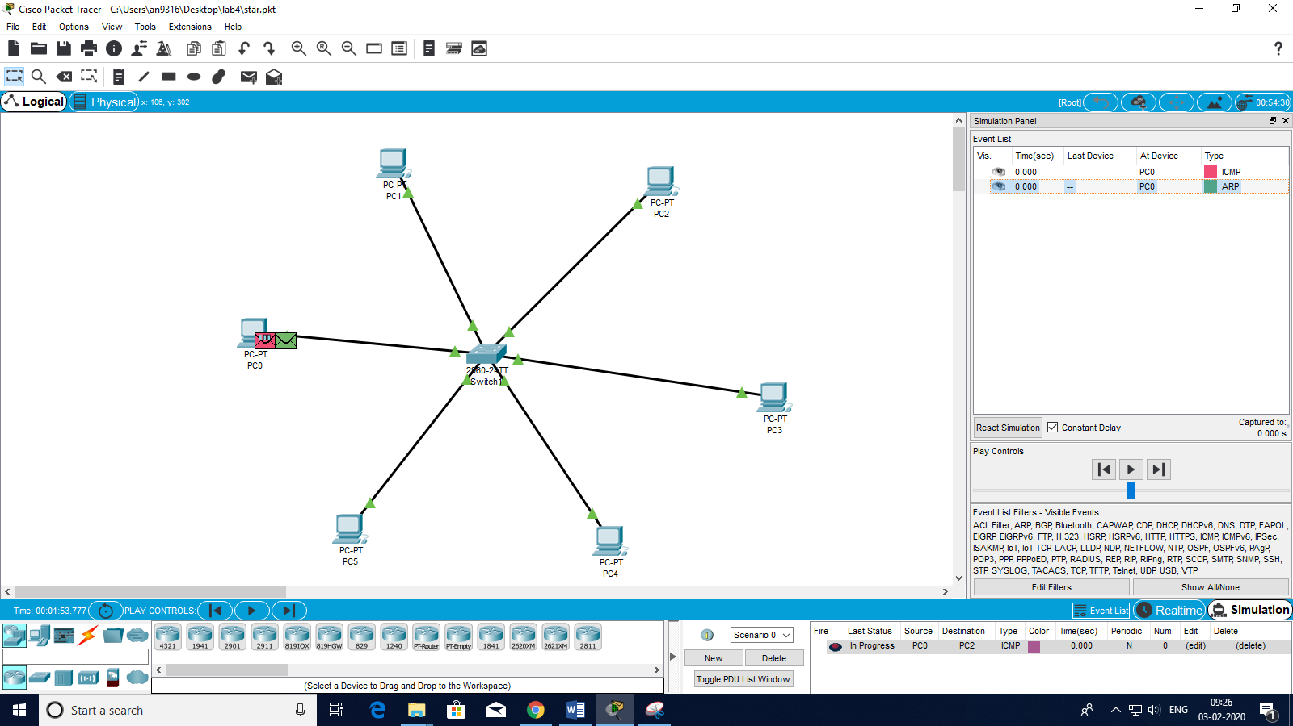

**Star (Ping)**



**Hybrid**

A combination of two or more topology is known as hybrid topology. For example a combination of star and mesh topology is known as hybrid topology.

**Hybrid (Realtime)** 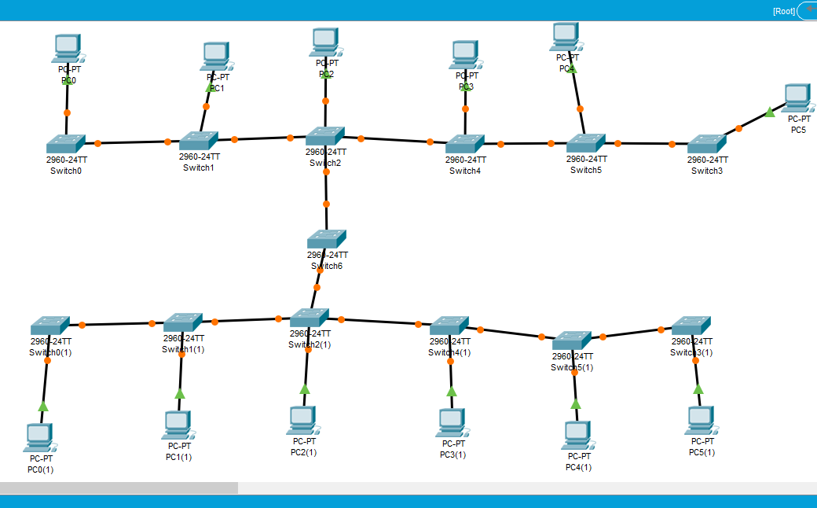

**Hybrid (Simulation)**

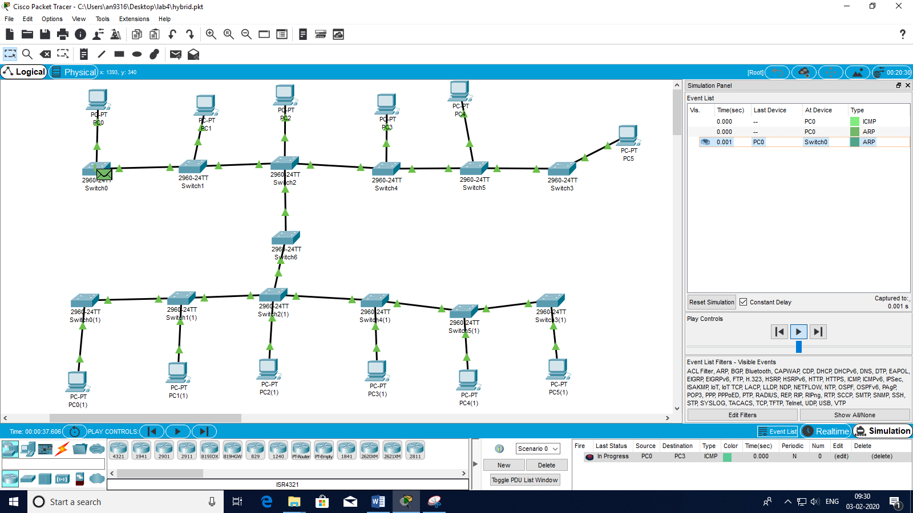

**Hybrid (Ping)**

