Lab 5

**Question 1**

This Network connects two star topologies showing communication across two different networks using a single router.

**Network Diagram / IP Scheme**

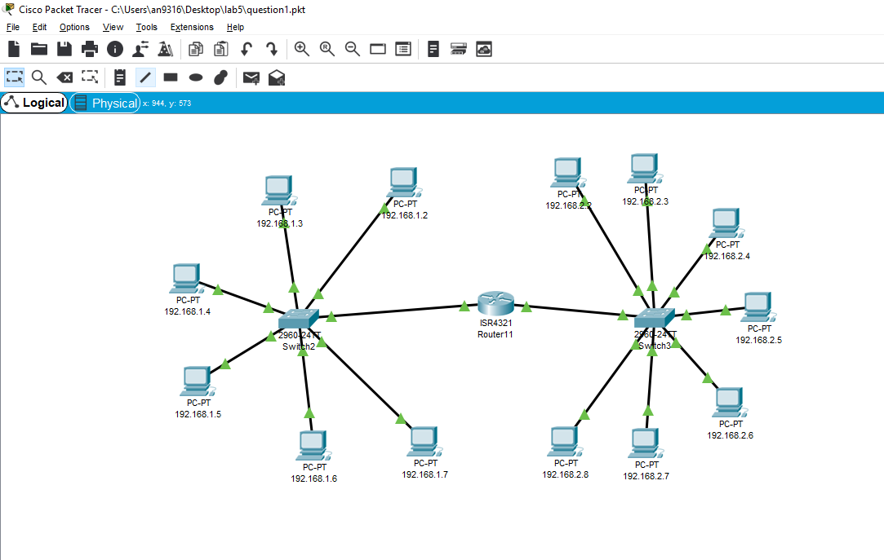

**Ping**

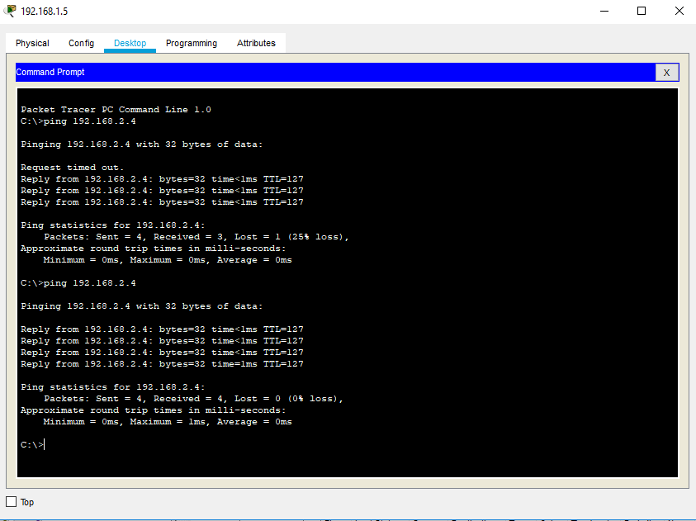

**Question 2**

This Network connects four star topologies showing communication across four different networks using two routers.

**Network Diagram / IP Scheme**

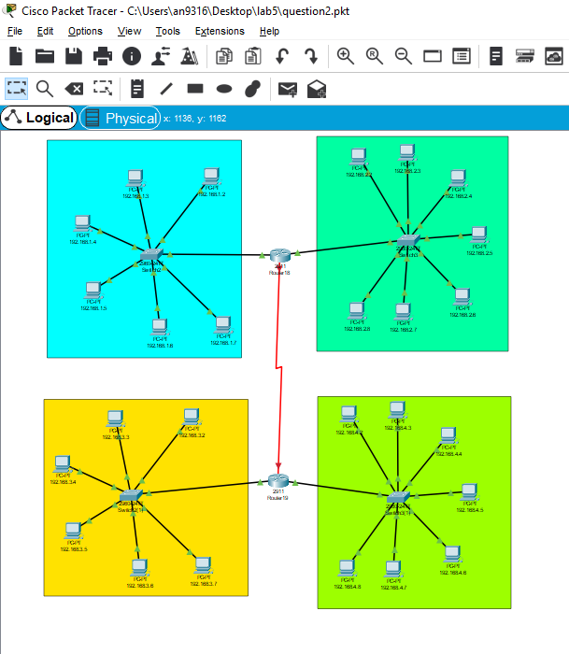

**Ping**

