- How does Zluri understand costs / spends? How is the data ingested? We use Netsuite as an ERP.

Zluri can ingest invoices and purchase orders directly from Netsuite. We can even filter for only certain GL codes that are relevant to software and IT, so that Zluri will not have any other finance information.

For contracts that are not in the system, Zluri has a support team who can upload the contracts for you. Or the DV team can upload the contract themselves, and Zluri’s contracts AI will parse and map the contract data.

- How secure is the contract information? Can I upload the contract data myself?

Zluri's security includes industry leading PII privacy measures, data security, rigorous audits & air-tight access control for all stakeholders - https://trust.zluri.com/

As an option, Zluri can provide secure data vaults for storing contract information and any PII you’d like to store on Zluri.

Zluri also has RBAC based access control, so even within the DV team, only the stakeholders with the right roles can access the contract data on the platform.
Yes, you can upload the data yourself, with the help of Zluri’s parsing AI.

- Are you able to provide visibility into plugins / applications used inside another application - Example: A JIRA being used inside Slack.

Where the application supports this via APIs - Zluri is able to identify ‘apps of apps‘ and bots used within another application. Ex: Slack (Zluri typically discovers Slack bots), Jira.
However, plugins might not be discovered. Example: Phishing alarm for Gmail may not be discovered.
If you have specific apps and plugins you’d like discovered, please let us know.

- How do you handle archiving? Do you include archived employees (accounts in the archive licence) in your optimisation results?

Archived licences are captured by Zluri. However, we can configure / filter on Zluri to not include suspended or archived users in optimisation results.

Zluri can also automate offboarding for DV - move a leaving user to an archive licence, transfer their Google drive contents to their reporting manager or Google Workspace Owner etc.,.
And after 30 - 60 days (or however long DV would like to retain the user account), Zluri can automatically go and revoke the archive licences and archive the users etc., This is 100% customisable according to your specific requirements and offboarding processes.

- Where does the data in the security tab come from?

Events - Publicly available recent events associated with the app’s risk or threat levels and all relevant information.
Data Shared - Permissions & scopes shared with other applications. Example: 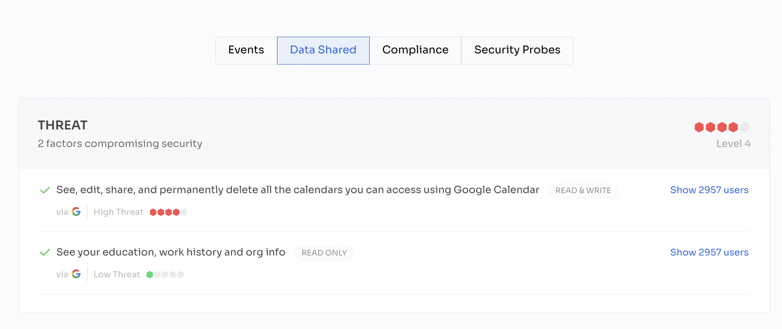
Compliance - Shows which security & compliance standards associated with the app. Ex: GDPR
Security Probes - This is the final security rating assigned to the app on a score of 100. The assessment for the same is done based on several security factors. To view the detailed information on the same or to rescan the security assessment for a newer score, click on the Security Probes tab

- How are Security scores calculated on Zluri? How is an app marked high/low/medium risk?
The risk level is marked by the security score; Lower the security score, higher the risk level. You can manually change the setting from high to low and so on.

Security scores are assigned based on the security probe score & compliance score.
Then multipliers are added to it based on the threat score (obtained from data shared), the impact of the event (with a cool-off period) & the number of users using the application. Security score is a score between 0 to 100

Detailed mechanism in this help article

- If the DV team wants to keep Access Request within the existing system but would want to enhance it by providing licence information and per licence cost/ overall department cost for the application, will that be possible, especially the data that already resides in Zluri?

Currently, we do have APIs exposed from Zluri for different use cases (Detailed API documentation can be found here) but as of now, the licences and cost APIs are not exposed. Based on the requirements confirmed by the DV team, Zluri can go ahead and expose those APIs for the same.

- Is there a prediction? Or some kind of way to predict your licences, we predict your need, or like here's what you're going to do before doing budget assessments for each year. Like, I want to predict in advance what would be the amount of users that I will need, or how much it will cost me.
Zluri does have a forecast option under contracts → optimization.
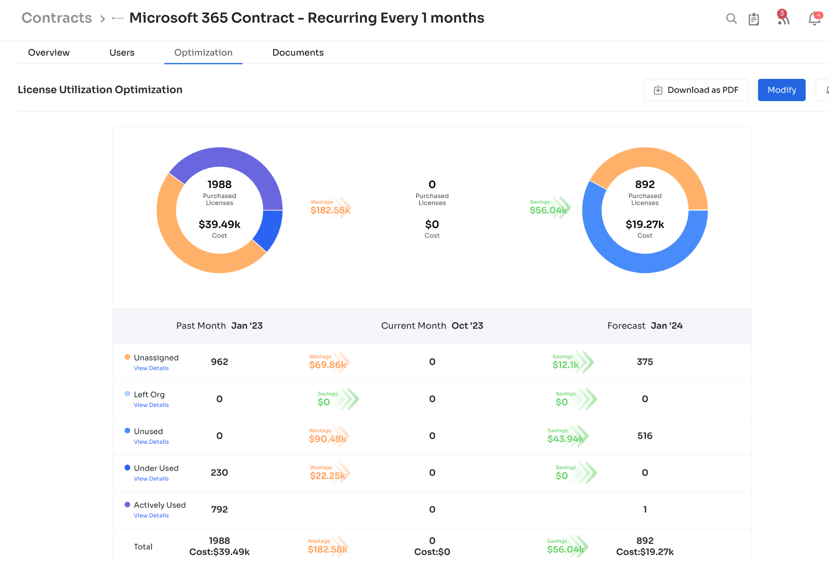

Where Zluri predicts the number of licences required for a particular time period based on previous usage.
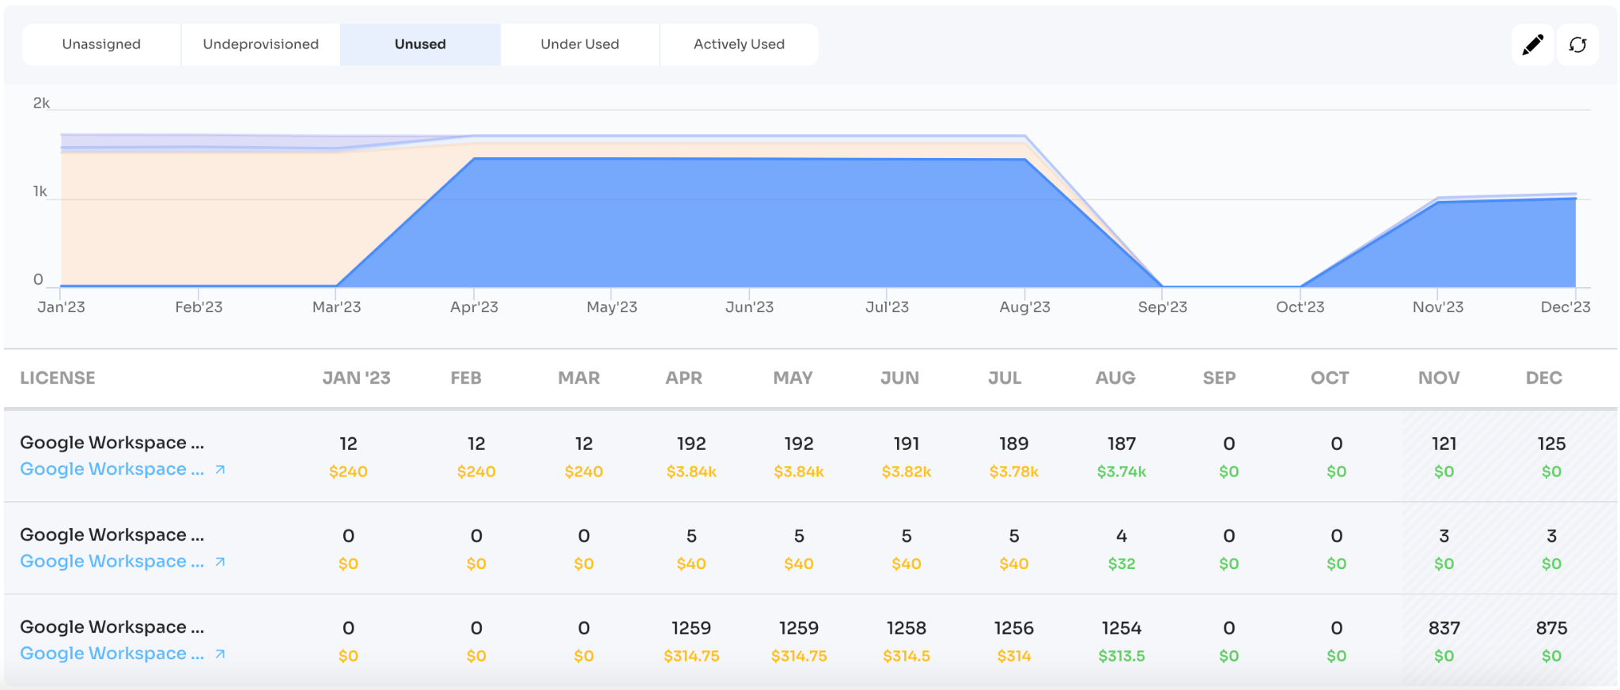
These modules could give you an estimate of how many licences you’d need and hence an estimate of how much you can expect to spend.

Austin demonstrated on the call that Zluri can also show you predicted spend for the following months for each application.
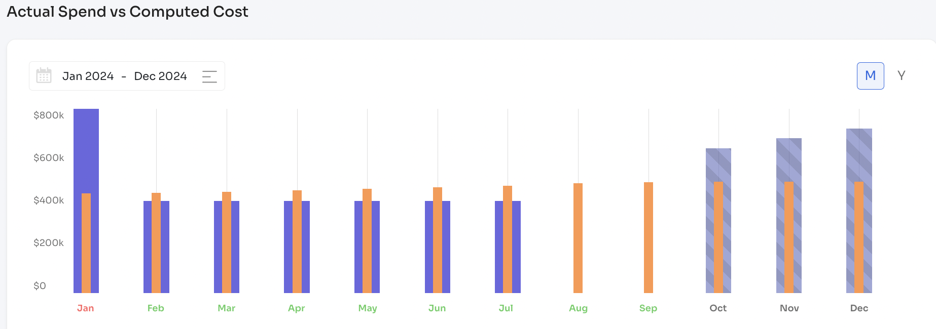

- Do you have playbooks that come built in as soon as you do an integration or you have to build them from scratch? Like I noticed, if you go to the application view, there is an automation tab. I don't know if you get a few out of the box.
As soon as you add an application to a playbook, Zluri automatically adds a template - list of actions you can do with that application. Additionally, Zluri also shows a list of all actions available for that application on the left hand side as well. You have the flexibility to modify the template or add actions from the left hand side panel, add manual tasks / approvals.

Note: Zluri has one of the best onboarding / customer success teams in the industry. We help you set up your offboarding playbooks and test them before publishing them.
