Course: MAI511-1 - Advanced Database Technologies
LAB Exercise – III Data Retrieval using JOINS, Subqueries and Correlated queries
ANUGRAHAA V 2648506

QUESTION 1 - JOINS
INNER JOIN
Objective: Display users along with their subscription details.
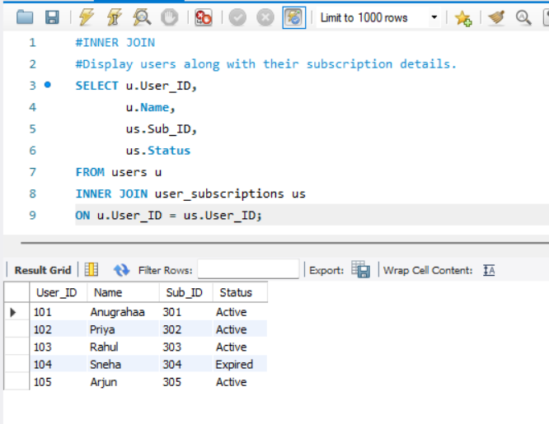
LEFT JOIN
Justification
Displays all users even if they don't have a subscription.
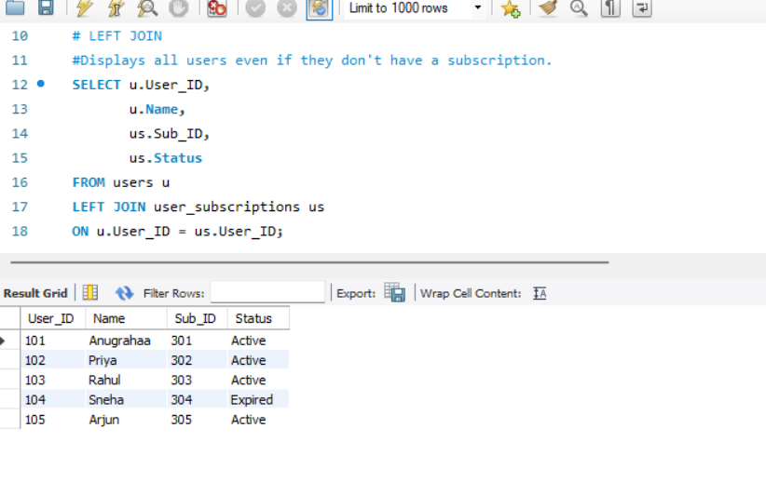

RIGHT JOIN
Displays all subscriptions even if a matching user doesn't exist.
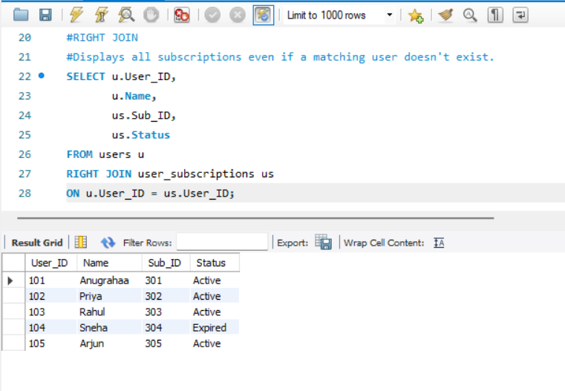
FULL OUTER JOIN
Displays all users and all subscriptions, whether matching or not.
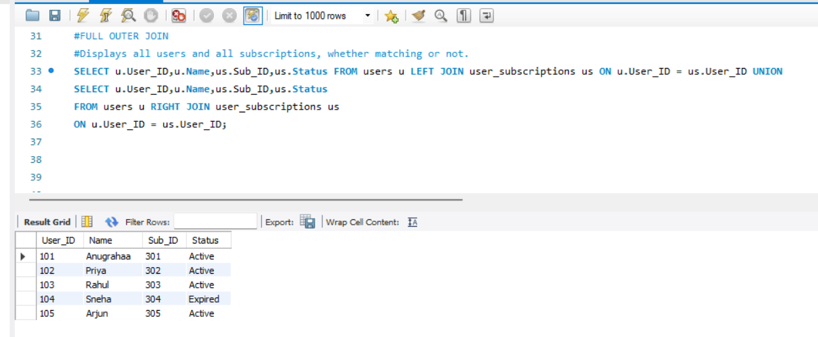

JOIN | Difference
INNER JOIN | Returns only matching records from both tables.
LEFT JOIN | Returns all rows from the left table and matching rows from the right table.
RIGHT JOIN | Returns all rows from the right table and matching rows from the left table.
FULL OUTER JOIN | Returns all rows from both tables. MySQL uses LEFT JOIN UNION RIGHT JOIN to achieve this.

QUESTION 2 – SUBQUERIES
Subquery 1
Users having the highest payment.
Justification
Finds the user who paid the maximum amount.
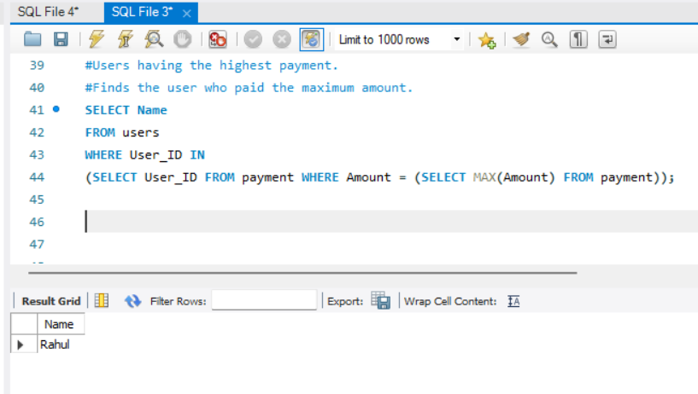
Subquery 2
Users subscribed to the Premium plan.
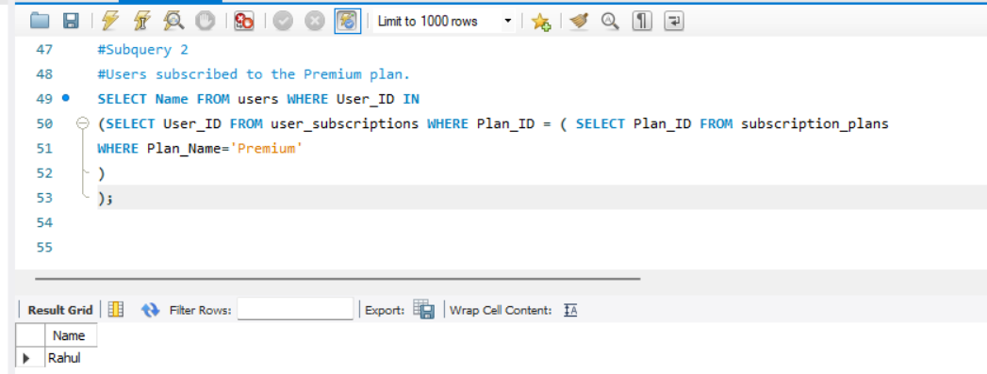

Subquery 3
Plans costing more than the average price.
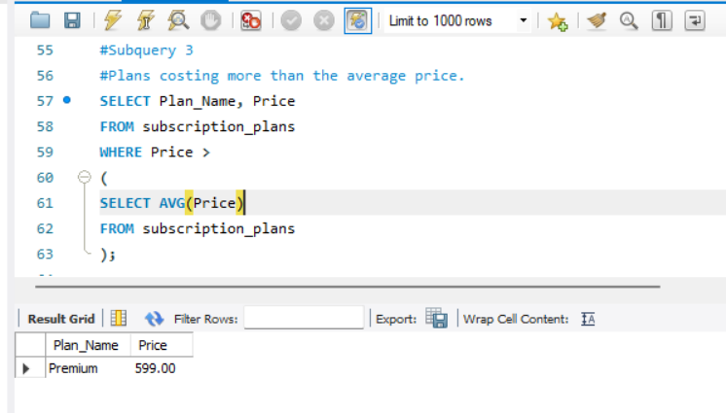
Subquery 4
Users who made a payment greater than ₹300.
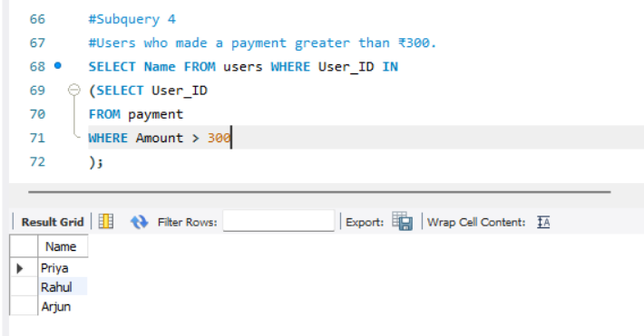
Subquery 5
Plans that are currently subscribed by users.
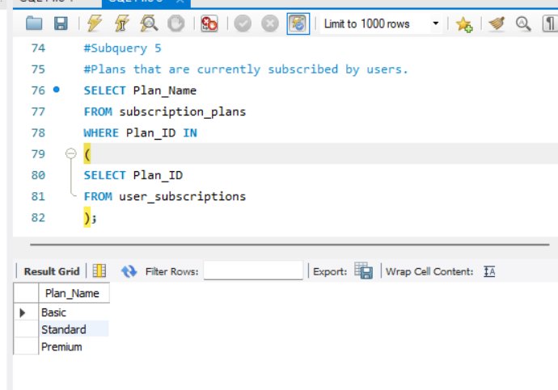

Compound SQL Query (Uses ALL Existing Tables)
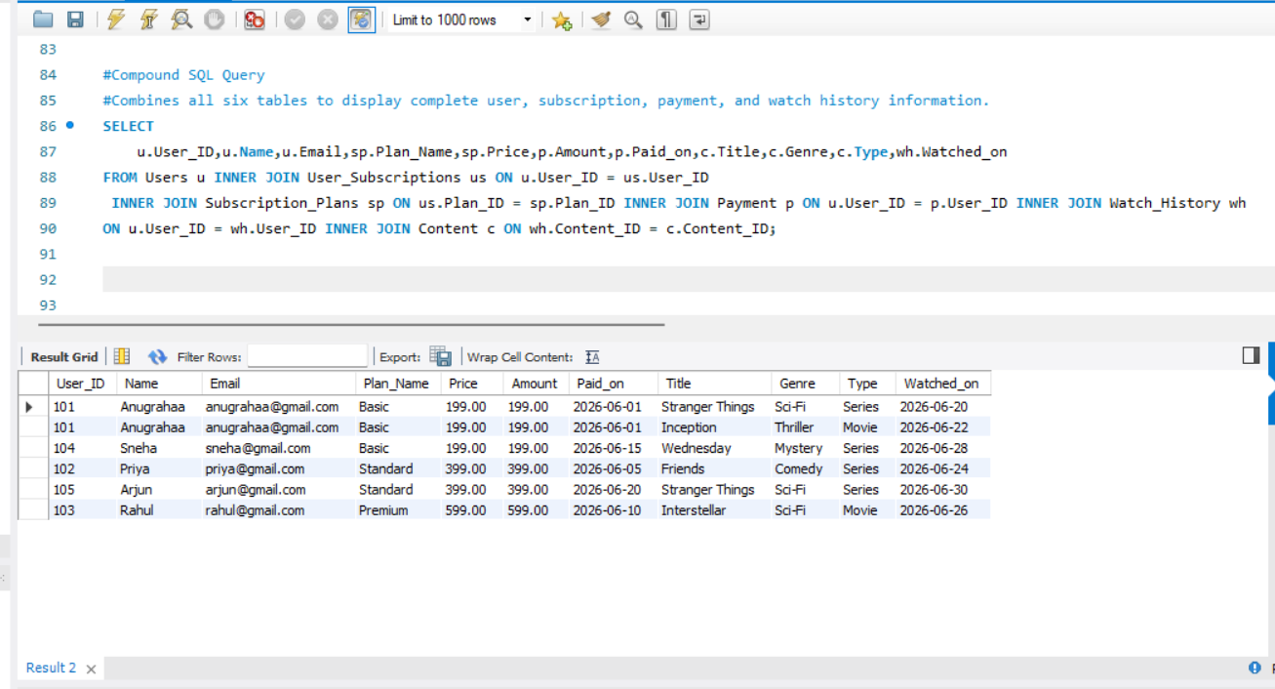

Justification:
This compound SQL query combines all the tables in the OTT Platform Management System. The Users table is joined with User_Subscriptions, Subscription_Plans, Payment, Watch_History, and Content using their foreign key relationships. The query retrieves complete information about each user, including subscription plan, payment details, and the content they have watched, in a single result set.

Correlated Query
Justification
Compares each payment against the average payment made by the same user.
