ADVANCE DATABASE MANAGEMENT SYSTEM
LAB 2 RELATIONAL MODEL DEMONSTRATION
Introduction
A Relational Database Management System (RDBMS) organizes data into related tables and maintains relationships using keys and constraints. In this experiment, an OTT Platform Management System database was developed using MySQL. The database consists of tables such as Users, Subscription_Plans, User_Subscriptions, Content, Watch_History, and Payments. Different constraints including Primary Key, Foreign Key, Unique, Not Null, Check, and Default were implemented to ensure data consistency and integrity. The experiment also demonstrates ALTER TABLE operations, constraint enforcement, referential integrity, DROP, and TRUNCATE commands.
Objective
The objective of this experiment is to understand the implementation of the relational model by creating database tables with appropriate constraints, enforcing those constraints, modifying table structures using ALTER TABLE, maintaining relationships between tables, and performing table management operations while preserving data integrity.
1. Create the necessary tables with constraints.
ER DIAGRAM
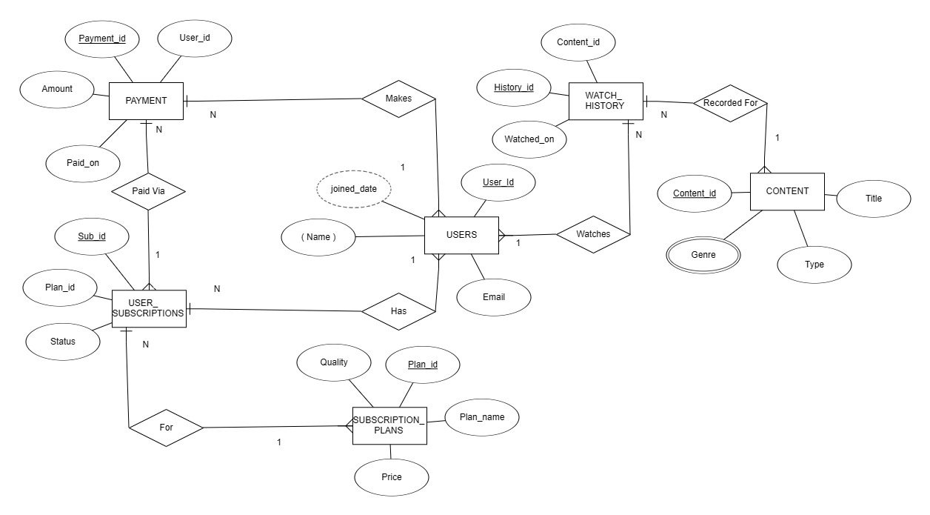
Explanation
The above ER diagram represents the OTT Platform Management System. It contains entities such as Users, Subscription_Plans, User_Subscriptions, Content, Watch_History, and Payments. The relationships between these entities are established using foreign keys, ensuring proper connectivity and referential integrity within the database.

DATABASE CREATION:
Explanation:
The OTT Platform Management System database was created successfully using the CREATE DATABASE command. After creating the database, the USE command was executed to select the database for further table creation.
Users Table
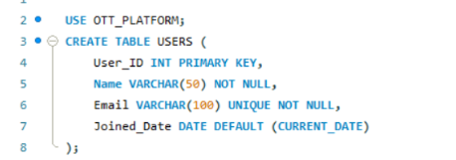
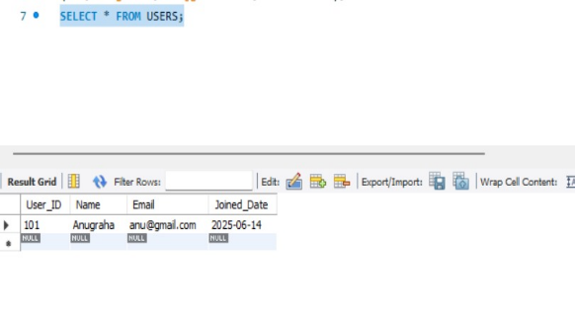
The USERS table stores the details of all users registered on the OTT platform. It contains information such as the user's unique ID, name, email address, and joining date. The User_ID is the Primary Key, which uniquely identifies each user. This table is connected to the USER_SUBSCRIPTIONS, PAYMENT, and WATCH_HISTORY tables, allowing the system to manage subscriptions, payments, and viewing history for every user.
Subscription_Plans Table
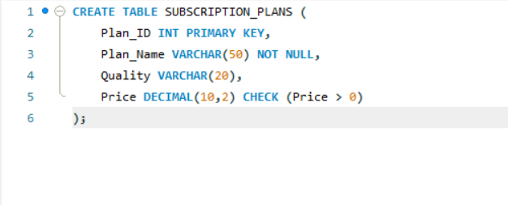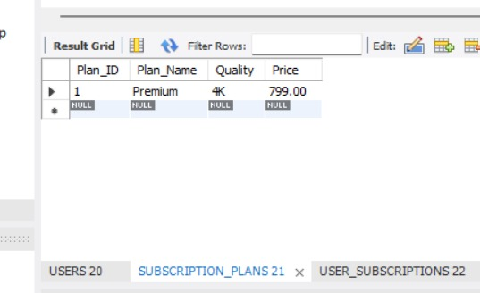

Explanation
The SUBSCRIPTION_PLANS table stores the different subscription plans available on the OTT platform. It contains details such as Plan_ID, Plan_Name, Price, and Quality. The Plan_ID is the Primary Key, which uniquely identifies each subscription plan. This table is linked to the USER_SUBSCRIPTIONS table to assign plans to users.
User_Subscriptions Table
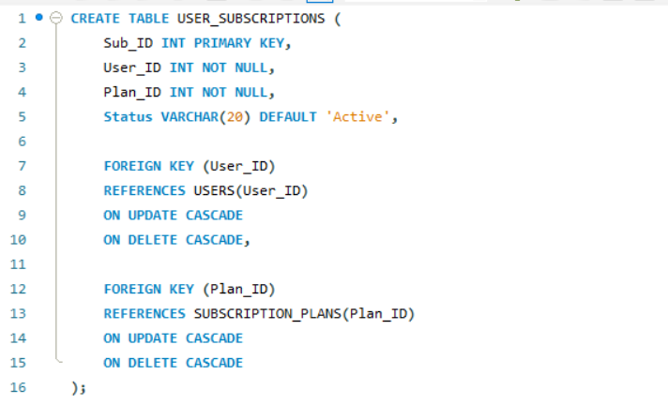
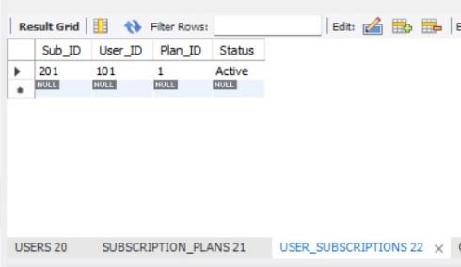
The USER_SUBSCRIPTIONS table stores the subscription details of users. It includes the Sub_ID as the Primary Key, along with the User_ID, Plan_ID, and Status of the subscription. The User_ID and Plan_ID are Foreign Keys that reference the USERS and SUBSCRIPTION_PLANS tables respectively. This table maintains the relationship between users and their subscribed plans.
Content Table
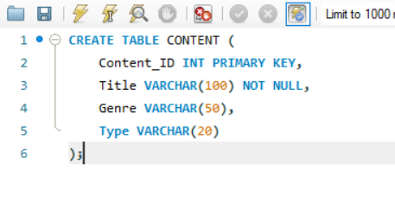
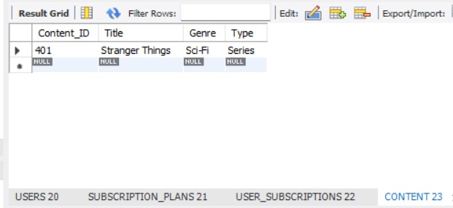
The CONTENT table stores the movies and web series available on the OTT platform. It contains details such as Content_ID, Title, Genre, and Type. The Content_ID is the Primary Key, which uniquely identifies each content item. This table is linked to the WATCH_HISTORY table to record the content watched by users.
Watch_History Table
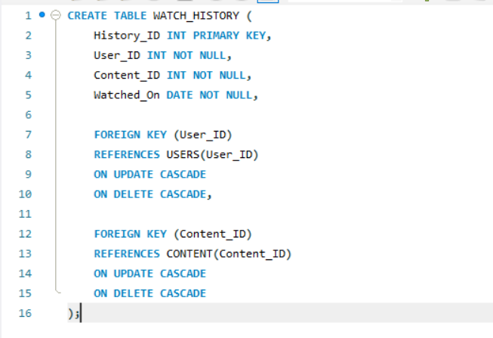
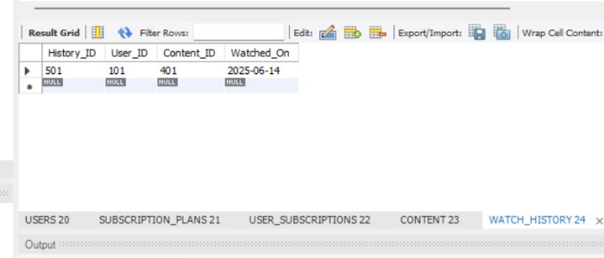
Explanation
The WATCH_HISTORY table stores the viewing history of users on the OTT platform. It contains History_ID, User_ID, Content_ID, and Watched_On. The History_ID is the Primary Key, while User_ID and Content_ID are Foreign Keys referencing the USERS and CONTENT tables. This table helps track which content has been watched by each user and on what date.
PAYMENT TABLE
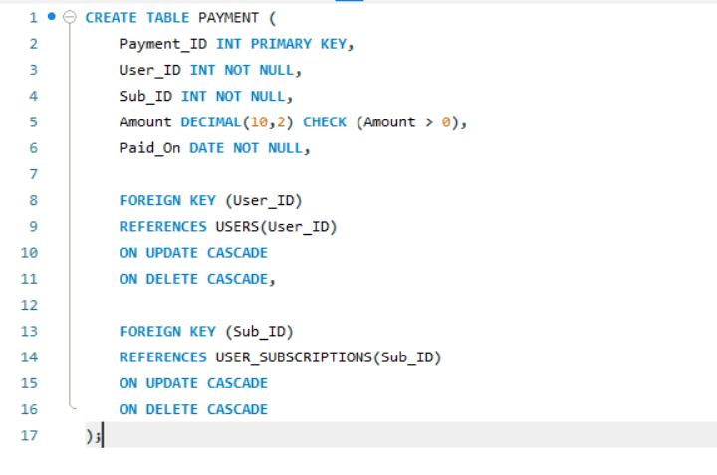

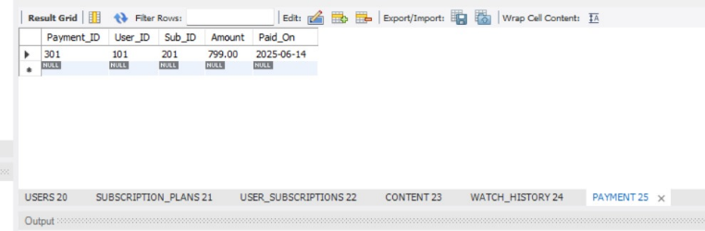
The PAYMENT table stores the payment details of users for their subscriptions. It contains Payment_ID, User_ID, Sub_ID, Amount, and Paid_On. The Payment_ID is the Primary Key, while User_ID and Sub_ID are Foreign Keys referencing the USERS and USER_SUBSCRIPTIONS tables. This table maintains the payment history of users and ensures that each payment is associated with a valid user and subscription.
2. Demonstration of Constraint Enforcement
Primary Key Constraint
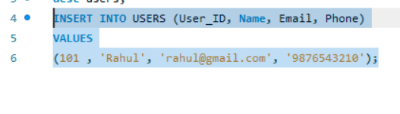
A duplicate value was inserted into the Primary Key column. Since Primary Keys must be unique, MySQL rejected the insertion and displayed an error message.
NOT NULL
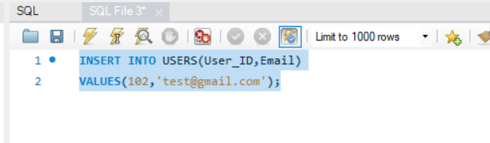
The NOT NULL constraint is demonstrated by attempting to insert a record without the mandatory Name field, causing MySQL to reject the insertion with the error "Field 'Name' doesn't have a default value.
UNIQUE CONSTRAINT
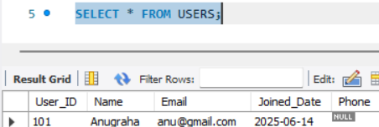
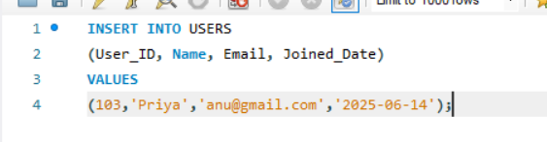
An attempt was made to insert two users with the same email address. Because the Email column is defined as UNIQUE, the second insertion failed.

CHECK CONSTRAINT
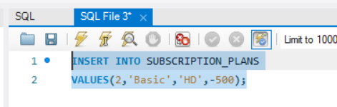
A negative subscription price was inserted into the Subscription_Plans table. The CHECK constraint rejected the value because the price must always be greater than zero.
FOREIGN KEY CONSTRAINT
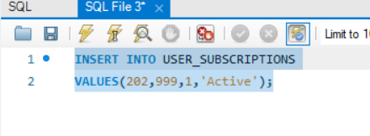
A subscription record was inserted using a User_ID that does not exist in the Users table. Since the User_ID is a Foreign Key, MySQL displayed an error and prevented the insertion.
DEFAULT CONSTRAINT
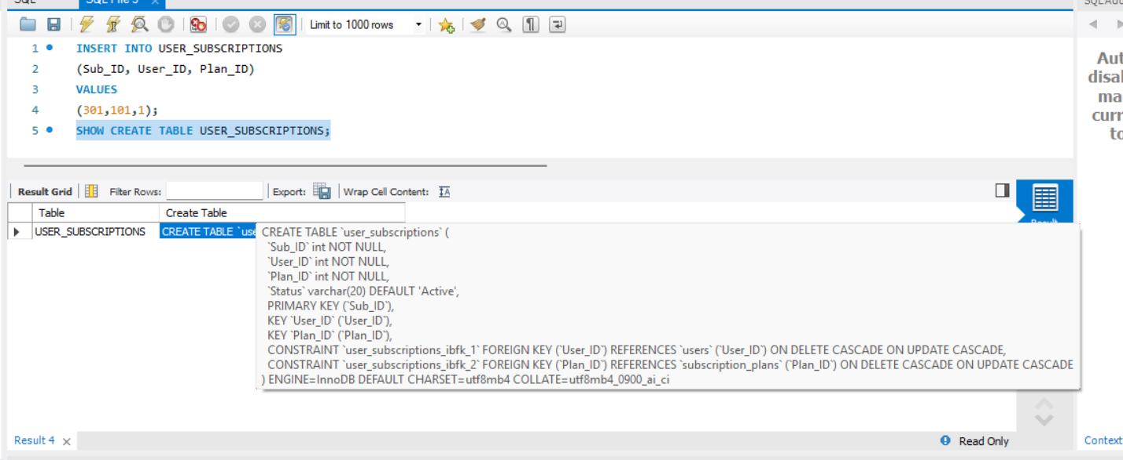
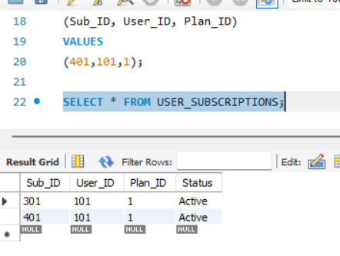
A record was inserted without specifying the Status column. The database automatically assigned the default value 'Active', demonstrating the working of the DEFAULT constraint.

3.Demonstrate the enforcement of constraints using the ALTER TABLE command.
ALTER TABLE
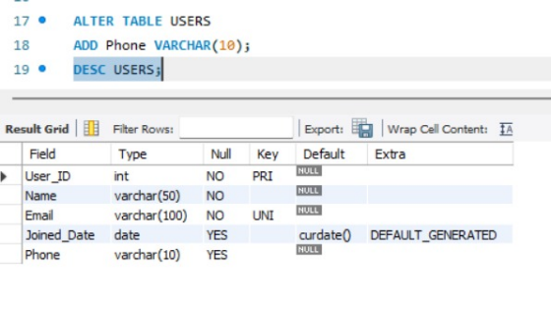
The ALTER TABLE command was used to modify the existing structure of the USERS table by adding a new Phone column. This demonstrates that the table structure can be changed without recreating the table or affecting the existing records.
4.List the constraints enforced on each table.
LISTING CONSTRAINTS
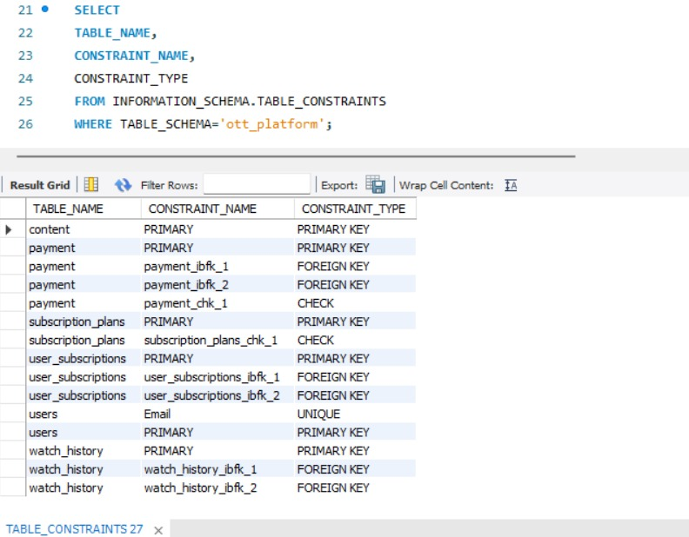
The SHOW CREATE TABLE command displays the complete structure of the table, including all constraints such as Primary Key, Foreign Key, Unique, Check, Default, and Not Null constraints. This verifies that the required constraints have been successfully implemented.
5. Demonstrate dropping of any one constraint of an object.
DROPING A CONSTRAINT
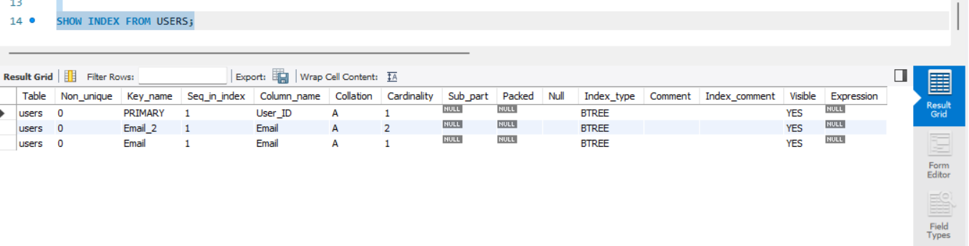
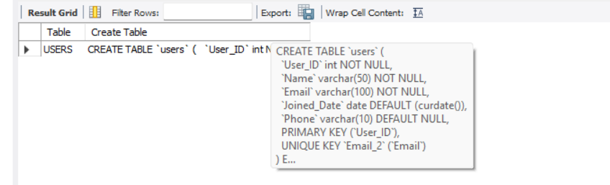
Dropping a constraint means removing a rule that was applied to a table or column. After the constraint is removed, the database no longer enforces that rule. In this project, the UNIQUE constraint on the Email column was removed, allowing duplicate email values to be stored.
6. Demonstrate how data integrity is maintained by propagating changes across parent and child tables present in the database.
DATA INTEGRITY MAINTENANCE
UPDATE CASCADE
The primary key value in the parent table was updated. Because the foreign key relationship uses ON UPDATE CASCADE, the corresponding value in the child table was automatically updated, maintaining referential integrity.
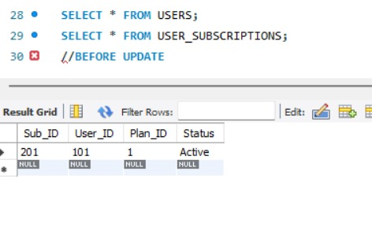
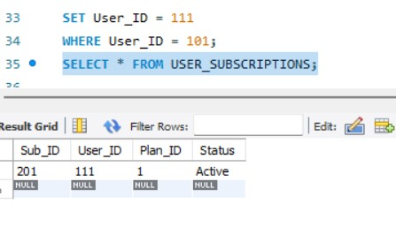
DELETE CASCADE
A record was deleted from the parent table. Since the foreign key uses ON DELETE CASCADE, the related records in the child table were automatically deleted, preventing orphan records.
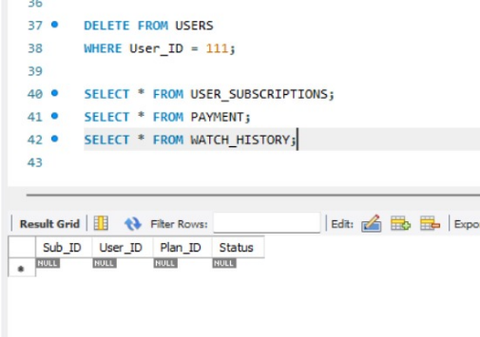
7. Demonstrate the Drop and Truncate Commands on the objects and display the
records.
TRUNCATE TABLE
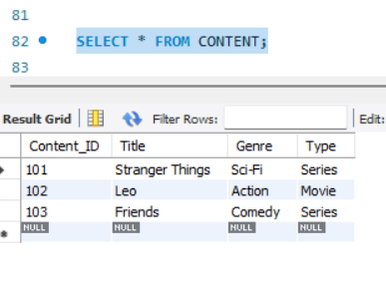
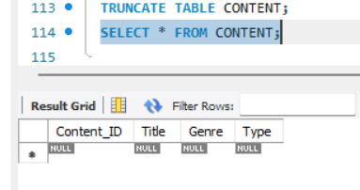
The TRUNCATE TABLE command removed all records from the selected table CONTENT while preserving the table structure. A subsequent SELECT statement confirmed that the table was empty.
DROP TABLE
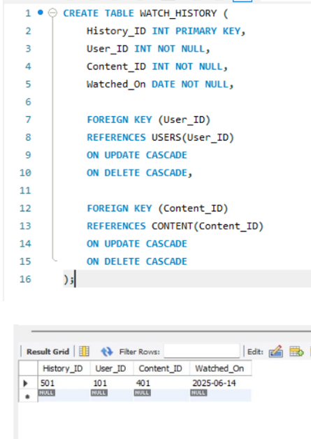

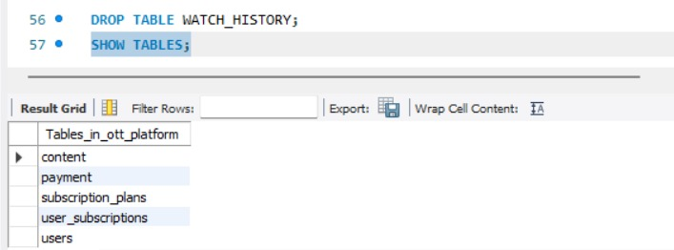
The DROP TABLE command permanently removed the selected table Which is watch history table along with all its records. The SHOW TABLES command confirmed that the table no longer existed in the database.
Conclusion
The Relational Model was successfully implemented for the OTT Platform Management System. Various constraints were applied to ensure data consistency and integrity. The enforcement of constraints, ALTER TABLE operations, referential integrity using cascading actions, and table management commands such as TRUNCATE and DROP were successfully demonstrated.

