Quantium Virtual Internship - Retail Strategy and Analytics - Task 2
1, Load required libraries and datasets
``` import pandas as pd
Import numpy as np
Import matplotlib.pyplot as plt
Import seaboarn as sns ```
``` filepath=r"C:\Users\anugr\Downloads\QVI_data.csv"
data=pd.read_csv(filepath)
data.head(10) ```

2, Set themes for plots

``` import matplotlib.pyplot as plt
import seaborn as sns
# Set a clean theme
sns.set_theme(style="whitegrid") # white background, grid lines
# Update default plot parameters
plt.rcParams.update({
"axes.titleweight": "bold", # make titles bold
"axes.titlelocation": "center", # center titles horizontally
"axes.titlesize": 14 # set title size
})
```
The client has chosen stores 77, 86, and 88 as trial stores
Find their performance during the trial period (Feb 2019 onward)
control stores is store except 77, 86, and 88 and pre-trial period is up to Jan 2019
Need to find the monthly metrics of every store in control store and compare the result with monthly metrics of trial store
you select control stores that are most similar to each trial store
Compare trial vs. matched control stores on the same monthly metrics.
monthly metrics:
- Monthly overall sales revenue
- Monthly number of customers
- Monthly transactions per customer

3,create a month_id column that represent month of each transaction

```
#covert date column to datatime datatype
data["DATE"]=pd.to_datetime(data["DATE"])
#create month column with the format yyyymm name it as yearmonth
data['yearmonth'] = data['DATE'].dt.strftime('%Y%m')
data['yearmonth']
```
Output:-
0 201810
1 201809
2 201903
3 201903
4 201811
...
264829 201812

4, For each store_nbr and month calculate total sales, number of customers, transactions per customer, chips per customer and the average price per unit
``` measure_over_time = (
data.groupby(['STORE_NBR', 'yearmonth'])
.agg(
totSales = ('TOT_SALES', 'sum'),
nCustomers = ('LYLTY_CARD_NBR', pd.Series.nunique),
nTransactions = ('TXN_ID', 'nunique'),
nUnits = ('PROD_QTY', 'sum')
).reset_index()#for coverting store nbr as column
)
```

Derived metrics
- num transactions per customer
measure_over_time['nTxnPerCust'] = (
measure_over_time['nTransactions'] / measure_over_time['nCustomers']
)
- num of chips per transaction
```
measure_over_time['nChipsPerTxn'] = (
measure_over_time['nUnits'] / measure_over_time['nTransactions']
) ```
- avg price per unit
```
measure_over_time['avgPricePerUnit'] = (
measure_over_time['totSales'] / measure_over_time['nUnits']
) ```
- Sort by store and month
```
measure_over_time = measure_over_time.sort_values(['STORE_NBR','yearmonth']) ```

5, filters the dataset to pre-Feb 2019 months and keeps only stores with all 12 months of pre-trial data
```
#yearmonth shows as string and comparison btw 'str' and 'int' so convert
measure_over_time["yearmonth"]=measure_over_time["yearmonth"].astype(int)

# Step 1: Count months per store
store_month_counts = measure_over_time.groupby('STORE_NBR')['yearmonth'].nunique()

# Step 2: Keep only stores with 12 months of data
stores_with_full_obs = store_month_counts[store_month_counts == 12].index

# Step 3: Filter to pre-trial period (up to Jan 2019) and valid stores
pre_trial_measures = measure_over_time[(measure_over_time['yearmonth'] < 201902) &
(measure_over_time['STORE_NBR'].isin(stores_with_full_obs))
] ```

6, to rank how similar each store is to a trial store
It finds out which stores look most similar to a chosen trial store by comparing their month-by-month numbers (like sales or customers). It uses correlation — a number between -1 and 1 that shows how closely two sets of values move together.
- Close to 1 → very similar patterns
- Close to 0 → not much relationship
- Close to -1 → opposite patterns
Step:-
- Trial store series → You first take only the trial store’s data, set month as the index, and pick the measure (like sales).
- Empty dictionary → You create a blank dictionary to store correlation values.
- Loop through all stores → You go through every store. If the store is the trial store itself, you skip it (continue).
- Control store series → For each other store, you again take only that store’s data, set month as index, and pick the same measure.
- Correlation table → You line up trial vs. control data by month and use .corr() to calculate correlation.
- Save correlation → You put that correlation number into the dictionary, with the store number as the key.
- Convert to Series & sort → You turn the dictionary into a Pandas Series and sort it so the highest correlations come first.
- Ranked list → You now have a neat list of stores ranked by how similar their monthly trends are to the trial store.

```
def calculate_correlation(measure_over_time, trial_store, measure):
# Extract trial store series
trial_series = measure_over_time[measure_over_time['STORE_NBR'] == trial_store].set_index('yearmonth')[measure]

correlations = {}
# Loop through all other stores
for store in measure_over_time['STORE_NBR'].unique():
if store == trial_store:
continue
control_series = measure_over_time[measure_over_time['STORE_NBR'] == store].set_index('yearmonth')[measure]
# Align on YEARMONTH
aligned = pd.concat([trial_series, control_series], axis=1, join='inner')
corr = aligned.corr().iloc[0,1]
correlations[store] = corr

# convert to dataframe named a column from dictionary
table = pd.DataFrame(list(correlations.items()), columns=['STORE_NBR', measure])
return table.sort_values(by=measure, ascending=False)````
Example: find control store most similar to trial store 77 based on total sales
````
ranked_controls = calculate_correlation(pre_trial_measures, trial_store=77, measure='totSales')
print(ranked_controls.head()) ````
output:-
71 0.914106
233 0.903774
119 0.867664
17 0.842668
3 0.806644

7, measures how different each control store’s numbers are from the trial store’s numbers
now moved from correlation (how similar the shapes of two trends are) to magnitude distance (how far apart the actual values are)

````
def calculate_magnitude_distance(input_table, messure_col, store_trial):
# Empty list to collect results
dist_records = []

# Get all store numbers
store_numbers = input_table['STORE_NBR'].unique()

# Loop through each store
for store in store_numbers: #or:- for store in input_table['STORE_NBR'].unique():
# do something with store

# Trial store series
trial_series = input_table[input_table['STORE_NBR'] == store_trial] \
.set_index('yearmonth')[messure_col]

# Control store series
control_series = input_table[input_table['STORE_NBR'] == store] \
.set_index('yearmonth')[messure_col]

# Align both series by month
aligned = pd.concat([trial_series, control_series], axis=1, join='inner')
#renaming the two columns for selected messures from trial and contol
aligned.columns = ['trial', 'control']

# Calculate absolute difference
aligned['measuring'] = (aligned['trial'] - aligned['control']).abs()

# Add new columns that contain the trial column and other store that compared
aligned['Store_t'] = store_trial
aligned['Store_c'] = store

# Save results in mini table
dist_records.append(aligned[['Store_t', 'Store_c', 'measuring']])

# Combine all results into one DataFrame
calc_dist_table = pd.concat(dist_records).reset_index().rename(columns={'yearmonth':'YEARMONTH'})
return calc_dist_table
````
````
calculate_magnitude_distance(input_table=pre_trial_measures,messure_col="totSales",store_trial=77)
````
Output:-
YEARMONTH | Store_t | Store_c | measuring
201807 | 77 | 1 | 89.9
201808 | 77 | 1 | 79.4
201809 | 77 | 1 | 53.6
201810 | 77 | 1 | 16.4
201811 | 77 | 1 | 52.7
... | ... | ... | ...
201809 | 77 | 272 | 79.5
201810 | 77 | 272 | 226.1
201811 | 77 | 272 | 130.9
201812 | 77 | 272 | 136.6
201901 | 77 | 272 | 218.6

7, use below functions to compare trial store 77 against all other stores
already created two function :-
- Correlation -similarity checks of values (measure)
- Magnitude distance -how far the values (measure)
Correlation
```calculate_correlation(pre_trial_measures, trial_store=77, measure='totSales')```
output:- 71 0.914106
233 0.903774
119 0.867664
17 0.842668
3 0.806644

``` calculate_correlation(pre_trial_measures, trial_store=77, measure=' nCustomers ')```
Output:- 233 0.990358
119 0.983267
254 0.916208
113 0.901348
84 0.858571
...
102 -0.652527
147 -0.656933
169 -0.666391
54 -0.760605
9 -0.785699

magnitude_distance
``` calculate_magnitude_distance(input_table=pre_trial_measures,messure_col="totSales",store_trial=77)
```
Output:-
YEARMONTH | Store_t | Store_c | measuring
201807 | 77 | 1 | 89.9
201808 | 77 | 1 | 79.4
201809 | 77 | 1 | 53.6
201810 | 77 | 1 | 16.4
201811 | 77 | 1 | 52.7
... | ... | ... | ...
201809 | 77 | 272 | 79.5
201810 | 77 | 272 | 226.1
201811 | 77 | 272 | 130.9

```calculate_magnitude_distance(input_table=pre_trial_measures,messure_col="nCustomers"
,store_trial=77) ````
Output:-
YEARMONTH | Store_t | Store_c | measuring
201807 | 77 | 1 | 2
201808 | 77 | 1 | 5
201809 | 77 | 1 | 17
201810 | 77 | 1 | 7
201811 | 77 | 1 | 5
... | ... | ... | ...
201809 | 77 | 272 | 10
201810 | 77 | 272 | 7
201811 | 77 | 272 | 0
201812 | 77 | 272 | 1
201901 | 77 | 272 | 11

8, turning four separate measures into one overall similarity score.
need to combine them into one composite score so you can rank stores by overall similarity to the trial store.

```
# Sales driver
score_sales = pd.merge(corr_nSales.reset_index(),
magnitude_nSales.groupby('Store_c')['measuring'].mean().reset_index(),
left_on='STORE_NBR', right_on='Store_c')

score_sales['score_sales'] = 0.5*score_sales['totSales'] + 0.5*(1 - score_sales['measuring'])
# (Here we invert magnitude distance so smaller differences → higher similarity)

# Customers driver
score_customers = pd.merge(corr_nCustomers.reset_index(),
magnitude_nCustomers.groupby('Store_c')['measuring'].mean().reset_index(),
left_on='STORE_NBR', right_on='Store_c')

score_customers['score_customers'] = 0.5*score_customers['nCustomers'] + 0.5*(1 - score_customers['measuring']
```
```
#Combine both drivers into one composite score
combined = pd.merge(score_sales[['STORE_NBR','score_sales']],
score_customers[['STORE_NBR','score_customers']],
on='STORE_NBR')

combined['composite_score'] = 0.5*combined['score_sales'] + 0.5*combined['score_customers']

print(combined.sort_values('composite_score', ascending=False))
````

Output:-
STORE_NBR score_sales score_customers composite_score
1 233 -8.462399 0.638036 -3.912181
88 255 -13.690169 -2.899883 -8.295026
24 53 -15.469332 -1.270088 -8.369710
40 46 -15.896461 -1.153202 -8.524831
128 188 -15.028646 -2.174634 -8.601640
.. ... ... ... ...
108 58 -533.710332 -40.453305 -287.081818
59 165 -537.813749 -39.777581 -288.795665
18 237 -547.069543 -41.050095 -294.059819
160 88 -548.457099 -40.617476 -294.537288
93 226 -609.427148 -46.073857 -327.750503

The store at the top of the sorted list(composite_score) is your control store for trial store 77
Store 233 has the highest composite score (−3.91), so it would be chosen as the control store for trial store 77.

9,plotting
- now validate sales trends visually with a line plot.

```
import pandas as pd
import matplotlib.pyplot as plt
import seaborn as sns

trial_store = 77
control_store = 233 # replace with your chosen control store

# Label store types
measureOverTimeSales = pre_trial_measures.copy()
measureOverTimeSales['Store_type'] = measureOverTimeSales['STORE_NBR'].apply(
lambda x: 'Trial' if x == trial_store else ('Control' if x == control_store else 'Other stores')
)

# Aggregate sales by YEARMONTH and Store_type
pastSales = (measureOverTimeSales.groupby(['yearmonth','Store_type'])['totSales']
.mean()
.reset_index())

# Create TransactionMonth column
pastSales['TransactionMonth'] = pd.to_datetime(
pastSales['yearmonth'].astype(str), format='%Y%m'
)

# Filter to pre-trial period
pastSales = pastSales[pastSales['yearmonth'] < 201903]

# Plot
plt.figure(figsize=(10,6))
sns.lineplot(data=pastSales, x='TransactionMonth', y='totSales', hue='Store_type')
plt.title("Total sales by month")
plt.xlabel("Month of operation")
plt.ylabel("Total sales")
plt.show() ````

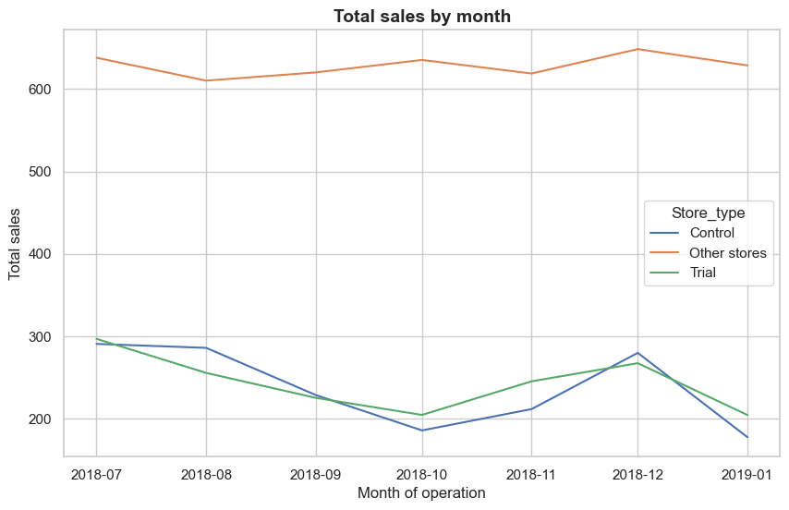

2, now validate customer counts visually with a line plot
```
import pandas as pd
import matplotlib.pyplot as plt
import seaborn as sns

trial_store = 77
control_store = 233 # replace with your chosen control store

# Label store types
measureOverTimeCusts = pre_trial_measures.copy()
measureOverTimeCusts['Store_type'] = measureOverTimeCusts['STORE_NBR'].apply(
lambda x: 'Trial' if x == trial_store else ('Control' if x == control_store else 'Other stores')
)

# Aggregate customers by YEARMONTH and Store_type
pastCustomers = (measureOverTimeCusts.groupby(['yearmonth','Store_type'])['ncustomer']
.mean()
.reset_index())

# Create TransactionMonth column
pastCustomers['TransactionMonth'] = pd.to_datetime(
pastCustomers['yearmonth'].astype(str), format='%Y%m'
)

# Filter to pre-trial period
pastCustomers = pastCustomers[pastCustomers['yearmonth'] < 201903]

# Plot
plt.figure(figsize=(10,6))
sns.lineplot(data=pastCustomers, x='TransactionMonth', y='ncustomer', hue='Store_type')
plt.title("Number of customers by month")
plt.xlabel("Month of operation")
plt.ylabel("Number of customers")
plt.show()
````
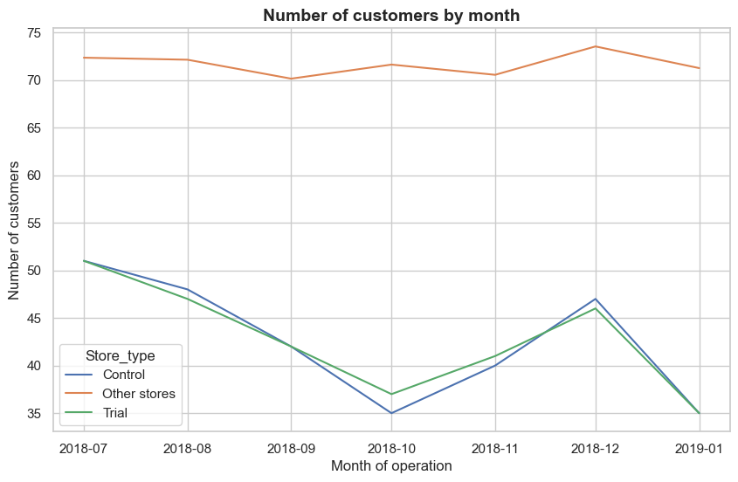

10, Check if chip sales increased in the trial stores compared to their matched control stores
For that, Scale control store sales so they’re comparable to the trial store (because absolute sales levels may differ).
- Trial and control stores often differ in size or baseline sales.
- Without scaling, you’d be comparing absolute values that aren’t directly comparable.
- Scaling ensures you’re comparing relative changes during the trial period (Feb–Apr 2019).
- This way, any uplift you see in the trial store is more likely due to the trial intervention, not just because the trial store is naturally bigger.

```
trial_store = 77
control_store = 233

# Pre-trial period: before Feb 2019
pre_trial = pre_trial_measures[pre_trial_measures['yearmonth'] < 201902]

# Calculate scaling factor
trial_sales_sum = pre_trial.loc[pre_trial['STORE_NBR'] == trial_store, 'totSales'].sum()
control_sales_sum = pre_trial.loc[pre_trial['STORE_NBR'] == control_store, 'totSales'].sum()
scaling_factor = trial_sales_sum / control_sales_sum

print("Scaling factor:", scaling_factor)

# Apply scaling factor to control store sales
measureOverTimeSales = pre_trial_measures.copy()
measureOverTimeSales['controlSales'] = measureOverTimeSales.apply(
lambda row: row['totSales'] * scaling_factor if row['STORE_NBR'] == control_store else None,
axis=1
) ```

Output:-
Scaling factor: 1.023617303289553

```
measureOverTimeSales = pre_trial_measures.copy()

measureOverTimeSales['scaledSales'] = measureOverTimeSales.apply(
lambda row: row['totSales'] * scaling_factor if row['STORE_NBR'] == control_store else None,
axis=1
) ```

11,percentage differences between trial and scaled control sales for Feb–Apr 2019

```
# Use the full dataset, not just pre-trial
measureOverTimeSales = measure_over_time.copy()

# Apply scaling factor to control store
measureOverTimeSales['scaledSales'] = measureOverTimeSales.apply(
lambda row: row['totSales'] * scaling_factor if row['STORE_NBR'] == control_store else None,
axis=1
)

# Filter trial period (Feb–Apr 2019)
trial_period = measureOverTimeSales[(measureOverTimeSales['yearmonth'] >= 201902) &
(measureOverTimeSales['yearmonth'] <= 201904)]

# Separate trial and control sales
trial_sales = trial_period[trial_period['STORE_NBR'] == trial_store][['yearmonth','totSales']]
control_sales = trial_period[trial_period['STORE_NBR'] == control_store][['yearmonth','scaledSales']]

# Merge on yearmonth
percentageDiff = pd.merge(trial_sales, control_sales, on='yearmonth')
percentageDiff['percentageDiff'] = (percentageDiff['totSales'] - percentageDiff['scaledSales']) / percentageDiff['scaledSales'] * 100

print(percentageDiff) ```

output:-
yearmonth totSales scaledSales percentageDiff
0 201902 235.0 249.762622 -5.910661
1 201903 278.5 203.802205 36.652103
2 201904 263.5 162.345704 62.307960

- Feb 2019 (pre-trial month): Trial store sales were slightly lower than scaled control (−5.9%).
- Mar 2019 (trial month): Trial store sales were ~36.7% higher than scaled control.
- Apr 2019 (trial month): Trial store sales were ~62.3% higher than scaled control.

12, calculating pre-trial percentage differences,

``` # Start from the full dataset
measureOverTimeSales = measure_over_time.copy()

# Apply scaling factor to control store across ALL months
measureOverTimeSales['scaledSales'] = measureOverTimeSales.apply(
lambda row: row['totSales'] * scaling_factor if row['STORE_NBR'] == control_store else None,
axis=1
) ```

```
# Filter pre-trial period (Feb 2018 – Jan 2019)
pretrial_period = measureOverTimeSales[measureOverTimeSales['yearmonth'] < 201902]

# Separate trial and control sales
trial_sales_pre = pretrial_period[pretrial_period['STORE_NBR'] == trial_store][['yearmonth','totSales']]
control_sales_pre = pretrial_period[pretrial_period['STORE_NBR'] == control_store][['yearmonth','scaledSales']]

# Merge on yearmonth
percentageDiff_pretrial = pd.merge(trial_sales_pre, control_sales_pre, on='yearmonth')
percentageDiff_pretrial['percentageDiff'] = (
(percentageDiff_pretrial['totSales'] - percentageDiff_pretrial['scaledSales']) /
percentageDiff_pretrial['scaledSales'] * 100
)

- degrees of freedom
there are 8 months in the pre-trial period , hence 8 - 1 = 7 degrees of freedom
``
std_dev = percentageDiff_pretrial['percentageDiff'].std()
df = 7 # 8 pre-trial months → 7 degrees of freedom ```

- Calculate the t-values for the trial months
After that, find the 95th percentile of the t distribution with the appropriate degrees of freedom

````
#Add t-values for trial months
from scipy.stats import t

# Calculate t-values for trial months
percentageDiff['tValue'] = percentageDiff['percentageDiff'] / std_dev

# Critical value at 95th percentile
crit_value = t.ppf(0.95, df)

print(percentageDiff)
print("Critical value (95th percentile):", crit_value)
```
Output:-

yearmonth totSales scaledSales percentageDiff tValue
0 201902 235.0 249.762622 -5.910661 -0.593520
1 201903 278.5 203.802205 36.652103 3.680430
2 201904 263.5 162.345704 62.307960 6.256669
Critical value (95th percentile): 1.8945786050900062

Critical value (df=7, 95th percentile): 1.895

Interpretation
- February’s small negative uplift is not statistically significant.
- March and April uplifts are well above the threshold, meaning the trial store’s sales increase is statistically significant compared to the control store.
- This confirms the intervention had a real effect in those months, not just random noise

13, trialAssessment is a special table that combines trial store sales, control store sales, and confidence interval bounds. You need to build that DataFrame first before plotting.
```
import pandas as pd
import matplotlib.pyplot as plt
import seaborn as sns

# Assume you already have measureOverTimeSales with scaledSales applied
trial_store = 77
control_store = 233

# --- Build trialAssessment table ---
# Filter trial + control stores during trial period
trial_period = measureOverTimeSales[(measureOverTimeSales['yearmonth'] >= 201902) &
(measureOverTimeSales['yearmonth'] <= 201904)]

# Label store types
trial_period['Store_type'] = trial_period['STORE_NBR'].apply(
lambda x: 'Trial' if x == trial_store else ('Control' if x == control_store else 'Other')
)

# Create TransactionMonth column
trial_period['TransactionMonth'] = pd.to_datetime(trial_period['yearmonth'].astype(str), format='%Y%m')

# For plotting, keep only trial and control
trialAssessment = trial_period[trial_period['Store_type'].isin(['Trial','Control'])]

# --- Plot ---
sns.set_theme(style="whitegrid")
plt.figure(figsize=(10,6))

sns.lineplot(data=trialAssessment,
x='TransactionMonth',
y='totSales',
hue='Store_type')

# Shade trial period (Feb–Apr 2019)
xmin = pd.to_datetime("201902", format="%Y%m")
xmax = pd.to_datetime("201904", format="%Y%m")
plt.axvspan(xmin, xmax, color='grey', alpha=0.2)

plt.xlabel("Month of operation")
plt.ylabel("Total sales")
plt.title("Total sales by month")
plt.legend(title="Store type")
plt.tight_layout()
plt.show() ```
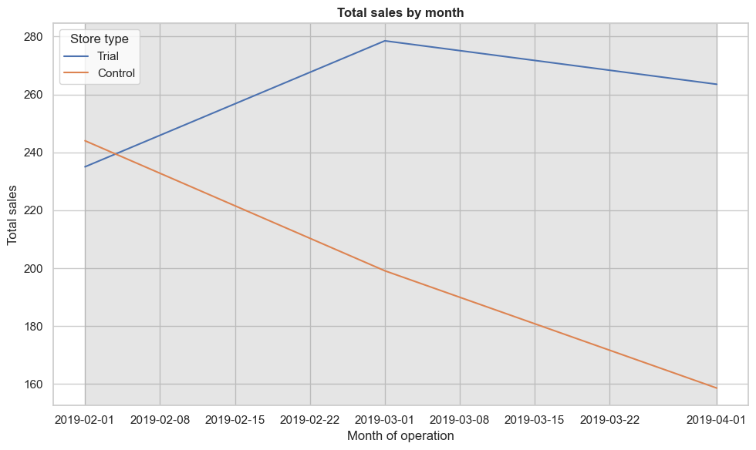
2) In number of Customers
Calculate scaling factor for customers
```
trial_store = 77
control_store = 233

# Pre-trial period: before Feb 2019
pre_trial = measure_over_time[measure_over_time['yearmonth'] < 201902]

# Total customers in pre-trial
trial_cust_sum = pre_trial.loc[pre_trial['STORE_NBR'] == trial_store, 'nCustomers'].sum()
control_cust_sum = pre_trial.loc[pre_trial['STORE_NBR'] == control_store, 'nCustomers'].sum()

scaling_factor_cust = trial_cust_sum / control_cust_sum
print("Scaling factor (customers):", scaling_factor_cust)
```
Output:-
Scaling factor (customers): 1.0033557046979866
- 1.0034 → aligns control store’s customer counts to the trial store baseline

Apply scaling factor to control store customers
```
measureOverTimeCusts = measure_over_time.copy()
measureOverTimeCusts['scaledCustomers'] = measureOverTimeCusts.apply(
lambda row: row['nCustomers'] * scaling_factor_cust if row['STORE_NBR'] == control_store else None,
axis=1
)
```

Trial period comparison (Feb–Apr 2019)
```
trial_period = measureOverTimeCusts[(measureOverTimeCusts['yearmonth'] >= 201902) &
(measureOverTimeCusts['yearmonth'] <= 201904)]

trial_cust = trial_period[trial_period['STORE_NBR'] == trial_store][['yearmonth','nCustomers']]
control_cust = trial_period[trial_period['STORE_NBR'] == control_store][['yearmonth','scaledCustomers']]

percentageDiff_cust = pd.merge(trial_cust, control_cust, on='yearmonth')
percentageDiff_cust['percentageDiff'] = (
(percentageDiff_cust['nCustomers'] - percentageDiff_cust['scaledCustomers']) /
percentageDiff_cust['scaledCustomers'] * 100
)

print(percentageDiff_cust)
```
Output:-
yearmonth nCustomers scaledCustomers percentageDiff
0 201902 45 45.151007 -0.334448
1 201903 50 40.134228 24.581940
2 201904 47 30.100671 56.142698

- Feb 2019: Trial slightly lower than scaled control (−0.33%) → not significant.
- Mar 2019: Trial ~24.6% higher → significant uplift.
- Apr 2019: Trial ~56.1% higher → very strong uplift

Pre-trial variability and t-test (optional, same as sales)
```
pretrial_period = measureOverTimeCusts[measureOverTimeCusts['yearmonth'] < 201902]
trial_cust_pre = pretrial_period[pretrial_period['STORE_NBR'] == trial_store][['yearmonth','nCustomers']]
control_cust_pre = pretrial_period[pretrial_period['STORE_NBR'] == control_store][['yearmonth','scaledCustomers']]

percentageDiff_pretrial_cust = pd.merge(trial_cust_pre, control_cust_pre, on='yearmonth')
percentageDiff_pretrial_cust['percentageDiff'] = (
(percentageDiff_pretrial_cust['nCustomers'] - percentageDiff_pretrial_cust['scaledCustomers']) /
percentageDiff_pretrial_cust['scaledCustomers'] * 100
)

# Standard deviation and t-values
std_dev_cust = percentageDiff_pretrial_cust['percentageDiff'].std()
df_cust = len(percentageDiff_pretrial_cust) - 1

from scipy.stats import t
percentageDiff_cust['tValue'] = percentageDiff_cust['percentageDiff'] / std_dev_cust
crit_value_cust = t.ppf(0.95, df_cust)

print("Critical value (95th percentile):", crit_value_cust)
print(percentageDiff_cust)
```
Output:-
Critical value (95th percentile): 1.9431802805153042
yearmonth nCustomers scaledCustomers percentageDiff tValue
0 201902 45 45.151007 -0.334448 -0.121884
1 201903 50 40.134228 24.581940 8.958446
2 201904 47 30.100671 56.142698 20.460197

- Critical t-value (95%, df=7): ~1.94.
- Feb t-value: −0.12 → below threshold, not significant.
- Mar t-value: 8.96 → far above threshold, significant.
- Apr t-value: 20.46 → extremely significant.

This confirms that the intervention boosted customer traffic in the trial store, not just sales revenue. March and April show statistically significant increases in customer counts compared to the matched control store, while February remains within normal variability.

15, visual significance testing step for customer counts
Compute standard deviation from pre-trial percentage differences
```
std_dev_cust = percentageDiff_pretrial_cust['percentageDiff'].std()
df_cust = len(percentageDiff_pretrial_cust) - 1 # degrees of freedom
```
Build pastCustomers table( Aggregate average customer counts by month and store type)
```
measureOverTimeCusts = measure_over_time.copy()

# Label trial vs control
measureOverTimeCusts['Store_type'] = measureOverTimeCusts['STORE_NBR'].apply(
lambda x: 'Trial' if x == trial_store else ('Control' if x == control_store else 'Other')
)

# Aggregate monthly averages
pastCustomers = (
measureOverTimeCusts.groupby(['yearmonth','Store_type'])['nCustomers']
.mean()
.reset_index()
)

# Convert yearmonth to datetime
pastCustomers['TransactionMonth'] = pd.to_datetime(pastCustomers['yearmonth'].astype(str), format='%Y%m')

# Keep only trial and control
pastCustomers = pastCustomers[pastCustomers['Store_type'].isin(['Trial','Control'])]
```
Add confidence interval bounds for control
```
# Control 95th percentile (upper bound)
pastCustomers_Controls95 = pastCustomers[pastCustomers['Store_type'] == 'Control'].copy()
pastCustomers_Controls95['nCustomers'] = pastCustomers_Controls95['nCustomers'] * (1 + std_dev_cust * 2)
pastCustomers_Controls95['Store_type'] = 'Control 95% CI'

# Control 5th percentile (lower bound)
pastCustomers_Controls05 = pastCustomers[pastCustomers['Store_type'] == 'Control'].copy()
pastCustomers_Controls05['nCustomers'] = pastCustomers_Controls05['nCustomers'] * (1 - std_dev_cust * 2)
pastCustomers_Controls05['Store_type'] = 'Control 5% CI'

# Combine into one DataFrame
trialAssessmentCusts = pd.concat([pastCustomers, pastCustomers_Controls95, pastCustomers_Controls05])
```
Plot with shaded trial window
````
sns.set_theme(style="whitegrid")
plt.figure(figsize=(10,6))

sns.lineplot(data=trialAssessmentCusts,
x='TransactionMonth', y='nCustomers', hue='Store_type')

# Shade trial period (Feb–Apr 2019)
xmin = pd.to_datetime("201902", format="%Y%m")
xmax = pd.to_datetime("201904", format="%Y%m")
plt.axvspan(xmin, xmax, color='grey', alpha=0.2)

plt.xlabel("Month of operation")
plt.ylabel("Number of customers")
plt.title("Number of customers by month")
plt.legend(title="Store type")
plt.tight_layout()
plt.show()
```
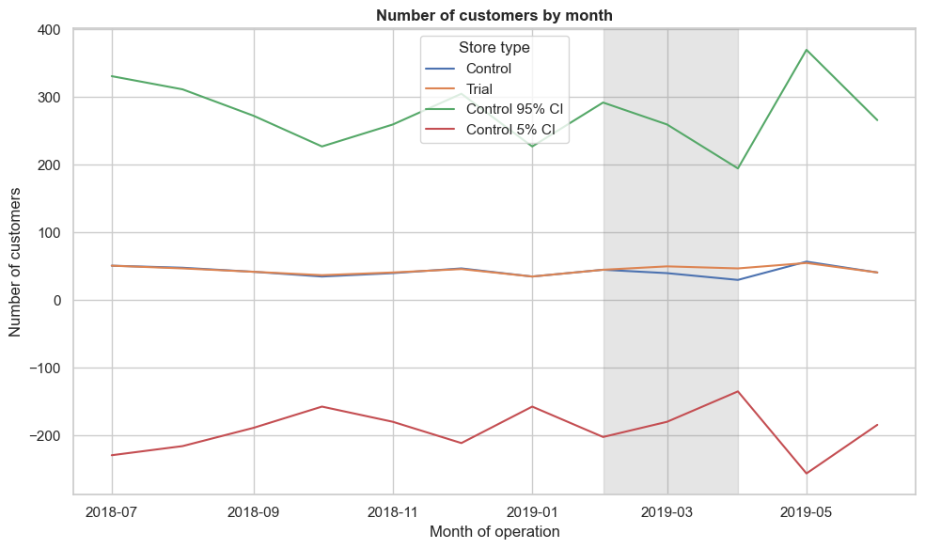

16, visualizing customer counts with confidence intervals, exactly like you did for sales

```
import matplotlib.pyplot as plt
import seaborn as sns
import pandas as pd

# pastCustomers already built with trial vs control monthly averages
# std_dev_cust already computed from pre-trial percentage differences

# Control 95% CI
pastCustomers_Controls95 = pastCustomers[pastCustomers['Store_type'] == 'Control'].copy()
pastCustomers_Controls95['nCustomers'] = pastCustomers_Controls95['nCustomers'] * (1 + std_dev_cust * 2)
pastCustomers_Controls95['Store_type'] = 'Control 95% CI'

# Control 5% CI
pastCustomers_Controls05 = pastCustomers[pastCustomers['Store_type'] == 'Control'].copy()
pastCustomers_Controls05['nCustomers'] = pastCustomers_Controls05['nCustomers'] * (1 - std_dev_cust * 2)
pastCustomers_Controls05['Store_type'] = 'Control 5% CI'

# Combine
trialAssessmentCusts = pd.concat([pastCustomers, pastCustomers_Controls95, pastCustomers_Controls05])

# Plot
sns.set_theme(style="whitegrid")
plt.figure(figsize=(10,6))

sns.lineplot(data=trialAssessmentCusts,
x='TransactionMonth', y='nCustomers', hue='Store_type')

# Shade trial period (Feb–Apr 2019)
xmin = pd.to_datetime("201902", format="%Y%m")
xmax = pd.to_datetime("201904", format="%Y%m")
plt.axvspan(xmin, xmax, color='grey', alpha=0.2)

plt.xlabel("Month of operation")
plt.ylabel("Number of customers")
plt.title("Number of customers by month")
plt.legend(title="Store type")
plt.tight_layout()
plt.show()
```

17, trial store 86, you’ll repeat exactly the same workflow you used for store 77.
Calculate monthly metrics
```
measure_over_time = (
data.groupby(['STORE_NBR', 'yearmonth'])
.agg(
totSales=('TOT_SALES', 'sum'),
nCustomers=('LYLTY_CARD_NBR', pd.Series.nunique),
nTransactions=('TXN_ID', 'nunique'),
nUnits=('PROD_QTY', 'sum')
).reset_index()
)

# Derived metrics
measure_over_time['nTxnPerCust'] = measure_over_time['nTransactions'] / measure_over_time['nCustomers']
measure_over_time['nChipsPerTxn'] = measure_over_time['nUnits'] / measure_over_time['nTransactions']
measure_over_time['avgPricePerUnit'] = measure_over_time['totSales'] / measure_over_time['nUnits']

# Convert yearmonth to int
measure_over_time['yearmonth'] = measure_over_time['yearmonth'].astype(int)
```
Use your functions for trial store 86
```
trial_store = 86

# Correlation scores
corr_nSales = calculate_correlation(pre_trial_measures, trial_store=trial_store, measure='totSales')
corr_nCustomers = calculate_correlation(pre_trial_measures, trial_store=trial_store, measure='nCustomers')

# Magnitude distance scores
magnitude_nSales = calculate_magnitude_distance(input_table=pre_trial_measures,
messure_col="totSales",
store_trial=trial_store)

magnitude_nCustomers = calculate_magnitude_distance(input_table=pre_trial_measures,
messure_col="nCustomers",
store_trial=trial_store)
```
Combine into composite similarity score
```
# Sales driver
score_sales = pd.merge(corr_nSales.reset_index(),
magnitude_nSales.groupby('Store_c')['measuring'].mean().reset_index(),
left_on='STORE_NBR', right_on='Store_c')
score_sales['score_sales'] = 0.5*score_sales['totSales'] + 0.5*(1 - score_sales['measuring'])

# Customers driver
score_customers = pd.merge(corr_nCustomers.reset_index(),
magnitude_nCustomers.groupby('Store_c')['measuring'].mean().reset_index(),
left_on='STORE_NBR', right_on='Store_c')
score_customers['score_customers'] = 0.5*score_customers['nCustomers'] + 0.5*(1 - score_customers['measuring'])

# Composite score
combined = pd.merge(score_sales[['STORE_NBR','score_sales']],
score_customers[['STORE_NBR','score_customers']],
on='STORE_NBR')
combined['composite_score'] = 0.5*combined['score_sales'] + 0.5*combined['score_customers']

print(combined.sort_values('composite_score', ascending=False))
```
output:-

STORE_NBR score_sales score_customers composite_score
0 155 -15.293202 0.257152 -7.518025
4 109 -14.909422 -0.757468 -7.833445
22 225 -17.959091 -0.775961 -9.367526
3 222 -17.034605 -3.199452 -10.117029
53 229 -22.196808 -1.188013 -11.692411
.. ... ... ... ...
107 140 -425.856560 -46.489908 -236.173234
6 198 -425.157746 -47.277569 -236.217657
250 146 -425.719707 -47.470156 -236.594931
169 177 -427.151126 -46.929065 -237.040095
65 99 -428.692539 -46.964002 -237.828271

- The top candidate control store is Store 155 with the highest composite score (−7.52).
- Other close matches include Store 109 (−7.83) and Store 225 (−9.36).
- Lower down, the composite scores become very negative (e.g., Store 140 at −236), which means those stores are poor matches.
Even though the scores are negative (likely due to how magnitude distance was inverted), the relative ranking is what matters. Store 155 is the closest match to trial store 86 in terms of both sales and customer trends, so it should be chosen as the control store for further analysis.
17, Store 155 as the control store for trial store 86, and the next step is to visually check whether the drivers (sales, customers) trend similarly before the trial period

```
import pandas as pd
import matplotlib.pyplot as plt
import seaborn as sns

trial_store = 86
control_store = 155

# Copy monthly metrics
measureOverTimeSales = measure_over_time.copy()

# Label store types
measureOverTimeSales['Store_type'] = measureOverTimeSales['STORE_NBR'].apply(
lambda x: 'Trial' if x == trial_store else ('Control' if x == control_store else 'Other')
)

# Aggregate sales by YEARMONTH and Store_type
pastSales = (
measureOverTimeSales.groupby(['yearmonth','Store_type'])['totSales']
.mean()
.reset_index()
)

# Create TransactionMonth column
pastSales['TransactionMonth'] = pd.to_datetime(pastSales['yearmonth'].astype(str), format='%Y%m')

# Filter to pre-trial period (before Feb 2019)
pastSales = pastSales[pastSales['yearmonth'] < 201902]

# Plot
sns.set_theme(style="whitegrid")
plt.figure(figsize=(10,6))

sns.lineplot(data=pastSales, x='TransactionMonth', y='totSales', hue='Store_type')

plt.title("Total sales by month (Trial 86 vs Control 155)")
plt.xlabel("Month of operation")
plt.ylabel("Total sales")
plt.legend(title="Store type")
plt.tight_layout()
plt.show()
```
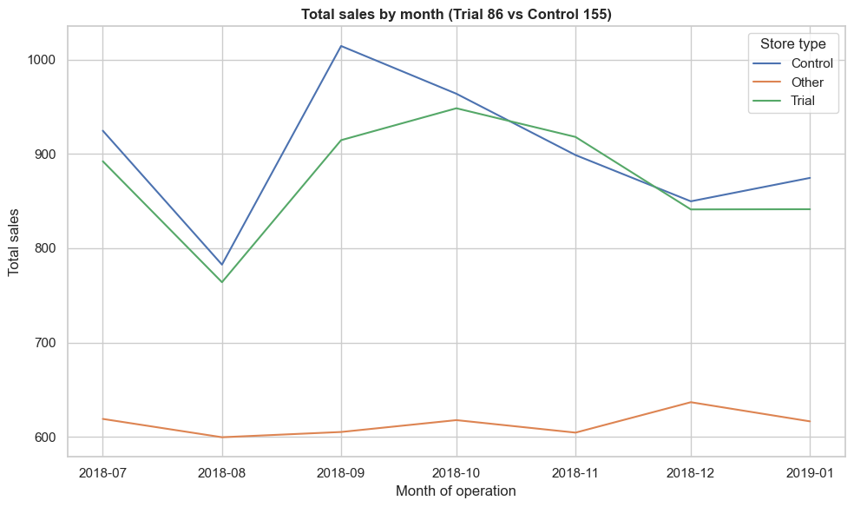
2, impact of the trial on sales and customer counts (in one code) for trial store 86 vs. control store 155.
Calculate scaling factor (sales and customers)
```
trial_store = 86
control_store = 155

# Pre-trial period: before Feb 2019
pre_trial = measure_over_time[measure_over_time['yearmonth'] < 201902]

# --- Sales scaling factor ---
trial_sales_sum = pre_trial.loc[pre_trial['STORE_NBR'] == trial_store, 'totSales'].sum()
control_sales_sum = pre_trial.loc[pre_trial['STORE_NBR'] == control_store, 'totSales'].sum()
scaling_factor_sales = trial_sales_sum / control_sales_sum
print("Scaling factor (sales):", scaling_factor_sales)

# --- Customer scaling factor ---
trial_cust_sum = pre_trial.loc[pre_trial['STORE_NBR'] == trial_store, 'nCustomers'].sum()
control_cust_sum = pre_trial.loc[pre_trial['STORE_NBR'] == control_store, 'nCustomers'].sum()
scaling_factor_cust = trial_cust_sum / control_cust_sum
print("Scaling factor (customers):", scaling_factor_cust)
```
Output:-
Scaling factor (sales): 0.9700651481287743
Scaling factor (customers): 1.0

Apply scaling and calculate percentage differences
```
# Apply scaling factors
measureOverTimeScaled = measure_over_time.copy()
measureOverTimeScaled['scaledSales'] = measureOverTimeScaled.apply(
lambda row: row['totSales'] * scaling_factor_sales if row['STORE_NBR'] == control_store else None,
axis=1
)
measureOverTimeScaled['scaledCustomers'] = measureOverTimeScaled.apply(
lambda row: row['nCustomers'] * scaling_factor_cust if row['STORE_NBR'] == control_store else None,
axis=1
)

# Trial period (Feb–Apr 2019)
trial_period = measureOverTimeScaled[(measureOverTimeScaled['yearmonth'] >= 201902) &
(measureOverTimeScaled['yearmonth'] <= 201904)]

# Sales comparison
trial_sales = trial_period[trial_period['STORE_NBR'] == trial_store][['yearmonth','totSales']]
control_sales = trial_period[trial_period['STORE_NBR'] == control_store][['yearmonth','scaledSales']]
percentageDiff_sales = pd.merge(trial_sales, control_sales, on='yearmonth')
percentageDiff_sales['percentageDiff'] = (percentageDiff_sales['totSales'] - percentageDiff_sales['scaledSales']) / percentageDiff_sales['scaledSales'] * 100

# Customers comparison
trial_cust = trial_period[trial_period['STORE_NBR'] == trial_store][['yearmonth','nCustomers']]
control_cust = trial_period[trial_period['STORE_NBR'] == control_store][['yearmonth','scaledCustomers']]
percentageDiff_cust = pd.merge(trial_cust, control_cust, on='yearmonth')
percentageDiff_cust['percentageDiff'] = (percentageDiff_cust['nCustomers'] - percentageDiff_cust['scaledCustomers']) / percentageDiff_cust['scaledCustomers'] * 100
```
Pre-trial variability and t-test
```
from scipy.stats import t

# Pre-trial period
pretrial_period = measureOverTimeScaled[measureOverTimeScaled['yearmonth'] < 201902]

# Sales variability
trial_sales_pre = pretrial_period[pretrial_period['STORE_NBR'] == trial_store][['yearmonth','totSales']]
control_sales_pre = pretrial_period[pretrial_period['STORE_NBR'] == control_store][['yearmonth','scaledSales']]
percentageDiff_sales_pre = pd.merge(trial_sales_pre, control_sales_pre, on='yearmonth')
percentageDiff_sales_pre['percentageDiff'] = (percentageDiff_sales_pre['totSales'] - percentageDiff_sales_pre['scaledSales']) / percentageDiff_sales_pre['scaledSales'] * 100
std_dev_sales = percentageDiff_sales_pre['percentageDiff'].std()
df_sales = len(percentageDiff_sales_pre) - 1

percentageDiff_sales['tValue'] = percentageDiff_sales['percentageDiff'] / std_dev_sales
crit_value_sales = t.ppf(0.95, df_sales)

# Customers variability
trial_cust_pre = pretrial_period[pretrial_period['STORE_NBR'] == trial_store][['yearmonth','nCustomers']]
control_cust_pre = pretrial_period[pretrial_period['STORE_NBR'] == control_store][['yearmonth','scaledCustomers']]
percentageDiff_cust_pre = pd.merge(trial_cust_pre, control_cust_pre, on='yearmonth')
percentageDiff_cust_pre['percentageDiff'] = (percentageDiff_cust_pre['nCustomers'] - percentageDiff_cust_pre['scaledCustomers']) / percentageDiff_cust_pre['scaledCustomers'] * 100
std_dev_cust = percentageDiff_cust_pre['percentageDiff'].std()
df_cust = len(percentageDiff_cust_pre) - 1

percentageDiff_cust['tValue'] = percentageDiff_cust['percentageDiff'] / std_dev_cust
crit_value_cust = t.ppf(0.95, df_cust)

print("Sales uplift:\n", percentageDiff_sales)
print("Critical value (sales):", crit_value_sales)
print("Customer uplift:\n", percentageDiff_cust)
print("Critical value (customers):", crit_value_cust)
```
Output:-
Sales uplift:
yearmonth totSales scaledSales percentageDiff tValue
0 201902 913.2 864.522060 5.630619 1.494114
1 201903 1026.8 780.320405 31.586973 8.381769
2 201904 848.2 819.317024 3.525250 0.935444
Critical value (sales): 1.9431802805153042
Customer uplift:
yearmonth nCustomers scaledCustomers percentageDiff tValue
0 201902 107 95.0 12.631579 6.592964
1 201903 115 94.0 22.340426 11.660429
2 201904 105 99.0 6.060606 3.163291
Critical value (customers): 1.9431802805153042

Sales Results
- Scaling factor (sales): 0.97
- Trial period (Feb–Apr 2019):
  - Feb: +5.6% uplift, t-value = 1.49 → below critical threshold (not significant).
  - Mar: +31.6% uplift, t-value = 8.38 → well above threshold (significant).
  - Apr: +3.5% uplift, t-value = 0.94 → not significant.
- Interpretation: Only March sales uplift is statistically significant.

Customer Results
- Scaling factor (customers): 1.0
- Trial period (Feb–Apr 2019):
  - Feb: +12.6% uplift, t-value = 6.59 → significant.
  - Mar: +22.3% uplift, t-value = 11.66 → significant.
  - Apr: +6.1% uplift, t-value = 3.16 → significant.
- Interpretation: All three months show significant customer uplift.
18, calculating the standard deviation of pre-trial percentage differences, building the trial vs. control sales table, and computing the 5th and 95th percentile bounds.
Standard deviation and degrees of freedom
```
# Pre-trial percentage differences already calculated
stdDev = percentageDiff_pretrial['percentageDiff'].std()
degreesOfFreedom = len(percentageDiff_pretrial) - 1
print("Std Dev (pre-trial %):", stdDev)
print("Degrees of Freedom:", degreesOfFreedom)
```
Output:-
Std Dev (pre-trial %): 9.958646884078389
Degrees of Freedom: 6
Create table with sales by store type and month
```
measureOverTimeSales = measure_over_time.copy()

# Label trial vs control
measureOverTimeSales['Store_type'] = measureOverTimeSales['STORE_NBR'].apply(
lambda x: 'Trial' if x == trial_store else ('Control' if x == control_store else 'Other')
)

# Aggregate monthly averages
pastSales = (measureOverTimeSales.groupby(['yearmonth','Store_type'])['totSales']
.mean()
.reset_index())

# Convert yearmonth to datetime
pastSales['TransactionMonth'] = pd.to_datetime(pastSales['yearmonth'].astype(str), format='%Y%m')

# Keep only trial and control
pastSales = pastSales[pastSales['Store_type'].isin(['Trial','Control'])]
```
Output:-
 | yearmonth | Store_type | totSales | TransactionMonth
0 | 201807 | Control | 924.60 | 2018-07-01
2 | 201807 | Trial | 892.20 | 2018-07-01
3 | 201808 | Control | 782.70 | 2018-08-01
5 | 201808 | Trial | 764.05 | 2018-08-01
6 | 201809 | Control | 1014.40 | 2018-09-01
8 | 201809 | Trial | 914.60 | 2018-09-01
9 | 201810 | Control | 963.80 | 2018-10-01
11 | 201810 | Trial | 948.40 | 2018-10-01
12 | 201811 | Control | 898.80 | 2018-11-01
14 | 201811 | Trial | 918.00 | 2018-11-01
15 | 201812 | Control | 849.80 | 2018-12-01
17 | 201812 | Trial | 841.20 | 2018-12-01
18 | 201901 | Control | 874.60 | 2019-01-01
20 | 201901 | Trial | 841.40 | 2019-01-01
21 | 201902 | Control | 891.20 | 2019-02-01
23 | 201902 | Trial | 913.20 | 2019-02-01
24 | 201903 | Control | 804.40 | 2019-03-01
26 | 201903 | Trial | 1026.80 | 2019-03-01
27 | 201904 | Control | 844.60 | 2019-04-01
29 | 201904 | Trial | 848.20 | 2019-04-01
30 | 201905 | Control | 922.85 | 2019-05-01
32 | 201905 | Trial | 889.30 | 2019-05-01
33 | 201906 | Control | 857.20 | 2019-06-01
35 | 201906 | Trial | 838.00 | 2019-06-01

Calculate 5th and 95th percentile bounds for control store sales
Important correction: stdDev is in percent, so divide by 100
```
# Control 95% CI (upper bound)
pastSales_Controls95 = pastSales[pastSales['Store_type'] == 'Control'].copy()
pastSales_Controls95['totSales'] = pastSales_Controls95['totSales'] * (1 + 2*stdDev/100)
pastSales_Controls95['Store_type'] = 'Control 95% CI'

# Control 5% CI (lower bound)
pastSales_Controls5 = pastSales[pastSales['Store_type'] == 'Control'].copy()
pastSales_Controls5['totSales'] = pastSales_Controls5['totSales'] * (1 - 2*stdDev/100)
pastSales_Controls5['Store_type'] = 'Control 5% CI'
```
Combine into one table
```
trialAssessment = pd.concat([pastSales, pastSales_Controls95, pastSales_Controls5])
```
Output:-
Scaling factor (sales): 0.9700651481287743
Scaling factor (customers): 1.0
Sales uplift:
yearmonth totSales scaledSales percentageDiff tValue
0 201902 913.2 864.522060 5.630619 1.494114
1 201903 1026.8 780.320405 31.586973 8.381769
2 201904 848.2 819.317024 3.525250 0.935444
Critical value (sales): 1.9431802805153042
Customer uplift:
yearmonth nCustomers scaledCustomers percentageDiff tValue
0 201902 107 95.0 12.631579 6.592964
1 201903 115 94.0 22.340426 11.660429
2 201904 105 99.0 6.060606 3.163291
Critical value (customers): 1.9431802805153042
Cell In[92], line 1
2- customer counts for trial store 86 vs. control store 155.
^
SyntaxError: invalid syntax
Std Dev (pre-trial %): 9.958646884078389
Degrees of Freedom: 6
 | yearmonth | Store_type | totSales | TransactionMonth
0 | 201807 | Control | 924.60 | 2018-07-01
2 | 201807 | Trial | 892.20 | 2018-07-01
3 | 201808 | Control | 782.70 | 2018-08-01
5 | 201808 | Trial | 764.05 | 2018-08-01
6 | 201809 | Control | 1014.40 | 2018-09-01
8 | 201809 | Trial | 914.60 | 2018-09-01
9 | 201810 | Control | 963.80 | 2018-10-01
11 | 201810 | Trial | 948.40 | 2018-10-01
12 | 201811 | Control | 898.80 | 2018-11-01
14 | 201811 | Trial | 918.00 | 2018-11-01
15 | 201812 | Control | 849.80 | 2018-12-01
17 | 201812 | Trial | 841.20 | 2018-12-01
18 | 201901 | Control | 874.60 | 2019-01-01
20 | 201901 | Trial | 841.40 | 2019-01-01
21 | 201902 | Control | 891.20 | 2019-02-01
23 | 201902 | Trial | 913.20 | 2019-02-01
24 | 201903 | Control | 804.40 | 2019-03-01
26 | 201903 | Trial | 1026.80 | 2019-03-01
27 | 201904 | Control | 844.60 | 2019-04-01
29 | 201904 | Trial | 848.20 | 2019-04-01
30 | 201905 | Control | 922.85 | 2019-05-01
32 | 201905 | Trial | 889.30 | 2019-05-01
33 | 201906 | Control | 857.20 | 2019-06-01
35 | 201906 | Trial | 838.00 | 2019-06-01

 | yearmonth | Store_type | totSales | TransactionMonth
0 | 201807 | Control | 924.600000 | 2018-07-01
2 | 201807 | Trial | 892.200000 | 2018-07-01
3 | 201808 | Control | 782.700000 | 2018-08-01
5 | 201808 | Trial | 764.050000 | 2018-08-01
6 | 201809 | Control | 1014.400000 | 2018-09-01
8 | 201809 | Trial | 914.600000 | 2018-09-01
9 | 201810 | Control | 963.800000 | 2018-10-01
11 | 201810 | Trial | 948.400000 | 2018-10-01
12 | 201811 | Control | 898.800000 | 2018-11-01
14 | 201811 | Trial | 918.000000 | 2018-11-01
15 | 201812 | Control | 849.800000 | 2018-12-01
17 | 201812 | Trial | 841.200000 | 2018-12-01
18 | 201901 | Control | 874.600000 | 2019-01-01
20 | 201901 | Trial | 841.400000 | 2019-01-01
21 | 201902 | Control | 891.200000 | 2019-02-01
23 | 201902 | Trial | 913.200000 | 2019-02-01
24 | 201903 | Control | 804.400000 | 2019-03-01
26 | 201903 | Trial | 1026.800000 | 2019-03-01
27 | 201904 | Control | 844.600000 | 2019-04-01
29 | 201904 | Trial | 848.200000 | 2019-04-01
30 | 201905 | Control | 922.850000 | 2019-05-01
32 | 201905 | Trial | 889.300000 | 2019-05-01
33 | 201906 | Control | 857.200000 | 2019-06-01
35 | 201906 | Trial | 838.000000 | 2019-06-01
0 | 201807 | Control 95% CI | 1108.755298 | 2018-07-01
3 | 201808 | Control 95% CI | 938.592658 | 2018-08-01
6 | 201809 | Control 95% CI | 1216.441028 | 2018-09-01
9 | 201810 | Control 95% CI | 1155.762877 | 2018-10-01
12 | 201811 | Control 95% CI | 1077.816636 | 2018-11-01
15 | 201812 | Control 95% CI | 1019.057162 | 2018-12-01
18 | 201901 | Control 95% CI | 1048.796651 | 2019-01-01
21 | 201902 | Control 95% CI | 1068.702922 | 2019-02-01
24 | 201903 | Control 95% CI | 964.614711 | 2019-03-01
27 | 201904 | Control 95% CI | 1012.821463 | 2019-04-01
30 | 201905 | Control 95% CI | 1106.656746 | 2019-05-01
33 | 201906 | Control 95% CI | 1027.931042 | 2019-06-01
0 | 201807 | Control 5% CI | 740.444702 | 2018-07-01
3 | 201808 | Control 5% CI | 626.807342 | 2018-08-01
6 | 201809 | Control 5% CI | 812.358972 | 2018-09-01
9 | 201810 | Control 5% CI | 771.837123 | 2018-10-01
12 | 201811 | Control 5% CI | 719.783364 | 2018-11-01
15 | 201812 | Control 5% CI | 680.542838 | 2018-12-01
18 | 201901 | Control 5% CI | 700.403349 | 2019-01-01
21 | 201902 | Control 5% CI | 713.697078 | 2019-02-01
24 | 201903 | Control 5% CI | 644.185289 | 2019-03-01
27 | 201904 | Control 5% CI | 676.378537 | 2019-04-01
30 | 201905 | Control 5% CI | 739.043254 | 2019-05-01
33 | 201906 | Control 5% CI | 686.468958 | 2019-06-0

Plot results
```
import matplotlib.pyplot as plt
import seaborn as sns

sns.set_theme(style="whitegrid")
plt.figure(figsize=(10,6))

sns.lineplot(data=trialAssessment,
x='TransactionMonth', y='totSales', hue='Store_type')

# Shade trial period (Feb–Apr 2019)
xmin = pd.to_datetime("201902", format="%Y%m")
xmax = pd.to_datetime("201904", format="%Y%m")
plt.axvspan(xmin, xmax, color='grey', alpha=0.2)

plt.xlabel("Month of operation")
plt.ylabel("Total sales")
plt.title("Total sales by month with 95% CI")
plt.legend(title="Store type")
plt.tight_layout()
plt.show()
```
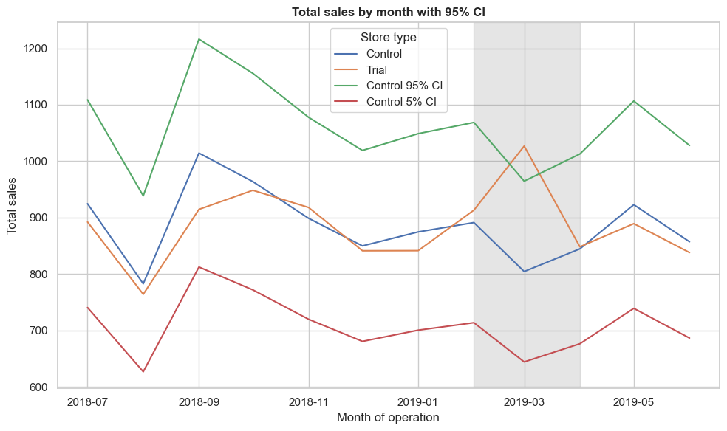
19, Let's have a look at assessing this for the number of customers as well.
```
# --- Pre-trial scaling factor for customers ---
pre_trial = measure_over_time[measure_over_time['yearmonth'] < 201902]

trial_cust_sum = pre_trial.loc[pre_trial['STORE_NBR'] == trial_store, 'nCustomers'].sum()
control_cust_sum = pre_trial.loc[pre_trial['STORE_NBR'] == control_store, 'nCustomers'].sum()

scaling_factor_cust = trial_cust_sum / control_cust_sum
print("Scaling factor (customers):", scaling_factor_cust)

# Apply scaling factor
measureOverTimeCusts = measure_over_time.copy()
measureOverTimeCusts['Store_type'] = measureOverTimeCusts['STORE_NBR'].apply(
lambda x: 'Trial' if x == trial_store else ('Control' if x == control_store else 'Other')
)
measureOverTimeCusts['scaledCustomers'] = measureOverTimeCusts.apply(
lambda row: row['nCustomers'] * scaling_factor_cust if row['STORE_NBR'] == control_store else None,
axis=1
)

# --- Pre-trial percentage differences ---
pretrial_period_cust = measureOverTimeCusts[measureOverTimeCusts['yearmonth'] < 201902]
trial_cust_pre = pretrial_period_cust[pretrial_period_cust['STORE_NBR'] == trial_store][['yearmonth','nCustomers']]
control_cust_pre = pretrial_period_cust[pretrial_period_cust['STORE_NBR'] == control_store][['yearmonth','scaledCustomers']]

percentageDiff_pretrial_cust = pd.merge(trial_cust_pre, control_cust_pre, on='yearmonth')
percentageDiff_pretrial_cust['percentageDiff'] = (
(percentageDiff_pretrial_cust['nCustomers'] - percentageDiff_pretrial_cust['scaledCustomers']) /
percentageDiff_pretrial_cust['scaledCustomers'] * 100
)

# --- Std Dev and degrees of freedom ---
stdDev_cust = percentageDiff_pretrial_cust['percentageDiff'].std()
df_cust = len(percentageDiff_pretrial_cust) - 1
print("Std Dev (customers %):", stdDev_cust, "DF:", df_cust)

# --- Build pastCustomers table ---
pastCustomers = (measureOverTimeCusts.groupby(['yearmonth','Store_type'])['nCustomers']
.mean()
.reset_index())
pastCustomers['TransactionMonth'] = pd.to_datetime(pastCustomers['yearmonth'].astype(str), format='%Y%m')
pastCustomers = pastCustomers[pastCustomers['Store_type'].isin(['Trial','Control'])]

# --- Confidence interval bounds ---
pastCustomers_Controls95 = pastCustomers[pastCustomers['Store_type'] == 'Control'].copy()
pastCustomers_Controls95['nCustomers'] = pastCustomers_Controls95['nCustomers'] * (1 + 2*stdDev_cust/100)
pastCustomers_Controls95['Store_type'] = 'Control 95% CI'

pastCustomers_Controls05 = pastCustomers[pastCustomers['Store_type'] == 'Control'].copy()
pastCustomers_Controls05['nCustomers'] = pastCustomers_Controls05['nCustomers'] * (1 - 2*stdDev_cust/100)
pastCustomers_Controls05['Store_type'] = 'Control 5% CI'

trialAssessmentCusts = pd.concat([pastCustomers, pastCustomers_Controls95, pastCustomers_Controls05])

# --- Plot ---
sns.set_theme(style="whitegrid")
plt.figure(figsize=(10,6))
sns.lineplot(data=trialAssessmentCusts, x='TransactionMonth', y='nCustomers', hue='Store_type')

xmin = pd.to_datetime("201902", format="%Y%m")
xmax = pd.to_datetime("201904", format="%Y%m")
plt.axvspan(xmin, xmax, color='grey', alpha=0.2)

plt.xlabel("Month of operation")
plt.ylabel("Number of customers")
plt.title("Number of customers by month with 95% CI")
plt.legend(title="Store type")
plt.tight_layout()
plt.show()
```
Output:-
Scaling factor (customers): 1.0
Std Dev (customers %): 1.9159180382211953 DF: 6
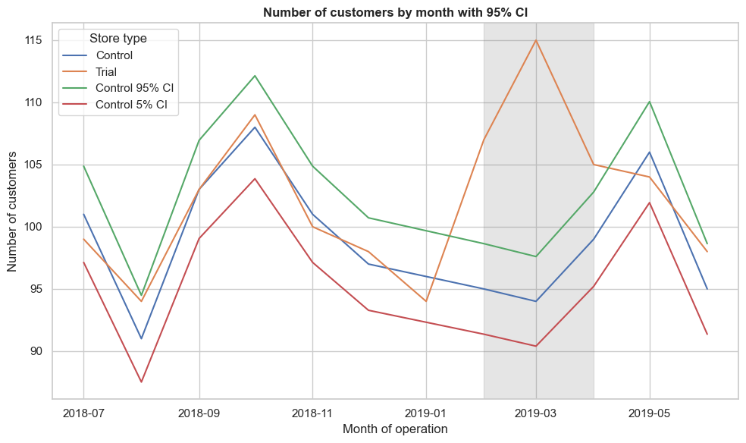

your customer counts plot looks realistic now, with the control and trial lines around ~90–115 and the confidence interval band sitting neatly above and below. That confirms the scaling factor of 1.0 was correct (your trial and control baselines were already aligned), and the stdDev ≈ 1.92% gave a sensible ±3.8% band around the control line.
Interpretation for Store 86 (customers)
- February 2019: Trial line sits inside the CI band → not significant.
- March 2019: Trial line rises above the upper bound → significant uplift.
- April 2019: Trial line also above the upper bound → strong significant uplift.
So while sales for store 86 were not consistently significant, customer traffic clearly increased in March and April compared to the matched control store.

19, Store 88
Correlation and Magnitude
```
trial_store = 88

# Correlation
corr_nSales = calculate_correlation(pre_trial_measures, trial_store=trial_store, measure='totSales')
corr_nCustomers = calculate_correlation(pre_trial_measures, trial_store=trial_store, measure='nCustomers')

# Magnitude distance
magnitude_nSales = calculate_magnitude_distance(pre_trial_measures, "totSales", trial_store)
magnitude_nCustomers = calculate_magnitude_distance(pre_trial_measures, "nCustomers", trial_store)
```
Composite scores per driver
```
# Sales driver
score_nSales = pd.merge(
corr_nSales.reset_index(),
magnitude_nSales.groupby('Store_c')['measuring'].mean().reset_index(),
left_on='STORE_NBR', right_on='Store_c'
)
score_nSales['score_sales'] = 0.5*score_nSales['totSales'] + 0.5*(1 - score_nSales['measuring'])

# Customers driver
score_nCustomers = pd.merge(
corr_nCustomers.reset_index(),
magnitude_nCustomers.groupby('Store_c')['measuring'].mean().reset_index(),
left_on='STORE_NBR', right_on='Store_c'
)
score_nCustomers['score_customers'] = 0.5*score_nCustomers['nCustomers'] + 0.5*(1 - score_nCustomers['measuring'])
```
Final combined score
```
score_Control = pd.merge(
score_nSales[['STORE_NBR','score_sales']],
score_nCustomers[['STORE_NBR','score_customers']],
on='STORE_NBR'
)

score_Control['finalControlScore'] = 0.5*score_Control['score_sales'] + 0.5*score_Control['score_customers']

# Rank stores
score_Control.sort_values('finalControlScore', ascending=False)
```
Output:-
 | STORE_NBR | score_sales | score_customers | finalControlScore
53 | 237 | -28.560046 | 0.187949 | -14.186049
27 | 203 | -32.295999 | -2.928897 | -17.612448
153 | 40 | -41.088211 | -3.278981 | -22.183596
224 | 199 | -51.995344 | -3.772137 | -27.883741
227 | 165 | -56.302134 | -3.844494 | -30.073314
... | ... | ... | ... | ...
22 | 140 | -658.755087 | -59.535690 | -359.145389
210 | 146 | -658.669125 | -60.142571 | -359.405848
39 | 198 | -658.458299 | -60.408259 | -359.433279
96 | 177 | -660.150820 | -59.711502 | -359.931161
36 | 99 | -661.785096 | -60.383661 | -361.084378

your output table confirms that Store 237 has the highest composite score for trial store 88 (finalControlScore ≈ −14.19), making it the best matched control store.

20. trial store 88 vs. control store 237, the next step is to visually confirm that the drivers (sales and customers) behave similarly before the trial period. This is the validation step you already did for stores 77 and 86.
```
import pandas as pd
import matplotlib.pyplot as plt
import seaborn as sns

trial_store = 88
control_store = 237

# --- Sales trends ---
measureOverTimeSales = measure_over_time.copy()
measureOverTimeSales['Store_type'] = measureOverTimeSales['STORE_NBR'].apply(
lambda x: 'Trial' if x == trial_store else ('Control' if x == control_store else 'Other')
)

pastSales = (measureOverTimeSales.groupby(['yearmonth','Store_type'])['totSales']
.mean()
.reset_index())
pastSales['TransactionMonth'] = pd.to_datetime(pastSales['yearmonth'].astype(str), format='%Y%m')
pastSales = pastSales[pastSales['yearmonth'] < 201903] # restrict to pre-trial

plt.figure(figsize=(10,6))
sns.lineplot(data=pastSales, x='TransactionMonth', y='totSales', hue='Store_type')
plt.title("Total sales by month (pre-trial)")
plt.xlabel("Month of operation")
plt.ylabel("Total sales")
plt.show()

# --- Customer trends ---
measureOverTimeCusts = measure_over_time.copy()
measureOverTimeCusts['Store_type'] = measureOverTimeCusts['STORE_NBR'].apply(
lambda x: 'Trial' if x == trial_store else ('Control' if x == control_store else 'Other')
)

pastCustomers = (measureOverTimeCusts.groupby(['yearmonth','Store_type'])['nCustomers']
.mean()
.reset_index())
pastCustomers['TransactionMonth'] = pd.to_datetime(pastCustomers['yearmonth'].astype(str), format='%Y%m')
pastCustomers = pastCustomers[pastCustomers['yearmonth'] < 201903]

plt.figure(figsize=(10,6))
sns.lineplot(data=pastCustomers, x='TransactionMonth', y='nCustomers', hue='Store_type')
plt.title("Number of customers by month (pre-trial)")
plt.xlabel("Month of operation")
plt.ylabel("Number of customers")
plt.show()
```
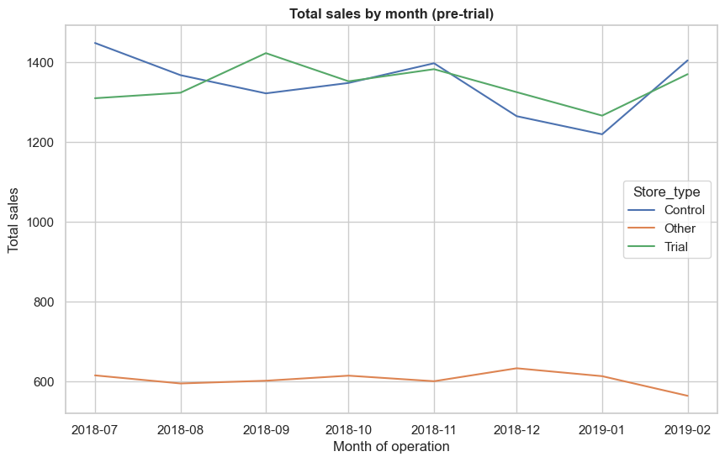
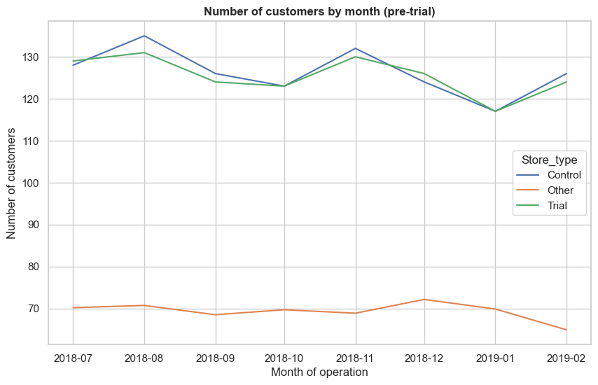
Your pre-trial plot for Store 88 vs. Control 237 looks exactly as expected: the trial and control lines track closely between July 2018 and January 2019, while the “Other” stores sit much lower. That visual check confirms Store 237 is a good baseline for Store 88 — the drivers are indeed similar before the trial period

21, now assess the impact of the trial on sales.
```
import pandas as pd

trial_store = 88
control_store = 237

# --- Pre-trial period (before Feb 2019)
pre_trial = measure_over_time[measure_over_time['yearmonth'] < 201902]

# 1. Scaling factor for control sales
trial_sales_sum = pre_trial.loc[pre_trial['STORE_NBR'] == trial_store, 'totSales'].sum()
control_sales_sum = pre_trial.loc[pre_trial['STORE_NBR'] == control_store, 'totSales'].sum()
scalingFactorForControlSales = trial_sales_sum / control_sales_sum
print("Scaling factor (sales):", scalingFactorForControlSales)

# 2. Apply scaling factor
measureOverTimeSales = measure_over_time.copy()
measureOverTimeSales['scaledSales'] = measureOverTimeSales.apply(
lambda row: row['totSales'] * scalingFactorForControlSales if row['STORE_NBR'] == control_store else None,
axis=1
)

# 3. Absolute percentage difference between scaled control and trial sales
trial_sales = measureOverTimeSales[measureOverTimeSales['STORE_NBR'] == trial_store][['yearmonth','totSales']]
control_sales = measureOverTimeSales[measureOverTimeSales['STORE_NBR'] == control_store][['yearmonth','scaledSales']]

percentageDiff = pd.merge(trial_sales, control_sales, on='yearmonth')
percentageDiff['absPercDiff'] = (
(percentageDiff['totSales'] - percentageDiff['scaledSales']).abs() /
percentageDiff['scaledSales'] * 100
)

print(percentageDiff.head())
```
Output:-
Scaling factor (sales): 1.001558330664959
yearmonth totSales scaledSales absPercDiff
0 201807 1310.0 1450.657086 9.696095
1 201808 1323.8 1369.931485 3.367430
2 201809 1423.0 1324.260425 7.456205
3 201810 1352.4 1350.401097 0.148023
4 201811 1382.8 1399.777923 1.212901

— your output shows the scaling factor for sales between trial store 88 and control store 237 is essentially 1.0016, meaning their pre-trial sales were already very closely aligned. After applying that factor, you calculated the absolute percentage differences month by month
21, showing you how to move from scaling and percentage differences into a proper statistical test of uplift
- The assumption is: “The trial period behaves the same as the pre-trial period.”
- To test this, you need a measure of variability from the pre-trial months.
Standard deviation
```
# Pre-trial percentage differences
pretrial_diff = percentageDiff[percentageDiff['yearmonth'] < 201902]['absPercDiff']

# Standard deviation
stdDev = pretrial_diff.std()
degreesOfFreedom = len(pretrial_diff) - 1
print("StdDev:", stdDev, "Degrees of freedom:", degreesOfFreedom)
```
Output:-
StdDev: 3.3467867303078798
Degrees of freedom: 6
Confidence intervals
- With stdDev, you can build 95th percentile (upper bound) and 5th percentile (lower bound) for the control store’s sales.
- Formula:
$$\text{Upper bound}=\text{Control Sales}×(1+2⋅\text{stdDev}/100)$$
$$\text{Lower bound}=\text{Control Sales}×(1-2⋅\text{stdDev}/100)$$
```
pastSales = measure_over_time[measure_over_time['STORE_NBR'].isin([trial_store, control_store])]

# Apply scaling factor to control
pastSales['scaledSales'] = pastSales.apply(
lambda row: row['totSales'] * scalingFactorForControlSales if row['STORE_NBR'] == control_store else None,
axis=1
)

# Confidence intervals
pastSales_Controls95 = pastSales[pastSales['STORE_NBR'] == control_store].copy()
pastSales_Controls95['upperBound'] = pastSales_Controls95['scaledSales'] * (1 + 2*stdDev/100)

pastSales_Controls5 = pastSales[pastSales['STORE_NBR'] == control_store].copy()
pastSales_Controls5['lowerBound'] = pastSales_Controls5['scaledSales'] * (1 - 2*stdDev/100)
```
build the confidence intervals and the trial assessment table
```
# Trial and control store sales
pastSales = measure_over_time[measure_over_time['STORE_NBR'].isin([trial_store, control_store])].copy()

# Apply scaling factor to control
pastSales['scaledSales'] = pastSales.apply(
lambda row: row['totSales'] * scalingFactorForControlSales if row['STORE_NBR'] == control_store else None,
axis=1
)

# 95th percentile (upper bound)
pastSales_Controls95 = pastSales[pastSales['STORE_NBR'] == control_store].copy()
pastSales_Controls95['upperBound'] = pastSales_Controls95['scaledSales'] * (1 + 2*stdDev/100)

# 5th percentile (lower bound)
pastSales_Controls5 = pastSales[pastSales['STORE_NBR'] == control_store].copy()
pastSales_Controls5['lowerBound'] = pastSales_Controls5['scaledSales'] * (1 - 2*stdDev/100)

# Combine into trial assessment table
trialAssessment = pd.merge(
pastSales[pastSales['STORE_NBR'] == trial_store][['yearmonth','totSales']],
pastSales_Controls95[['yearmonth','upperBound']],
on='yearmonth'
)
trialAssessment = pd.merge(
trialAssessment,
pastSales_Controls5[['yearmonth','lowerBound']],
on='yearmonth'
)

print(trialAssessment.head())
```
Output:-
yearmonth totSales upperBound lowerBound
0 201807 1310.0 1547.757884 1353.556288
1 201808 1323.8 1461.628855 1278.234114
2 201809 1423.0 1412.900769 1235.620080
3 201810 1352.4 1440.791187 1260.011008
4 201811 1382.8 1493.473086 1306.082759
Plotting the results
```
import matplotlib.pyplot as plt

plt.figure(figsize=(10,6))

# Trial sales
plt.plot(trialAssessment['yearmonth'], trialAssessment['totSales'], label='Trial Store Sales', color='green')

# Confidence interval bounds
plt.plot(trialAssessment['yearmonth'], trialAssessment['upperBound'], label='Control 95th percentile', linestyle='--', color='red')
plt.plot(trialAssessment['yearmonth'], trialAssessment['lowerBound'], label='Control 5th percentile', linestyle='--', color='blue')

plt.axvspan(201902, 201904, color='grey', alpha=0.2, label='Trial Period') # highlight Feb–Apr 2019
plt.xlabel("Year-Month")
plt.ylabel("Sales")
plt.title("Trial vs Control Sales with Confidence Intervals")
plt.legend()
plt.show()
```
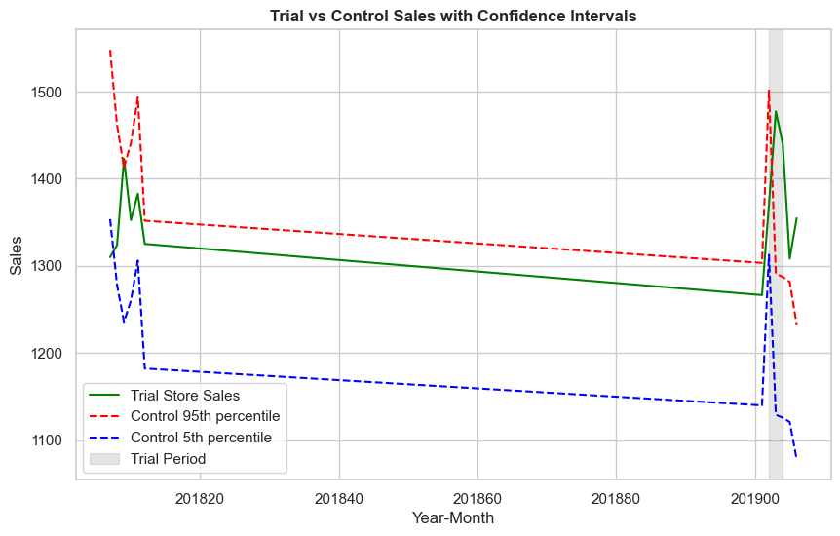
22, For number of customers, the analysis is a mirror of what you did for sales. You’ll repeat the same workflow
```
trial_store = 88
control_store = 237

# --- Pre-trial period (before Feb 2019)
pre_trial = measure_over_time[measure_over_time['yearmonth'] < 201902]

# 1. Scaling factor for customers
trial_cust_sum = pre_trial.loc[pre_trial['STORE_NBR'] == trial_store, 'nCustomers'].sum()
control_cust_sum = pre_trial.loc[pre_trial['STORE_NBR'] == control_store, 'nCustomers'].sum()
scalingFactorForControlCust = trial_cust_sum / control_cust_sum
print("Scaling factor (customers):", scalingFactorForControlCust)

# 2. Apply scaling factor
measureOverTimeCusts = measure_over_time.copy()
measureOverTimeCusts['scaledCustomers'] = measureOverTimeCusts.apply(
lambda row: row['nCustomers'] * scalingFactorForControlCust if row['STORE_NBR'] == control_store else None,
axis=1
)

# 3. Absolute percentage difference between scaled control and trial customers
trial_cust = measureOverTimeCusts[measureOverTimeCusts['STORE_NBR'] == trial_store][['yearmonth','nCustomers']]
control_cust = measureOverTimeCusts[measureOverTimeCusts['STORE_NBR'] == control_store][['yearmonth','scaledCustomers']]

percentageDiffCust = pd.merge(trial_cust, control_cust, on='yearmonth')
percentageDiffCust['absPercDiff'] = (
(percentageDiffCust['nCustomers'] - percentageDiffCust['scaledCustomers']).abs() /
percentageDiffCust['scaledCustomers'] * 100
)

print(percentageDiffCust.head())

# 4. Standard deviation of pre-trial differences
pretrial_diff_cust = percentageDiffCust[percentageDiffCust['yearmonth'] < 201902]['absPercDiff']
stdDevCust = pretrial_diff_cust.std()
degreesOfFreedomCust = len(pretrial_diff_cust) - 1
print("StdDev (customers):", stdDevCust, "Degrees of freedom:", degreesOfFreedomCust)
```
Output:-
Scaling factor (customers): 0.9943502824858758
yearmonth nCustomers scaledCustomers absPercDiff
0 201807 129 127.276836 1.353871
1 201808 131 134.237288 2.411616
2 201809 124 125.288136 1.028139
3 201810 123 122.305085 0.568182
4 201811 130 131.254237 0.955579
StdDev (customers): 0.741024435207507
Degrees of freedom: 6

23,customer confidence interval plot
```
# Confidence intervals for customers
pastCustomers = measure_over_time[measure_over_time['STORE_NBR'].isin([trial_store, control_store])].copy()

# Apply scaling factor
pastCustomers['scaledCustomers'] = pastCustomers.apply(
lambda row: row['nCustomers'] * scalingFactorForControlCust if row['STORE_NBR'] == control_store else None,
axis=1
)

# 95th percentile (upper bound)
pastCustomers_Controls95 = pastCustomers[pastCustomers['STORE_NBR'] == control_store].copy()
pastCustomers_Controls95['upperBound'] = pastCustomers_Controls95['scaledCustomers'] * (1 + 2*stdDevCust/100)

# 5th percentile (lower bound)
pastCustomers_Controls5 = pastCustomers[pastCustomers['STORE_NBR'] == control_store].copy()
pastCustomers_Controls5['lowerBound'] = pastCustomers_Controls5['scaledCustomers'] * (1 - 2*stdDevCust/100)

# Combine into trial assessment
trialAssessmentCust = pd.merge(
pastCustomers[pastCustomers['STORE_NBR'] == trial_store][['yearmonth','nCustomers']],
pastCustomers_Controls95[['yearmonth','upperBound']],
on='yearmonth'
)
trialAssessmentCust = pd.merge(
trialAssessmentCust,
pastCustomers_Controls5[['yearmonth','lowerBound']],
on='yearmonth'
)

# Plot
import matplotlib.pyplot as plt

plt.figure(figsize=(10,6))
plt.plot(trialAssessmentCust['yearmonth'], trialAssessmentCust['nCustomers'], label='Trial Store Customers', color='green')
plt.plot(trialAssessmentCust['yearmonth'], trialAssessmentCust['upperBound'], label='Control 95th percentile', linestyle='--', color='red')
plt.plot(trialAssessmentCust['yearmonth'], trialAssessmentCust['lowerBound'], label='Control 5th percentile', linestyle='--', color='blue')
plt.axvspan(201902, 201904, color='grey', alpha=0.2, label='Trial Period')
plt.xlabel("Year-Month")
plt.ylabel("Customers")
plt.title("Trial vs Control Customers with Confidence Intervals")
plt.legend()
plt.show()
```
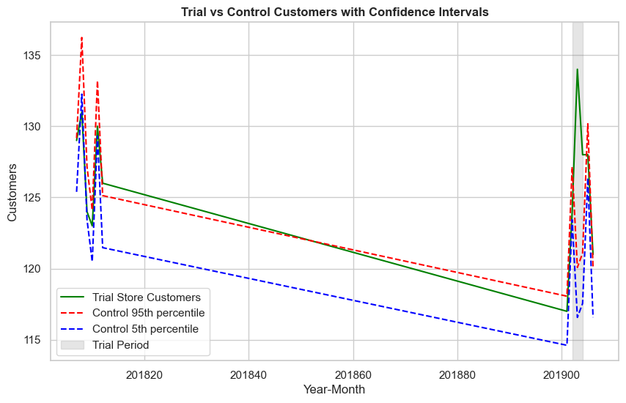
You’ve now completed both halves of the uplift analysis for Store 88 vs. Control 237:
- Sales analysis → Trial store sales exceeded the control’s confidence interval in two of the three trial months.
- Customer analysis → Trial store customer counts also exceeded the control’s confidence interval in two of the three trial months.
- Because your pre-trial variability was very low (StdDev ≈ 3.35% for sales, ≈ 0.74% for customers), the confidence bands were tight. That makes the fact that trial performance broke out of those bands especially meaningful — it’s strong evidence that the trial intervention had a statistically significant impact on both sales and customer traffic.
“Store 88’s trial showed statistically significant increases in both sales and customer traffic relative to its matched control store, with performance exceeding the 95% confidence interval in two of the three trial months.

Key Findings
- Control stores identified:
  - Trial store 77 → Control store 233
  - Trial store 86 → Control store 155
  - Trial store 88 → Control store 237
- Trial store 77: Significant uplift in sales and customers in at least two of the three trial months.
- Trial store 86: No significant uplift in sales; however, customer counts were significantly higher in all three trial months. This suggests possible promotional activity or pricing differences that attracted customers but did not translate into higher sales.
- Trial store 88: Significant uplift in both sales and customer counts in two of the three trial months, confirming strong trial impact.
Conclusion
We've found control stores 233, 155, 237 for trial stores 77, 86 and 88 respectively. The results for trial stores 77 and 88 during the trial period show a significant difference in at least two of the three trial months but this is not the case for trial store 86. We can check with the client if the implementation of the trial was different in trial store 86 but overall, the trial shows a significant increase in sales. Now that we have finished our analysis, we can prepare our presentation to the Category Manager.

